TABLE OF CONTENTS
UNITED STATES
SECURITIES AND EXCHANGE COMMISSION
Washington, D.C. 20549
SCHEDULE 14A
Proxy Statement Pursuant to Section 14(a) of
the Securities Exchange Act of 1934 (Amendment No. )
Filed by the Registrant ☒
Filed by a Party other than the Registrant ☐
Check the appropriate box:
Preliminary Proxy Statement
☐
​
Confidential, for Use of the Commission Only (as permitted by Rule 14a-(e)(2))
☐
​
Definitive Proxy Statement
☒
​
Definitive Additional Materials
☐
​
Soliciting Material under §240.14a-12
☐
​
GENERAC HOLDINGS INC.
​
(Name of Registrant as Specified In Its Charter)​

​
(Name of Person(s) Filing Proxy Statement, if other than the Registrant)​
Payment of Filing Fee (Check all boxes that apply):
No fee required.
☒
​
Fee paid previously with preliminary materials.
☐
​
Fee computed on table in exhibit required by Item 25(b) per Exchange Act Rules 14a-6(I)(1) and 0-11.
☐
​

TABLE OF CONTENTS

April 28, 2023
​
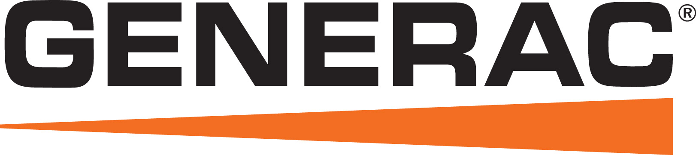
Notice of Annual
Meeting of Stockholders
To the Stockholders of our Company:
You are cordially invited to attend the 2023 Annual Meeting of Stockholders where we will be voting on the below matters.
Items of Business
To elect the four nominees named herein as Class II directors;
•
​
To ratify the selection of Deloitte & Touche LLP as our independent, registered public accounting firm for the year ending December 31, 2023;
•
​
To approve, on an advisory, non-binding basis, the compensation of our executive officers;
•
​
To approve, on an advisory, non-binding basis, the frequency of future advisory votes on executive compensation; and
•
​
To consider any other matters that may properly come before the meeting or any adjournments or postponements of the meeting.
•
​
​ |   DATE AND TIME:  Thursday, June 15, 2023 9:00 a.m. CT | ​ | ​ | Instructions regarding all methods of voting are contained on any Notice of Internet Availability of Proxy Materials or proxy card provided. If your shares are held in the name of a bank, broker, fiduciary or custodian, follow the voting instructions you receive from your record holder.  Your vote is important. Whether or not you intend to be present at the meeting, to assure that your shares are represented at the meeting, please vote promptly using one of the methods mentioned below. | ​
​
 | ​
WHERE: | ​
Generac Power  Systems, Inc.  S45 W29290 Hwy. 59  Waukesha, Wisconsin  53189    ADMISSION: Holders of record of our common stock at the close of business on April 17, 2023 are entitled to notice of, and to vote at, the annual meeting. | ​

​ |  | ​ | ​ |  | ​ | ​ |  | ​ | ​ |  | ​
​ | Internet | ​ | ​ | Telephone | ​ | ​ | Mail | ​ | ​ | In Person | ​
​ | Visit the internet  website indicated on  the Notice of  Internet Availability  or any proxy card  you receive and  follow the on-screen  instructions. | ​ | ​ | Use the toll-free  telephone number  shown on the  Notice of Internet  Availability or any  proxy card you  receive. | ​ | ​ | If you request a paper proxy card by telephone or internet, you may elect to vote by mail. If you elect to do so, you should date, sign and promptly return your proxy card by mail in the postage prepaid envelope which accompanied that proxy card. | ​ | ​ | You can deliver a completed proxy card at the  meeting or vote in person. | ​
​ | Thank you for your continued support of and interest in the Company. |  |  |  |  |  |  |  |  |  | ​
By Order of the Board of Directors,
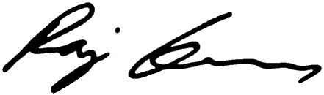
Raj Kanuru
Executive Vice President, General Counsel, and Secretary

TABLE OF CONTENTS​

TABLE OF CONTENTS
​ | SUMMARY INFORMATION | ​ | ​ | ​ | ​ | 1 | ​ | ​
​ | PROPOSAL 1 — ELECTION OF CLASS II DIRECTORS | ​ | ​ | ​ | ​ | 4 | ​ | ​
​ | CORPORATE GOVERNANCE | ​ | ​ | ​ | ​ | 16 | ​ | ​
​ | BENEFICIAL OWNERSHIP OF OUR COMMON STOCK | ​ | ​ | ​ | ​ | 25 | ​ | ​
​ | EXECUTIVE COMPENSATION | ​ | ​ | ​ | ​ | 27 | ​ | ​
​ | REPORT OF THE HUMAN CAPITAL AND COMPENSATION COMMITTEE | ​ | ​ | ​ | ​ | 41 | ​ | ​
​ | 2022 DIRECTOR COMPENSATION | ​ | ​ | ​ | ​ | 55 | ​ | ​
​ | RELATED PERSON TRANSACTIONS | ​ | ​ | ​ | ​ | 57 | ​ | ​
​ | PROPOSAL 2 — RATIFICATION OF THE SELECTION OF INDEPENDENT REGISTERED PUBLIC ACCOUNTING FIRM | ​ | ​ | ​ | ​ | 58 | ​ | ​
​ | PROPOSAL 3 — ADVISORY APPROVAL OF EXECUTIVE COMPENSATION | ​ | ​ | ​ | ​ | 60 | ​ | ​
​ | PROPOSAL 4 — ADVISORY APPROVAL OF THE FREQUENCY OF FUTURE ADVISORY VOTES ON EXECUTIVE COMPENSATION | ​ | ​ | ​ | ​ | 61 | ​ | ​
​ | REPORT OF THE AUDIT COMMITTEE | ​ | ​ | ​ | ​ | 62 | ​ | ​
​ | NOMINATIONS AND PROPOSALS BY STOCKHOLDERS | ​ | ​ | ​ | ​ | 63 | ​ | ​
​ | INFORMATION CONCERNING SOLICITATION AND VOTING | ​ | ​ | ​ | ​ | 64 | ​ | ​
​ | ​ | Important notice: | ​ | ​
​ | ​ | The Board of Directors (the “Board of Directors” or “Board”) of Generac Holdings Inc. (“Generac,” “we,” “us,” “our,” or the “Company”) is soliciting your proxy to be voted at the Annual Meeting of Stockholders to be held on Thursday, June 15, 2023. | ​ | ​
​ | ​ | Instead of mailing a printed copy of our proxy materials to each stockholder, we furnish proxy materials to our stockholders over the internet by mailing a Notice of Internet Availability of Proxy Materials (“Notice of Internet Availability”), unless otherwise instructed by the stockholder. The Notice of Internet Availability includes information on where to view all proxy materials online, as well as voting instructions. If you received a Notice of Internet Availability and you would like to receive a printed copy of our proxy materials, you should follow the instructions for requesting such materials included in the Notice of Internet Availability. The Notice of Internet Availability was first mailed on or about April 28, 2023 to all stockholders of record as of the record date for the annual meeting, which was the close of business on April 17, 2023. | ​ | ​

​ |  | ​ | ​ | ​ | ​ | ​ | 2023 Proxy Statement | ​

TABLE OF CONTENTS​
Summary Information
Our Corporate Strategy
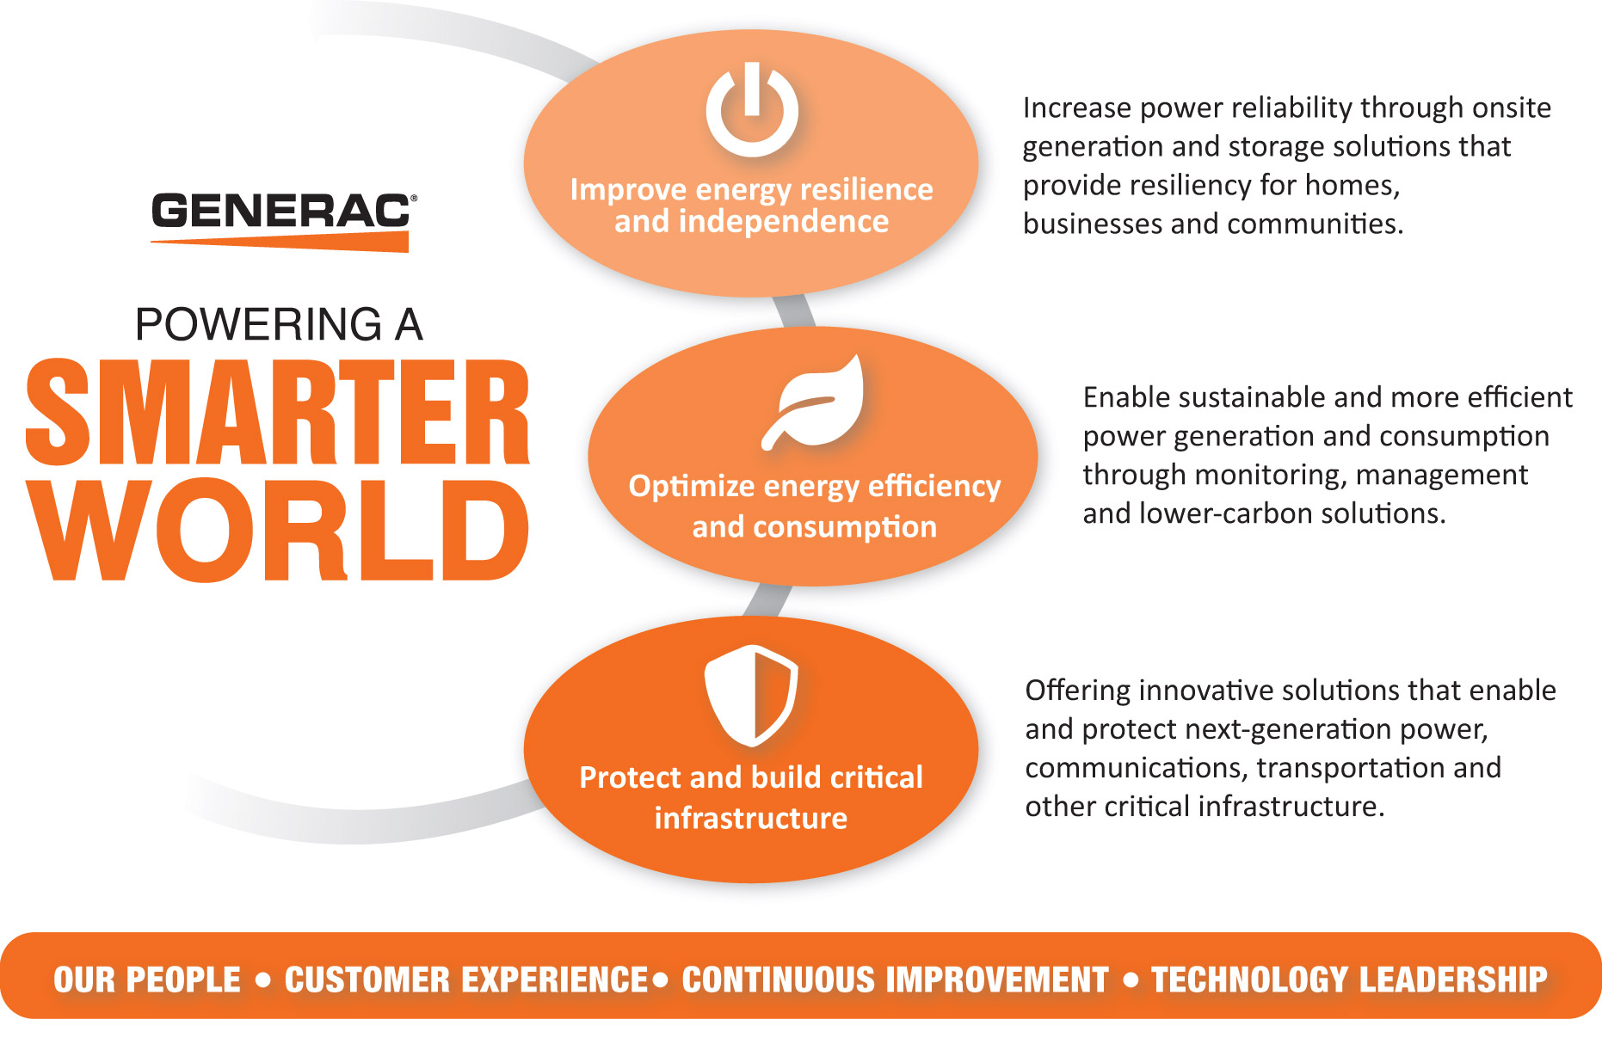
Generac By The Numbers
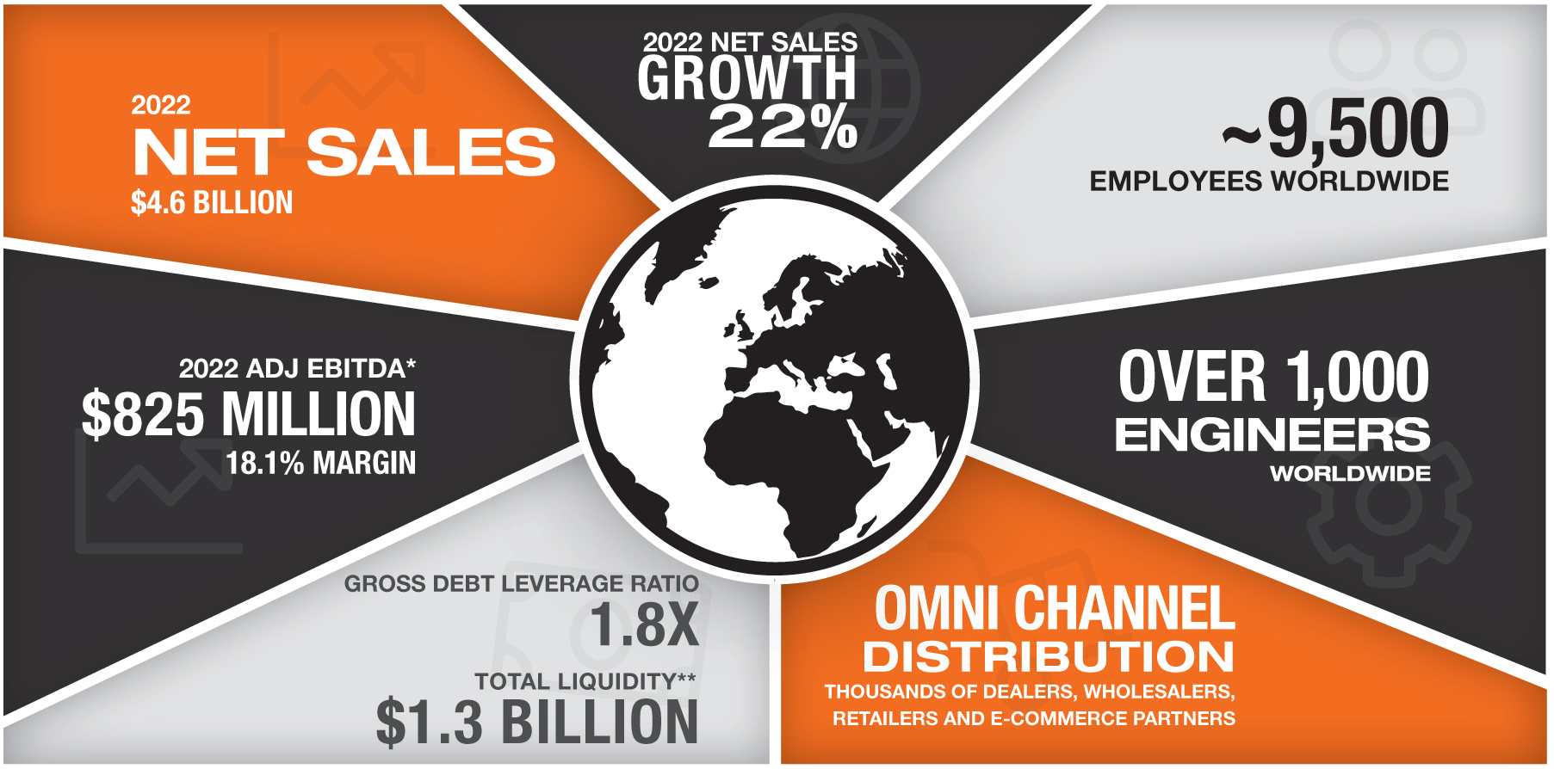
* A full discussion of our use of non-U.S. generally accepted accounting principles measures to provide a baseline for evaluating and comparing our operating results, and a reconciliation of Adjusted EBITDA to net income can be found in Item 7 of the Company’s Annual Report on Form 10-K for the fiscal year ended December 31, 2022.
** Gross debt leverage ratio and total liquidity as of 12/31/2022.

​ |  | ​ | ​ | 1 | ​ | ​ | 2023 Proxy Statement | ​

TABLE OF CONTENTS
SUMMARY INFORMATION
Proposals at the Meeting |  |  |  | ​ | ​ | Board Recommendations: |  |  |  | ​
Proposal 1: Election of  Directors  Marcia J. Avedon  Bennett J. Morgan  Dominick P. Zarcone | ​ | ​ | Pages 4-15 | ​ | ​ |  | ​ | ​ | FOR each  director  nominee | ​
Proposal 2:  To ratify the selection of  Deloitte & Touche LLP as our  independent registered public  accounting firm for the year  ending December 31, 2023 | ​ | ​ | Page 58 | ​ | ​ |  | ​ | ​ | FOR | ​
Proposal 3:  To approve, on an advisory,  non-binding basis,  the compensation of  our executive officers | ​ | ​ | Page 60 | ​ | ​ |  | ​ | ​ | FOR | ​
Proposal 4:  To approve, on an advisory,  non-binding basis,  the frequency of future  votes on executive  compensation | ​ | ​ | Page 61 | ​ | ​ |  | ​ | ​ | 1 YEAR | ​

​ |  | ​ | ​ | 2 | ​ | ​ | 2023 Proxy Statement | ​

TABLE OF CONTENTS
SUMMARY INFORMATION
Our 2022 Business Highlights
We achieved another year of solid financial results, including record sales, in 2022.
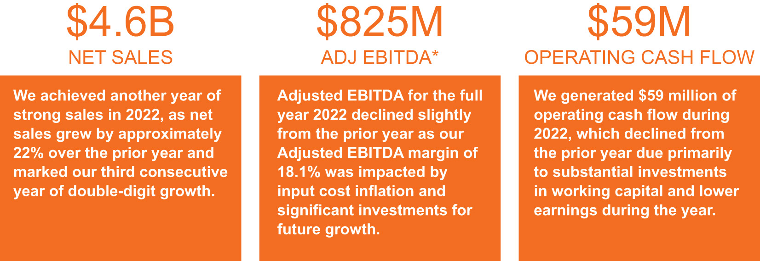
Key Components and Design of the Executive Compensation Program
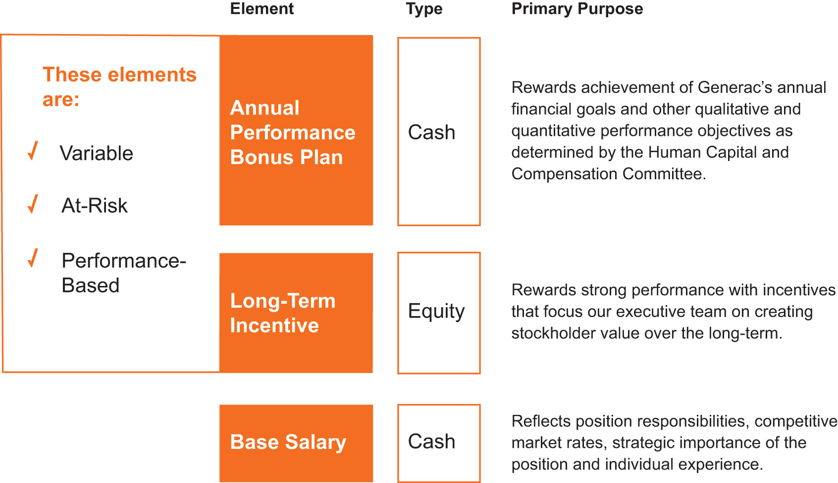
* A full discussion of our use of non-U.S. generally accepted accounting principles measures to provide a baseline for evaluating and comparing our operating results, and a reconciliation of Adjusted EBITDA to net income can be found in Item 7 of the Company’s Annual Report on Form 10-K for the fiscal year ended December 31, 2022.

​ |  | ​ | ​ | 3 | ​ | ​ | 2023 Proxy Statement | ​

TABLE OF CONTENTS​
Proposal 1 — Election of Class II Directors
​
​

​ | ​ | The nominees for election as Class II Directors at the 2023 annual meeting are described below, each of whom has been nominated by the Board of Directors. If elected, each of the nominees is expected to serve for a three-year term expiring at the annual meeting of stockholders of the Company in 2026 and until their respective successors have been elected and qualified.  The Board of Directors recommends a vote FOR the Company’s nominees for Class II Directors. | ​ | ​

Our Board of Directors is divided into three classes, with each class serving a consecutive three-year term. The term of the current Class II Directors will expire on the date of the 2023 annual meeting, subject to the election and qualification of their respective successors. The Board of Directors expects that each of the nominees will be available for election as a director. However, if by reason of an unexpected occurrence, one or more of the nominees is not available for election, the persons named in the form of proxy have advised that they will vote for such substitute nominees as the Board of Directors may nominate.
In selecting director candidates, the Nominating and Corporate Governance Committee considers whether the candidates possess the required skill sets and fulfill the qualification requirements of directors approved by the Board of Directors, including integrity, objectivity, sound judgment, leadership, courage, and diversity in all aspects of that term, including differences of perspective, professional experience, education, skills, and other individual qualities, such as gender, race and ethnicity, and sexual orientation.
The following table provides the composition of each of our committees:
​ | Director | ​ | ​ | ​ | Audit Committee | ​ | ​ | ​ | Human  Capital and  Compensation  Committee | ​ | ​ | ​ | Nominating  and Corporate  Governance  Committee | ​
​ | Marcia Avedon | ​ | ​ | ​ | ​ | ​ | ​ | ​ | C | ​ | ​ | ​ | X | ​
​ | John Bowlin | ​ | ​ | ​ | ​ | ​ | ​ | ​ | X | ​ | ​ | ​ | ​ | ​
​ | Robert Dixon | ​ | ​ | ​ | X | ​ | ​ | ​ | ​ | ​ | ​ | ​ | C | ​
​ | William Jenkins | ​ | ​ | ​ | ​ | ​ | ​ | ​ | X | ​ | ​ | ​ | ​ | ​
​ | Andrew Lampereur | ​ | ​ | ​ | C | ​ | ​ | ​ | ​ | ​ | ​ | ​ | ​ | ​
​ | Bennett Morgan (L) | ​ | ​ | ​ | ​ | ​ | ​ | ​ | X | ​ | ​ | ​ | X | ​
​ | Nam Nguyen | ​ | ​ | ​ | ​ | ​ | ​ | ​ | ​ | ​ | ​ | ​ | X | ​
​ | David Ramon | ​ | ​ | ​ | X | ​ | ​ | ​ | ​ | ​ | ​ | ​ | X | ​
​ | Kathryn Roedel | ​ | ​ | ​ | X | ​ | ​ | ​ | ​ | ​ | ​ | ​ | X | ​
​ | Dominick Zarcone | ​ | ​ | ​ | X | ​ | ​ | ​ | X | ​ | ​ | ​ | ​ | ​
“C” = Chairperson
“L” = Lead Director

​ |  | ​ | ​ | 4 | ​ | ​ | 2023 Proxy Statement | ​

TABLE OF CONTENTS
PROPOSAL 1 — ELECTION OF CLASS II DIRECTORS
Our directors and nominees bring a broad range of skills, experiences, and perspectives to our board. The below tables and graphics summarize the skills and experiences that bring value to our company.
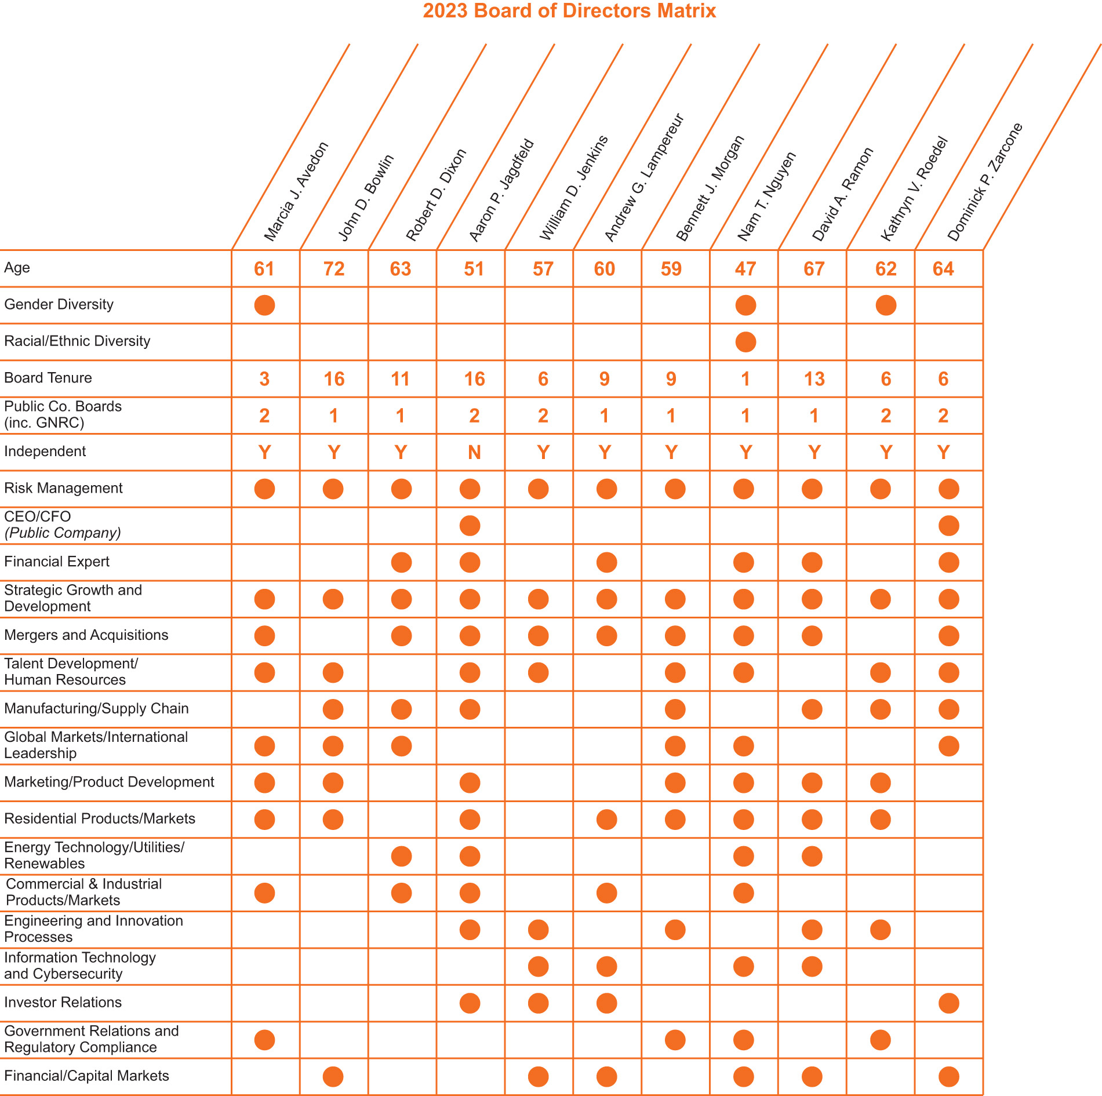

​ |  | ​ | ​ | 5 | ​ | ​ | 2023 Proxy Statement | ​

TABLE OF CONTENTS
PROPOSAL 1 — ELECTION OF CLASS II DIRECTORS
The following biographies describe the business experience of each director. Following the biographical information for each director below, we have listed qualifications that, in addition to those discussed above, the Board of Directors considered in determining whether to recommend the director be nominated for reelection.
Nominees for Election
Class II Directors
MARCIA J. AVEDON, PH.D. |  |  |  | ​
  Age: 61  Director Since: 2019 | ​ | ​ | EXPERIENCE & QUALIFICATIONS  2022-Current: Founder and CEO, Avedon Advisory, LLC  •  ​  2020-2022: Executive Vice President, Chief Human Resources, Marketing, & Communications Officer for Trane Technologies, a climate control innovation company focusing on heating and cooling in buildings, homes, and transportation (previously Ingersoll-Rand, plc)  •  ​  2007-2020: Senior Vice President of Human Resources, Communications, and Corporate Affairs for Ingersoll-Rand, plc, leading global human resources, public affairs, corporate social responsibility, communications, and strategic marketing  •  ​  2002-2006: Chief Human Resources Officer at Merck, a global pharmaceutical company  •  ​  1995-2002: Held increasingly responsible leadership positions in Human Resources and Communications for Honeywell International, a global diversified company  •  ​  Prior to 1995: Held positions in Human Resources at Anheuser-Busch Companies and as a consultant with Booz, Allen & Hamilton  •  ​  Other Board Service  Current Director of Acuity Brands, Inc.  •  ​  Former Director of GCP Applied Technologies, a global manufacturer of construction products  •  ​  Former Director of Lincoln National Corporation, a Fortune 500 financial services company  •  ​  Ms. Avedon brings to Generac extensive expertise on global human resources and human capital topics. Ms. Avedon has over 30 years of experience leading organizational transformation, talent and succession management, culture change, corporate social responsibility, and communications.  Ms. Avedon earned a Bachelor of Arts in Psychology from the University of North Carolina at Wilmington, and a Master’s Degree and Ph.D. in Industrial and Organizational Psychology from George Washington University. | ​

​ |  | ​ | ​ | 6 | ​ | ​ | 2023 Proxy Statement | ​

TABLE OF CONTENTS
PROPOSAL 1 — ELECTION OF CLASS II DIRECTORS
BENNETT J. MORGAN |  |  |  | ​
  Age: 59  Director Since: 2013  Lead Director Since: 2018 | ​ | ​ | EXPERIENCE & QUALIFICATIONS  2005-2016: President and Chief Operating Officer, Polaris Industries Inc., a manufacturer of power sports vehicles (“Polaris”)  •  ​  2004-2005: Vice President and General Manager, ATV Division, Polaris  •  ​  2001-2004: General Manager, ATV Division, Polaris  •  ​  1997-2001: General Manager, PGA Division, Polaris  •  ​  1987-1997: Various marketing, product development, and operations positions at Polaris Industries  •  ​  Mr. Morgan brings to Generac extensive leadership skills. Having served in senior roles as President and Chief Operating Officer for a public company, Mr. Morgan has over 25 years of expertise in international consumer durables products, dealer distribution, product development, and innovation. Serving in these leadership roles provides Mr. Morgan with in-depth knowledge of strategic growth and development and company oversight, including talent development, product development, engineering, and manufacturing operations.  Mr. Morgan earned his Bachelor of Science in Economics from St. John’s University and Master of Business Administration from the Carlson School of Management at the University of Minnesota. | ​

​ |  | ​ | ​ | 7 | ​ | ​ | 2023 Proxy Statement | ​

TABLE OF CONTENTS
PROPOSAL 1 — ELECTION OF CLASS II DIRECTORS
DOMINICK P. ZARCONE |  |  |  | ​
  Age: 64  Director Since: 2017 | ​ | ​ | EXPERIENCE & QUALIFICATIONS  2017-Current: President and Chief Executive Officer of LKQ Corporation, a global distributor of vehicle parts and accessories  •  ​  2015-2017: Chief Financial Officer, LKQ Corporation  •  ​  2011-2015: Managing Director and Chief Financial Officer of Baird Financial Group, a capital markets and wealth management company, and certain of its affiliates  •  ​  2011-2015: Treasurer of Baird Funds, Inc., a family of fixed income and equity mutual funds managed by Robert W. Baird & Co. Incorporated, a registered broker/dealer  •  ​  1995-2011: Managing Director of the Investment Banking department of Robert W. Baird & Co. Incorporated  •  ​  1986-1995: Held various positions with investment banking company Kidder, Peabody & Co., Incorporated, most recently as Senior Vice President of Investment Banking  •  ​  Other Board Service  Current Director of LKQ Corporation  •  ​  Mr. Zarcone brings to Generac extensive management and leadership experience, serving in senior leadership roles as Chief Executive Officer and Chief Financial Officer of a public corporation. Mr. Zarcone has also held senior leadership roles as Managing Director and Chief Financial Officer of privately held companies. Mr. Zarcone has over 35 years of expertise in investment banking, wealth management, and capital markets bringing significant financial expertise to Generac.  Mr. Zarcone earned his Bachelor of Science in Finance from the University of Illinois at Urbana-Champaign and Master of Business Administration from the University of Chicago Graduate School of Business. | ​

​ |  | ​ | ​ | 8 | ​ | ​ | 2023 Proxy Statement | ​

TABLE OF CONTENTS
PROPOSAL 1 — ELECTION OF CLASS II DIRECTORS
Other Members of the Board of Directors
Including the nominees, the Board of Directors currently consists of eleven directors, each of whom, other than the nominees, is described below. The terms of the Class III Directors expire at the 2024 Annual Meeting of Stockholders, subject to the election and qualification of their respective successors. The terms of the Class I Directors expire at the 2025 Annual Meeting of Stockholders, subject to the election and qualification of their respective successors.
Class I Directors
JOHN D. BOWLIN |  |  |  | ​
  Age: 72  Director Since: 2006 | ​ | ​ | EXPERIENCE & QUALIFICATIONS  2008-2011: Consultant to CCMP Capital Advisors, LLC  •  ​  1985-2003: Held various leadership positions with Philip Morris Companies, Inc. and Miller Brewing Company, including  •  ​  President, Oscar Mayer Food Corporation,  ◦  ​  President and Chief Operating Officer, Miller Brewing Company,  ◦  ​  President and Chief Operating Officer, Kraft Foods North America,  ◦  ​  President and Chief Executive Officer, Kraft International, Inc., and  ◦  ​  President and Chief Executive Officer, Miller Brewing Company.  ◦  ​  Other Board Service  Current Director of Cerity Partners, a leading, national registered financial advisory firm  •  ​  Former Director of the Schwan Food Company, Quiznos, and ChupaChups  •  ​  Former Director and Non-Executive Chairman of  •  ​  Vitamin Shoppe, Inc.,  ◦  ​  Spectrum Brands, and  ◦  ​  Pliant Corporation.  ◦  ​  Mr. Bowlin brings to Generac extensive leadership skills and operational experience having served in several executive positions, including as Chairman, Chief Executive Officer and Chief Operating Officer for a number of privately held companies and divisions of public companies. With over 30 years in leadership roles in the consumer products industry, Mr. Bowlin’s background also provides Generac with significant strategic growth and development expertise.  Mr. Bowlin holds a Bachelor of Business Administration from Georgetown University and a Master of Business Administration from Columbia University. | ​

​ |  | ​ | ​ | 9 | ​ | ​ | 2023 Proxy Statement | ​

TABLE OF CONTENTS
PROPOSAL 1 — ELECTION OF CLASS II DIRECTORS
AARON P. JAGDFELD |  |  |  | ​
Age: 51  Director Since: 2006  Chairman Since: 2016 | ​ | ​ | EXPERIENCE & QUALIFICATIONS  2008-Current: President and Chief Executive Officer of Generac  •  ​  2007: President of Generac, responsible for sales, marketing, engineering, and product development  •  ​  2002-2006: Chief Financial Officer, Generac  •  ​  1994-2001: Finance Department, Generac  •  ​  Prior to 1994: Audit Practice, Deloitte & Touche, LLP  •  ​  Other Board Service  Current Director of The Hillman Group, a public company providing complete hardware solutions  •  ​  As the Chief Executive Officer and the only management representative on the Board, Mr. Jagdfeld provides valuable insight to the Board regarding the day-to-day business issues facing the Company. Since joining the Company, he has navigated a number of challenges, including our initial public offering, the significant increase in sales, numerous acquisitions, and our international expansion. Mr. Jagdfeld has extensive finance and operational experience and has high-level leadership experience in several prior positions. Mr. Jagdfeld holds a Bachelor of Business Administration in Accounting from the University of Wisconsin-Whitewater. | ​
ANDREW G. LAMPEREUR |  |  |  | ​
  Age: 60  Director Since: 2014 | ​ | ​ | EXPERIENCE & QUALIFICATIONS  2000-2017: Executive Vice President and Chief Financial Officer, Actuant Corporation, a global diversified company that designs and manufactures industrial products and systems  •  ​  1999-2000: Applied Power (Actuant) Business Development Leader  •  ​  1998-1999: Vice President and General Manager-Distribution, Gardner Bender (Actuant subsidiary)  •  ​  1996-1998: Vice President Finance, Gardner Bender  •  ​  1993-1996: Corporate Controller, Actuant Corporation  •  ​  Prior to 1993: Held various financial positions with Fruehauf Trailer Corporation, Terex Corporation, and Price Waterhouse  •  ​  Other Board Service  Former Director of Jason Industries, Inc.  •  ​  Former Director of Robbins & Myers  •  ​  Mr. Lampereur brings extensive financial experience to Generac. Mr. Lampereur has over 26 years of senior-level financial experience in a variety of businesses complementary to Generac, including as a chief financial officer and director of a public company.  Mr. Lampereur graduated with a Bachelor of Business Administration in Accounting from St. Norbert College. | ​

​ |  | ​ | ​ | 10 | ​ | ​ | 2023 Proxy Statement | ​

TABLE OF CONTENTS
PROPOSAL 1 — ELECTION OF CLASS II DIRECTORS
NAM T. NGUYEN |  |  |  | ​
  Age: 47  Director Since: 2022 | ​ | ​ | EXPERIENCE & QUALIFICATIONS  2020-Current: Chief Operating Officer, Generate Capital, a leading sustainable infrastructure company  •  ​  2013-2020: Executive Vice President, SunPower Corp., a solar power products company  •  ​  Prior to 2013: Vice President of Global Business Development at First Solar and held various positions in investment banking, working in New York, Singapore and Los Angeles  •  ​  Ms. Nguyen brings to Generac over 20 years of experience as an executive leader in renewable energy and sustainable infrastructure. Ms. Nguyen specializes in P&L management, international market expansion, business development, sales strategy and operations, and financing. Working in the domestic and international solar sector, Ms. Nguyen has led startup and expansion projects, specifically driving revenue and scaling businesses in new markets. Ms. Nguyen’s background with solar power and renewable energy markets provides Generac with valuable expertise and strategic insight within key areas of Generac’s business. Ms. Nguyen also brings significant international experience, having worked in Latin America and Singapore.  Ms. Nguyen graduated with a Bachelor of Arts in Economics from Columbia University and a Master of Business Administration from Harvard University. | ​

​ |  | ​ | ​ | 11 | ​ | ​ | 2023 Proxy Statement | ​

TABLE OF CONTENTS
PROPOSAL 1 — ELECTION OF CLASS II DIRECTORS
Class III Directors
ROBERT D. DIXON |  |  |  | ​
  Age: 63  Director Since: 2012 | ​ | ​ | EXPERIENCE & QUALIFICATIONS  2014-2016: Chairman and CEO of Natural Systems Utilities LLC, a distributed water infrastructure company  •  ​  2012-2014: Chief Executive Officer of Seven Seas Water Corporation, an international services corporation  •  ​  1983-2011: Held various leadership roles at Air Products and Chemicals, Inc., including Senior Vice President & General Manager  •  ​  Other Board Service  Former Director of Valicor Environmental Services, a private equity-owned company that is one of the largest providers of nonhazardous wastewater treatment services in North America.  •  ​  Mr. Dixon brings to Generac over 30 years of global management, operations and finance experience. Mr. Dixon has significant prior experience working in the energy industry, including specifically within the industrial gas sector on various clean energy initiatives. Mr. Dixon also brings vast international experience to Generac, having managed international operations for the majority of his career, including spending several years working overseas in Asia.  Mr. Dixon earned a Bachelor of Business Administration from Miami University and a Master of Business Administration from Pennsylvania State University. He also attended the Advanced Management Program at INSEAD in Fontainebleau, France. | ​

​ |  | ​ | ​ | 12 | ​ | ​ | 2023 Proxy Statement | ​

TABLE OF CONTENTS
PROPOSAL 1 — ELECTION OF CLASS II DIRECTORS
DAVID A. RAMON |  |  |  | ​
  Age: 67  Director Since: 2010 | ​ | ​ | EXPERIENCE & QUALIFICATIONS  2019-Current: Investment Partner in Gratitude Railroad, an ESG alternative investment capital firm  •  ​  1998-Current: Founder and Managing Partner of Vaduz Partners, a private investment firm  •  ​  2014-2018: Chairman and Chief Executive Officer of Diversified Maintenance, a specialized facility services company  •  ​  2000-2007: President and Chief Executive Officer of USA.NET, Inc.  •  ​  1997-1998: President, Coleman Outdoor Recreation Group  •  ​  1994-1997: Held various senior management positions, including President and Chief Operating Officer of New World Television, Inc.  •  ​  1982-1994: Executive Vice President and Chief Financial Officer of Gillett Holdings, Inc.  •  ​  Prior to 1982: Arthur Young & Company  •  ​  Other Board Service  Current Director of Sagent-CTAM Holdings, Inc., a leading network solutions provider  •  ​  Former Director of Diversified Maintenance  •  ​  Former Director of New World Communications Group, Inc.  •  ​  Former Director of USA.NET, Inc.  •  ​  Mr. Ramon brings to Generac more than 30 years of broad management, operations, and investment experience with established consumer product markets, emerging companies in cloud computing and software services, and in enterprises that deliver positive social and environmental impact. Mr. Ramon also brings significant leadership and financial experience, having served as CEO, COO, President or CFO for a number of privately held and public companies. Mr. Ramon’s work as a founder and managing partner of a private investment firm gives him significant and valuable capital markets experience.  Mr. Ramon earned a Bachelor of Business Administration in Accounting from the University of Wisconsin. | ​

​ |  | ​ | ​ | 13 | ​ | ​ | 2023 Proxy Statement | ​

TABLE OF CONTENTS
PROPOSAL 1 — ELECTION OF CLASS II DIRECTORS
WILLIAM D. JENKINS, JR. |  |  |  | ​
  Age: 57  Director Since: 2017 | ​ | ​ | EXPERIENCE & QUALIFICATIONS  2021-Current: President of Palo Alto Networks, a public cybersecurity firm  •  ​  2012-2021: President & Chief Executive Officer of Barracuda Networks, a private network technology company  •  ​  1998-2012: Held various positions at EMC Corporation, an information infrastructure company, including President of the Backup Recovery Systems division  •  ​  Other Board Service  Current Director of Skydeck Acquisition Corporation, a special purpose acquisition company focused on media, technology, communications, and digital health companies  •  ​  Former Director of Barracuda Networks  •  ​  Former Director of Sumo Logic, a public cloud-based machine data analytics company  •  ​  Former Lead Director for Apigee Corporation (acquired by Google, Inc.)  •  ​  Former Director for Nimble Storage, Inc. (acquired by Hewlett Packard Enterprise Company)  •  ​  Mr. Jenkins brings to Generac over 10 years of cybersecurity and technology experience, most recently serving as the President of a leading global cybersecurity company.  Mr. Jenkins holds a Bachelor of Science in General Engineering from the University of Illinois and a Master of Business Administration from Harvard Business School. | ​

​ |  | ​ | ​ | 14 | ​ | ​ | 2023 Proxy Statement | ​

TABLE OF CONTENTS
PROPOSAL 1 — ELECTION OF CLASS II DIRECTORS
KATHRYN V. ROEDEL |  |  |  | ​
  Age: 62  Director Since: 2016 | ​ | ​ | EXPERIENCE & QUALIFICATIONS  2005-2016: Held various leadership roles at Sleep Number Corporation (formerly Select Comfort Corporation), a manufacturer of mattresses and sleep-related products, including  •  ​  Executive Vice President and Chief Services and Fulfillment Officer  ◦  ​  Executive Vice President, Product and Service, and  ◦  ​  Senior Vice President, Global Supply Chain.  ◦  ​  1983-2005: Held various leadership roles at GE, including  •  ​  General Manager, Global Supply Chain Strategy, GE Healthcare,  ◦  ​  General Manager, Global Quality and Six Sigma, GE Healthcare,  ◦  ​  Vice President Technical Operations and Director/Vice President of Quality Programs for GE Clinical Services, a division of GE Healthcare, and  ◦  ​  Various roles in Sourcing, Engineering, and Manufacturing at GE Information Services and GE Healthcare.  ◦  ​  Other Board Service  Current Director of Columbus McKinnon Corporation, a public company that designs and manufactures precision material handling systems  •  ​  Former Director of The Jones Family of Companies, a private, family-owned manufacturer serving the mattress and janitorial industries  •  ​  Ms. Roedel brings to Generac extensive leadership experience across B2B and B2C sophisticated technology products and services and consumer/​retail businesses. Ms. Roedel has held several senior level management positions, giving her significant experience in strategic growth and development and human resources/talent management. Ms. Roedel has over 30 years of expertise that includes extensive risk management, regulatory compliance, operations, and supply chain experience.  Ms. Roedel graduated with a Bachelor of Science in Mechanical Engineering from Michigan State University. | ​

​ |  | ​ | ​ | 15 | ​ | ​ | 2023 Proxy Statement | ​

TABLE OF CONTENTS​
Corporate Governance
Board of Directors Independence Standards for Directors
Pursuant to our Corporate Governance Guidelines and Principles, a copy of which is available on our website at www.generac.com, the Board of Directors is required to affirmatively determine whether our directors are independent under the listing standards of the New York Stock Exchange (“NYSE”), the principal exchange on which our common stock is traded.
​
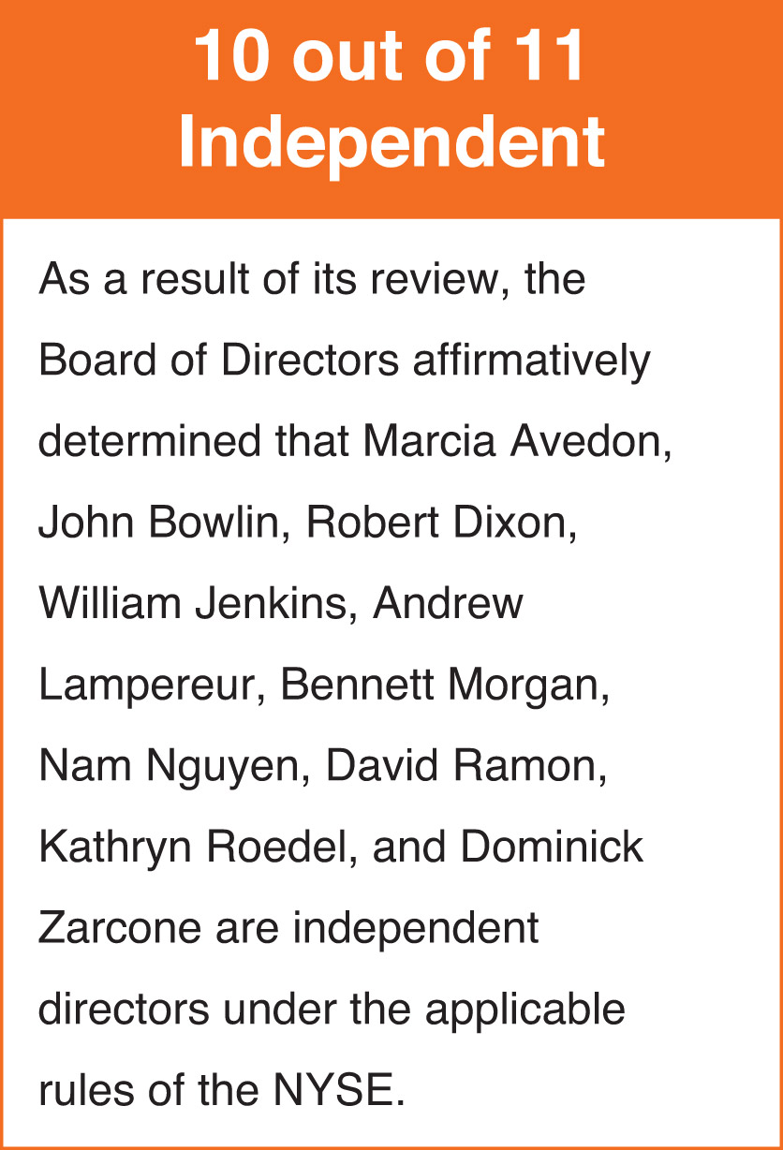
During its annual review of director independence, the Board of Directors considers all information it deems relevant, including without limitation any transactions and relationships between each director or any member of his or her immediate family and the Company and its subsidiaries and affiliates. The Board of Directors also considers the recommendations of the Nominating and Corporate Governance Committee, which conducts a separate independence assessment of all directors as part of its nomination process for the Board of Directors and its respective committees. The purpose of this review is to determine whether any such relationship or transaction is considered a “material relationship” that would be inconsistent with a determination that a director is independent. The Board of Directors has not adopted any “categorical standards” for assessing independence, preferring instead to consider all relevant facts and circumstances in making an independence determination including, without limitation, applicable independence standards promulgated by the NYSE.

​ |  | ​ | ​ | 16 | ​ | ​ | 2023 Proxy Statement | ​

TABLE OF CONTENTS
CORPORATE GOVERNANCE
Committees of the Board of Directors
Our Board of Directors has three standing committees: an Audit Committee, a Human Capital and Compensation Committee, and a Nominating and Corporate Governance Committee. Our Board of Directors has adopted charters for each of its standing committees. Copies of our committee charters are posted on our website at www.generac.com.
Audit Committee
Members | ​ | ​ | Key Responsibilities | ​ | ​ | (10 Meetings in 2022) | ​
ANDREW G.  LAMPEREUR  (Chair)  ROBERT D. DIXON  DAVID A. RAMON  KATHRYN V.  ROEDEL  DOMINICK P.  ZARCONE | ​ | ​ | The Audit Committee, among other items, assists the Board of Directors in fulfilling its responsibility relating to the following:  the integrity of our financial statements,  •  ​  our systems of internal controls and disclosure controls and procedures,  •  ​  our compliance with applicable law and ethics programs,  •  ​  the annual independent audit of our financial statements,  •  ​  review and assessment of the Company’s policies, practices, strategies, goals, and public reporting related to those environmental, social, and governance (“ESG”) matters falling within the Audit Committee’s responsibilities, and  •  ​  the evaluation of financial and enterprise risks, including areas related to legal compliance and ethics, cybersecurity, and certain other functional areas.  •  ​  The Board has determined that each of Messrs. Dixon, Lampereur, Ramon, and Zarcone is an “audit committee financial expert” as defined in Item 407(d)(5) of Regulation SK, and the Board is satisfied that all members of our Audit Committee have sufficient expertise and business and financial experience necessary to effectively perform their duties as members of the Audit Committee. The Board has determined that all members of the Audit Committee meet the NYSE and SEC definitions of independence.  In connection with its review of the Company’s financial statements, the Audit Committee receives reports from the Company’s Chief Financial Officer and the Company’s independent registered public accounting firm regarding significant risks and exposures and assesses management’s steps to minimize them. The Audit Committee also reviews material legal and regulatory matters and compliance with significant applicable legal, ethical, and regulatory requirements, and receives reports from the Company’s General Counsel relating to these matters. |  |  |  | ​
In discharging its duties, the Audit Committee has the sole authority to select, retain, oversee, and terminate, if necessary, the independent registered public accounting firm, review and approve the scope of the annual audit, review and preapprove the engagement of our independent registered public accounting firm to perform audit and non-audit services, meet independently with our independent registered public accounting firm and senior management, review the integrity of our financial reporting process, and review our financial statements and disclosures and certain SEC filings and financial press releases.
The Audit Committee formally met ten times in 2022, and members of the Audit Committee also met informally among themselves, with management and with other members of the Board from time to time. Decisions regarding audit-related matters were approved by our Board after considering the recommendations of the Audit Committee and its members. The Audit Committee maintains a committee charter and meets with our independent registered public accounting firm without management present on a regular basis.

​ |  | ​ | ​ | 17 | ​ | ​ | 2023 Proxy Statement | ​

TABLE OF CONTENTS
CORPORATE GOVERNANCE
Human Capital and Compensation Committee
Members | ​ | ​ | Key Responsibilities | ​ | ​ | (5 Meetings in 2022) | ​
MARCIA J. AVEDON  (Chair)  JOHN D. BOWLIN  WILLIAM D.  JENKINS JR.  BENNETT J.  MORGAN  DOMINICK P.  ZARCONE | ​ | ​ | The Human Capital and Compensation Committee:  oversees the Company’s plans, policies, and programs relating to human capital management and corporate culture, including diversity, equity, and inclusion, to help ensure the Company is seeking, developing, and retaining human capital appropriate to meet the Company’s needs,  •  ​  reviews, assesses, and advises the Board regarding the Company’s policies, practices, strategies, and goals with respect to those ESG matters falling within its responsibilities,  •  ​  plays an integral role in the Company’s processes and procedures for the consideration and determination of executive and director compensation,  •  ​  determines the compensation policies and individual compensation decisions for our executive officers and ensures these policies and decisions are consistent with overall corporate performance,  •  ​  in conjunction with the Nominating and Corporate Governance Committee as needed, reviews the form and amount of director compensation and makes recommendations to the Board related thereto,  •  ​  has the authority to approve all stock option grants and other equity awards to our employees, directors, and executive officers,  •  ​  reviews and recommends to the Board of Directors the target annual incentive pool, the annual performance objectives for participants, and actual payouts to participants, including the executive officers,  •  ​  works with its independent compensation consultant and management in setting compensation to create incentives that encourage an appropriate level of risk taking that is consistent with the Company’s business strategy and maximization of stockholder value,  •  ​  reviews and approves annual ESG goals for the CEO and certain executives related to incentive compensation,  •  ​  oversees the Company’s Organizational Talent Review process and human capital programs and initiatives to determine whether outcomes are effective and achieve their intended purposes, and  •  ​  reviews management development and executive succession plans, including for the CEO.  •  ​ |  |  |  | ​
The Human Capital and Compensation Committee has decision-making authority with respect to all compensation decisions for our executive officers, including annual incentive plan awards and grants of equity awards. The Human Capital and Compensation Committee is responsible for finalizing and approving the performance objectives relevant to the compensation of our CEO and other executive officers.
The Human Capital and Compensation Committee’s recommendations are developed with input from our CEO and, where appropriate, other senior executives. The Human Capital and Compensation Committee reviews management recommendations and input from compensation consultants, along with other sources of data when formulating its independent recommendations to the Board of Directors. A discussion and analysis of the Company’s compensation decisions

​ |  | ​ | ​ | 18 | ​ | ​ | 2023 Proxy Statement | ​

TABLE OF CONTENTS
CORPORATE GOVERNANCE
regarding the executive officers named in the Summary Compensation Table appears in this proxy statement under the heading “EXECUTIVE COMPENSATION — Compensation Discussion and Analysis.”
To assist it in performing its duties, the Human Capital and Compensation Committee has the authority to engage outside consulting firms. The Human Capital and Compensation Committee has engaged Willis Towers Watson & Co. (“Willis Towers Watson”) as its independent compensation consultant since September 2014. In its capacity as outside and independent compensation consultants, Willis Towers Watson reports directly to the Human Capital and Compensation Committee.
The Human Capital and Compensation Committee has sole authority to replace compensation consultants retained from time to time, and to hire additional consultants for the Human Capital and Compensation Committee at any time.
Representatives from outside consulting firms engaged by the Human Capital and Compensation Committee attend meetings of the Human Capital and Compensation Committee, as requested, and communicate with the Chair of the Human Capital and Compensation Committee between meetings.
The Human Capital and Compensation Committee assessed the independence of Willis Towers Watson pursuant to applicable SEC rules and concluded that no conflict of interest exists that would prevent Willis Towers Watson from independently advising the Human Capital and Compensation Committee.
The Human Capital and Compensation Committee reviews and discusses with management proposed Compensation Discussion and Analysis disclosures and determines whether to recommend the Compensation Discussion and Analysis to the Board of Directors for inclusion in the Company’s proxy statement and annual report. The recommendation is described in the Human Capital and Compensation Committee Report included in this proxy statement.
The Human Capital and Compensation Committee formally met five times in 2022, and members of the Human Capital and Compensation Committee also met informally among themselves, with management, with other members of the Board, and with Willis Towers Watson from time to time. Decisions regarding executive compensation were approved by our Board after considering the recommendations of the Human Capital and Compensation Committee.
Nominating and Corporate Governance Committee
Members | ​ | ​ | Key Responsibilities | ​ | ​ | (8 Meetings in 2022) | ​
ROBERT D. DIXON  (Chair)  MARCIA J. AVEDON  BENNETT J.  MORGAN  NAM T. NGUYEN  DAVID A. RAMON  KATHRYN V.  ROEDEL | ​ | ​ | The Nominating and Corporate Governance Committee:  identifies candidates to serve as directors and on committees of the Board of Directors,  •  ​  develops, recommends, and reviews our corporate governance guidelines on a regular basis,  •  ​  oversees any necessary search, selection, and hiring process for appointing a new Chief Executive Officer  •  ​  assists the Board of Directors in its annual review of the performance and effectiveness of the Board of Directors and its Committees, and  •  ​  reviews the Company’s ESG policies, practices, and disclosures.  •  ​  The Nominating and Corporate Governance Committee also undertakes such other tasks delegated to the committee by the Board of Directors. |  |  |  | ​

​ |  | ​ | ​ | 19 | ​ | ​ | 2023 Proxy Statement | ​

TABLE OF CONTENTS
CORPORATE GOVERNANCE
Decisions regarding board nominations and corporate governance-related matters were approved by our Board after considering the recommendations of the Nominating and Corporate Governance Committee.
Criteria for Director Nominees
In selecting director candidates, the Nominating and Corporate Governance Committee considers whether the candidates possess the required skill sets and fulfill the qualification requirements of directors approved by the Board of Directors, including integrity, objectivity, sound judgment, leadership and diversity in all aspects of that term, including differences of perspective, professional experience, education, skills, and other individual qualities, such as gender, race, ethnicity, and sexual orientation. Annually, the Nominating and Corporate Governance Committee assesses the composition of the Board of Directors, including the Committee’s effectiveness in balancing the above considerations.
Other than the foregoing, there are no minimum criteria for director nominees, although the Nominating and Corporate Governance Committee may consider such other factors as it may deem are in the best interests of the Company and its stockholders. The Nominating and Corporate Governance Committee does not assign specific weights to, and a potential or incumbent director will not necessarily satisfy all, the foregoing criteria, and in evaluating a candidate does not distinguish on the basis of whether the candidate was recommended by a stockholder.
Notwithstanding the foregoing, in furtherance of the Committee’s commitment to increasing diversity within the Board of Directors, the Committee and the Board have determined that a focused effort to identify director candidates from underrepresented minority groups will be an important consideration and priority in selecting and nominating director candidates for election as future openings become available on the Board of Directors. Accordingly, the Company’s Corporate Governance Guidelines and Principles include a requirement that any search firm engaged to fill such openings include qualified women, racially or ethnically diverse candidates, and/or other candidates from underrepresented minority groups in all prospective director candidate pools.
Process for Identifying and Evaluating Director Nominees
The Nominating and Corporate Governance Committee identifies nominees by first evaluating the current members of the Board of Directors willing to continue in service. Current members of the Board of Directors with skills and experience that are relevant to the Company’s business and who are willing to continue in service are considered for renomination, balancing the value of continuity of service by existing members of the Board of Directors with that of obtaining a new perspective on the Board. If any member of the Board of Directors does not wish to continue in service or if the Nominating and Corporate Governance Committee decides not to renominate a member for reelection, the Nominating and Corporate Governance Committee identifies the desired skills and experience of a new nominee based on the criteria listed above. Current members of the Nominating and Corporate Governance Committee and Board of Directors are polled for suggestions as to individuals meeting the criteria of the Nominating and Corporate Governance Committee. Executive search firms may also be retained to identify qualified individuals.
Stockholders who wish to recommend a candidate for consideration by the Nominating & Corporate Governance Committee may do so by sending the candidate’s name and supporting information to Mr. Robert Dixon, Nominating and Corporate Governance Committee Chair,

​ |  | ​ | ​ | 20 | ​ | ​ | 2023 Proxy Statement | ​

TABLE OF CONTENTS
CORPORATE GOVERNANCE
c/o Raj Kanuru, Executive Vice President, General Counsel, & Corporate Secretary, Generac Power Systems, Inc., S45 W29290 Highway 59, Waukesha, Wisconsin 53189. Our Bylaws contain provisions that address the processes by which a stockholder may nominate an individual to stand for election to the Board of Directors. See “NOMINATIONS AND PROPOSALS BY STOCKHOLDERS” below for additional information.
Board of Directors Role in Risk Oversight
Our Board and management continually monitor the material risks facing our Company, including financial risk, strategic risk, operational risk, and legal and compliance risk. Management regularly reports to the Board on its activities in monitoring and mitigating such risks. Overall responsibility for risk oversight rests with our Board. In addition, the Board may delegate risk oversight responsibility to a particular committee in situations in which the risk falls within the committee’s area of focus or expertise. Our Board believes that for certain areas of risk, our Company is better served by having the initial risk evaluation and risk monitoring undertaken by a subset of the entire Board that is more focused on the issues pertaining to the particular risk. For instance, our Human Capital and Compensation Committee assists the Board in evaluating risks relating to social responsibility matters and compensation policies and procedures. Also, our Audit Committee assists the Board in fulfilling the Board’s oversight responsibility relating to the evaluation of financial and enterprise risks, including information security, environmental, health and safety, product regulatory, and product safety matters. As it deems necessary and on at least an annual basis, the respective committee to which oversight and monitoring of a particular risk has been assigned reports on risk exposures and mitigation strategies with respect to such risk to the entire Board.
Board of Directors Leadership Structure
Aaron Jagdfeld has served as a director of the Company since 2006 and is the Company’s Chairman of the Board, President, and Chief Executive Officer. Bennett Morgan serves as Lead Director.
The Lead Director has broad responsibility and authority, including to:
Review the agendas for and preside over meetings of the independent directors.
•
​
Preside at all meetings of the Board of Directors at which the Chairman is not present, including executive sessions of the independent directors.
•
​
Call meetings of the independent directors.
•
​
Serve as the principal liaison between the Chairman and the independent directors.
•
​
Consult with the Chairman regarding:
•
​
Information sent to the Board of Directors, including the quality, quantity, appropriateness, and timeliness of such information.
◦
​
Meeting agendas for the Board of Directors.
◦
​
The frequency of Board of Directors meetings and meeting schedules, assuring there is sufficient time for discussion of all agenda items.
◦
​
Development of annual priorities and goals for the Board of Directors.
◦
​
Be available, when appropriate, for consultation and direct communication with stockholders.
•
​

​ |  | ​ | ​ | 21 | ​ | ​ | 2023 Proxy Statement | ​

TABLE OF CONTENTS
CORPORATE GOVERNANCE
Select, retain, and consult with outside counsel and other advisors as the Lead Director deems appropriate.
•
​
In conjunction with both the Human Capital and Compensation Committee and the full Board of Directors:
•
​
Annually review the performance of, and provide feedback to, the CEO.
◦
​
Annually meet with each Director to collect and review feedback.
◦
​
Periodically, our Board assesses these roles and the Board leadership structure to ensure the interests of the Company and its stockholders are best served.
Our Board has determined that its current structure, with a combined Chairman and CEO role and an independent Lead Director, at this time is in the best interests of the Company and its stockholders based on a number of factors, including:
A combined Chairman and CEO structure provides the Company with decisive and effective leadership with clearer accountability to our stockholders and customers.
•
​
The combined role is both counterbalanced and enhanced by the effective oversight and independence of our Board of Directors, and the independent leadership provided by our Lead Director and independent committee chairs.
•
​
The Board believes that the appointment of a strong independent Lead Director and the use of regular executive sessions of the non-management Directors, along with the Board’s strong committee system and all Directors being independent except for Mr. Jagdfeld, allow it to maintain effective oversight of management.
•
​
Stockholders and other parties interested in communicating directly with Mr. Bennett Morgan as Lead Director may do so by writing to Mr. Bennett Morgan, Lead Director, c/o Generac Holdings Inc., S45 W29290 Highway. 59, Waukesha, Wisconsin 53189.
Attendance at Meetings
It is our policy that each director is expected to dedicate sufficient time to the performance of his or her duties as a director, including by attending meetings of the stockholders, Board of Directors, and committees of which he or she is a member. All then-serving members of the Board of Directors attended the 2022 Annual Meeting of Stockholders.
In 2022, the Board of Directors held five meetings (including regularly scheduled and special meetings) and took action by unanimous written consent from time to time. All incumbent directors attended at least 75% of (i) the total number of meetings of the Board of Directors (held during the period for which he or she has been a director); and (ii) the total number of meetings held by all committees on which he or she served (during the periods that he or she served).
Stockholder Communications with the Board of Directors
Stockholders and other parties interested in communicating directly with the Board of Directors, whether individually or as a group, may do so by writing to the Board of Directors, c/o Generac Holdings Inc., S45 W29290 Highway 59, Waukesha, Wisconsin 53189. The Secretary will review all correspondence and regularly forward to the Board of Directors all such correspondence that, in the opinion of the Secretary, deals with the functions of the Board of Directors or committees thereof, or that the Secretary otherwise determines requires attention. Concerns relating to

​ |  | ​ | ​ | 22 | ​ | ​ | 2023 Proxy Statement | ​

TABLE OF CONTENTS
CORPORATE GOVERNANCE
accounting, internal controls, or auditing matters will immediately be brought to the attention of the Chair of the Audit Committee. We have adopted a Whistleblower Policy, which establishes procedures for submitting these types of concerns, either personally or anonymously through a toll-free telephone “hotline” or web transmission operated by an independent party. Our Whistleblower Policy can be found on the Company’s website at www.generac.com.
Stockholders and other parties interested in communicating directly with Mr. Andrew Lampereur, as Chair of the Audit Committee, may do so by writing to Mr. Lampereur, Chair, Audit Committee, c/o Generac Holdings Inc., S45 W29290 Highway 59, Waukesha, Wisconsin 53189.
Code of Ethics and Business Conduct
We have adopted a Code of Ethics and Business Conduct (the “Code”), that applies to all our directors, officers and employees, including our principal executive officer and principal financial accounting officer. In addition, we have adopted a Supplemental Code of Ethics and Conduct (the “Supplement”) that applies to all our directors and executive officers, including our principal executive officer and principal financial accounting officer. The Code and Supplement are both posted on our website at www.generac.com. Any amendments to, or waivers under, our Code or Supplement which are required to be disclosed by the rules promulgated by the SEC will be disclosed on the Company’s website at www.generac.com.
Corporate Governance Guidelines and Principles
We have adopted Corporate Governance Guidelines and Principles. These guidelines outline the role of our Board of Directors, the composition and operating principles of our Board of Directors and its committees, and our Board of Directors’ working process. Our Corporate Governance Guidelines and Principles are posted on our website at www.generac.com.
Environmental, Social, and Governance Practices
Generac’s purpose is to lead the world’s evolution to more resilient, efficient, and sustainable energy solutions. In furthering that mission, Generac takes seriously its ESG responsibilities and, in the course of its business, encounters and manages a broad range of ESG matters. We understand and appreciate that there is a growing interest in greater ESG disclosure by public companies. To meet these growing expectations, the Company published its 2022 Environmental, Social, and Governance Report (“ESG Report”) in April 2023. The ESG Report can be found at www.generac.com, and will be updated and published on an annual basis.
Political Contributions
It is Generac’s policy that Company funds or assets will not be used to make a political contribution to any political party or candidate, unless approval has been given by the Board of Directors or its authorized designee. Generac did not contribute to any political parties or candidates in 2022. In addition, Generac has not organized or established any political action committee.
Website Information
Website references and their hyperlinks throughout this document are provided for convenience only, and the content of the referenced websites, including but not limited to the content contained in our ESG Report, is not incorporated by reference into this proxy statement, nor does it constitute a part of this proxy statement.

​ |  | ​ | ​ | 23 | ​ | ​ | 2023 Proxy Statement | ​

TABLE OF CONTENTS
CORPORATE GOVERNANCE
Human Capital and Compensation Committee Interlocks and Insider Participation
In 2022, the members of our Human Capital and Compensation Committee were Marcia Avedon (Chairperson), John Bowlin, Bennett Morgan, William Jenkins, and Dominick Zarcone. No member of the Human Capital and Compensation Committee was, during 2022 or previously, an officer or employee of Generac or its subsidiaries. In addition, during 2022, there were no Human Capital and Compensation Committee interlocks required to be disclosed.

​ |  | ​ | ​ | 24 | ​ | ​ | 2023 Proxy Statement | ​

TABLE OF CONTENTS​
Beneficial Ownership of our Common Stock
The following table shows information regarding the beneficial ownership of our common stock as of April 17, 2023, by:
each person or group who is known to own beneficially more than five percent of our common stock;
•
​
each member of our Board of Directors, each nominee for election as a director, and each of our named executive officers; and
•
​
all members of our Board of Directors and our executive officers as a group.
•
​
Beneficial ownership of shares is determined under rules of the SEC, and generally includes any shares over which a person exercises sole or shared voting or investment power. Except as noted by footnote, and subject to community property laws where applicable, we believe based on the information provided to us that the persons and entities named in the table below have sole voting and investment power with respect to all shares of our common stock shown as beneficially owned by them.
Unless otherwise indicated, the address for each holder listed below is c/o Generac Holdings Inc., S45 W29290 Highway 59, Waukesha, Wisconsin 53189.
​ | Name and address of beneficial owner | ​ | ​ | Number of  Shares |  |  |  | ​ | ​ | Percentage of  Shares |  |  |  | ​
​ | Principal stockholders | ​ | ​ | ​ | ​ | ​ | ​ | ​ | ​ | ​ | ​ | ​ | ​ | ​
​ | The Vanguard Group(1) | ​ | ​ | ​ | ​ | 7,007,878 | ​ | ​ | ​ | ​ | ​ | 11.3% | ​ | ​
​ | BlackRock, Inc.(2) | ​ | ​ | ​ | ​ | 4,259,220 | ​ | ​ | ​ | ​ | ​ | 6.9% | ​ | ​
​ | Directors and Named Executive Officers(3)(4) | ​ | ​ | ​ | ​ | ​ | ​ | ​ | ​ | ​ | ​ | ​ | ​ | ​
​ | Aaron Jagdfeld | ​ | ​ | ​ | ​ | 1,156,084 | ​ | ​ | ​ | ​ | ​ | 1.9% | ​ | ​
​ | York Ragen | ​ | ​ | ​ | ​ | 241,410 | ​ | ​ | ​ | ​ | ​ | 0.4% | ​ | ​
​ | Norman Taffe | ​ | ​ | ​ | ​ | 4,348 | ​ | ​ | ​ | ​ | ​ | * | ​ | ​
​ | Erik Wilde | ​ | ​ | ​ | ​ | 33,600 | ​ | ​ | ​ | ​ | ​ | 0.1% | ​ | ​
​ | Patrick Forsythe | ​ | ​ | ​ | ​ | 82,908 | ​ | ​ | ​ | ​ | ​ | 0.1% | ​ | ​
​ | Marcia Avedon | ​ | ​ | ​ | ​ | 4,204 | ​ | ​ | ​ | ​ | ​ | * | ​ | ​
​ | John Bowlin | ​ | ​ | ​ | ​ | 75,608 | ​ | ​ | ​ | ​ | ​ | 0.1% | ​ | ​
​ | Robert Dixon | ​ | ​ | ​ | ​ | 17,083 | ​ | ​ | ​ | ​ | ​ | * | ​ | ​
​ | William Jenkins | ​ | ​ | ​ | ​ | 8,161 | ​ | ​ | ​ | ​ | ​ | * | ​ | ​
​ | Andrew Lampereur | ​ | ​ | ​ | ​ | 21,731 | ​ | ​ | ​ | ​ | ​ | * | ​ | ​
​ | Bennett Morgan | ​ | ​ | ​ | ​ | 25,554 | ​ | ​ | ​ | ​ | ​ | * | ​ | ​
​ | Nam Nguyen | ​ | ​ | ​ | ​ | 726 | ​ | ​ | ​ | ​ | ​ | * | ​ | ​
​ | David Ramon | ​ | ​ | ​ | ​ | 33,759 | ​ | ​ | ​ | ​ | ​ | 0.1% | ​ | ​
​ | Kathryn Roedel | ​ | ​ | ​ | ​ | 9,604 | ​ | ​ | ​ | ​ | ​ | * | ​ | ​
​ | Dominick Zarcone | ​ | ​ | ​ | ​ | 13,369 | ​ | ​ | ​ | ​ | ​ | * | ​ | ​
​ | All members of the Board of Directors and executive officers as a  group (17 persons) | ​ | ​ | ​ | ​ | 1,768,481 | ​ | ​ | ​ | ​ | ​ | 2.8% | ​ | ​
​
Less than 0.1%
*
​
Based on information obtained from Amendment No. 12 to Schedule 13G filed by The Vanguard Group (“Vanguard”) on February 9, 2023. According to that report, Vanguard
(1)
​

​ |  | ​ | ​ | 25 | ​ | ​ | 2023 Proxy Statement | ​

TABLE OF CONTENTS
BENEFICIAL OWNERSHIP OF OUR COMMON STOCK
possesses shared power to vote or to direct the voting of 93,885 of such shares and possesses shared power to dispose or to direct the disposition of 264,005 of such shares and possesses sole power to dispose or to direct the disposition of 6,743,873 of such shares. In addition, according to that report, Vanguard’s business address is 100 Vanguard Blvd., Malvern, Pennsylvania 19355.
Based on information obtained from Amendment No. 9 to Schedule 13G filed by Blackrock, Inc. on February 7, 2023. According to that report, Blackrock, Inc. possesses sole power to vote 3,841,841 of such shares and possesses sole power to dispose 4,259,220 of such shares. In addition, according to that report, Blackrock, Inc.’s business address is 55 East 52nd Street, New York, New York 10022.
(2)
​
With respect to Messrs. Jagdfeld, Ragen, Forsythe and Wilde, the number of shares beneficially owned includes 528,394, 108,394, 64,624 and 17,337 shares respectively, which may be acquired pursuant to options issued under the Omnibus Plan because such options are exercisable within 60 days. The respective number of shares for the individuals mentioned above were in each case also added to the denominator for purposes of calculating the percentage ownership of that individual.
(3)
​
With respect to Ms. Roedel and Messrs. Ramon, Dixon, Morgan, Lampereur, Jenkins and Zarcone, the number of shares beneficially owned includes 9,604, 4,231, 8,188, 12,208, 14,833, 1,417 and 10,356 Deferred Stock Units, respectively, all of which were issued pursuant to the Company’s Deferred Stock Unit Plan for Non-Employee Directors, effective April 1, 2017.
(4)
​

​ |  | ​ | ​ | 26 | ​ | ​ | 2023 Proxy Statement | ​

TABLE OF CONTENTS​
Executive Compensation
Compensation Discussion and Analysis
This Compensation Discussion and Analysis (“CD&A”) describes our executive compensation program. It provides an overview of the 2022 compensation for the following named executive officers (“NEOs”), practices and policies, and how the Human Capital and Compensation Committee made its decisions.
​ | Named Executive Officer | ​ | ​ | Title | ​
​ | Aaron Jagdfeld | ​ | ​ | President, Chief Executive Officer & Chairman | ​
​ | York Ragen | ​ | ​ | Chief Financial Officer | ​
​ | Norman Taffe | ​ | ​ | President Energy Technology | ​
​ | Erik Wilde | ​ | ​ | Executive Vice President Industrial, Americas | ​
​ | Patrick Forsythe | ​ | ​ | Chief Technical Officer | ​
​ |  | ​ | ​ | 2022 Business Highlights & Performance | ​
2022 was another solid year for Generac:
* A full discussion of our use of non-U.S. generally accepted accounting principles measures to provide a baseline for evaluating and comparing our operating results, and a reconciliation of Adjusted EBITDA to net income can be found in Item 7 of the Company’s Annual Report on Form 10-K for the fiscal year ended December 31, 2022.
Thanks to the collective efforts of our global team of approximately 9,500 employees, Generac achieved another year of strong revenue in 2022, notably exceeding the previous record levels seen last year. Revenue grew by approximately 22% over the prior year, marking our third consecutive year of double-digit increases, with strong growth in both our Residential and Commercial & Industrial (“C&I”) product categories in the full-year period. Additionally, our International segment achieved all-time highs in net sales, Adjusted EBITDA, and Adjusted EBITDA margin. However, our Residential product category faced some challenges during the second half of 2022 as softness in home standby generator shipments resulted from elevated levels of field inventory and sales of PWRcell energy storage systems were negatively impacted by the loss of a large customer that ceased operations and the overhang of certain quality-related concerns. In addition, Adjusted EBITDA margins for the Domestic segment during the year were impacted by higher-than-expected input costs due to supply chain challenges and the overall inflationary environment, as well as continued operating expense investments for future growth

​ |  | ​ | ​ | 27 | ​ | ​ | 2023 Proxy Statement | ​

TABLE OF CONTENTS
EXECUTIVE COMPENSATION
and the impact of acquisitions. The combination of these factors resulted in the full-year 2022 financial performance for the company to come in below bonus threshold targets.
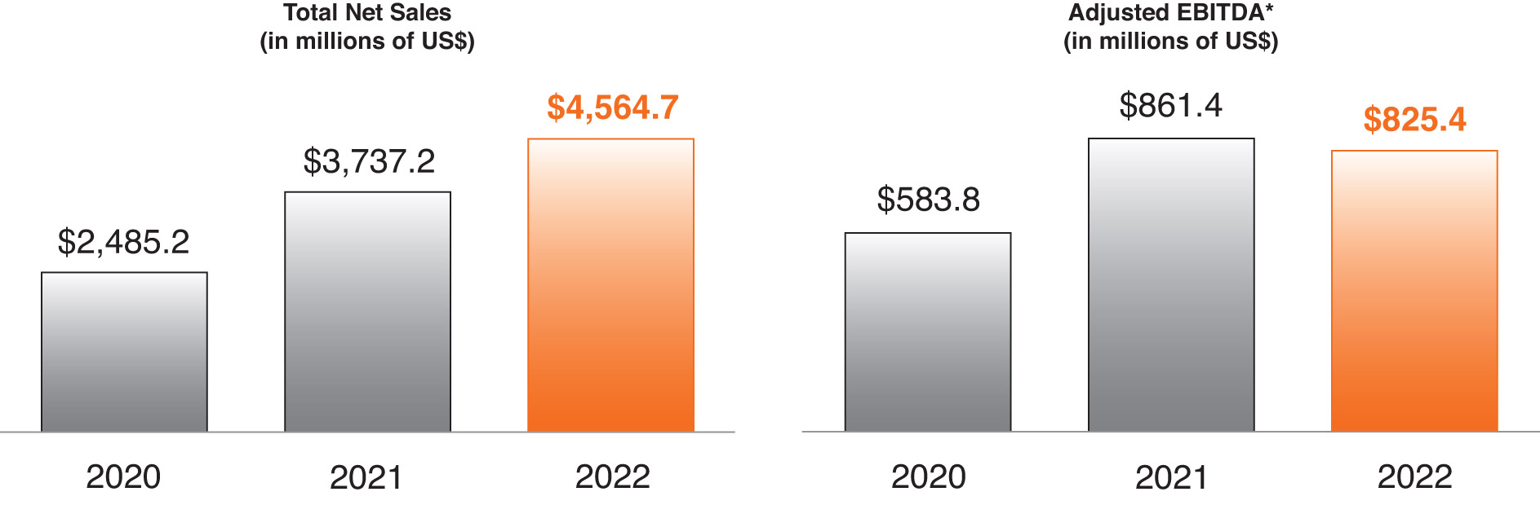
* A full discussion of our use of non-U.S. generally accepted accounting principles measures to provide a baseline for evaluating and comparing our operating results, and a reconciliation of Adjusted EBITDA to net income can be found in Item 7 of the Company’s Annual Report on Form 10-K for the fiscal year ended December 31, 2022.
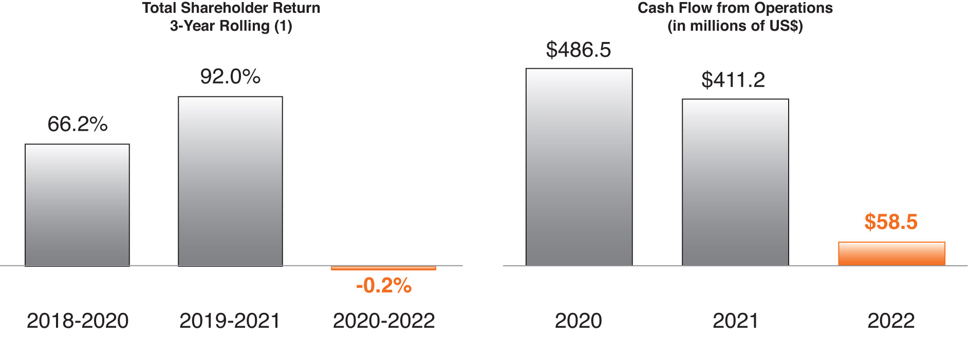
(1) Total Shareholder Return reflects the compound annual price appreciation of Generac shares expressed as a percentage.
Generac also made important progress on several key strategic initiatives in 2022, including:
We began building a significantly deeper and more experienced energy technology leadership team, which we expect to lead the full integration of our energy technology investments under a common strategy.
•
​
We continued to develop and invest in numerous new technologies and capabilities during the year, including taking a minority equity investment in Watt Fuel Cell, acquiring C&I connectivity capabilities via the purchase of Blue Pillar, and launching our “Single Pane of Glass” initiative, which is focused on developing the user interface, or central hub, of our smart home energy ecosystem.
•
​
We brought multiple new solutions to market during the year as we began shipping our second-generation load control device called PWRmanager, launched a line of portable battery solutions called Portable Power Stations, and announced new electric vehicle (“EV”) charging solutions for utilities and EV owners.
•
​
We repurchased more than 2.7 million shares during the second half of 2022, returning approximately $346 million of cash to stockholders.
•
​
Our 2022 accomplishments across both our residential and C&I product categories furthered Generac’s evolution to an energy technology solutions company as we continue to execute against our ‘Powering a Smarter World’ enterprise strategy.

​ |  | ​ | ​ | 28 | ​ | ​ | 2023 Proxy Statement | ​

TABLE OF CONTENTS
EXECUTIVE COMPENSATION
Generac’s Executive Compensation Practices
The following best practices ensure alignment between stockholders and executives while maintaining corporate governance.
​ | WHAT WE DO: |  |  |  |  |  |  | ​
​ |  | ​ | ​ | Pay for Performance | ​ | ​ | Over 70% of executive officer pay is based on the achievement of specific annual and long term strategic and financial goals. | ​
​ |  | ​ | ​ | Stock Ownership Guidelines | ​ | ​ | Stock ownership guidelines have been established for executive officers and directors. | ​
​ |  | ​ | ​ | Compensation Risk Assessments | ​ | ​ | A compensation risk assessment is performed on a regular basis. | ​
​ |  | ​ | ​ | Independent Compensation Consultant | ​ | ​ | An independent consultant is retained by the Human Capital and Compensation Committee. | ​
​ |  | ​ | ​ | Clawback Policy | ​ | ​ | A clawback policy has been adopted that requires the CEO, CFO and other key members of executive management to reimburse or forfeit any excess incentive compensation received due to an accounting restatement of the Company’s financial statements as a result of the Company’s material noncompliance with any financial reporting requirement under federal securities and in certain instances of an executive officer’s gross negligence or misconduct, including a failure to manage and monitor risks that result in significant harm to the Company. | ​
​ |  | ​ | ​ | ESG in Incentive Plan | ​ | ​ | Our short-term incentive plan includes individual executive ESG goals related to the development of our ESG strategy and qualitative metrics to measure success over time. | ​
​ | WHAT WE DO NOT DO: |  |  |  |  |  |  | ​
​ |  | ​ | ​ | Hedging of Company Stock | ​ | ​ | It is against Company policy to trade in puts or calls in Company securities, sell Company securities short, or otherwise hedge ownership of Company securities. | ​
​ |  | ​ | ​ | Pledging of Company Stock | ​ | ​ | Executive officers may not pledge Company securities or hold Company securities in margin accounts. | ​
​ |  | ​ | ​ | Tax Gross Ups | ​ | ​ | Executive officers do not receive tax gross ups either directly or indirectly. | ​
​ |  | ​ | ​ | Dividends on Unearned Performance Awards | ​ | ​ | Executive officers do not receive dividends on unearned performance awards. | ​
​ |  | ​ | ​ | “Single Trigger” Change in Control Severance Provisions | ​ | ​ | Executive officers do not have severance arrangements that trigger solely by virtue of a change in control. | ​

​ |  | ​ | ​ | 29 | ​ | ​ | 2023 Proxy Statement | ​

TABLE OF CONTENTS
EXECUTIVE COMPENSATION
ABOUT OUR EXECUTIVE COMPENSATION PROGRAM
2022 Executive Compensation Program Changes and Events
We remain focused on the continuous improvement of our executive compensation program to ensure alignment with our compensation philosophy, Powering a Smarter World Strategy, and shareholder interests, as well as market best practices. To this end, the Human Capital and Compensation Committee has made the following refinements to executive compensation:
​ | What’s Changed | ​ | ​ | How It’s Changed | ​ | ​ | Rationale for Change | ​
​ | ​ |  | ​ | ​ | Ownership Requirements | ​ | ​ |  | ​ | ​ | Increased stock ownership requirements for Executive Vice Presidents from 2 to 3 times annual base pay | ​ | ​ |  | ​ | ​ | The Human Capital and Compensation Committee and Generac believe increasing ownership requirements supports long-term performance alignment. | ​ | ​
​ | ​ |  | ​ | ​ | Peer Group | ​ | ​ |  | ​ | ​ | Removed three companies and added five new companies for a total of 22 companies | ​ | ​ |  | ​ | ​ | Removed companies due to small size and industrials focus. Added new companies due to similar business model/end products and revenue positioning. | ​ | ​
​ | ​ |  | ​ | ​ | Annual Incentive Plan | ​ | ​ |  | ​ | ​ | Added Individual Performance Modifier to further differentiate pay for performance outcomes | ​ | ​ |  | ​ | ​ | The Human Capital and Compensation Committee and Generac believe individual performance is a key component of Generac’s compensation philosophy and objectives. | ​ | ​
Philosophy and Objectives
We believe that the compensation program for our executives should directly support the achievement of specific annual, long-term, and strategic goals of the business and, thereby, align the interests of executives with the interests of our stockholders. Our compensation program is designed to balance rewards for corporate, business, and individual results.
The program’s strong pay-for-performance alignment is an important part of our continuing commitment to enhancing long-term stockholder value.

​ |  | ​ | ​ | 30 | ​ | ​ | 2023 Proxy Statement | ​

TABLE OF CONTENTS
EXECUTIVE COMPENSATION
We also believe that stockholders are best served when we can attract and retain high caliber executive talent. To that end, we offer competitive base salaries, as well as annual and long-term incentive opportunities, which encourage specific performance and reward the successful efforts of our executives. Within this context, the four major objectives for our executive compensation program are:
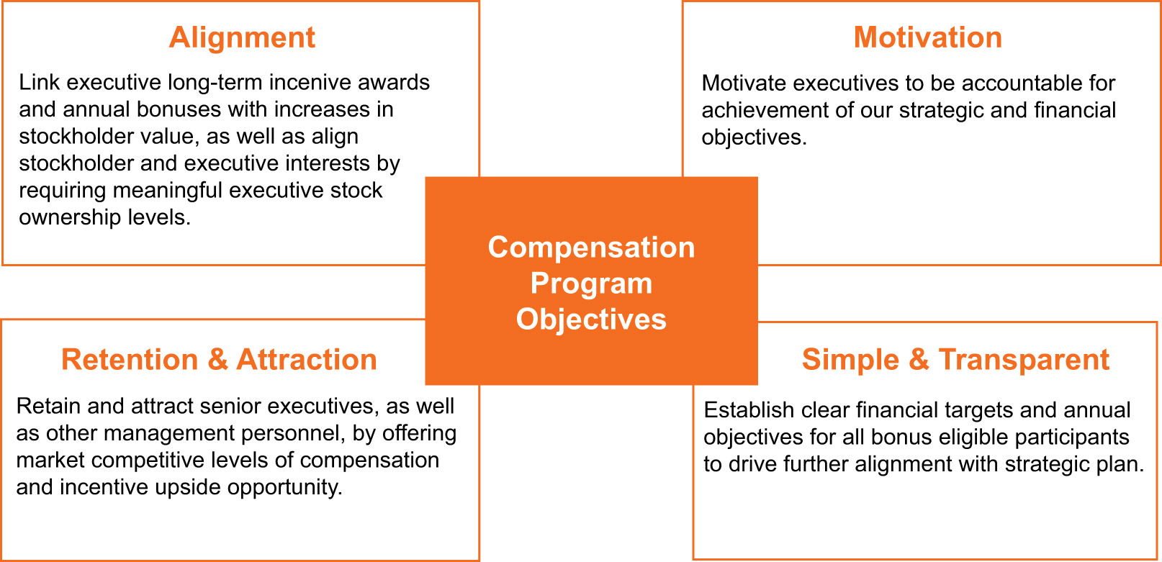
To achieve these objectives, we have structured a compensation program that provides our executives with the following:
​ | Pay Element | ​ | ​ | Form | ​ | ​ | Purpose | ​
​ | Base Salary | ​ | ​ | Cash (Fixed) | ​ | ​ | Reflects position responsibilities, competitive market rates, strategic importance of the position, and individual experience. | ​
​ | Annual Performance  Bonus Plan (Short- Term Incentive) | ​ | ​ | Cash (Variable) | ​ | ​ | Rewards achievement of Generac’s annual financial goals as defined by the Human Capital and Compensation Committee and other qualitative and quantitative performance objectives as determined by the Human Capital and Compensation Committee. | ​
​ | Long-Term Incentives | ​ | ​ | Equity (Variable) | ​ | ​ | Rewards strong performance with incentives that focus our executive team on creating stockholder value over the long-term. Performance share weighting supports our pay for performance philosophy. | ​
The total direct compensation of our executives is market-based, and a significant portion of that compensation, including annual and long-term incentives, is also performance-based. The Human Capital and Compensation Committee believes this construct results in a fair level of pay for target performance, and an above-market opportunity if the executive team builds share value in a sustainable way. We target cash compensation (base salary and annual bonus) around the median of our market and compensation peer group, taking into account the relative responsibilities of our executives. In general, we target long-term incentives at or above the

​ |  | ​ | ​ | 31 | ​ | ​ | 2023 Proxy Statement | ​

TABLE OF CONTENTS
EXECUTIVE COMPENSATION
market median to encourage the sustainability of the business and drive long-term stockholder value creation. This aligns with our approach to long-term financial goal setting in which the Company often sets performance goals above the median, and in some cases above the 75th percentile. Actual total compensation in any given year may be above or below the total target level based on individual and corporate performance.
Target Pay Mix
The charts below reflect the target pay mix for our CEO and average target pay mix for our other named executives, and show that the majority of the total target direct compensation for our NEOs in 2022 was variable and performance based:
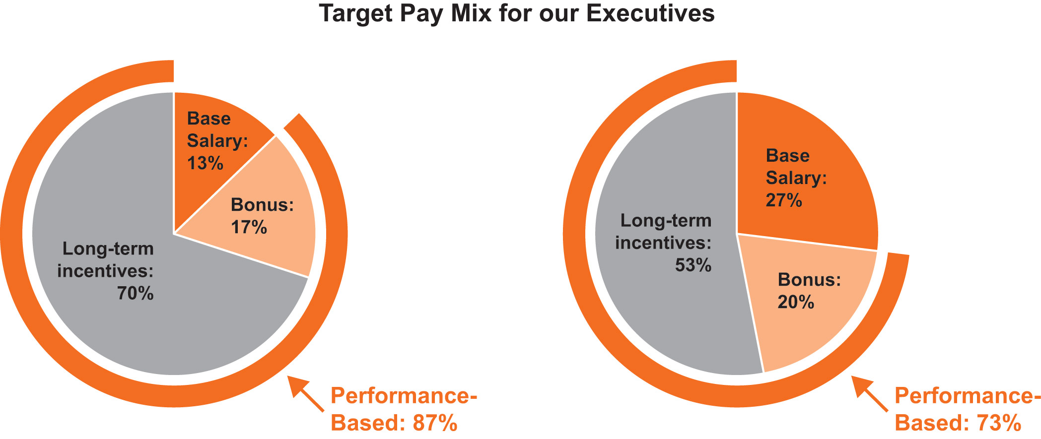
​ | CEO Target Pay Mix | ​ | ​ | Avg Other NEOs  Target Pay Mix | ​
HOW COMPENSATION DECISIONS ARE MADE
​ | ​ | Role of the Human Capital and Compensation Committee and Management | ​ | ​
The Human Capital and Compensation Committee, composed solely of independent directors, is responsible for making executive compensation decisions for the named executive officers. The Human Capital and Compensation Committee works closely with its independent compensation consultant and management to examine pay and performance matters throughout the year.
Each year, the CEO and CFO establish a budget that is approved by the Board of Directors. The budget establishes financial targets and other performance-related goals, which gives the Human Capital and Compensation Committee a basis for approving financial targets under the annual incentive plans for the year. The Human Capital and Compensation Committee also reviews the basis for establishing goals and objectives related to the compensation of the named executive officers.
During this review, the Human Capital and Compensation Committee considers the balance between short-term cash compensation and long-term incentives and evaluates alignment of pay for performance in light of established goals and objectives. The Human Capital and Compensation Committee also considers profitable growth of the business and financial performance.

​ |  | ​ | ​ | 32 | ​ | ​ | 2023 Proxy Statement | ​

TABLE OF CONTENTS
EXECUTIVE COMPENSATION
The Human Capital and Compensation Committee sets the CEO compensation based on that evaluation using market and peer group data to determine appropriate total direct compensation levels (consisting of base salary and annual and long-term incentives). The Human Capital and Compensation Committee also reviews and approves compensation for all executive officers using market data and in conjunction with recommendations from the CEO and EVP, Human Resources. See “Assessing External Market Practice” below for more information.
Finally, in making subjective evaluations of the overall performance of the CEO, the Human Capital and Compensation Committee considers performance from the perspective of our core values and our leadership principles, which include practicing integrity, driving innovation, demonstrating agility, operational excellence, developing our employees, and building a team environment.
The CEO and EVP, Human Resources also provide the Human Capital and Compensation Committee with additional analyses and recommendations related to compensation of the CFO, our other executive officers, and certain other key members of executive management. The annual analysis includes market compensation data and a review of factors such as industry knowledge, level of experience, scope and complexity of position, skill set, and future potential. Neither the CEO nor the EVP, Human Resources makes recommendations with respect to his or her own compensation.
​ | ​ | The Role of the Independent Consultant | ​ | ​
In 2022, Willis Towers Watson provided advice to the Human Capital and Compensation Committee regarding base pay, peer group, benchmarking of unique job scopes, and annual and long-term incentive design, along with a variety of other compensation-related topics and trends. The Human Capital and Compensation Committee has assessed the independence of Willis Towers Watson pursuant to the SEC rules and concluded that no conflict of interest exists that would prevent Willis Towers Watson from independently advising the Human Capital and Compensation Committee.
​ | ​ | Assessing External Market Practice | ​ | ​
Attracting and incentivizing high caliber executive talent is a critical part of our compensation philosophy and leadership strategy. Therefore, integral to our approach for setting compensation levels is ensuring we have a competitive pay framework. In support of this objective, Willis Towers Watson annually provides the Human Capital and Compensation Committee with compensation data with respect to similarly sized manufacturing and technology companies in the identified peer group and amongst similarly sized general and technology industry companies from a published survey perspective. In 2022, the Human Capital and Compensation Committee considered both sources in determining competitive total direct compensation benchmarks for our CEO, CFO and for the EVPs of our business groups. Published industry-specific market survey data was considered in determining market total direct compensation benchmarks for all other executive officers. The Human Capital and Compensation Committee has generally targeted the market median for total cash compensation of our named executive officers, with the opportunity to meet or exceed market median if the Company achieves outstanding financial performance in a particular year. The Human Capital and Compensation has targeted long-term incentive grant values at or above market median, which may result in total direct compensation at or above the market median with outstanding financial performance.
Peer group composition is also reviewed annually. In September 2022, the Human Capital and Compensation Committee engaged Willis Towers Watson to evaluate the peer group to ensure

​ |  | ​ | ​ | 33 | ​ | ​ | 2023 Proxy Statement | ​

TABLE OF CONTENTS
EXECUTIVE COMPENSATION
alignment with the company’s energy technology strategy and recent growth. Following the review, the Human Capital and Compensation Committee approved changes to remove three companies, Altra Industrial Motion Corporation, Itron, and Watts Water Technologies, due to the companies’ different scopes and their size being outside of our financial parameters. The Human Capital and Compensation Committee also approved the addition of five new companies, including Brookfield Renewable Corporation, Dover Corporation, Ingersoll Rand, Inc., Skyworks Solutions Inc., and Xylem, Inc., which are other general industrials that fall within our financial parameters. Following these changes, the Human Capital and Compensation Committee examined the compensation practices of the following peer group companies for 2023 compensation decisions:
​ | ​ | A.O. Smith Corporation | ​ | ​ | EnerSys | ​ | ​ | Lennox International, Inc. | ​ | ​ | Snap-on Incorporated | ​ | ​
​ | ​ | Acuity Brands, Inc. | ​ | ​ | Enphase Energy, Inc. | ​ | ​ | Nordson Corporation | ​ | ​ | SolarEdge Technologies, Inc. | ​ | ​
​ | ​ | AMETEK, Inc. | ​ | ​ | First Solar, Inc. | ​ | ​ | Regal Rexnord Corporation | ​ | ​ | The Toro Company | ​ | ​
​ | ​ | Brookfield Renewable Corporation | ​ | ​ | Hubbell Incorporated | ​ | ​ | Resideo Technologies, Inc. | ​ | ​ | Xylem, Inc. | ​ | ​
​ | ​ | Donaldson Company, Inc. | ​ | ​ | IDEX Corporation | ​ | ​ | Rockwell Automation, Inc. | ​ | ​ | ​ | ​ | ​
​ | ​ | Dover Corporation | ​ | ​ | Ingersoll Rand, Inc. | ​ | ​ | Skyworks Solutions, Inc. | ​ | ​ | ​ | ​ | ​
Companies highlighted are new, effective September 2022.
​ | ​ | Stockholder Input and Outreach | ​ | ​
​
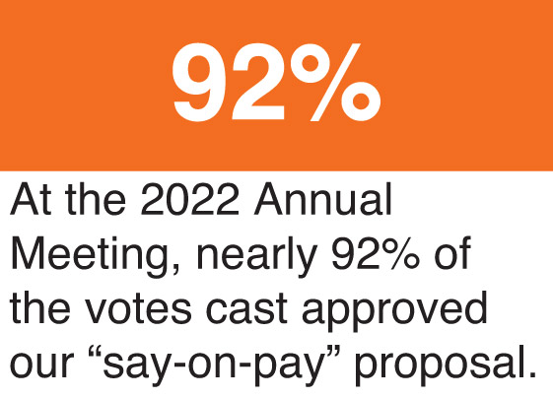
The Committee also considers the results of advisory “say-on-pay” stockholder votes when making compensation decisions. At the 2022 Annual Meeting of Stockholders, when the Company’s most recent advisory say-on-pay vote was held, nearly 92% of shares voting approved the compensation of the Company’s executive officers. The Company currently holds say-on-pay votes every year.
During 2022, we met with various stockholders to discuss corporate governance, executive compensation, and other matters. The Board and the Human Capital and Compensation Committee have considered, and will continue to seriously consider, feedback from these discussions as we review and evaluate our corporate governance practices and executive compensation programs.

​ |  | ​ | ​ | 34 | ​ | ​ | 2023 Proxy Statement | ​

TABLE OF CONTENTS
EXECUTIVE COMPENSATION
2022 EXECUTIVE COMPENSATION PROGRAM
DECISIONS
Base Salary
The Human Capital and Compensation Committee reviews and approves base salary levels for all named executive officers at the beginning of each year. The following decisions reflect the Human Capital and Compensation Committee’s consideration of external market practices, company performance, peer and published survey data, and other factors, including the executive’s industry knowledge, level of experience, scope, complexity of position, skill set, performance, and future potential.
​ | Named Executive Officer | ​ | ​ | Annual Base  Salary at  12/31/2021 |  |  |  | ​ | ​ | Annual Base  Salary at  12/31/2022 |  |  |  | ​ | ​ | % Change |  |  |  | ​
​ | Aaron Jagdfeld | ​ | ​ | ​ | $ | 1,000,000 | ​ | ​ | ​ | ​ | $ | 1,050,000 | ​ | ​ | ​ | ​ | ​ | 5.0% | ​ | ​
​ | York Ragen | ​ | ​ | ​ | $ | 475,000 | ​ | ​ | ​ | ​ | $ | 525,000 | ​ | ​ | ​ | ​ | ​ | 10.5% | ​ | ​
​ | Norman Taffe | ​ | ​ | ​ | ​ | N/A | ​ | ​ | ​ | ​ | $ | 425,000 | ​ | ​ | ​ | N/A |  |  |  | ​
​ | Erik Wilde | ​ | ​ | ​ | $ | 395,000 | ​ | ​ | ​ | ​ | $ | 420,000 | ​ | ​ | ​ | ​ | ​ | 6.3% | ​ | ​
​ | Patrick Forsythe | ​ | ​ | ​ | $ | 420,000 | ​ | ​ | ​ | ​ | $ | 430,000 | ​ | ​ | ​ | ​ | ​ | 2.4% | ​ | ​
In early March 2022, the Human Capital and Compensation Committee addressed market considerations and recognized the sustained strong performance and strategic contributions of Mr. Jagdfeld with an increase in base salary to $1,050,000. The Human Capital and Compensation Committee also increased the base salary for Messrs. Ragen, Forsythe and Wilde to $525,000, $430,000, and $420,000, respectively. The increases for Messrs. Ragen and Wilde recognize performance and further align their pay to market competitive levels. Mr. Taffe joined the Company in August of 2022.
No 2023 pay changes for NEOs were approved by the Human Capital and Compensation Committee at this time.
Annual Performance Bonus Plan
Under the Annual Performance Bonus Plan, the Human Capital and Compensation Committee approved the financial targets of the 2022 Annual Incentive Plan (“AIP”). Consistent with prior years, the annual incentive is calculated as a percentage of base salary and is paid in cash.
In February 2022, the Human Capital and Compensation Committee increased Mr. Jagdfeld’s Target Bonus from 125% to 130% and Mr. Wilde’s Target Bonus from 65% to 75%, to further align their pay to market competitive levels. The Threshold, Target, and Maximum Bonus opportunities for each NEO are as follows:
​ | Named Executive Officer | ​ | ​ | Below Threshold as  a % of Base Salary |  |  |  | ​ | ​ | Threshold Bonus  as a % of Base  Salary |  |  |  | ​ | ​ | Target Bonus  as a % of Base  Salary |  |  |  | ​ | ​ | Maximum Bonus  as a % of Base  Salary |  |  |  | ​
​ | Aaron Jagdfeld | ​ | ​ | ​ | ​ | 0% | ​ | ​ | ​ | ​ | ​ | 74.8% | ​ | ​ | ​ | ​ | ​ | 130% | ​ | ​ | ​ | ​ | ​ | 260% | ​ | ​
​ | York Ragen | ​ | ​ | ​ | ​ | 0% | ​ | ​ | ​ | ​ | ​ | 43.1% | ​ | ​ | ​ | ​ | ​ | 75% | ​ | ​ | ​ | ​ | ​ | 150% | ​ | ​
​ | Norman Taffe | ​ | ​ | ​ | ​ | 0% | ​ | ​ | ​ | ​ | ​ | 43.1% | ​ | ​ | ​ | ​ | ​ | 75% | ​ | ​ | ​ | ​ | ​ | 150% | ​ | ​
​ | Erik Wilde | ​ | ​ | ​ | ​ | 0% | ​ | ​ | ​ | ​ | ​ | 43.1% | ​ | ​ | ​ | ​ | ​ | 75% | ​ | ​ | ​ | ​ | ​ | 150% | ​ | ​
​ | Patrick Forsythe | ​ | ​ | ​ | ​ | 0% | ​ | ​ | ​ | ​ | ​ | 37.4% | ​ | ​ | ​ | ​ | ​ | 65% | ​ | ​ | ​ | ​ | ​ | 130% | ​ | ​

​ |  | ​ | ​ | 35 | ​ | ​ | 2023 Proxy Statement | ​

TABLE OF CONTENTS
EXECUTIVE COMPENSATION
For 2022, the AIP financial metrics used in the plan did not change as the Human Capital and Compensation Committee felt the plan effectively connected the CEO, our executives, and our employees to our strategy and appropriate financial metrics for managing the business. The two financial metrics used include: Adjusted EBITDA (excluding the impact of acquisitions that occurred during the performance period and before deduction for noncontrolling interests) and Primary Working Capital (“PWC”) as a percentage of net sales. Individual performance goals (“IPG”) continued to be the third and nonfinancial metric. The Human Capital and Compensation Committee approved an adjustment of the Threshold payout level from 40% to 50% for the financial metrics of Adjusted EBITDA and PWC, and retained a payout of 80% at Threshold for the IPG portion.
Executive officers with enterprise responsibilities, including all NEOs other than Mr. Wilde, had 100% of their cash incentive tied to the enterprise’s consolidated financial performance. 75% of Mr. Wilde’s cash incentive was tied to specific business group performance, as described further below. The weighting of the metrics for those responsible for enterprise performance is as follows:
​ | Adjusted EBITDA | ​ | ​ | PWC as % of  Net Sales |  |  |  | ​ | ​ | IPG | ​
​ | 50% | ​ | ​ | ​ | ​ | 25% | ​ | ​ | ​ | 25% | ​
2022 Annual Performance Bonus Plan Results
The 2022 consolidated financial targets for Adjusted EBITDA and PWC were $1,167.7 million and 24.0%, respectively. IPG goals for named executive officers in 2022 were based on achieving these financial targets, improving energy resilience and independence, optimizing energy efficiency and consumption, protecting and building critical infrastructure, culture and employee engagement, customer experience, continuous improvement, and technology leadership. For 2022, we incorporated ESG goals into the IPGs for our named executive officers, which address the design and development of our ESG programs, goals, initiatives, and metrics.
Achievement of the above-stated financial targets under the AIP would result in a 100%-of-Target payout for the three components in the plan, assuming 100% achievement of IPGs. Under the AIP, the consolidated Adjusted EBITDA (excluding the impact of acquisitions that occurred during the performance period and before deduction for noncontrolling interests) was $824.7 million, which was well below Threshold for the Adjusted EBITDA portion. The IPG portion of the AIP is paid out at the same level of achievement as that achieved for Adjusted EBITDA, subject to adjustments for each NEO’s performance against certain defined and measurable goals established at the commencement of the year and developed to achieve specific initiatives related to the Company’s long-term strategy. The Company’s PWC, excluding the impact of acquisitions, was 33.6%, which also fell well below Threshold for the PWC portion. As a result, there was no AIP payment for 2022 for those with enterprise responsibilities, including Messrs. Jagdfeld, Ragen, Forsythe, and Taffe.
​ | Annual Performance Bonus Metrics | ​ | ​ | 2022 Financial Targets | ​ | ​ | 2022 Achievement | ​ | ​ | Overall  Payout % | ​
​ | Adjusted EBITDA (50%) * | ​ | ​ | $1,167.7 million | ​ | ​ | $824.7 million | ​ | ​ | ​ | ​
​ | PWC as % of Net Sales (25%) | ​ | ​ | 24.0% | ​ | ​ | 33.6% | ​ | ​ | 0% | ​
​ | IPGs (25%) | ​ | ​ | NA | ​ | ​ | Paid Out Based on Adjusted  EBITDA Achievement | ​ | ​ | ​ | ​
​
Adjusted EBITDA under the AIP excludes the impact of acquisitions that occurred during the performance period and is calculated before deduction for noncontrolling interests.
*
​

​ |  | ​ | ​ | 36 | ​ | ​ | 2023 Proxy Statement | ​

TABLE OF CONTENTS
EXECUTIVE COMPENSATION
​ | Named Executive Officers (NEOs) | ​ | ​ | AIP Target |  |  |  | ​ | ​ | 2022 AIP  Achievement* |  |  |  | ​ | ​ | 2022 AIP  Payment |  |  |  | ​
​ | Aaron Jagdfeld | ​ | ​ | ​ | $ | 1,365,000 | ​ | ​ | ​ | ​ | ​ | 0.0% | ​ | ​ | ​ | ​ | $ | 0 | ​ | ​
​ | York Ragen | ​ | ​ | ​ | $ | 393,750 | ​ | ​ | ​ | ​ | ​ | 0.0% | ​ | ​ | ​ | ​ | $ | 0 | ​ | ​
​ | Norman Taffe | ​ | ​ | ​ | $ | 318,750 | ​ | ​ | ​ | ​ | ​ | 0.0% | ​ | ​ | ​ | ​ | $ | 0 | ​ | ​
​ | Erik Wilde | ​ | ​ | ​ | $ | 315,000 | ​ | ​ | ​ | ​ | ​ | 34.9% | ​ | ​ | ​ | ​ | $ | 109,778 | ​ | ​
​ | Patrick Forsythe | ​ | ​ | ​ | $ | 279,500 | ​ | ​ | ​ | ​ | ​ | 0.0% | ​ | ​ | ​ | ​ | $ | 0 | ​ | ​
​
Achievement percentages are inclusive of each NEO’s IPG ratings
*
​
Under the AIP, Mr. Wilde was measured on a combination of business group and consolidated financial targets (25% business group Adjusted EBITDA, 25% business group PWC, 25% consolidated Adjusted EBITDA, and 25% Individual Performance Goals). As a result, Mr. Wilde received an overall AIP payment of 34.9% of his Target Bonus. This payment is slightly below his Threshold amount, reflecting achievement of Threshold for two of the four AIP financial metrics — business group Adjusted EBITDA and IPG. The remaining two metrics, business group PWC and consolidated Adjusted EBITDA, fell below Threshold achievement.
The Human Capital and Compensation Committee maintains its discretion to adjust the annual performance bonuses, regardless of the outcome under incentive bonus formulas. For 2022, the Human Capital and Compensation Committee made no adjustments or modifications to the financial targets or payouts.
Long-Term Incentives
Generac believes that equity awards and other forms of long-term incentive compensation are a critical component of a competitive, comprehensive executive compensation program, and thus as a component of annual compensation for NEOs.
Our long-term incentive program (“LTIP”) is designed to reward our executives for their contribution to the Company’s long-term growth and performance, and to better align the interests of our named executive officers with those of our stockholders. In addition, our long-term awards are used to attract and retain critical employee talent by providing a competitive market-based opportunity.
For the grants made in 2022, the Company granted to the named executive officers a combination of stock options, restricted stock, and performance share awards, as follows:
Thirty-three percent (33.3%) of the award was granted in the form of performance shares. Named executive officers may earn from 0% to 200% of their target performance share awards based on the achievement of specified revenue growth, EBITDA margin, and Free Cash Flow Conversion goals. Each performance share has a value equal to a share of common stock and the number of shares that can be earned is contingent upon Company performance, over a three-year performance period, against goals approved by the Human Capital and Compensation Committee.
•
​
Thirty-three percent (33.3%) of the award was granted in the form of restricted stock, with those shares vesting equally over the three anniversaries immediately following the date of grant.
•
​
Thirty-three percent (33.4%) of the award was granted in the form of stock options, with those options vesting equally over the four anniversaries immediately following the date of grant.
•
​

​ |  | ​ | ​ | 37 | ​ | ​ | 2023 Proxy Statement | ​

TABLE OF CONTENTS
EXECUTIVE COMPENSATION
2022 Long-Term Equity Incentive Mix
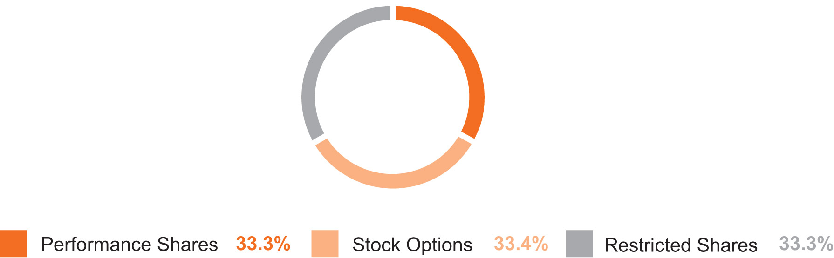
For 2022, the LTIP awards granted to the NEOs were as follows:
2022 Long-Term Equity Awards
​ | Executive | ​ | ​ | Value of Stock  Options(1) |  |  |  | ​ | ​ | Value of Time -  Vested  Restricted  Stock(2) |  |  |  | ​ | ​ | Value of  Performance  Shares(3) |  |  |  | ​ | ​ | Total Value of  2022 Long -  Term Incentive  Grants |  |  |  | ​
​ | Aaron Jagdfeld | ​ | ​ | ​ | $ | 1,920,529 | ​ | ​ | ​ | ​ | $ | 1,914,834 | ​ | ​ | ​ | ​ | $ | 1,914,834 | ​ | ​ | ​ | ​ | $ | 5,750,198 | ​ | ​
​ | York Ragen | ​ | ​ | ​ | $ | 438,474 | ​ | ​ | ​ | ​ | $ | 437,171 | ​ | ​ | ​ | ​ | $ | 437,171 | ​ | ​ | ​ | ​ | $ | 1,312,816 | ​ | ​
​ | Norman Taffe(4) | ​ | ​ | ​ | ​ | N/A | ​ | ​ | ​ | ​ | $ | 500,216 | ​ | ​ | ​ | ​ | $ | 1,500,197 | ​ | ​ | ​ | ​ | $ | 2,000,413 | ​ | ​
​ | Erik Wilde | ​ | ​ | ​ | $ | 245,571 | ​ | ​ | ​ | ​ | $ | 244,803 | ​ | ​ | ​ | ​ | $ | 244,803 | ​ | ​ | ​ | ​ | $ | 735,177 | ​ | ​
​ | Patrick Forsythe | ​ | ​ | ​ | $ | 251,409 | ​ | ​ | ​ | ​ | $ | 250,805 | ​ | ​ | ​ | ​ | $ | 250,805 | ​ | ​ | ​ | ​ | $ | 753,018 | ​ | ​
​
Represents value of time-vested stock options at March 2022 grant date.
(1)
​
Represents value of time-vested restricted stock at March 2022 grant date.
(2)
​
Represents value of performance shares at March 2022 grant date.
(3)
​
Mr. Taffe was hired on August 22, 2022. This represents the value of equity awards approved by the Human Capital and Compensation Committee, to be granted to Mr. Taffe effective September 1, 2022. The equity award included $500,000 in restricted stock that vests in equal installments on the first three anniversaries of the grant date, and performance shares valued at $1.5 million, at target achievement level, with a 3-year performance period ending December 31, 2026. Other than the use of financial metrics tied to the Company’s Energy Technology business for measuring target achievement and share payout, the awards have the same vesting terms and conditions as the performance shares received by other executives in 2022.
(4)
​
2020-2022 Performance Share Results
The named executive officers held performance shares granted in 2020 that vested based on results during the three-year, 2020 to 2022 performance period. This grant was intended to encourage target revenue growth measured in compound annual growth rate (“CAGR”), target Adjusted EBITDA margin percentages, and Free Cash Flow (“FCF”) Conversion percentages for 2020 to 2022. Specifically, if revenue growth (CAGR), average Adjusted EBITDA margin percentages, and FCF Conversion percentages during the period were achieved within a defined target range on a performance matrix, the named executive officers would earn from

​ |  | ​ | ​ | 38 | ​ | ​ | 2023 Proxy Statement | ​

TABLE OF CONTENTS
EXECUTIVE COMPENSATION
50% to 200% of their target performance share awards. The revenue growth (CAGR), Adjusted EBITDA margin, and FCF Conversion targets were set at a level, given business conditions at the time the awards were granted, that were designed to be challenging but achievable with strong management performance. After the conclusion of the three-year period, the performance share targets were measured against actual financial results for Generac, excluding any businesses acquired during the three-year period. For the three-year period from 2020 to 2022, the Human Capital and Compensation Committee determined and approved a final payout equal to 133.2% of target, out of a maximum of 200%. The Minimum, Target, and Maximum financial performance metrics and the actual results for the 2020 to 2022 performance awards are reflected below:
​ | Performance Measure | ​ | ​ | Weight |  |  |  | ​ | ​ | Minimum |  |  |  | ​ | ​ | Target |  |  |  | ​ | ​ | Maximum |  |  |  | ​ | ​ | Actual 2020-2022  Cycle Results |  |  |  | ​ | ​ | Final  Vesting | ​
​ | Revenue Growth (CAGR) | ​ | ​ | ​ | ​ | 33% | ​ | ​ | ​ | ​ | ​ | 5.8% | ​ | ​ | ​ | ​ | ​ | 8.8% | ​ | ​ | ​ | ​ | ​ | 11.8% | ​ | ​ | ​ | ​ | ​ | 23.55% | ​ | ​ | ​ | ​ | ​
​ | Adjusted EBITDA Margin % | ​ | ​ | ​ | ​ | 33% | ​ | ​ | ​ | ​ | ​ | 19.5% | ​ | ​ | ​ | ​ | ​ | 20.5% | ​ | ​ | ​ | ​ | ​ | 21.5% | ​ | ​ | ​ | ​ | ​ | 22.19% | ​ | ​ | ​ | 133.2% | ​
​ | FCF Conversion % | ​ | ​ | ​ | ​ | 33% | ​ | ​ | ​ | ​ | ​ | 85.0% | ​ | ​ | ​ | ​ | ​ | 90.0% | ​ | ​ | ​ | ​ | ​ | 95% | ​ | ​ | ​ | ​ | ​ | 46.36% | ​ | ​ | ​ | ​ | ​
OTHER PRACTICES, POLICIES & GUIDELINES
Clawback and Hedging Policies
Effective April 2019, the Company adopted a formal “clawback” policy applicable to annual and long-term incentive awards made to the CEO, CFO and any other key member of executive management as identified by the board or CEO. Under this policy, the Company may seek to recoup incentive compensation paid to covered employees to the extent that such compensation was granted, vested, or earned based on financial results that the Company is required to restate as a result of material noncompliance with any financial reporting requirement under federal securities laws.
In March 2022, the Company expanded the policy to allow recoupment of incentive compensation paid in the event of gross negligence in performance or misconduct resulting in a violation of law or Company policy, where such acts resulted in significant financial or reputational harm to the Company. The Company expects to revise its compensation recovery policy in the next year to comply with new NYSE and SEC rules.
In addition, under our insider trading policy, officers, employees, and members of the Board of Directors may not engage in short-selling Company common stock at any time. Such individuals are also prohibited from pledging Company securities, including holding Company securities in a margin account, and from engaging in hedging transactions. The prohibition on hedging transactions covers all officers, employees and members of the Board of Directors, and their designees, and prohibits the purchase of any financial instruments (including prepaid variable forward contracts, equity swaps, collars and exchange funds) and other transactions that hedge or offset, or are designed to hedge or offset, any decrease in the market value of the Company’s securities. The prohibition on hedging does not preclude general portfolio diversification or investing in broad-based index funds.
Stock Ownership Guidelines
The Human Capital and Compensation Committee believes that it is in the best interest of Generac and its stockholders to align the financial interests of the Company’s officers and directors with those of Generac’s stockholders by requiring officers and directors to establish and maintain a permanent minimum ownership position in Company stock (based on the market

​ |  | ​ | ​ | 39 | ​ | ​ | 2023 Proxy Statement | ​

TABLE OF CONTENTS
EXECUTIVE COMPENSATION
value of our common stock), and by limiting the ability to sell Company stock until guideline ownership levels have been achieved. In addition, the Human Capital and Compensation Committee believes that the investment community values stock ownership by such officers and that share ownership demonstrates a commitment to and belief in the long-term strategic direction of Generac. Accordingly, stock ownership guidelines have been established for the Company’s officers and directors, including all the named executive officers.
In June 2022, the Human Capital and Compensation Committee revised the top executive ownership requirements, excluding the CEO, from 2.0X to 3.0X annual base salary. The current stock ownership guidelines are as follows:
​ | Position/Level | ​ | ​ | Stock Ownership Requirements | ​
​ | CEO | ​ | ​ | 6.0X annual base pay | ​
​ | Board of Directors | ​ | ​ | 5.0X annual retainer | ​
​ | Generac Chief & EVP | ​ | ​ | 3.0X annual base pay | ​
​ | Subsidiary President & Generac SVP | ​ | ​ | 1.0X annual base pay | ​
Executives are expected to build ownership value over time as a result of their performance and participation in the Company’s equity compensation programs. Under the guidelines, no time period is specified for compliance by officers. The following retention ratios apply to each executive based on years of service and percentage of the guideline that has been achieved. Under the stock ownership guidelines, (i) an executive that has met 50% of the multiple of salary guideline and has less than five years of service has a 50% retention ratio, (ii) an executive that has met 50% of the multiple of salary guideline and has five or more years of service has a 25% retention ratio and (iii) an executive that has met less than 50% of the multiple of salary guideline has a 75% retention ratio. The Human Capital and Compensation Committee assesses progress towards meeting the guidelines on an annual basis. As of March 31, 2023, four out of five NEOs, including the CEO and CFO, have met their ownership guidelines.
Outside directors have five years to meet their minimum ownership requirement. As of March 31, 2023, all Directors are compliant with the applicable stock ownership guidelines.
Benefits and Perquisites
Generac does not provide special medical, dental, insurance or disability benefits for the named executive officers beyond that offered to all employees. In addition, Generac does not offer special perquisites for any of the named executive officers.
Retirement Plans
The named executive officers are eligible to participate in the Generac Power Systems, Inc. Employees 401(k) Savings Plan on the same terms as other participating employees.

​ |  | ​ | ​ | 40 | ​ | ​ | 2023 Proxy Statement | ​

TABLE OF CONTENTS​
Report of the Human Capital and Compensation Committee
The Human Capital and Compensation Committee has reviewed and discussed the “EXECUTIVE COMPENSATION — Compensation Discussion and Analysis” section with our management. Based upon this review and discussion, the Human Capital and Compensation Committee recommended to the Board of Directors that the “EXECUTIVE COMPENSATION — Compensation Discussion and Analysis” section be included in this Proxy Statement, which has been incorporated by reference in our Annual Report on Form 10-K for the fiscal year ended December 31, 2022.
Respectfully submitted by the Human Capital and Compensation Committee of the Board of Directors.
Marcia Avedon, Chair
John Bowlin
William Jenkins
Bennett Morgan
Dominick Zarcone

​ |  | ​ | ​ | 41 | ​ | ​ | 2023 Proxy Statement | ​

TABLE OF CONTENTS

2022 Summary Compensation Table
The following table shows compensation information for 2020, 2021 and 2022 for our named executive officers.
​ | Name and principal position | ​ | ​ | Year |  |  |  | ​ | ​ | Salary  ($) |  |  |  | ​ | ​ | Bonus  ($) |  |  |  | ​ | ​ | Stock  awards  ($)(1) |  |  |  | ​ | ​ | Option  awards  ($)(1) |  |  |  | ​ | ​ | Non-equity  incentive plan  compensation  ($)(2) |  |  |  | ​ | ​ | All other  compensation  ($)(3) |  |  |  | ​ | ​ | Total  ($) |  |  |  | ​
​ | Aaron Jagdfeld  Chairman, President and Chief Executive Officer | ​ | ​ | ​ | ​ | 2022 | ​ | ​ | ​ | ​ | ​ | 1,039,178 | ​ | ​ | ​ | ​ | ​ | — | ​ | ​ | ​ | ​ | ​ | 3,829,669 | ​ | ​ | ​ | ​ | ​ | 1,920,529 | ​ | ​ | ​ | ​ | ​ | — | ​ | ​ | ​ | ​ | ​ | 18,300 | ​ | ​ | ​ | ​ | ​ | 6,807,676 | ​ | ​
​ |  | ​ | ​ | ​ | ​ | 2021 | ​ | ​ | ​ | ​ | ​ | 989,178 | ​ | ​ | ​ | ​ | ​ | — | ​ | ​ | ​ | ​ | ​ | 3,330,212 | ​ | ​ | ​ | ​ | ​ | 1,670,075 | ​ | ​ | ​ | ​ | ​ | 1,497,563 | ​ | ​ | ​ | ​ | ​ | 32,785 | ​ | ​ | ​ | ​ | ​ | 7,519,812 | ​ | ​
​ |  | ​ | ​ | ​ | ​ | 2020 | ​ | ​ | ​ | ​ | ​ | 944,151 | ​ | ​ | ​ | ​ | ​ | — | ​ | ​ | ​ | ​ | ​ | 2,664,019 | ​ | ​ | ​ | ​ | ​ | 1,336,020 | ​ | ​ | ​ | ​ | ​ | 1,963,769 | ​ | ​ | ​ | ​ | ​ | 53,638 | ​ | ​ | ​ | ​ | ​ | 6,961,596 | ​ | ​
​ | York Ragen  Chief Financial Officer | ​ | ​ | ​ | ​ | 2022 | ​ | ​ | ​ | ​ | ​ | 515,616 | ​ | ​ | ​ | ​ | ​ | — | ​ | ​ | ​ | ​ | ​ | 874,342 | ​ | ​ | ​ | ​ | ​ | 438,474 | ​ | ​ | ​ | ​ | ​ | — | ​ | ​ | ​ | ​ | ​ | 12,200 | ​ | ​ | ​ | ​ | ​ | 1,840,632 | ​ | ​
​ | York Ragen  Chief Financial Officer | ​ | ​ | ​ | ​ | 2021 | ​ | ​ | ​ | ​ | ​ | 469,658 | ​ | ​ | ​ | ​ | ​ | — | ​ | ​ | ​ | ​ | ​ | 632,854 | ​ | ​ | ​ | ​ | ​ | 317,302 | ​ | ​ | ​ | ​ | ​ | 423,902 | ​ | ​ | ​ | ​ | ​ | 44,485 | ​ | ​ | ​ | ​ | ​ | 1,888,200 | ​ | ​
​ | York Ragen  Chief Financial Officer | ​ | ​ | ​ | ​ | 2020 | ​ | ​ | ​ | ​ | ​ | 447,911 | ​ | ​ | ​ | ​ | ​ | — | ​ | ​ | ​ | ​ | ​ | 599,537 | ​ | ​ | ​ | ​ | ​ | 300,624 | ​ | ​ | ​ | ​ | ​ | 524,306 | ​ | ​ | ​ | ​ | ​ | 22,650 | ​ | ​ | ​ | ​ | ​ | 1,895,028 | ​ | ​
​ | Norman Taffe  President Energy Technology | ​ | ​ | ​ | ​ | 2022 | ​ | ​ | ​ | ​ | ​ | 152,534 | ​ | ​ | ​ | ​ | ​ | — | ​ | ​ | ​ | ​ | ​ | 2,000,413 | ​ | ​ | ​ | ​ | ​ | — | ​ | ​ | ​ | ​ | ​ | — | ​ | ​ | ​ | ​ | ​ | 2,942 | ​ | ​ | ​ | ​ | ​ | 2,155,889 | ​ | ​
​ | Norman Taffe  President Energy Technology | ​ | ​ | ​ | ​ | ​ | ​ | ​ | ​ | ​ | ​ | ​ | ​ | ​ | ​ | ​ | ​ | ​ | ​ | ​ | ​ | ​ | ​ | ​ | ​ | ​ | ​ | ​ | ​ | ​ | ​ | ​ | ​ | ​ | ​ | ​ | ​ | ​ | ​ | ​ | ​ | ​ | ​ | ​ | ​ | ​ | ​ | ​ | ​ | ​
​ | Erik Wilde  Executive Vice President Industrial — Americas | ​ | ​ | ​ | ​ | 2022 | ​ | ​ | ​ | ​ | ​ | 414,877 | ​ | ​ | ​ | ​ | ​ | — | ​ | ​ | ​ | ​ | ​ | 489,606 | ​ | ​ | ​ | ​ | ​ | 245,571 | ​ | ​ | ​ | ​ | ​ | 109,778 | ​ | ​ | ​ | ​ | ​ | 8,840 | ​ | ​ | ​ | ​ | ​ | 1,268,671 | ​ | ​
​ | Erik Wilde  Executive Vice President Industrial — Americas | ​ | ​ | ​ | ​ | 2021 | ​ | ​ | ​ | ​ | ​ | 391,816 | ​ | ​ | ​ | ​ | ​ | — | ​ | ​ | ​ | ​ | ​ | 460,869 | ​ | ​ | ​ | ​ | ​ | 230,910 | ​ | ​ | ​ | ​ | ​ | 305,507 | ​ | ​ | ​ | ​ | ​ | 20,769 | ​ | ​ | ​ | ​ | ​ | 1,409,872 | ​ | ​
​ | Erik Wilde  Executive Vice President Industrial — Americas | ​ | ​ | ​ | ​ | 2020 | ​ | ​ | ​ | ​ | ​ | 379,995 | ​ | ​ | ​ | ​ | ​ | — | ​ | ​ | ​ | ​ | ​ | 445,300 | ​ | ​ | ​ | ​ | ​ | 223,283 | ​ | ​ | ​ | ​ | ​ | 407,833 | ​ | ​ | ​ | ​ | ​ | 12,958 | ​ | ​ | ​ | ​ | ​ | 1,469,369 | ​ | ​
​ | Patrick Forsythe  Chief Technical Officer | ​ | ​ | ​ | ​ | 2022 | ​ | ​ | ​ | ​ | ​ | 427,233 | ​ | ​ | ​ | ​ | ​ | — | ​ | ​ | ​ | ​ | ​ | 501,609 | ​ | ​ | ​ | ​ | ​ | 251,409 | ​ | ​ | ​ | ​ | ​ | — | ​ | ​ | ​ | ​ | ​ | 9,150 | ​ | ​ | ​ | ​ | ​ | 1,189,401 | ​ | ​
​ | Patrick Forsythe  Chief Technical Officer | ​ | ​ | ​ | ​ | 2021 | ​ | ​ | ​ | ​ | ​ | 416,425 | ​ | ​ | ​ | ​ | ​ | — | ​ | ​ | ​ | ​ | ​ | 489,757 | ​ | ​ | ​ | ​ | ​ | 245,534 | ​ | ​ | ​ | ​ | ​ | 324,843 | ​ | ​ | ​ | ​ | ​ | 9,508 | ​ | ​ | ​ | ​ | ​ | 1,486,066 | ​ | ​
​ | Patrick Forsythe  Chief Technical Officer | ​ | ​ | ​ | ​ | 2020 | ​ | ​ | ​ | ​ | ​ | 402,493 | ​ | ​ | ​ | ​ | ​ | — | ​ | ​ | ​ | ​ | ​ | 472,133 | ​ | ​ | ​ | ​ | ​ | 236,763 | ​ | ​ | ​ | ​ | ​ | 471,876 | ​ | ​ | ​ | ​ | ​ | 31,915 | ​ | ​ | ​ | ​ | ​ | 1,615,180 | ​ | ​
​
The amounts reported for 2022 represent the aggregate grant date fair value for awards of restricted stock, stock options, and performance shares and are computed in accordance with Financial Accounting Standards Board Accounting Standards Codification Subtopic 718. See Note 17 to the Consolidated Financial Statements included in our Annual Report on Form 10-K for the year ended December 31, 2022 for a discussion of the relevant assumptions used in calculating these amounts. All amounts represent potential future income calculated for financial reporting purposes; actual amounts recognized by the named executive officers may be materially different depending on, among other things, the Company’s stock price performance and the period of service of the executive. The Stock Award amounts are composed in equal measure of restricted stock and performance shares, with the performance share portion assuming target performance by the Company during the relevant performance period. Assuming achievement of maximum performance during the relevant performance period for the performance shares, the Stock Award amounts provided would increase by a multiplier of 1.5.
(1)
​
The non-equity incentive plan compensation column reflects cash incentive awards earned pursuant to our Annual Performance Bonus Plan as previously described. These awards are earned during the year reflected and paid in the following year.
(2)
​
All other compensation represents the employer matching contributions and employer nonelective contributions of the defined contribution plan.
(3)
​

​ |  | ​ | ​ | 42 | ​ | ​ | 2023 Proxy Statement | ​

TABLE OF CONTENTS

Grants of Plan-Based Awards in 2022
The following table indicates potential cash incentive compensation under our Annual Performance Bonus Plan based on 2022 performance and equity awards granted in 2022.
​ | ​ | ​ | ​ | ​ | ​ | ​ | ​ | ​ | ​ | ​ | ​ | ​ | ​ | ​ | ​ | Possible payouts  under non-equity  incentive plan awards(1) |  |  |  |  |  |  |  |  |  |  |  |  |  |  |  | ​ | ​ | Possible payouts  under equity  incentive plan awards(2) |  |  |  |  |  |  |  |  |  |  |  |  |  |  |  | ​ | ​ | All other  stock  awards:  number of  shares of  stock or  units  (#)(3) |  |  |  | ​ | ​ | All other  option  awards:  number of  securities  underlying  options  (#)(4) |  |  |  | ​ | ​ | Exercise  or base  price of  option  awards  ($/sh)(5) |  |  |  | ​ | ​ | Closing  market  price on  date  of  grant  ($/sh) |  |  |  | ​ | ​ | Grant  date  fair value  of stock  and  option  awards  ($) |  |  |  | ​
​ | Name | ​ | ​ | Grant  Date |  |  |  | ​ | ​ | Approval  Date |  |  |  | ​ | ​ | Threshold  ($) |  |  |  | ​ | ​ | Target  ($) |  |  |  | ​ | ​ | Maximum  ($) |  |  |  | ​ | ​ | Threshold  (#) |  |  |  | ​ | ​ | Target  (#) |  |  |  | ​ | ​ | Maximum  (#) |  |  |  | ​
​ | Aaron Jagdfeld | ​ | ​ | ​ | ​ | — | ​ | ​ | ​ | ​ | ​ | — | ​ | ​ | ​ | ​ | ​ | 1,020,338 | ​ | ​ | ​ | ​ | ​ | 1,365,000 | ​ | ​ | ​ | ​ | ​ | 2,730,000 | ​ | ​ | ​ | ​ | ​ | ​ | ​ | ​ | ​ | ​ | ​ | ​ | ​ | ​ | ​ | ​ | ​ | ​ | ​ | ​ | ​ | ​ | ​ | ​ | ​ | ​ | ​ | ​ | ​ | ​ | ​ | ​  ​  ​  ​  ​  ​  ​  ​  ​  ​  ​  ​  ​  ​  ​  ​  ​  ​  ​
​ | Aaron Jagdfeld | ​ | ​ | ​ | ​ | 3/1/22 | ​ | ​ | ​ | ​ | ​ | 2/21/22 | ​ | ​ | ​ | ​ | ​ | — | ​ | ​ | ​ | ​ | ​ | — | ​ | ​ | ​ | ​ | ​ | — | ​ | ​ | ​ | ​ | ​​ | 3,031  — | ​ | ​ | ​ | ​ | ​ | 6,062 | ​ | ​ | ​ | ​ | ​ | 12,124 | ​ | ​ | ​ | ​ | ​ | — | ​ | ​ | ​ | ​ | ​ | — | ​ | ​  ​  ​  ​  —  ​  ​  ​  ​  ​  ​  ​  ​  ​  ​  ​  1,914,834  ​  ​
​ | Aaron Jagdfeld | ​ | ​ | ​ | ​ | 3/1/22 | ​ | ​ | ​ | ​ | ​ | 2/21/22 | ​ | ​ | ​ | ​ | ​ | — | ​ | ​ | ​ | ​ | ​ | — | ​ | ​ | ​ | ​ | ​ | — | ​ | ​ | ​ | ​ | ​ | — | ​ | ​ | ​ | ​ | ​ | — | ​ | ​ | ​ | ​ | ​ | — | ​ | ​ | ​ | ​ | ​ | 6,062 | ​ | ​ | ​ | ​ | ​ | — | ​ | ​  ​  ​  ​  —  ​  ​  ​  ​  ​  —  ​  ​  ​  ​  ​  1,914,834  ​  ​
​ | Aaron Jagdfeld | ​ | ​ | ​ | ​ | 3/1/22 | ​ | ​ | ​ | ​ | ​ | 2/21/22 | ​ | ​ | ​ | ​ | ​ | — | ​ | ​ | ​ | ​ | ​ | — | ​ | ​ | ​ | ​ | ​ | — | ​ | ​ | ​ | ​ | ​ | — | ​ | ​ | ​ | ​ | ​ | — | ​ | ​ | ​ | ​ | ​ | — | ​ | ​ | ​ | ​ | ​ | — | ​ | ​ | ​ | ​ | ​ | 15,133 | ​ | ​  ​  ​  ​  315.88  ​  ​  ​  ​  ​  321.24  ​  ​  ​  ​  ​  1,920,529  ​  ​
​ | York Ragen | ​ | ​ | ​ | ​ | — | ​ | ​ | ​ | ​ | ​ | — | ​ | ​ | ​ | ​ | ​ | 169,805 | ​ | ​ | ​ | ​ | ​ | 393,750 | ​ | ​ | ​ | ​ | ​ | 787,500 | ​ | ​ | ​ | ​ | ​ | ​ | ​ | ​ | ​ | ​ | ​ | ​ | ​ | ​ | ​ | ​ | ​ | ​ | ​ | ​ | ​ | ​ | ​ | ​ | ​ | ​ | ​ | ​ | ​ | ​ | ​ | ​  ​  ​  ​  ​  ​  ​  ​  ​  ​  ​  ​  ​  ​  ​  ​  ​  ​  ​
​ | York Ragen | ​ | ​ | ​ | ​ | 3/1/22 | ​ | ​ | ​ | ​ | ​ | 2/21/22 | ​ | ​ | ​ | ​ | ​ | — | ​ | ​ | ​ | ​ | ​ | — | ​ | ​ | ​ | ​ | ​ | — | ​ | ​ | ​ | ​ | ​ | 692 | ​ | ​ | ​ | ​ | ​ | 1,384 | ​ | ​ | ​ | ​ | ​ | 2,768 | ​ | ​ | ​ | ​ | ​ | — | ​ | ​ | ​ | ​ | ​ | — | ​ | ​  ​  ​  ​  —  ​  ​  ​  ​  ​  ​  ​  ​  ​  ​  ​  437,171  ​  ​
​ | York Ragen | ​ | ​ | ​ | ​ | 3/1/22 | ​ | ​ | ​ | ​ | ​ | 2/21/22 | ​ | ​ | ​ | ​ | ​ | — | ​ | ​ | ​ | ​ | ​ | — | ​ | ​ | ​ | ​ | ​ | — | ​ | ​ | ​ | ​ | ​ | — | ​ | ​ | ​ | ​ | ​ | — | ​ | ​ | ​ | ​ | ​ | — | ​ | ​ | ​ | ​ | ​ | 1,384 | ​ | ​ | ​ | ​ | ​ | — | ​ | ​  ​  ​  ​  —  ​  ​  ​  ​  ​  —  ​  ​  ​  ​  ​  437,171  ​  ​
​ | York Ragen | ​ | ​ | ​ | ​ | 3/1/22 | ​ | ​ | ​ | ​ | ​ | 2/21/22 | ​ | ​ | ​ | ​ | ​ | — | ​ | ​ | ​ | ​ | ​ | — | ​ | ​ | ​ | ​ | ​ | — | ​ | ​ | ​ | ​ | ​ | — | ​ | ​ | ​ | ​ | ​ | — | ​ | ​ | ​ | ​ | ​ | — | ​ | ​ | ​ | ​ | ​ | — | ​ | ​ | ​ | ​ | ​ | 3,455 | ​ | ​  ​  ​  ​  315.88  ​  ​  ​  ​  ​  321.24  ​  ​  ​  ​  ​  438,474  ​  ​
​ | Norman Taffe | ​ | ​ | ​ | ​ | — | ​ | ​ | ​ | ​ | ​ | — | ​ | ​ | ​ | ​ | ​ | 137,461 | ​ | ​ | ​ | ​ | ​ | 318,750 | ​ | ​ | ​ | ​ | ​ | 637,500 | ​ | ​ | ​ | ​ | ​ | ​ | ​ | ​ | ​ | ​ | ​ | ​ | ​ | ​ | ​ | ​ | ​ | ​ | ​ | ​ | ​ | ​ | ​ | ​ | ​ | ​ | ​ | ​ | ​ | ​ | ​ | ​  ​  ​  ​  ​  ​  ​  ​  ​  ​  ​  ​  ​  ​  ​  ​  ​  ​  ​
​ | Norman Taffe | ​ | ​ | ​ | ​ | 9/1/22 | ​ | ​ | ​ | ​ | ​ | 6/10/22 | ​ | ​ | ​ | ​ | ​ | — | ​ | ​ | ​ | ​ | ​ | — | ​ | ​ | ​ | ​ | ​ | — | ​ | ​ | ​ | ​ | ​ | 3,338 | ​ | ​ | ​ | ​ | ​ | 6,676 | ​ | ​ | ​ | ​ | ​ | 13,352 | ​ | ​ | ​ | ​ | ​ | — | ​ | ​ | ​ | ​ | ​ | — | ​ | ​  ​  ​  ​  —  ​  ​  ​  ​  ​  ​  ​  ​  ​  ​  ​  1,500,197  ​  ​
​ | Norman Taffe | ​ | ​ | ​ | ​ | 9/1/22 | ​ | ​ | ​ | ​ | ​ | 6/10/22 | ​ | ​ | ​ | ​ | ​ | — | ​ | ​ | ​ | ​ | ​ | — | ​ | ​ | ​ | ​ | ​ | — | ​ | ​ | ​ | ​ | ​ | — | ​ | ​ | ​ | ​ | ​ | — | ​ | ​ | ​ | ​ | ​ | — | ​ | ​ | ​ | ​ | ​ | 2,226 | ​ | ​ | ​ | ​ | ​ | — | ​ | ​  ​  ​  ​  —  ​  ​  ​  ​  ​  —  ​  ​  ​  ​  ​  500,216  ​  ​
​ | Erik Wilde | ​ | ​ | ​ | ​ | — | ​ | ​ | ​ | ​ | ​ | — | ​ | ​ | ​ | ​ | ​ | 135,844 | ​ | ​ | ​ | ​ | ​ | 315,000 | ​ | ​ | ​ | ​ | ​ | 630,000 | ​ | ​ | ​ | ​ | ​ | ​ | ​ | ​ | ​ | ​ | ​ | ​ | ​ | ​ | ​ | ​ | ​ | ​ | ​ | ​ | ​ | ​ | ​ | ​ | ​ | ​ | ​ | ​ | ​ | ​ | ​ | ​  ​  ​  ​  ​  ​  ​  ​  ​  ​  ​  ​  ​  ​  ​  ​  ​  ​  ​
​ | Erik Wilde | ​ | ​ | ​ | ​ | 3/1/22 | ​ | ​ | ​ | ​ | ​ | 2/21/22 | ​ | ​ | ​ | ​ | ​ | — | ​ | ​ | ​ | ​ | ​ | — | ​ | ​ | ​ | ​ | ​ | — | ​ | ​ | ​ | ​ | ​ | 338 | ​ | ​ | ​ | ​ | ​ | 775 | ​ | ​ | ​ | ​ | ​ | 1,550 | ​ | ​ | ​ | ​ | ​ | — | ​ | ​ | ​ | ​ | ​ | — | ​ | ​  ​  ​  ​  —  ​  ​  ​  ​  ​  —  ​  ​  ​  ​  ​  244,803  ​  ​
​ | Erik Wilde | ​ | ​ | ​ | ​ | 3/1/22 | ​ | ​ | ​ | ​ | ​ | 2/21/22 | ​ | ​ | ​ | ​ | ​ | — | ​ | ​ | ​ | ​ | ​ | — | ​ | ​ | ​ | ​ | ​ | — | ​ | ​ | ​ | ​ | ​ | — | ​ | ​ | ​ | ​ | ​ | — | ​ | ​ | ​ | ​ | ​ | — | ​ | ​ | ​ | ​ | ​ | 775 | ​ | ​ | ​ | ​ | ​ | — | ​ | ​  ​  ​  ​  —  ​  ​  ​  ​  ​  —  ​  ​  ​  ​  ​  244,803  ​  ​
​ | Erik Wilde | ​ | ​ | ​ | ​ | 3/1/22 | ​ | ​ | ​ | ​ | ​ | 2/21/22 | ​ | ​ | ​ | ​ | ​ | — | ​ | ​ | ​ | ​ | ​ | — | ​ | ​ | ​ | ​ | ​ | — | ​ | ​ | ​ | ​ | ​ | — | ​ | ​ | ​ | ​ | ​ | — | ​ | ​ | ​ | ​ | ​ | — | ​ | ​ | ​ | ​ | ​ | — | ​ | ​ | ​ | ​ | ​ | 1,935 | ​ | ​  ​  ​  ​  315.88  ​  ​  ​  ​  ​  321.24  ​  ​  ​  ​  ​  245,571  ​  ​
​ | Patrick Forsythe | ​ | ​ | ​ | ​ | — | ​ | ​ | ​ | ​ | ​ | — | ​ | ​ | ​ | ​ | ​ | 104,463 | ​ | ​ | ​ | ​ | ​ | 279,500 | ​ | ​ | ​ | ​ | ​ | 559,000 | ​ | ​ | ​ | ​ | ​ | ​ | ​ | ​ | ​ | ​ | ​ | ​ | ​ | ​ | ​ | ​ | ​ | ​ | ​ | ​ | ​ | ​ | ​ | ​ | ​ | ​ | ​ | ​ | ​ | ​ | ​ | ​  ​  ​  ​  ​  ​  ​  ​  ​  ​  ​  ​  ​  ​  ​  ​  ​  ​  ​
​ | Patrick Forsythe | ​ | ​ | ​ | ​ | 3/1/22 | ​ | ​ | ​ | ​ | ​ | 2/21/22 | ​ | ​ | ​ | ​ | ​ | — | ​ | ​ | ​ | ​ | ​ | — | ​ | ​ | ​ | ​ | ​ | — | ​ | ​ | ​ | ​ | ​ | 397 | ​ | ​ | ​ | ​ | ​ | 794 | ​ | ​ | ​ | ​ | ​ | 1,588 | ​ | ​ | ​ | ​ | ​ | — | ​ | ​ | ​ | ​ | ​ | — | ​ | ​  ​  ​  ​  —  ​  ​  ​  ​  ​  ​  ​  ​  ​  ​  ​  250,805  ​  ​
​ | Patrick Forsythe | ​ | ​ | ​ | ​ | 3/1/22 | ​ | ​ | ​ | ​ | ​ | 2/21/22 | ​ | ​ | ​ | ​ | ​ | — | ​ | ​ | ​ | ​ | ​ | — | ​ | ​ | ​ | ​ | ​ | — | ​ | ​ | ​ | ​ | ​ | — | ​ | ​ | ​ | ​ | ​ | — | ​ | ​ | ​ | ​ | ​ | — | ​ | ​ | ​ | ​ | ​ | 794 | ​ | ​ | ​ | ​ | ​ | — | ​ | ​  ​  ​  ​  —  ​  ​  ​  ​  ​  —  ​  ​  ​  ​  ​  250,805  ​  ​
​ | Patrick Forsythe | ​ | ​ | ​ | ​ | 3/1/22 | ​ | ​ | ​ | ​ | ​ | 2/21/22 | ​ | ​ | ​ | ​ | ​ | — | ​ | ​ | ​ | ​ | ​ | — | ​ | ​ | ​ | ​ | ​ | — | ​ | ​ | ​ | ​ | ​ | — | ​ | ​ | ​ | ​ | ​ | — | ​ | ​ | ​ | ​ | ​ | — | ​ | ​ | ​ | ​ | ​ | — | ​ | ​ | ​ | ​ | ​ | 1,981 | ​ | ​  ​  ​  ​  315.88  ​  ​  ​  ​  ​  321.24  ​  ​  ​  ​  ​  251,409  ​  ​
​
Under the Annual Performance Bonus Plan, the Human Capital and Compensation Committee approved the 2022 AIP. For additional information regarding the AIP, please see the Compensation Discussion and Analysis above.
(1)
​
Represents an award of performance shares that vests between 50% to 200% of target on the third anniversary of the grant date if certain Company performance goals relating to the 2022-2024 performance period are met.
(2)
​
Represents an award of restricted stock, vesting in equal installments on each anniversary of the date of grant over three years.
(3)
​
Represents an award of stock options, vesting 25% on each anniversary of the date of grant over four years.
(4)
​
The grant date fair values were computed in accordance with Financial Accounting Standards Board Accounting Standards Codification Subtopic 718. See Note 17 to the Consolidated Financial Statements included in our Annual Report on Form 10-K for the year ended December 31, 2022 for a discussion of the relevant assumptions used in calculating these amounts.
(5)
​

​ |  | ​ | ​ | 43 | ​ | ​ | 2023 Proxy Statement | ​

TABLE OF CONTENTS

2022 Outstanding Equity Awards at Fiscal Year-End
The following table sets forth information regarding outstanding equity awards held by our named executive officers as of December 31, 2022:
​ | ​ | ​ | ​ | Option awards |  |  |  |  |  |  |  |  |  |  |  |  |  |  |  |  |  |  |  |  |  | ​ | ​ | ​ | Stock awards |  |  |  |  |  |  |  |  |  |  |  |  |  |  |  |  |  |  |  |  |  | ​
​ | Name | ​ | ​ | Number of  securities  underlying  unexercised  options (#)  exercisable |  |  |  | ​ | ​ | Number of  securities  underlying  unexercised  options (#)  unexercisable |  |  |  | ​ | ​ | Option  exercise  price  ($)(19) |  |  |  | ​ | ​ | Option  expiration  date |  |  |  | ​ | ​ | ​ | Number of  shares or  units of stock  that have  not vested  (#) |  |  |  | ​ | ​ | Market value  of shares or  units of  stock  that have  not vested  ($) |  |  |  | ​ | ​ | Equity incentive  plan awards:  number of  unearned  shares, units or  other rights  that have not  vested (#) |  |  |  | ​ | ​ | Equity incentive  plan awards:  market or  payout value of  unearned  shares, units or  other rights  that have not  vested ($) |  |  |  | ​
​ | Aaron Jagdfeld | ​ | ​ | ​ | ​ | 69,501 | ​ | ​ | ​ | ​ | ​ | —(1) | ​ | ​ | ​ | ​ | ​ | 29.81 | ​ | ​ | ​ | ​ | ​ | 03/14/23 | ​ | ​ | ​ | ​ | ​ | ​ | — | ​ | ​ | ​ | ​ | ​ | — | ​ | ​ | ​ | ​ | ​ | — | ​ | ​ | ​ | ​ | ​ | — | ​ | ​
​ | Aaron Jagdfeld | ​ | ​ | ​ | ​ | 47,156 | ​ | ​ | ​ | ​ | ​ | —(2) | ​ | ​ | ​ | ​ | ​ | 57.63 | ​ | ​ | ​ | ​ | ​ | 02/28/24 | ​ | ​ | ​ | ​ | ​ | ​ | — | ​ | ​ | ​ | ​ | ​ | — | ​ | ​ | ​ | ​ | ​ | — | ​ | ​ | ​ | ​ | ​ | — | ​ | ​
​ | Aaron Jagdfeld | ​ | ​ | ​ | ​ | 53,641 | ​ | ​ | ​ | ​ | ​ | —(3) | ​ | ​ | ​ | ​ | ​ | 49.70 | ​ | ​ | ​ | ​ | ​ | 02/13/25 | ​ | ​ | ​ | ​ | ​ | ​ | — | ​ | ​ | ​ | ​ | ​ | — | ​ | ​ | ​ | ​ | ​ | — | ​ | ​ | ​ | ​ | ​ | — | ​ | ​
​ | Aaron Jagdfeld | ​ | ​ | ​ | ​ | 109,052 | ​ | ​ | ​ | ​ | ​ | —(4) | ​ | ​ | ​ | ​ | ​ | 33.23 | ​ | ​ | ​ | ​ | ​ | 02/18/26 | ​ | ​ | ​ | ​ | ​ | ​ | — | ​ | ​ | ​ | ​ | ​ | — | ​ | ​ | ​ | ​ | ​ | — | ​ | ​ | ​ | ​ | ​ | — | ​ | ​
​ | Aaron Jagdfeld | ​ | ​ | ​ | ​ | 95,069 | ​ | ​ | ​ | ​ | ​ | —(5) | ​ | ​ | ​ | ​ | ​ | 40.12 | ​ | ​ | ​ | ​ | ​ | 03/01/27 | ​ | ​ | ​ | ​ | ​ | ​ | — | ​ | ​ | ​ | ​ | ​ | — | ​ | ​ | ​ | ​ | ​ | — | ​ | ​ | ​ | ​ | ​ | — | ​ | ​
​ | Aaron Jagdfeld | ​ | ​ | ​ | ​ | 94,044 | ​ | ​ | ​ | ​ | ​ | —(6) | ​ | ​ | ​ | ​ | ​ | 43.88 | ​ | ​ | ​ | ​ | ​ | 03/01/28 | ​ | ​ | ​ | ​ | ​ | ​ | — | ​ | ​ | ​ | ​ | ​ | — | ​ | ​ | ​ | ​ | ​ | — | ​ | ​ | ​ | ​ | ​ | — | ​ | ​
​ | Aaron Jagdfeld | ​ | ​ | ​ | ​ | 67,899 | ​ | ​ | ​ | ​ | ​ | 22,634(7) | ​ | ​ | ​ | ​ | ​ | 52.07 | ​ | ​ | ​ | ​ | ​ | 03/01/29 | ​ | ​ | ​ | ​ | ​ | ​ | — | ​ | ​ | ​ | ​ | ​ | — | ​ | ​ | ​ | ​ | ​ | — | ​ | ​ | ​ | ​ | ​ | — | ​ | ​
​ | Aaron Jagdfeld | ​ | ​ | ​ | ​ | 18,881 | ​ | ​ | ​ | ​ | ​ | 18,881(8) | ​ | ​ | ​ | ​ | ​ | 102.42 | ​ | ​ | ​ | ​ | ​ | 03/01/30 | ​ | ​ | ​ | ​ | ​ | ​ | 4,336(11) | ​ | ​ | ​ | ​ | ​ | 436,462 | ​ | ​ | ​ | ​ | ​ | 13,006(12) | ​ | ​ | ​ | ​ | ​ | 1,309,184 | ​ | ​
​ | Aaron Jagdfeld | ​ | ​ | ​ | ​ | 3,397 | ​ | ​ | ​ | ​ | ​ | 10,193(9) | ​ | ​ | ​ | ​ | ​ | 335.91 | ​ | ​ | ​ | ​ | ​ | 03/01/31 | ​ | ​ | ​ | ​ | ​ | ​ | 3,304(13) | ​ | ​ | ​ | ​ | ​ | 332,581 | ​ | ​ | ​ | ​ | ​ | 4,957(14) | ​ | ​ | ​ | ​ | ​ | 498,972 | ​ | ​
​ | Aaron Jagdfeld | ​ | ​ | ​ | ​ | — | ​ | ​ | ​ | ​ | ​ | 15,133(10) | ​ | ​ | ​ | ​ | ​ | 315.88 | ​ | ​ | ​ | ​ | ​ | 03/01/32 | ​ | ​ | ​ | ​ | ​ | ​ | 6,062(15) | ​ | ​ | ​ | ​ | ​ | 610,201 | ​ | ​ | ​ | ​ | ​ | 6,062(16) | ​ | ​ | ​ | ​ | ​ | 610,201 | ​ | ​
​ | York Ragen | ​ | ​ | ​ | ​ | 9,335 | ​ | ​ | ​ | ​ | ​ | —(1) | ​ | ​ | ​ | ​ | ​ | 29.81 | ​ | ​ | ​ | ​ | ​ | 03/14/23 | ​ | ​ | ​ | ​ | ​ | ​ | — | ​ | ​ | ​ | ​ | ​ | — | ​ | ​ | ​ | ​ | ​ | — | ​ | ​ | ​ | ​ | ​ | — | ​ | ​
​ | York Ragen | ​ | ​ | ​ | ​ | 13,770 | ​ | ​ | ​ | ​ | ​ | —(2) | ​ | ​ | ​ | ​ | ​ | 57.63 | ​ | ​ | ​ | ​ | ​ | 02/28/24 | ​ | ​ | ​ | ​ | ​ | ​ | — | ​ | ​ | ​ | ​ | ​ | — | ​ | ​ | ​ | ​ | ​ | — | ​ | ​ | ​ | ​ | ​ | — | ​ | ​
​ | York Ragen | ​ | ​ | ​ | ​ | 18,357 | ​ | ​ | ​ | ​ | ​ | —(3) | ​ | ​ | ​ | ​ | ​ | 49.70 | ​ | ​ | ​ | ​ | ​ | 02/13/25 | ​ | ​ | ​ | ​ | ​ | ​ | — | ​ | ​ | ​ | ​ | ​ | — | ​ | ​ | ​ | ​ | ​ | — | ​ | ​ | ​ | ​ | ​ | — | ​ | ​
​ | York Ragen | ​ | ​ | ​ | ​ | 29,081 | ​ | ​ | ​ | ​ | ​ | —(4) | ​ | ​ | ​ | ​ | ​ | 33.23 | ​ | ​ | ​ | ​ | ​ | 02/18/26 | ​ | ​ | ​ | ​ | ​ | ​ | — | ​ | ​ | ​ | ​ | ​ | — | ​ | ​ | ​ | ​ | ​ | — | ​ | ​ | ​ | ​ | ​ | — | ​ | ​
​ | York Ragen | ​ | ​ | ​ | ​ | 24,362 | ​ | ​ | ​ | ​ | ​ | —(5) | ​ | ​ | ​ | ​ | ​ | 40.12 | ​ | ​ | ​ | ​ | ​ | 03/01/27 | ​ | ​ | ​ | ​ | ​ | ​ | — | ​ | ​ | ​ | ​ | ​ | — | ​ | ​ | ​ | ​ | ​ | — | ​ | ​ | ​ | ​ | ​ | — | ​ | ​
​ | York Ragen | ​ | ​ | ​ | ​ | 23,791 | ​ | ​ | ​ | ​ | ​ | —(6) | ​ | ​ | ​ | ​ | ​ | 43.88 | ​ | ​ | ​ | ​ | ​ | 03/01/28 | ​ | ​ | ​ | ​ | ​ | ​ | — | ​ | ​ | ​ | ​ | ​ | — | ​ | ​ | ​ | ​ | ​ | — | ​ | ​ | ​ | ​ | ​ | — | ​ | ​
​ | York Ragen | ​ | ​ | ​ | ​ | 16,975 | ​ | ​ | ​ | ​ | ​ | 5,659(7) | ​ | ​ | ​ | ​ | ​ | 52.07 | ​ | ​ | ​ | ​ | ​ | 03/01/29 | ​ | ​ | ​ | ​ | ​ | ​ | — | ​ | ​ | ​ | ​ | ​ | — | ​ | ​ | ​ | ​ | ​ | — | ​ | ​ | ​ | ​ | ​ | — | ​ | ​
​ | York Ragen | ​ | ​ | ​ | ​ | 4,248 | ​ | ​ | ​ | ​ | ​ | 4,249(8) | ​ | ​ | ​ | ​ | ​ | 102.42 | ​ | ​ | ​ | ​ | ​ | 03/01/30 | ​ | ​ | ​ | ​ | ​ | ​ | 975(11) | ​ | ​ | ​ | ​ | ​ | 98,144 | ​ | ​ | ​ | ​ | ​ | 2,927(12) | ​ | ​ | ​ | ​ | ​ | 294,632 | ​ | ​
​ | York Ragen | ​ | ​ | ​ | ​ | 645 | ​ | ​ | ​ | ​ | ​ | 1,937(9) | ​ | ​ | ​ | ​ | ​ | 335.91 | ​ | ​ | ​ | ​ | ​ | 03/01/31 | ​ | ​ | ​ | ​ | ​ | ​ | 628(13) | ​ | ​ | ​ | ​ | ​ | 63,214 | ​ | ​ | ​ | ​ | ​ | 942(14) | ​ | ​ | ​ | ​ | ​ | 94,822 | ​ | ​
​ | York Ragen | ​ | ​ | ​ | ​ | — | ​ | ​ | ​ | ​ | ​ | 3,455(10) | ​ | ​ | ​ | ​ | ​ | 315.88 | ​ | ​ | ​ | ​ | ​ | 03/01/32 | ​ | ​ | ​ | ​ | ​ | ​ | 1,384(15) | ​ | ​ | ​ | ​ | ​ | 139,313 | ​ | ​ | ​ | ​ | ​ | 1,384(16) | ​ | ​ | ​ | ​ | ​ | 139,313 | ​ | ​
​ | Norman Taffe | ​ | ​ | ​ | ​ | — | ​ | ​ | ​ | ​ | ​ | — | ​ | ​ | ​ | ​ | ​ | — | ​ | ​ | ​ | ​ | ​ | — | ​ | ​ | ​ | ​ | ​ | ​ | 2,226(17) | ​ | ​ | ​ | ​ | ​ | 224,069 | ​ | ​ | ​ | ​ | ​ | 6,676(18) | ​ | ​ | ​ | ​ | ​ | 672,006 | ​ | ​
​ | Erik Wilde | ​ | ​ | ​ | ​ | 4,384 | ​ | ​ | ​ | ​ | ​ | —(6) | ​ | ​ | ​ | ​ | ​ | 43.88 | ​ | ​ | ​ | ​ | ​ | 03/01/28 | ​ | ​ | ​ | ​ | ​ | ​ | — | ​ | ​ | ​ | ​ | ​ | — | ​ | ​ | ​ | ​ | ​ | — | ​ | ​ | ​ | ​ | ​ | — | ​ | ​
​ | Erik Wilde | ​ | ​ | ​ | ​ | 4,187 | ​ | ​ | ​ | ​ | ​ | 4,188(7) | ​ | ​ | ​ | ​ | ​ | 52.07 | ​ | ​ | ​ | ​ | ​ | 03/01/29 | ​ | ​ | ​ | ​ | ​ | ​ | — | ​ | ​ | ​ | ​ | ​ | — | ​ | ​ | ​ | ​ | ​ | — | ​ | ​ | ​ | ​ | ​ | — | ​ | ​
​ | Erik Wilde | ​ | ​ | ​ | ​ | 1,578 | ​ | ​ | ​ | ​ | ​ | 3,156(8) | ​ | ​ | ​ | ​ | ​ | 102.42 | ​ | ​ | ​ | ​ | ​ | 03/01/30 | ​ | ​ | ​ | ​ | ​ | ​ | 724(11) | ​ | ​ | ​ | ​ | ​ | 72,878 | ​ | ​ | ​ | ​ | ​ | 2,174(12) | ​ | ​ | ​ | ​ | ​ | 218,835 | ​ | ​
​ | Erik Wilde | ​ | ​ | ​ | ​ | 469 | ​ | ​ | ​ | ​ | ​ | 1,410(9) | ​ | ​ | ​ | ​ | ​ | 335.91 | ​ | ​ | ​ | ​ | ​ | 03/01/31 | ​ | ​ | ​ | ​ | ​ | ​ | 457(13) | ​ | ​ | ​ | ​ | ​ | 46,002 | ​ | ​ | ​ | ​ | ​ | 686(14) | ​ | ​ | ​ | ​ | ​ | 69,053 | ​ | ​
​ | Erik Wilde | ​ | ​ | ​ | ​ | — | ​ | ​ | ​ | ​ | ​ | 1,935(10) | ​ | ​ | ​ | ​ | ​ | 315.88 | ​ | ​ | ​ | ​ | ​ | 03/01/32 | ​ | ​ | ​ | ​ | ​ | ​ | 775(15) | ​ | ​ | ​ | ​ | ​ | 78,012 | ​ | ​ | ​ | ​ | ​ | 775(16) | ​ | ​ | ​ | ​ | ​ | 78,012 | ​ | ​
​ | Patrick Forsythe | ​ | ​ | ​ | ​ | 9,733 | ​ | ​ | ​ | ​ | ​ | —(4) | ​ | ​ | ​ | ​ | ​ | 33.23 | ​ | ​ | ​ | ​ | ​ | 02/18/26 | ​ | ​ | ​ | ​ | ​ | ​ | — | ​ | ​ | ​ | ​ | ​ | — | ​ | ​ | ​ | ​ | ​ | — | ​ | ​ | ​ | ​ | ​ | — | ​ | ​
​ | Patrick Forsythe | ​ | ​ | ​ | ​ | 12,234 | ​ | ​ | ​ | ​ | ​ | —(5) | ​ | ​ | ​ | ​ | ​ | 40.12 | ​ | ​ | ​ | ​ | ​ | 03/01/27 | ​ | ​ | ​ | ​ | ​ | ​ | — | ​ | ​ | ​ | ​ | ​ | — | ​ | ​ | ​ | ​ | ​ | — | ​ | ​ | ​ | ​ | ​ | — | ​ | ​
​ | Patrick Forsythe | ​ | ​ | ​ | ​ | 18,490 | ​ | ​ | ​ | ​ | ​ | —(6) | ​ | ​ | ​ | ​ | ​ | 43.88 | ​ | ​ | ​ | ​ | ​ | 03/01/28 | ​ | ​ | ​ | ​ | ​ | ​ | — | ​ | ​ | ​ | ​ | ​ | — | ​ | ​ | ​ | ​ | ​ | — | ​ | ​ | ​ | ​ | ​ | — | ​ | ​
​ | Patrick Forsythe | ​ | ​ | ​ | ​ | 13,240 | ​ | ​ | ​ | ​ | ​ | 4,414(7) | ​ | ​ | ​ | ​ | ​ | 52.07 | ​ | ​ | ​ | ​ | ​ | 03/01/29 | ​ | ​ | ​ | ​ | ​ | ​ | — | ​ | ​ | ​ | ​ | ​ | — | ​ | ​ | ​ | ​ | ​ | — | ​ | ​ | ​ | ​ | ​ | — | ​ | ​
​ | Patrick Forsythe | ​ | ​ | ​ | ​ | 3,346 | ​ | ​ | ​ | ​ | ​ | 3,346(8) | ​ | ​ | ​ | ​ | ​ | 102.42 | ​ | ​ | ​ | ​ | ​ | 03/01/30 | ​ | ​ | ​ | ​ | ​ | ​ | 767(11) | ​ | ​ | ​ | ​ | ​ | 77,206 | ​ | ​ | ​ | ​ | ​ | 2,305(12) | ​ | ​ | ​ | ​ | ​ | 232,021 | ​ | ​
​ | Patrick Forsythe | ​ | ​ | ​ | ​ | 499 | ​ | ​ | ​ | ​ | ​ | 1,499(9) | ​ | ​ | ​ | ​ | ​ | 335.91 | ​ | ​ | ​ | ​ | ​ | 03/01/31 | ​ | ​ | ​ | ​ | ​ | ​ | 486(13) | ​ | ​ | ​ | ​ | ​ | 48,921 | ​ | ​ | ​ | ​ | ​ | 729(14) | ​ | ​ | ​ | ​ | ​ | 73,381 | ​ | ​
​ | Patrick Forsythe | ​ | ​ | ​ | ​ | — | ​ | ​ | ​ | ​ | ​ | 1,981(10) | ​ | ​ | ​ | ​ | ​ | 315.88 | ​ | ​ | ​ | ​ | ​ | 03/01/32 | ​ | ​ | ​ | ​ | ​ | ​ | 794(15) | ​ | ​ | ​ | ​ | ​ | 79,924 | ​ | ​ | ​ | ​ | ​ | 794(16) | ​ | ​ | ​ | ​ | ​ | 79,924 | ​ | ​
​
These options were granted on March 14, 2013, and have fully vested.
(1)
​
These options were granted on February 28, 2014, and have fully vested.
(2)
​
These options were granted on February 13, 2015, and have fully vested.
(3)
​
These options were granted on February 18, 2016, and have fully vested.
(4)
​
These options were granted on March 1, 2017, and have fully vested.
(5)
​
These options were granted on March 1, 2018, and have fully vested.
(6)
​
These options were granted on March 1, 2019, and vest 25% on each anniversary of the date of grant over four years.
(7)
​

​ |  | ​ | ​ | 44 | ​ | ​ | 2023 Proxy Statement | ​

TABLE OF CONTENTS

These options were granted on March 1, 2020, and vest 25% on each anniversary of the date of grant over four years.
(8)
​
These options were granted on March 1, 2021, and vest 25% on each anniversary of the date of grant over four years.
(9)
​
These options were granted on March 1, 2022, and vest 25% on each anniversary of the date of grant over four years.
(10)
​
Represents an award of restricted stock granted March 1, 2020, and vests in equal installments on each anniversary of the date of grant over three years.
(11)
​
Represents an award of restricted stock with performance features granted March 1, 2020, which vests from 50% to 200% on the third anniversary of the grant date based on meeting certain Company performance goals relating to 2020-2022 fiscal years.
(12)
​
Represents an award of restricted stock granted March 1, 2021, and vests in equal installments on each anniversary of the date of grant over three years.
(13)
​
Represents an award of restricted stock with performance features granted March 1, 2021, which vests from 50% to 200% on the third anniversary of the grant date based on meeting certain Company performance goals relating to 2021-2023 fiscal years.
(14)
​
Represents an award of restricted stock granted March 1, 2022, and vests in equal installments on each anniversary of the date of grant over three years.
(15)
​
Represents an award of restricted stock with performance features granted March 1, 2022, which vests from 50% to 200% on the third anniversary of the grant date based on meeting certain Company performance goals relating to 2022-2024 fiscal years.
(16)
​
Represents an award of restricted stock granted September 1, 2022, and vests in equal installments on each anniversary of the date of grant over three years.
(17)
​
Represents an award of restricted stock with performance features granted September 1, 2022, which vests from 50% to 200% on March 1, 2026 based on meeting certain Company performance goals relating to 2023-2025 fiscal years.
(18)
​
In connection with the Company’s June 2012 $6.00/share special dividend and June 2013 $5.00/share special dividend, our Board of Directors reduced the exercise prices of options granted prior to the dividend dates by the amount of the dividend in accordance with the applicable Plan provisions. The exercise price reported in this table represents the exercise price after adjusting for such dividend.
(19)
​

​ |  | ​ | ​ | 45 | ​ | ​ | 2023 Proxy Statement | ​

TABLE OF CONTENTS

Option Exercises and Stock Vested in 2022
The following table sets forth information regarding option exercises and the vesting of stock awards during 2022 for our NEOs:
​ | ​ | ​ | ​ | Option Exercises and Stock Vested in 2022 |  |  |  |  |  |  |  |  |  |  |  |  |  |  |  |  |  |  |  |  |  | ​
​ | ​ | ​ | ​ | Option awards |  |  |  |  |  |  |  |  |  | ​ | ​ | Stock awards |  |  |  |  |  |  |  |  |  | ​
​ | Name | ​ | ​ | Number of  shares  acquired on  exercise (#) |  |  |  | ​ | ​ | Value  realized  on exercise  ($) |  |  |  | ​ | ​ | Number of  shares acquired on  vesting  (#)(1) |  |  |  | ​ | ​ | Value  realized  on vesting  ($) |  |  |  | ​
​ | Aaron Jagdfeld | ​ | ​ | ​ | ​ | 62,087 | ​ | ​ | ​ | ​ | ​ | 16,507,462 | ​ | ​ | ​ | ​ | ​ | 33,976 | ​ | ​ | ​ | ​ | ​ | 10,732,169 | ​ | ​
​ | York Ragen | ​ | ​ | ​ | ​ | — | ​ | ​ | ​ | ​ | ​ | — | ​ | ​ | ​ | ​ | ​ | 8,287 | ​ | ​ | ​ | ​ | ​ | 2,617,656 | ​ | ​
​ | Norman Taffe | ​ | ​ | ​ | ​ | — | ​ | ​ | ​ | ​ | ​ | — | ​ | ​ | ​ | ​ | ​ | — | ​ | ​ | ​ | ​ | ​ | — | ​ | ​
​ | Erik Wilde | ​ | ​ | ​ | ​ | — | ​ | ​ | ​ | ​ | ​ | — | ​ | ​ | ​ | ​ | ​ | 6,133 | ​ | ​ | ​ | ​ | ​ | 1,937,261 | ​ | ​
​ | Patrick Forsythe | ​ | ​ | ​ | ​ | — | ​ | ​ | ​ | ​ | ​ | — | ​ | ​ | ​ | ​ | ​ | 6,470 | ​ | ​ | ​ | ​ | ​ | 2,043,711 | ​ | ​
​
The actual shares received after withholding shares using the net share settlement method to cover the tax liability resulting from the vesting of such shares were 18,397, 4,911, 3,942, and 3,772 for Mr. Jagdfeld, Mr. Ragen, Mr. Forsythe and Mr. Wilde, respectively.
(1)
​
Employment Agreements and Severance Benefits
Mr. Jagdfeld is subject to an employment agreement with the Company which, as of November 5, 2018, provided for a three-year initial term and annual renewal thereafter. The agreement’s most recent annual renewal occurred on November 5, 2022. In the event of a Change in Control as defined in the Company’s Executive Change in Control Policy, the current expiration of Mr. Jagdfeld’s term would be extended by 24 months from the date of the Change in Control.
In the event Mr. Jagdfeld’s employment is terminated by us without Cause or by him for Good Reason, we are obligated to provide severance benefits.
Cause is defined as the executive’s: (a) willful and continued failure to substantially perform his or her duties; (b) gross negligence or willful misconduct in the performance of his or her duties; (c) commission of fraud, embezzlement, misappropriation of funds, breach of fiduciary duty or a material act of dishonesty against us; (d) gross negligence or willful misconduct deemed a material violation of Company policy; (e) indictment for a felony; or (f) drug addiction or habitual intoxication that adversely effects his or her performance or the reputation or best interests of the Company.
In Mr. Jagdfeld’s employment agreement, Good Reason is defined as: (a) a reduction in excess of 5% of the executive’s base salary or target bonus opportunity, excluding across the board reductions affecting all senior executives; (b) a material reduction of the executive’s duties or responsibilities; (c) a failure of the Company to make available to the executive the type of employee benefits which are available to the executive as of November 5, 2018; (d) a requirement by us that the executive be based in an office that is 50 miles or more from his principal place of employment as of November 5, 2018; and (e) a material breach of any material term or condition of the employment agreement by us that has not been cured within 20 days after written notice has been given.
All severance payments are subject to the executive’s execution and effectiveness of a release of claims in the form attached to the employment agreement, and the executive’s continued compliance with a Restrictive Covenant Agreement (as defined herein).

​ |  | ​ | ​ | 46 | ​ | ​ | 2023 Proxy Statement | ​

TABLE OF CONTENTS

If we terminate Mr. Jagdfeld’s employment for Cause, or if he terminates his employment without Good Reason, he is entitled only to the obligations already accrued under his employment agreement and his outstanding equity award agreements. If we terminate Mr. Jagdfeld’s employment without Cause or if he terminates his employment for Good Reason, he is entitled to (1) any accrued but unpaid base salary and vacation pay through the Termination Date (as defined in his employment agreement), payable within 30 days following such Termination Date, (2) any earned annual bonus for the fiscal year during which the Termination Date occurred (and the annual bonus for the prior fiscal year, if earned but not yet paid), payable in accordance with our usual bonus payment schedule, (3) continued participation for him and his spouse and dependents in our medical, hospitalization, dental and life insurance programs for a period of 24 months at our expense commencing on the Termination Date, and he would be entitled to full COBRA rights following the termination of such benefits, and (4) acceleration of certain outstanding equity awards, in accordance with the terms of his award agreements. In addition, Mr. Jagdfeld would be entitled to continued payment of his base salary for a period of 24 months commencing on the Termination Date, payable in accordance with our standard payroll practices, and payments equal to 200% of his target annual bonus for the year in which the Termination Date occurs, payable in equal installments over a period of 24 months commencing on the Termination Date.
The following table sets forth the severance benefits that would have been payable to Mr. Jagdfeld if we had terminated Mr. Jagdfeld’s employment agreement without Cause on December 31, 2022 or if he terminated his employment agreement for Good Reason on December 31, 2022:
​ | Executive | ​ | ​ | Severance  Period |  |  |  | ​ | ​ | Salary |  |  |  | ​ | ​ | Target Bonus |  |  |  | ​ | ​ | Benefits |  |  |  | ​ | ​ | Value of  Accelerated  Equity(1) |  |  |  | ​ | ​ | Total  Severance |  |  |  | ​
​ | Aaron Jagdfeld | ​ | ​ | ​ | ​ | 24 months | ​ | ​ | ​ | ​ | $ | 2,100,000 | ​ | ​ | ​ | ​ | $ | 5,460,000 | ​ | ​ | ​ | ​ | $ | 25,371 | ​ | ​ | ​ | ​ | $ | 4,324,375 | ​ | ​ | ​ | ​ | $ | 11,909,746 | ​ | ​
​
Represents the value of the long-term incentive awards to be received upon a qualifying termination of employment. Under the terms of the restricted stock and stock option agreements, if within the one-year period following a change in control, the participant’s employment is terminated without cause, the participant’s outstanding restricted stock and stock options shall vest as of the date of such termination of employment. In the case of the outstanding restricted stock awards, the equity value represents the value of the shares (determined by multiplying the closing price of $100.66 per share on December 31, 2022 by the number of unvested shares of restricted stock that would vest upon termination of employment). In the case of option awards, the equity value was determined by multiplying (i) the spread between the exercise price and the closing price of $100.66 per share on December 31, 2022 and (ii) the number of unvested option shares that would vest following termination.
(1)
​
Simultaneously with the execution of Mr. Jagdfeld’s employment agreement, we entered into a confidentiality, non-competition and intellectual property agreement (“Restrictive Covenant Agreement”) with Mr. Jagdfeld. Pursuant to the Restrictive Covenant Agreement, Mr. Jagdfeld has agreed to maintain Confidential Information (as defined in the Restrictive Covenant Agreement) in confidence and secrecy and has agreed not to compete with us or solicit any of our employees during his employment and for a period of 24 months following his termination.
Although they have not entered into employment agreements, Messrs. Ragen, Forsythe, Taffe, and Wilde have also signed employee nondisclosure and noncompete agreements. Our salary

​ |  | ​ | ​ | 47 | ​ | ​ | 2023 Proxy Statement | ​

TABLE OF CONTENTS

and bonus arrangements with Messrs. Ragen, Forsythe, Taffe and Wilde are described under “Compensation Discussion and Analysis — 2022 Executive Compensation Program Decisions.”
All executive officers, other than the CEO, are participants under the Company’s Executive Change in Control Policy (“CIC Policy”) described below, and all capitalized terms used therein are as defined in the CIC Policy unless otherwise noted.
Under the CIC Policy, an eligible executive is entitled to severance benefits upon termination of employment by us without Cause or by the executive for Good Reason during the period commencing 120 days prior to the occurrence of a Change in Control and ending on the second anniversary of the date of the Change in Control.
Under the CIC Policy, a Change in Control is defined as any of the following: (a) acquisition by any individual, entity or group (within the meaning of Section 13(d)(3) or 14(d)(2) of the Exchange Act) (a “Person”) of beneficial ownership (within the meaning of Rule 13d3 promulgated under the Exchange Act) of more than 50% of either (i) the then outstanding shares of common stock of the Company (the “Outstanding Company Common Stock”) or (ii) the combined voting power of the then outstanding voting securities of the Company entitled to vote generally in the election of directors (the “Outstanding Company Voting Securities”); provided, however, that for purposes of this subsection (a), the following acquisitions shall not constitute a Change in Control: (1) any acquisition directly from the Company, (2) any acquisition by the Company, (3) any acquisition by any employee benefit plan (or related trust) sponsored or maintained by the Company or any corporation controlled by the Company, or (4) any acquisition by any corporation pursuant to a transaction which complies with clauses (1) and (2) of subsection (c) of this definition; (b) the cessation for any reason of individuals who, as of November 5, 2018, constitute the Board (the “Incumbent Board”) to constitute at least a majority of the Board; provided, however, that any individual becoming a director subsequent to the date hereof whose election, or nomination for election by the Company’s stockholders, was approved by a vote of at least a majority of the directors then comprising the Incumbent Board shall be considered as though such individual were a member of the Incumbent Board, but excluding, for this purpose, any such individual whose initial assumption of office occurs as a result of an actual or threatened election contest with respect to the election or removal of directors or other actual or threatened solicitation of proxies or consents by or on behalf of a Person other than the Board; (c) the consummation of a reorganization, merger or consolidation or sale or other disposition of all or substantially all of the assets of the Company (a “Business Combination”), in each case, unless, following such Business Combination, (1) all or substantially all of the individuals and entities who were the beneficial owners, respectively, of the Outstanding Company Common Stock and Outstanding Company Voting Securities immediately prior to such Business Combination beneficially own, directly or indirectly, more than 50% of, respectively, the then outstanding shares of common stock and the combined voting power of the then outstanding voting securities entitled to vote generally in the election of directors, as the case may be, of the corporation resulting from such Business Combination (including, without limitation, a corporation which as a result of such transaction owns the Company or all or substantially all of the Company’s assets either directly or through one or more subsidiaries) in substantially the same proportions as their ownership, immediately prior to such Business Combination of the Outstanding Company Common Stock and Outstanding Company Voting Securities, as the case may be, and (2) at least a majority of the members of the board of directors of the corporation resulting from such Business Combination were members of the Incumbent Board at the time of the execution of the initial agreement, or of the action of the Board, providing for such Business Combination; or (d) the approval by the stockholders of the Company of a complete liquidation or dissolution of the Company.

​ |  | ​ | ​ | 48 | ​ | ​ | 2023 Proxy Statement | ​

TABLE OF CONTENTS

Cause is defined as: (a) an Executive’s willful and continued failure to perform substantially his or her duties owed to the Employer (other than such failure resulting from a Disability) after a written demand for substantial performance is delivered to the Executive specifically identifying the nature of such unacceptable performance and is not cured by the Executive within a reasonable period, not to exceed 30 days; (b) an Executive is convicted of (or pleads guilty or no contest to) a felony or any crime involving moral turpitude; (c) an Executive has engaged in conduct that constitutes gross negligence or willful misconduct in the performance of his or her employment duties and/or deemed a material violation of a Company policy; (d) an Executive commits fraud, embezzlement, misappropriation of funds, breach of fiduciary duty, or a material act of dishonesty against the Company; (e) an Executive’s drug addiction, habitual intoxication, or violation of the Company’s Code of Ethics and Business Conduct and/or Supplemental Code of Ethics and Business Conduct adversely affects Executive’s job performance and duties, or the reputation or best interests of the Company; or (f) an Executive’s breach of any representation, warranty or covenant under this Policy, an award agreement, an employment agreement or other agreement or arrangement with an Employer. However, an act or omission by an Executive shall not be “willful” if conducted in good faith and with the Executive’s reasonable belief that such conduct is in the best interests of the Employer.
Good Reason means, without the express written consent of an Executive, the occurrence of any of the following events during a Protection Period: (a) an Executive’s Base Salary or target annual bonus opportunity under the Company’s Annual Performance Bonus Plan or other similar annual bonus plan of the Company or any other Employer is reduced in excess of 5%, excluding across the board reductions affecting all executive officers of the Company; (b) an Executive’s duties or responsibilities are negatively and materially changed in a manner inconsistent with the Executive’s position (including status, offices, titles, and reporting responsibilities) or authority; or (c) the Company requires an Executive’s principal office to be relocated more than 50 miles from its location as of the date immediate preceding a Change in Control. However, Good Reason shall not exist unless the Executive provides the Board not less than 30 nor more than 90 days’ written notice, with specificity, of the grounds constituting Good Reason and an opportunity within such notice period for the Company to cure such grounds, and the Company fails to cure such grounds within the prescribed time period. Such notice shall be given within 90 days following the initial existence of such grounds constituting Good Reason for such notice and subsequent termination, if not so cured above, to be effective.
If we terminate the employment of the Executive without Cause or if the Executive terminates his or her employment for Good Reason during the Protection Period, the Executive is entitled to receive from us: (i) any accrued but unpaid Base Salary and vacation pay through the Qualifying Termination date; (ii) any annual bonus for the fiscal year prior to the year in which the Qualifying Termination date occurred, if earned but not yet paid; (iii) a lump sum payment in the aggregate amount equal to the sum of the Executive’s Base Salary and the Executive’s target annual bonus for the year during which the Qualifying Termination occurred, multiplied by two (2) (collectively, “CIC Severance Pay”); and (iv) continued participation for the Executive and his or her spouse and dependents in the Employer’s medical, hospitalization, dental, and life insurance programs in which Executive participated immediately prior to the Qualifying Termination date for a period of 24 months following such date (the “Continued Benefits”), and Executive and his or her eligible spouse and dependents shall be entitled to full COBRA rights following the termination of such Continued Benefits; (v) unvested options and other long-term incentive awards granted to the Executive pursuant to award agreements through the date of termination shall vest in accordance with such agreements upon the Qualifying Termination or, in the event of a Qualifying Termination prior to the Change in Control, upon the Change in Control. Any long-term incentive award where the number of shares that are earned upon

​ |  | ​ | ​ | 49 | ​ | ​ | 2023 Proxy Statement | ​

TABLE OF CONTENTS

vesting or the amount of payment varies dependent on attainment of a performance level will be deemed earned at the “target” performance level (i.e., 100% payout).
Under the CIC Policy, if we had terminated the employment of Messrs. Ragen, Forsythe, Taffe, and Wilde without Cause or if they terminated their employment for Good Reason on December 31, 2022 and such date was within a Protection Period, they would have been entitled to the amounts set forth in the following table:
​ | Executive | ​ | ​ | Change in  Control  Severance  Period | ​ | ​ | Salary |  |  |  | ​ | ​ | Target  Bonus |  |  |  | ​ | ​ | Benefits |  |  |  | ​ | ​ | Value of  Accelerated  Equity(1) |  |  |  | ​ | ​ | Total  Severance |  |  |  | ​
​ | York Ragen | ​ | ​ | 24 months | ​ | ​ | ​ | $ | 1,050,000 | ​ | ​ | ​ | ​ | $ | 1,575,000 | ​ | ​ | ​ | ​ | $ | 28,197 | ​ | ​ | ​ | ​ | $ | 979,955 | ​ | ​ | ​ | ​ | $ | 3,633,152 | ​ | ​
​ | Norman Taffe | ​ | ​ | 24 months | ​ | ​ | ​ | $ | 850,000 | ​ | ​ | ​ | ​ | $ | 1,275,000 | ​ | ​ | ​ | ​ | $ | 25,271 | ​ | ​ | ​ | ​ | $ | 448,071 | ​ | ​ | ​ | ​ | $ | 2,598,342 | ​ | ​
​ | Erik Wilde | ​ | ​ | 24 months | ​ | ​ | ​ | $ | 840,000 | ​ | ​ | ​ | ​ | $ | 1,260,000 | ​ | ​ | ​ | ​ | $ | 32,188 | ​ | ​ | ​ | ​ | $ | 691,281 | ​ | ​ | ​ | ​ | $ | 2,823,469 | ​ | ​
​ | Patrick Forsythe | ​ | ​ | 24 months | ​ | ​ | ​ | $ | 860,000 | ​ | ​ | ​ | ​ | $ | 1,118,000 | ​ | ​ | ​ | ​ | $ | 22,527 | ​ | ​ | ​ | ​ | $ | 728,133 | ​ | ​ | ​ | ​ | $ | 2,728,660 | ​ | ​
​
Represents the value of the long-term incentive awards to be received upon a Qualifying Termination. Under the terms of the CIC Policy, if during a Protection Period the Executive’s employment is terminated by the Company without Cause (or by the Executive for Good Reason), the Executive’s outstanding restricted stock, stock options, and performance shares shall vest as of the date of such termination of employment. In the case of the outstanding restricted stock and performance share awards, the equity value represents the value of the shares (determined by multiplying the closing price of $100.66 per share on December 31, 2022 by the number of unvested shares of restricted stock and performance shares that would vest upon termination of employment, with the number of performance shares calculated at target achievement, and in accordance with the applicable award agreements). In the case of stock option awards, the equity value was determined by multiplying (i) the spread between the exercise price and the closing price of $100.66 per share on December 31, 2022 and (ii) the number of unvested option shares that would vest following termination
(1)
​
All severance benefits are subject to the Executive’s execution and the effectiveness of a release of claims, as well as continued compliance with the nondisclosure and noncompete agreement between each Executive and the Company.
Pay Ratio Disclosure
In accordance with Item 402(u) of Regulation S-K, passed as part of the Dodd-Frank Wall Street Reform Act and Consumer Protection Act of 2010, we determined the ratio of the annual total compensation of Mr. Jagdfeld relative to the annual total compensation of our median employee.
Also, in accordance with the SEC rules, we used the same median employee for the 2022 pay ratio disclosure that we used for the 2021 disclosure. We identified our median employee in 2020 using a multi-step process. We used payroll data to examine the annualized base salaries for all individuals who were employed as of November 30, 2020. The total number of employees was 6,546, which included all full-time, part-time, and seasonal employees. After examining annual cash compensation paid to each employee, other than our CEO, we selected the median employee. For purposes of reporting annual total compensation and the 2022 ratio of annual total compensation of the CEO to the median employee, both the CEO and median employee’s annual total compensation were calculated consistent with the disclosure requirement of

​ |  | ​ | ​ | 50 | ​ | ​ | 2023 Proxy Statement | ​

TABLE OF CONTENTS

executive compensation under the Summary Compensation Table. Consistent with prior years and to present a holistic view of total compensation, we elected to include the value of health and welfare benefits in the annual total compensation of both our CEO and our median employee. The results of the 2022 ratio calculation are as follows:
Annual total compensation of our median employee: $63,759
•
​
Annual Total Compensation of CEO: $6,819,822
•
​
Ratio of CEO annual total compensation to median employee compensation: 107:1
•
​
Pay Versus Performance
Pay Versus Performance Table
As required by Section 953(a) of the Dodd-Frank Wall Street Reform and Consumer Protection Act, and Item 402(v) of Regulation S-K, we are providing the following information about the relationship between executive compensation actually paid and certain financial performance of the Company. The table below reflects Compensation Actually Paid to the Company’s Chief Executive Officer (“CEO”) and average Compensation Actually Paid to Non-CEO NEOs during 2018 through 2022. In addition, the table compares the Company’s Total Shareholder Return (“TSR”) against peer group TSR using S&P 500 Industrials (sector comparison). For further information concerning the Company’s variable pay-for-performance philosophy and how the Company aligns executive compensation with the Company’s performance, refer to “Compensation Discussion and Analysis.”
​ | ​ | ​ | ​ | Summary  Compensation  Table Total for  CEO  ($)(1) |  |  |  | ​ | ​ | Compensation  Actually Paid to  CEO  ($)(1) |  |  |  | ​ | ​ | Average  Summary  Compensation  Table Total for  Non-CEO NEOs  ($)(1) |  |  |  | ​ | ​ | Average  Compensation  Actually Paid to  Non-CEO NEOs  ($)(1) |  |  |  | ​ | ​ | Value of Initial Fixed $100  Investment Based on: |  |  |  |  |  |  |  |  |  | ​ | ​ | Net Income  ($ millions)(3) |  |  |  | ​ | ​ | Adjusted  EBITDA  ($ millions)  (3)(4)​ |  |  |  | ​
​ | Year | ​ |  |  |  |  |  |  |  |  |  |  |  |  |  |  |  |  |  |  |  |  |  |  |  |  | ​ | Generac  TSR  ($) |  |  |  | ​ | ​ | Peer Group  TSR  ($)(2) |  |  |  | ​
​ | 2022 | ​ | ​ | ​ | ​ | 6,807,676 | ​ | ​ | ​ | ​ | ​ | (19,884,139) | ​ | ​ | ​ | ​ | ​ | 1,613,648 | ​ | ​ | ​ | ​ | ​ | (2,501,201) | ​ | ​ | ​ | ​ | ​ | 203.14 | ​ | ​ | ​ | ​ | ​ | 142.63 | ​ | ​ | ​ | ​ | ​ | 408.9 | ​ | ​ | ​ | ​ | ​ | 825.4 | ​ | ​
​ | 2021 | ​ | ​ | ​ | ​ | 7,519,812 | ​ | ​ | ​ | ​ | ​ | 45,045,143 | ​ | ​ | ​ | ​ | ​ | 2,178,594 | ​ | ​ | ​ | ​ | ​ | 10,308,753 | ​ | ​ | ​ | ​ | ​ | 710.28 | ​ | ​ | ​ | ​ | ​ | 150.89 | ​ | ​ | ​ | ​ | ​ | 556.6 | ​ | ​ | ​ | ​ | ​ | 861.4 | ​ | ​
​ | 2020 | ​ | ​ | ​ | ​ | 6,961,596 | ​ | ​ | ​ | ​ | ​ | 50,563,134 | ​ | ​ | ​ | ​ | ​ | 1,748,639 | ​ | ​ | ​ | ​ | ​ | 11,189,642 | ​ | ​ | ​ | ​ | ​ | 459.04 | ​ | ​ | ​ | ​ | ​ | 124.59 | ​ | ​ | ​ | ​ | ​ | 347.2 | ​ | ​ | ​ | ​ | ​ | 583.8 | ​ | ​
​ | 2019 | ​ | ​ | ​ | ​ | 6,050,937 | ​ | ​ | ​ | ​ | ​ | 28,371,014 | ​ | ​ | ​ | ​ | ​ | 1,597,189 | ​ | ​ | ​ | ​ | ​ | 6,346,729 | ​ | ​ | ​ | ​ | ​ | 203.08 | ​ | ​ | ​ | ​ | ​ | 112.17 | ​ | ​ | ​ | ​ | ​ | 252.3 | ​ | ​ | ​ | ​ | ​ | 454.1 | ​ | ​
​ | 2018 | ​ | ​ | ​ | ​ | 5,883,719 | ​ | ​ | ​ | ​ | ​ | 8,623,168 | ​ | ​ | ​ | ​ | ​ | 1,603,323 | ​ | ​ | ​ | ​ | ​ | 2,177,446 | ​ | ​ | ​ | ​ | ​ | 100.35 | ​ | ​ | ​ | ​ | ​ | 86.71 | ​ | ​ | ​ | ​ | ​ | 241.2 | ​ | ​ | ​ | ​ | ​ | 424.6 | ​ | ​
​
Amounts represent Summary Compensation Table (“SCT”) total compensation and compensation “actually paid” ​(“CAP”) to our primary executive officer (our CEO), and the average SCT compensation and CAP to our remaining NEOs for the relevant fiscal year. Our NEOs include the individuals indicated in the table below for each fiscal year:
(1)
​
​ | Year | ​ | ​ | CEO | ​ | ​ | Non-CEO NEOs | ​
​ | 2022 | ​ | ​ | Aaron Jagdfeld | ​ | ​ | Patrick Forsythe, York Ragen, Norm Taffe, and Erik Wilde | ​
​ | 2021 | ​ | ​ | Aaron Jagdfeld | ​ | ​ | Patrick Forsythe, Russell Minick, York Ragen, and Erik Wilde | ​
​ | 2020 | ​ | ​ | Aaron Jagdfeld | ​ | ​ | Patrick Forsythe, Russell Minick, York Ragen, and Erik Wilde | ​
​ | 2019 | ​ | ​ | Aaron Jagdfeld | ​ | ​ | Patrick Forsythe, Russell Minick, York Ragen, and Erik Wilde | ​
​ | 2018 | ​ | ​ | Aaron Jagdfeld | ​ | ​ | Patrick Forsythe, Russell Minick, York Ragen, and Erik Wilde | ​

​ |  | ​ | ​ | 51 | ​ | ​ | 2023 Proxy Statement | ​

TABLE OF CONTENTS

CAP represents the “Total” compensation reported in the SCT for the applicable fiscal year, adjusted as set forth below. None of our NEOs participate in a pension plan; therefore, no adjustments from the SCT total related to pension value are needed.
​ | ​ | ​ | ​ | 2018 |  |  |  |  |  |  |  |  |  | ​ | ​ | 2019 |  |  |  |  |  |  |  |  |  | ​ | ​ | 2020 |  |  |  |  |  |  |  |  |  | ​ | ​ | 2021 |  |  |  |  |  |  |  |  |  | ​ | ​ | 2022 |  |  |  |  |  |  |  |  |  | ​
​ | Adjustments | ​ | ​ | CEO |  |  |  | ​ | ​ | Average non-  CEO NEOs |  |  |  | ​ | ​ | CEO |  |  |  | ​ | ​ | Average non-  CEO NEOs |  |  |  | ​ | ​ | CEO |  |  |  | ​ | ​ | Average non-  CEO NEOs |  |  |  | ​ | ​ | CEO |  |  |  | ​ | ​ | Average non-  CEO NEOs |  |  |  | ​ | ​ | CEO |  |  |  | ​ | ​ | Average non-  CEO NEOs |  |  |  | ​
​ | Deduction for Amounts  Reported under the “Stock  Awards” and “Option  Awards” Columns in the  Summary Compensation  Table for Applicable FY | ​ | ​ | ​ | $ | (3,360,079) | ​ | ​ | ​ | ​ | $ | (751,814) | ​ | ​ | ​ | ​ | $ | (3,500,012) | ​ | ​ | ​ | ​ | $ | (775,080) | ​ | ​ | ​ | ​ | $ | (4,000,039) | ​ | ​ | ​ | ​ | $ | (819,443) | ​ | ​ | ​ | ​ | $ | (5,000,287) | ​ | ​ | ​ | ​ | $ | (1,344,446) | ​ | ​ | ​ | ​ | $ | (5,750,198) | ​ | ​ | ​ | ​ | $ | (1,200,356) | ​ | ​
​ | Increase for ASC 718 Fair  Value of Awards Granted  during Applicable FY that  Remain Unvested as of  Applicable FY End,  determined as of Applicable  FY End | ​ | ​ | ​ | $ | 4,585,583 | ​ | ​ | ​ | ​ | $ | 1,026,023 | ​ | ​ | ​ | ​ | $ | 9,078,989 | ​ | ​ | ​ | ​ | $ | 2,010,525 | ​ | ​ | ​ | ​ | $ | 12,496,480 | ​ | ​ | ​ | ​ | $ | 2,559,987 | ​ | ​ | ​ | ​ | $ | 5,503,280 | ​ | ​ | ​ | ​ | $ | 1,455,423 | ​ | ​ | ​ | ​ | $ | 1,297,184 | ​ | ​ | ​ | ​ | $ | 295,801 | ​ | ​
​ | Increase/deduction for Awards  Granted during Prior FY that  were Outstanding and  Unvested as of Applicable  FY End, determined based  on change in ASC 718 Fair  Value from Prior FY End to  Applicable FY End | ​ | ​ | ​ | $ | 1,745,445 | ​ | ​ | ​ | ​ | $ | 314,505 | ​ | ​ | ​ | ​ | $ | 16,466,626 | ​ | ​ | ​ | ​ | $ | 3,398,108 | ​ | ​ | ​ | ​ | $ | 34,780,954 | ​ | ​ | ​ | ​ | $ | 7,646,497 | ​ | ​ | ​ | ​ | $ | 18,401,180 | ​ | ​ | ​ | ​ | $ | 3,975,629 | ​ | ​ | ​ | ​ | $ | (18,601,108) | ​ | ​ | ​ | ​ | $ | (2,648,632) | ​ | ​
​ | Increase/deduction for Awards  Granted during Prior FY that  Vested During Applicable  FY, determined based on  change in ASC 718 Fair  Value from Prior FY End to  Vesting Date | ​ | ​ | ​ | $ | (231,500) | ​ | ​ | ​ | ​ | $ | (14,591) | ​ | ​ | ​ | ​ | $ | 325,693 | ​ | ​ | ​ | ​ | $ | 124,286 | ​ | ​ | ​ | ​ | $ | 324,142 | ​ | ​ | ​ | ​ | $ | 53,962 | ​ | ​ | ​ | ​ | $ | 18,621,157 | ​ | ​ | ​ | ​ | $ | 4,043,554 | ​ | ​ | ​ | ​ | $ | (3,637,693) | ​ | ​ | ​ | ​ | $ | (561,662) | ​ | ​
​ | Deduction of ASC 718 Fair  Value of Awards Granted  during Prior FY that were  Forfeited during Applicable  FY, determined as of Prior  FY End | ​ | ​ | ​ | $ | 0 | ​ | ​ | ​ | ​ | $ | 0 | ​ | ​ | ​ | ​ | $ | (51,219) | ​ | ​ | ​ | ​ | $ | (8,297) | ​ | ​ | ​ | ​ | $ | 0 | ​ | ​ | ​ | ​ | $ | 0 | ​ | ​ | ​ | ​ | $ | 0 | ​ | ​ | ​ | ​ | $ | 0 | ​ | ​ | ​ | ​ | $ | 0 | ​ | ​ | ​ | ​ | $ | 0 | ​ | ​
​ | TOTAL ADJUSTMENTS | ​ | ​ | ​ | $ | 2,739,449 | ​ | ​ | ​ | ​ | $ | 574,123 | ​ | ​ | ​ | ​ | $ | 22,320,076 | ​ | ​ | ​ | ​ | $ | 4,749,541 | ​ | ​ | ​ | ​ | $ | 43,601,537 | ​ | ​ | ​ | ​ | $ | 9,441,003 | ​ | ​ | ​ | ​ | $ | 37,525,330 | ​ | ​ | ​ | ​ | $ | 8,130,159 | ​ | ​ | ​ | ​ | $ | (26,691,815) | ​ | ​ | ​ | ​ | $ | (4,114,850) | ​ | ​
​
Our peer group is the S&P 500 Industrials (Sector) Index, which is the industry index used to show our performance in our Form 10-K.
(2)
​
Net income and Adjusted EBITDA as reported in the Pay Versus Performance Table are before adjusting for non-controlling interests.
(3)
​
Our company-selected measure, which is the measure we believe represents the most important financial performance measure not otherwise presented in the table above that we use to link CAP for fiscal 2022 to performance, is Adjusted EBITDA, which is a Non-GAAP measure that excludes the impact of acquisitions. A reconciliation of Adjusted EBITDA to net income can be found in Item 7 of the Company’s Annual Report on Form 10-K for the fiscal year ended December 31, 2022.
(4)
​
Relationship Between Pay and Performance Measures
The line graphs below compare CAP to our CEO and the average of CAP to our remaining NEOs, with (i) our cumulative TSR, (ii) Peer Group TSR, (iii) our net income, and (iv) our Adjusted EBITDA, in each case, for the fiscal years ended December 31, 2018, 2019, 2020, 2021 and 2022.
TSR amounts reported in the graph assume an initial fixed investment of $100 made on the last trading day of 2017, and that all dividends, if any, were reinvested.

​ |  | ​ | ​ | 52 | ​ | ​ | 2023 Proxy Statement | ​

TABLE OF CONTENTS

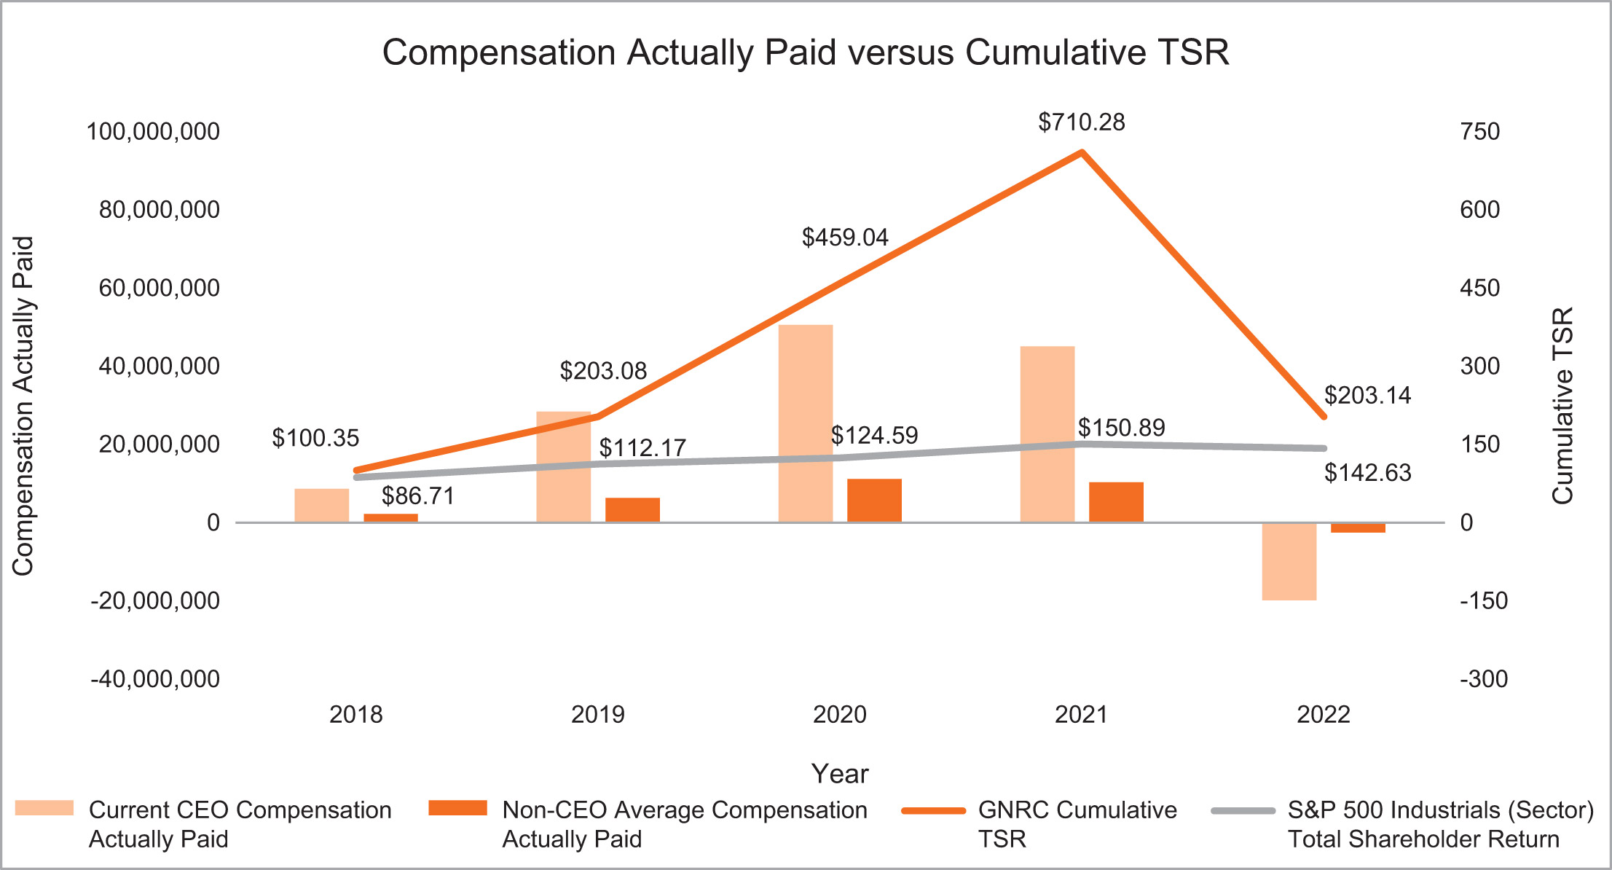
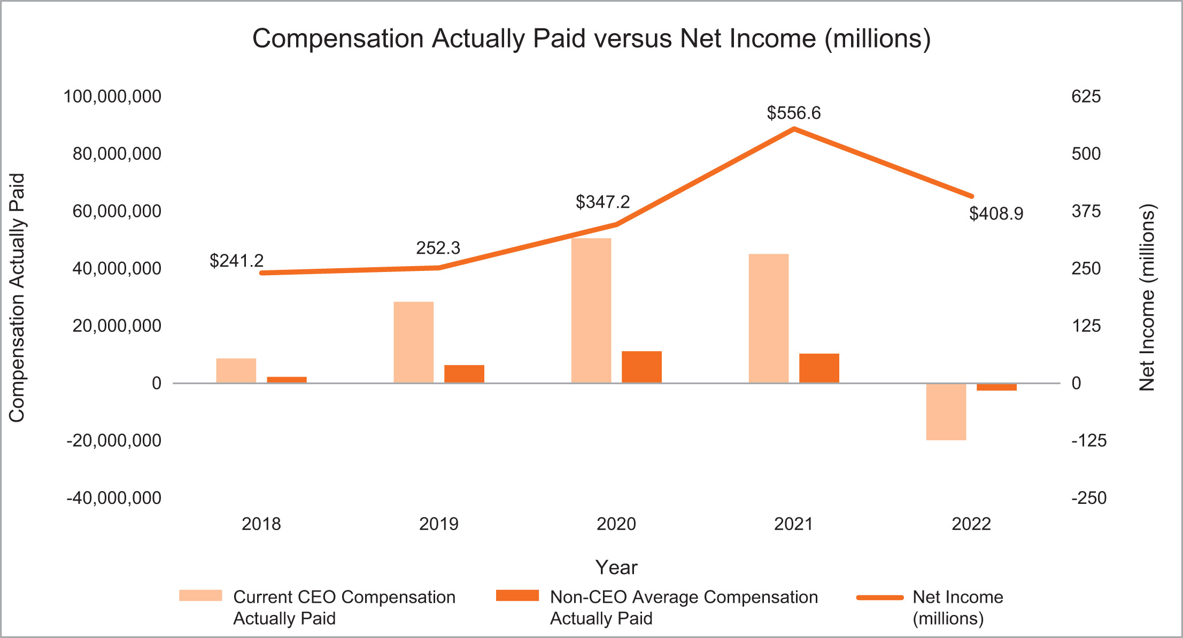

​ |  | ​ | ​ | 53 | ​ | ​ | 2023 Proxy Statement | ​

TABLE OF CONTENTS

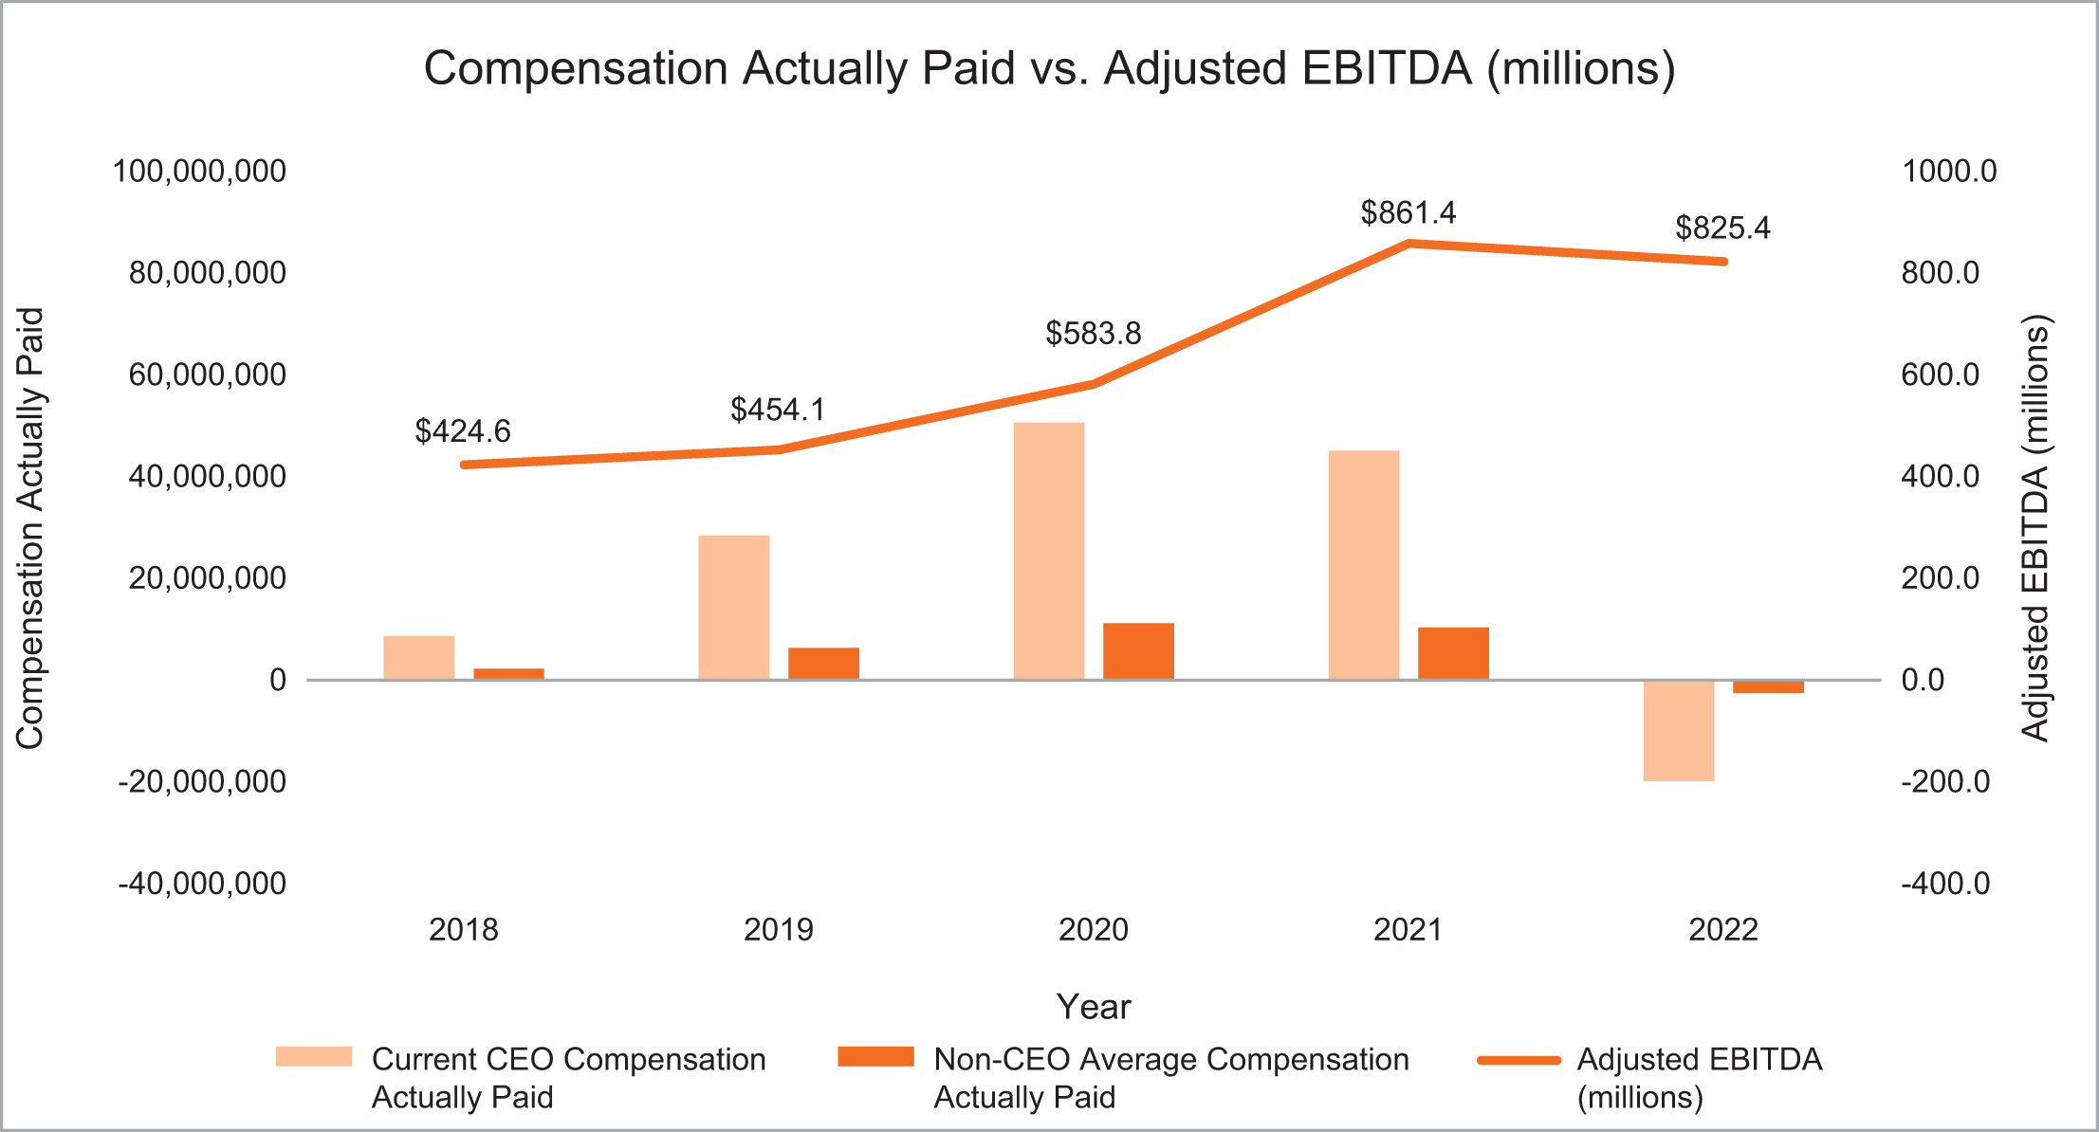
Pay Versus Performance Tabular List
We believe the following performance measures represent the most important financial performance measures used by us to link compensation actually paid to our NEOs for the fiscal year ended December 31, 2022:
​ | Financial Performance Measures Linked to the Compensation of Named Executive Officers | ​
​ | Adjusted EBITDA | ​
​ | Primary Working Capital (“PWC”) as a Percent of Net Sales | ​
​ | Annual Revenue Growth Rate (“CAGR”) | ​
​ | Adjusted EBITDA Margin Percentage | ​
​ | Free Cash Flow (“FCF”) | ​
The Compensation Discussion and Analysis provides a further description of how these metrics are defined and used in the Company’s executive compensation program.

​ |  | ​ | ​ | 54 | ​ | ​ | 2023 Proxy Statement | ​

TABLE OF CONTENTS​
2022 Director Compensation
Non-employee directors are paid in accordance with the Company’s Non-Employee Director Compensation Policy, as amended. The following table shows compensation information for 2022 for our Board of Directors.
​ | Name | ​ | ​ | Fees earned  ($) |  |  |  | ​ | ​ | Stock awards  ($)(1)(2) |  |  |  | ​ | ​ | Total  ($) |  |  |  | ​
​ | Marcia Avedon | ​ | ​ | ​ | ​ | — | ​ | ​ | ​ | ​ | ​ | 240,212 | ​ | ​ | ​ | ​ | ​ | 240,212 | ​ | ​
​ | John Bowlin | ​ | ​ | ​ | ​ | — | ​ | ​ | ​ | ​ | ​ | 230,473 | ​ | ​ | ​ | ​ | ​ | 230,473 | ​ | ​
​ | Robert Dixon | ​ | ​ | ​ | ​ | 105,000 | ​ | ​ | ​ | ​ | ​ | 135,075 | ​ | ​ | ​ | ​ | ​ | 240,075 | ​ | ​
​ | William Jenkins | ​ | ​ | ​ | ​ | 45,000 | ​ | ​ | ​ | ​ | ​ | 180,331 | ​ | ​ | ​ | ​ | ​ | 225,331 | ​ | ​
​ | Andrew Lampereur | ​ | ​ | ​ | ​ | — | ​ | ​ | ​ | ​ | ​ | 250,317 | ​ | ​ | ​ | ​ | ​ | 250,317 | ​ | ​
​ | Bennett Morgan | ​ | ​ | ​ | ​ | — | ​ | ​ | ​ | ​ | ​ | 255,208 | ​ | ​ | ​ | ​ | ​ | 255,208 | ​ | ​
​ | David Ramon | ​ | ​ | ​ | ​ | 90,000 | ​ | ​ | ​ | ​ | ​ | 135,075 | ​ | ​ | ​ | ​ | ​ | 225,075 | ​ | ​
​ | Kathryn Roedel | ​ | ​ | ​ | ​ | 90,000 | ​ | ​ | ​ | ​ | ​ | 135,075 | ​ | ​ | ​ | ​ | ​ | 225,075 | ​ | ​
​ | Dominick Zarcone | ​ | ​ | ​ | ​ | — | ​ | ​ | ​ | ​ | ​ | 225,360 | ​ | ​ | ​ | ​ | ​ | 225,360 | ​ | ​
​ | Nam Nguyen | ​ | ​ | ​ | ​ | 90,000 | ​ | ​ | ​ | ​ | ​ | 135,075 | ​ | ​ | ​ | ​ | ​ | 225,075 | ​ | ​
​
Represents shares received in connection with annual equity grants and, if elected in lieu of cash by the non-employee director, quarterly retainer fees. The amounts indicated represent the aggregate grant date fair value for awards of stock (including Deferred Stock Units), computed in accordance with Financial Accounting Standards Board Accounting Standards Codification Subtopic 718. See Note 17 to the Consolidated Financial Statements included in our Annual Report on Form 10-K for the year ended December 31, 2022 for a discussion of the relevant assumptions used in calculating these amounts.
(1)
​
As of December 31, 2022, each individual who served as a non-employee director during 2022 had outstanding the following number of stock awards, all of which consist of Deferred Stock Units issued pursuant to the Company’s Deferred Stock Unit Plan for Non-Employee Directors:
(2)
​
​ | Name | ​ | ​ | Stock awards  (#) |  |  |  | ​
​ | Marcia Avedon | ​ | ​ | ​ | ​ | — | ​ | ​
​ | John Bowlin | ​ | ​ | ​ | ​ | — | ​ | ​
​ | Robert Dixon | ​ | ​ | ​ | ​ | 8,188 | ​ | ​
​ | William Jenkins | ​ | ​ | ​ | ​ | 1,417 | ​ | ​
​ | Andrew Lampereur | ​ | ​ | ​ | ​ | 14,833 | ​ | ​
​ | Bennett Morgan | ​ | ​ | ​ | ​ | 12,208 | ​ | ​
​ | David Ramon | ​ | ​ | ​ | ​ | 4,231 | ​ | ​
​ | Kathryn Roedel | ​ | ​ | ​ | ​ | 9,604 | ​ | ​
​ | Dominick Zarcone | ​ | ​ | ​ | ​ | 10,356 | ​ | ​
​ | Nam Nguyen | ​ | ​ | ​ | ​ | — | ​ | ​
Non-Employee Director Pay
Non-employee directors receive an annual cash retainer of $90,000 and an annual equity grant valued at $135,000. The additional annual retainer paid to the Chair of the Audit Committee is

​ |  | ​ | ​ | 55 | ​ | ​ | 2023 Proxy Statement | ​

TABLE OF CONTENTS
2022 Director Compensation
$25,000, the additional annual retainer paid to the Chair of the Human Capital and Compensation Committee is $20,000, and the additional annual retainer paid to the Chair of the Nominating and Corporate Governance Committee is $15,000. The annual equity grant is made in the form of fully vested shares of our common stock; however, any director who has met the minimum stock ownership requirement may elect to receive the value of the annual equity grant in cash. None of the directors elected this for 2022. Our non-employee directors are reimbursed for out-of-pocket expenses incurred in connection with rendering board services.
In September 2022, the Human Capital and Compensation Committee reviewed a competitive assessment of its non-employee director compensation program with the assistance of Willis Towers Watson. Based on that assessment, the Human Capital and Compensation Committee determined that no changes were to be made for 2023. The non-employee Director Pay remains the same as shown in the table below.
​ | ​ | ​ | ​ | Annual  Retainers |  |  |  | ​
​ | Board Compensation | ​ | ​ | ​ | ​ | ​ | ​ | ​
​ | Annual Retainer | ​ | ​ | ​ | $ | 90,000 | ​ | ​
​ | Annual Equity Grant | ​ | ​ | ​ | $ | 135,000 | ​ | ​
​ | Additional Board Leadership Retainers | ​ | ​ | ​ | ​ | ​ | ​ | ​
​ | Lead Director | ​ | ​ | ​ | $ | 30,000 | ​ | ​
​ | Audit Committee Chair | ​ | ​ | ​ | $ | 25,000 | ​ | ​
​ | Human Capital and Compensation Committee Chair | ​ | ​ | ​ | $ | 20,000 | ​ | ​
​ | Nominating and Corporate Governance Committee Chair | ​ | ​ | ​ | $ | 15,000 | ​ | ​
2022 Equity Compensation Plan Information at Fiscal Year-End
​ | Plan Category | ​ | ​ | Number of  securities to be  issued upon  exercise of  outstanding  options,  warrants and rights  (a) |  |  |  | ​ | ​ | Weighted average  exercise price of  outstanding  options,  warrants and rights  (b) |  |  |  | ​ | ​ | Number of  securities  remaining available  for future issuance  under equity  compensation plans  (excluding  securities reflected  in column (a))  (c) |  |  |  | ​
​ | Equity compensation plans  approved by security holders | ​ | ​ | ​ | ​ | 1,394,946 | ​ | ​ | ​ | ​ | $ | 81.35 | ​ | ​ | ​ | ​ | ​ | 1,743,847 | ​ | ​
​ | Equity compensation plans not  approved by security holders(1) | ​ | ​ | ​ | ​ | — | ​ | ​ | ​ | ​ | ​ | — | ​ | ​ | ​ | ​ | ​ | — | ​ | ​
​
Not applicable. There were no equity compensation plans not approved by the security holders.
(1)
​

​ |  | ​ | ​ | 56 | ​ | ​ | 2023 Proxy Statement | ​

TABLE OF CONTENTS​
Related Person Transactions
Policies for Approval of Related Person Transactions
We adopted a written policy relating to the approval of related person transactions. Our Audit Committee reviews and approves or ratifies all relationships and related person transactions between us and (1) our directors, director nominees, or executive officers, (2) any five percent record or beneficial owner of our common stock, or (3) any immediate family member of any person specified in (1) and (2) above. Our Chief Financial Officer is primarily responsible for the development and implementation of processes and controls to obtain information from our directors and executive officers with respect to related person transactions and for determining, based on the facts and circumstances, whether we or a related person have a direct or indirect material interest in the transaction.
As set forth in the Company’s related person transaction policy, in the course of its review and approval or ratification of a related party transaction, the Audit Committee will consider:
the nature of the related person’s interest in the transaction;
•
​
the availability of other sources of comparable products or services;
•
​
the material terms of the transaction, including, without limitation, the amount and type of transaction; and
•
​
the importance of the transaction to us.
•
​
Any member of the Audit Committee who is a related person with respect to a transaction under review will not be permitted to participate in the discussions or approval or ratification of the transaction. However, such member of the Audit Committee will provide all material information concerning the transaction to the Audit Committee.
There were no related person transactions required to be disclosed since January 1, 2022, and no such transactions are currently proposed.

​ |  | ​ | ​ | 57 | ​ | ​ | 2023 Proxy Statement | ​

TABLE OF CONTENTS​
Proposal 2 — Ratification of the Selection of Independent Registered Public Accounting Firm
The Board of Directors recommends that the stockholders ratify the selection of Deloitte & Touche LLP as our independent registered public accounting firm for the year ending December 31, 2023.
A representative of Deloitte & Touche LLP will attend the annual meeting, will have an opportunity to make a statement if such representative desires to do so, and will be available to respond to appropriate questions.
Although the Company is not required to seek stockholder approval of this appointment, the Board of Directors believes that doing so is consistent with good corporate governance practices. If the appointment is not ratified, the Audit Committee will explore the reasons for stockholder rejection and will reconsider the appointment.
​

​ | ​ | The Board of Directors unanimously recommends a vote FOR ratification of the selection of Deloitte & Touche LLP as our independent registered public accounting firm. | ​ | ​

Principal Accounting Fees and Services
Deloitte & Touche LLP (“Deloitte & Touche”) audited our financial statements for the years ended December 31, 2022, 2021, and 2020 and currently serves as our independent registered public accounting firm. The following table presents fees paid for the audit of our annual consolidated financial statements and all other professional services for each of the last two years:
​ | ​ | ​ | ​ | For the Years Ended  December 31, |  |  |  |  |  |  |  |  |  | ​
​ | ​ | ​ | ​ | 2021 |  |  |  | ​ | ​ | 2022 |  |  |  | ​
​ | Audit fees(1) | ​ | ​ | ​ | $ | 1,727,000 | ​ | ​ | ​ | ​ | $ | 1,919,000 | ​ | ​
​ | Audit related fees(2) | ​ | ​ | ​ | $ | 103,000 | ​ | ​ | ​ | ​ | $ | 99,000 | ​ | ​
​ | Tax fees(3) | ​ | ​ | ​ | $ | 825,000 | ​ | ​ | ​ | ​ | $ | 948,000 | ​ | ​
​ | All other fees(4) | ​ | ​ | ​ | $ | 3,000 | ​ | ​ | ​ | ​ | $ | 3,000 | ​ | ​
​ | Total Fees | ​ | ​ | ​ | $ | 2,658,000 | ​ | ​ | ​ | ​ | $ | 2,969,000 | ​ | ​
​
Audit fees include amounts for the annual audit of our consolidated financial statements and internal control over financial reporting, statutory audits at certain foreign subsidiaries, and the reviews of the consolidated financial statements included in our Quarterly Reports on Form 10-Q.
(1)
​
Audit related fees represent amounts reasonably related to the performance of the audit or review of the consolidated financial statements that are not reported under the Audit Fees category such as attestation services requested by management.
(2)
​

​ |  | ​ | ​ | 58 | ​ | ​ | 2023 Proxy Statement | ​

TABLE OF CONTENTS

Tax fees were primarily related to tax planning and compliance services, including assistance related to certain foreign subsidiaries. The increase in 2022 is primarily related to tax planning and compliance at recently acquired subsidiaries.
(3)
​
All other fees are licensing fees for technical research tools.
(4)
​
The services provided by Deloitte & Touche were preapproved by the Audit Committee. The Audit Committee has considered whether the provision of the above noted services is compatible with maintaining the independence of the independent registered public accounting firm and has determined, based on advice from Deloitte & Touche, that the provision of such services has not adversely affected Deloitte & Touche’s independence.
According to its charter, the Audit Committee is responsible for approving all audit engagement fees, terms, and non-audit engagements with the independent auditors on behalf of the Company in advance of providing any service.

​ |  | ​ | ​ | 59 | ​ | ​ | 2023 Proxy Statement | ​

TABLE OF CONTENTS​

Proposal 3 — Advisory Approval of Executive Compensation
As required by Regulation 14A of the Exchange Act, we are offering our stockholders an opportunity to cast an advisory vote on the compensation of our named executive officers, as disclosed in this proxy statement. Although the vote is non-binding, we value continuing and constructive feedback from our stockholders on compensation and other important matters. The Board and the Human Capital and Compensation Committee will consider the voting results when making future compensation decisions.
At the 2022 Annual Meeting of Stockholders, we provided our stockholders with the opportunity to cast an advisory vote on the compensation of our named executive officers as disclosed in the proxy statement for the 2022 Annual Meeting, and our stockholders overwhelmingly approved the proposal, with nearly 92% of the votes cast in favor.
As described in the “Compensation Discussion and Analysis” section of this proxy statement, we believe that our executive compensation program enables us to attract, retain, and motivate a high-performance executive management team that improves our fundamental financial performance and provides value to the long-term interests of Generac and its stockholders.
We ask for your advisory vote on the following resolution:
“RESOLVED, that the stockholders hereby approve the compensation of Generac’s named executive officers, as described in this proxy statement pursuant to the compensation disclosure rules of the Securities and Exchange Commission.”
•
​
​

​ | ​ | The Board of Directors unanimously recommends a vote “FOR” approval of the compensation of our executive officers. | ​ | ​

​ |  | ​ | ​ | 60 | ​ | ​ | 2023 Proxy Statement | ​

TABLE OF CONTENTS​

Proposal 4 — Advisory Approval of the Frequency of Future Votes on Executive Compensation
As required by Section 14A of the Securities Exchange Act of 1934, we are offering our stockholders an opportunity to cast an advisory vote on the frequency with which the Company’s stockholders will vote to approve the compensation of our named executive officers. The Dodd-Frank Act requires that stockholders have such opportunity to vote on the frequency of say-on-pay votes once every six years. When we last held the advisory vote at the 2017 annual meeting of stockholders, stockholders voted for every one year as the frequency of future advisory votes to approve executive compensation, and the Board implemented this standard.
The Board has determined that an advisory vote on executive compensation every year is the best approach for the Company based on a number of considerations, including the vote frequency which the Board believes the majority of our investors prefer.
Although the vote is non-binding, we value continuing and constructive feedback from our stockholders on compensation and other important matters. The Board and the Human Capital and Compensation Committee will take into consideration the voting results when determining how often a non-binding stockholder advisory vote on the compensation of our named executive officers should occur.
For the reasons discussed above, we are asking our stockholders to indicate their support for the non-binding advisory vote on executive compensation to be held every one year. However, stockholders are not voting to approve or disapprove of the Board's recommendation. Instead, stockholders may vote to hold the advisory vote every one year, two years, or three years. Stockholders may also abstain from voting on the proposal.
The frequency option (every 1 Year, 2 Years or 3 Years) that receives the highest number of votes cast will be deemed the choice of the stockholders.
​

​ | ​ | The Board of Directors unanimously recommends a vote of “1 Year” as the frequency of future advisory votes on executive compensation. | ​ | ​

​ |  | ​ | ​ | 61 | ​ | ​ | 2023 Proxy Statement | ​

TABLE OF CONTENTS​

Report of the Audit Committee
The Audit Committee represents and assists the Board in fulfilling its oversight responsibility relating to (i) the integrity of the Company’s financial statements and financial reporting process and the Company’s systems of internal accounting and financial controls; (ii) the performance of the internal audit services function; (iii) the annual independent audits of the Company’s financial statements and management’s report regarding the effectiveness of the Company’s system of internal control over financial reporting, the engagement of the independent auditors and the evaluation of the independent auditors’ qualifications, independence and performance; (iv) the compliance by the Company with legal and regulatory requirements, including the Company’s disclosure controls and procedures; (v) the evaluation of enterprise risk issues; and (vi) the fulfillment of the other responsibilities set out in the Audit Committee’s charter. The Audit Committee has the responsibility for the engagement and retention of the Company’s independent registered public accounting firm and the approval of all audit and other engagement fees.
In discharging its responsibilities, the Audit Committee is not itself responsible for the planning or conducting of audits or for any determination that the Company’s financial statements are complete and accurate or in accordance with generally accepted accounting principles. The Company’s management is primarily responsible for its financial statements and the quality and integrity of the reporting process. The independent registered public accounting firm Deloitte & Touche LLP (“Deloitte & Touche”) is responsible for auditing those financial statements in accordance with accounting principles generally accepted in the United States of America.
In fulfilling its oversight responsibilities, the Audit Committee has reviewed and discussed the audited consolidated financial statements for the year ended December 31, 2022, management’s report of the effectiveness of the Company’s system of internal control over financial reporting, and Deloitte & Touche’s report of the effectiveness of the Company’s system of internal control over financial reporting with the Company’s management and representatives of the independent registered public accounting firm. The Audit Committee discussed with the independent registered public accounting firm the matters required to be discussed by the applicable requirements of the Public Company Accounting Oversight Board (“PCAOB”) and the SEC. In addition, the Audit Committee has received the written disclosures and the letter from the independent registered public accounting firm required by applicable requirements of the PCAOB regarding the independent registered public accounting firm’s communications with the Audit Committee concerning independence and has discussed with the independent registered public accounting firm its independence.
In reliance on its review of the audited consolidated financial statements, the review of the report of management on the effectiveness of the Company’s internal control over financial reporting and Deloitte & Touche’s report thereon, the discussions referred to above and the receipt of the written disclosures referred to above, the Audit Committee has recommended to the Board of Directors that the audited consolidated financial statements be included in the Company’s Annual Report on Form 10-K for the year ended December 31, 2022, for filing with the SEC.
Respectfully submitted by the Audit Committee of the Board of Directors on April 17, 2023.
Andrew Lampereur, Chair
Robert Dixon
David Ramon
Kathryn Roedel
Dominick Zarcone

​ |  | ​ | ​ | 62 | ​ | ​ | 2023 Proxy Statement | ​

TABLE OF CONTENTS​

Nominations and Proposals by Stockholders
Stockholder Proposals for Inclusion in Our Proxy Statement — Proposals that stockholders wish to submit for inclusion in our proxy statement for our 2024 annual meeting of stockholders pursuant to Rule 14a-8 under the Exchange Act must be received by us no later than December 30, 2023, unless the date of our 2024 annual meeting is more than 30 days before or after June 15, 2024, in which case the deadline will be a reasonable time before we begin to print and mail our proxy materials. Any stockholder proposal submitted for inclusion must be eligible for inclusion in our proxy statement in accordance with the rules and regulations promulgated by the SEC.
Proxy Access Nominations — In 2023, we adopted a proxy access Bylaw that permits a stockholder or group of up to 20 stockholders owning at least 3% of our outstanding common stock continuously for at least the previous three years to nominate up to the greater of two individuals or 20% of the Board of Directors. Requests to include stockholder-nominated candidates in our proxy statement for our 2024 annual meeting of stockholders must be received by us no earlier than November 30, 2023 and no later than December 30, 2023. Each nominee must meet the qualifications required by our Bylaws, and the nominating stockholder or group of stockholders must provide certain information and meet the other specific requirements of our Bylaws.
Stockholder Nominations and Proposals Other than for Inclusion in Our Proxy Statement — With respect to nominations or proposals submitted by a stockholder other than for inclusion in our proxy statement for our 2024 annual meeting of stockholders, timely notice of any stockholder proposal must be received by us in accordance with our Bylaws no later than the close of business on March 17, 2024 nor earlier than the close of business on February 16, 2024, unless the date of our 2024 annual meeting is more than 30 days before or 60 days after June 15, 2024, in which case notice by the stockholder to be timely must be so delivered not earlier than the close of business on the 120th day prior to such annual meeting and not later than the close of business on the later of the 90th day prior to the date of such annual meeting or, if the first public announcement of the date of such annual meeting is less than 100 days prior to the date of such annual meeting, the 10th day following the day on which public announcement of the date of such meeting is first made. The notice must contain the information required by our Bylaws. A stockholder nomination must be accompanied by the information required by the Bylaws with respect to a stockholder director nominee. We may require any proposed nominee to furnish other information as we may reasonably require to determine the eligibility of the proposed nominee to serve as a director of the Company.
In addition to satisfying the foregoing requirements, to comply with the universal proxy rules, stockholders who intend to solicit proxies in support of director nominees other than the Board of Directors’ nominees must provide notice that sets forth the information required by Rule 14a-19 under the Exchange Act no later than April 16, 2024.
Address for Notices — In the case of any notice of a nomination or proposal submitted in accordance with the procedures above, the notice must be received by us at S45 W29290 Hwy. 59, Waukesha, WI 53189, attention of Raj Kanuru, Executive Vice President, General Counsel, and Secretary.

​ |  | ​ | ​ | 63 | ​ | ​ | 2023 Proxy Statement | ​

TABLE OF CONTENTS​
Information Concerning Solicitation and Voting
The Board of the Company is soliciting your proxy to be voted at the Annual Meeting of Stockholders to be held on Thursday, June 15, 2023, at 9:00 a.m. local time, at Generac’s headquarters located at S45 W29290 Highway 59 Waukesha, Wisconsin 53189, and any postponement or adjournment thereof.
Record Date; Stock Outstanding and Entitled to Vote
Holders of common stock as of the record date, April 17, 2023, are entitled to notice of, and to vote at, the annual meeting. As of the record date, there were 62,405,951 shares of common stock outstanding and entitled to vote at the annual meeting, with each share entitled to one vote.
If you are a stockholder of record, you will need to present the Notice of Internet Availability or proxy card that you received, together with a form of personal photo identification, in order to be admitted into the meeting. If you are the beneficial owner of shares held in “street name,” you will need to provide proof of ownership, such as a recent account statement or letter from your bank, broker, or other nominee as of the close of business on April 17, 2023, along with a form of personal photo identification. Alternatively, you may contact the broker, bank, or other nominee in whose name your shares of common stock are registered and obtain a legal proxy to bring to the meeting. Audio or visual recording of any portion of the annual meeting is not permitted. No cameras, recording equipment, large bags, briefcases, or packages will be allowed in the meeting or adjacent areas. All other items may be subject to search.

​ |  | ​ | ​ | 64 | ​ | ​ | 2023 Proxy Statement | ​

TABLE OF CONTENTS
INFORMATION CONCERNING SOLICITATION AND VOTING
Information About This Proxy Statement
Why you received a Notice of Internet Availability. We are mailing only a Notice of Internet Availability to all stockholders. The Notice of Internet Availability includes information on where to view all proxy materials online, as well as voting instructions. These materials have been made available to you on the internet because our Board of Directors is soliciting your proxy to vote your shares at the annual meeting and any postponement or adjournment thereof. This proxy statement includes information that we are required to provide to you under the rules of the SEC and that is designed to assist you in voting your shares. If you own our common stock in more than one account, such as individually and also jointly with your spouse, you may receive more than one Notice of Internet Availability relating to these proxy materials. To assist us in saving money and to serve you more efficiently, we encourage you to have all your accounts registered in the same name and address by contacting our transfer agent:
Computershare, Inc.
P.O. Box 43006
Providence, RI 02940-3006
United States of America
By Overnight Delivery:
Computershare, Inc.
250 Royall Street
Canton, MA 02021
United States of America
Toll Free — 877-373-6374
U.S. — 800-962-4284
Householding. The SEC’s rules permit us to deliver a single Notice of Internet Availability or set of annual meeting materials to one address shared by two or more of our stockholders. This delivery method is referred to as “householding” and can result in significant cost savings. To take advantage of this opportunity, we have delivered only one Notice of Internet Availability to multiple stockholders who share an address, unless we received contrary instructions from the impacted stockholders prior to the mailing date. We agree to deliver promptly, upon written or oral request, a separate Notice of Internet Availability to any stockholder at the shared address to which a single copy of the Notice of Internet Availability was delivered. If you are a record holder and if you prefer to receive separate copies of the proxy materials, or if you currently receive multiple copies and prefer to receive a single copy, please contact Raj Kanuru, Executive Vice President, General Counsel, and Secretary, Generac Holdings Inc., S45 W29290 Highway 59, Waukesha, Wisconsin 53189, or by telephone at (262) 544-4811.

​ |  | ​ | ​ | 65 | ​ | ​ | 2023 Proxy Statement | ​

TABLE OF CONTENTS
INFORMATION CONCERNING SOLICITATION AND VOTING
Voting by and Revocation of Proxies
Stockholders of record are requested to vote by proxy in one of the following ways:
By telephone — Use the toll-free telephone number shown on the Notice of Internet Availability or any proxy card you receive;
•
​
By internet — Visit the internet website indicated on the Notice of Internet Availability or any proxy card you receive and follow the on-screen instructions;
•
​
By mail — If you request a paper proxy card by telephone or internet, you may elect to vote by mail. If you elect to do so, you should date, sign, and promptly return your proxy card by mail in the postage prepaid envelope which accompanied that proxy card; or
•
​
In person — You can deliver a completed proxy card at the meeting or vote in person.
•
​
Voting instructions (including instructions for both telephonic and internet proxies) are provided on the Notice of Internet Availability and on any proxy card you receive. The internet and telephone proxy procedures are designed to authenticate stockholder identities, to allow stockholders to give voting instructions and to confirm that stockholders’ instructions have been recorded properly. A control number, located on the Notice of Internet Availability or proxy card, will identify stockholders and allow them to submit their proxies and confirm that their voting instructions have been properly recorded. Costs associated with electronic access, such as usage charges from internet access providers and telephone companies, must be borne by the stockholder. If you submit your proxy by internet or telephone, it will not be necessary to return a proxy card for your vote to be counted.
If a stockholder does not submit a proxy by the internet or by telephone or return a signed proxy card, and does not attend the meeting and vote in person, his or her shares will not be voted. Shares of our common stock represented by properly executed proxies received by us or proxies submitted by telephone or via the internet, which are not revoked, will be voted at the meeting in accordance with the instructions contained therein.
If instructions are not given and you do not indicate how your shares should be voted on a proposal, the shares represented by a properly completed proxy will be voted as the Board recommends. In addition, we reserve the right to exercise discretionary authority to vote proxies, in the manner determined by the Board in its sole discretion, on any matters brought before the Annual Meeting for which we did not receive adequate notice under the proxy rules promulgated by the SEC.
Any proxy signed and returned by a stockholder or submitted by telephone or via the internet may be revoked at any time before it is exercised by giving written notice of revocation to the Company’s Secretary at our address set forth herein, by executing and delivering a later-dated proxy (either in writing, by telephone or via the internet) or by voting in person at the meeting. Attendance at the meeting will not, in and of itself, constitute revocation of a proxy.
If your shares are held in the name of a bank, broker, fiduciary or custodian, follow the voting instructions on the form you receive from your record holder. The availability of internet and telephone proxies for these stockholders will depend on their voting procedures.
Quorum
The presence at the annual meeting, in person or by proxy, of the holders of at least a majority of the number of shares of common stock issued and outstanding and entitled to vote as of the record date, is required to constitute a quorum to transact business at the annual meeting. Abstentions and broker non-votes will be counted toward the establishment of a quorum.

​ |  | ​ | ​ | 66 | ​ | ​ | 2023 Proxy Statement | ​

TABLE OF CONTENTS
INFORMATION CONCERNING SOLICITATION AND VOTING
Required Votes
Election of Three Nominees Named Herein as Class II Directors. Under our Amended and Restated Bylaws (the “Bylaws”), the affirmative vote of a plurality of shares of common stock voting on this matter at the Annual Meeting is required to elect each nominee named herein as a director. Consequently, only shares that are voted in favor of a particular nominee will be counted toward such nominee’s achievement of a plurality. Notwithstanding the foregoing, if a nominee for Director receives more “against” votes for his or her election than votes “for” his or her election in an uncontested election at a meeting of stockholders, without regard for abstentions, the Director shall, in accordance with and subject to our Corporate Governance Guidelines and Principles, promptly tender his or her resignation to the Board.
Ratification of the selection of Deloitte & Touche LLP as our Independent Registered Public Accounting Firm. Proposal 2, relating to the ratification of the selection of Deloitte & Touche LLP as our independent registered public accounting firm for 2023, will be approved if it receives the affirmative vote of a majority of the shares of common stock present in person or represented by proxy at the Annual Meeting and voting on the proposal.
Approval of Non-Binding “Say-on-Pay” Resolution Regarding Executive Compensation. Proposal 3, relating to the non-binding resolution to approve our executive compensation, will be approved if it receives the affirmative vote of a majority of the shares of common stock present in person or represented by proxy at the Annual Meeting and voting on the proposal.
Approval of the Frequency of the Vote on Executive Compensation. Proposal 4, relating to the non-binding advisory vote on the frequency of future advisory votes on executive compensation, allows stockholders to choose among the frequency options of holding this advisory vote every one year, two years, or three years, or to abstain from voting. The frequency option receiving the highest number of votes will be considered as the stockholders’ preferred frequency for future “say-on-pay” votes.
Impact of Abstentions. Abstentions will have no effect on the determination of the election of directors or the approval of any proposal.
Shares Held by Brokers
If you are the beneficial owner of shares held for you by a broker, your broker must vote those shares in accordance with your instructions. If you do not give voting instructions to your broker, your broker may vote your shares for you on any discretionary items of business to be voted upon at the annual meeting. If you do not provide voting instructions on a nondiscretionary item, including the election of the nominees named herein as directors, the shares will be treated as “broker non-votes.” We believe that the ratification of the appointment of Deloitte & Touche LLP (Proposal 2) is a routine matter on which brokers will generally be permitted to vote any unvoted shares in their discretion. We believe that election of the three nominees named herein as Class II directors (Proposal 1), the advisory, non-binding approval of executive compensation (Proposal 3), and the advisory, non-binding approval of the frequency of future votes on executive compensation (Proposal 4) are non-routine matters on which brokers will not be permitted to vote any unvoted shares. “Broker non-votes” will be included in determining the presence of a quorum at the annual meeting, but will have no effect on the outcome of any proposal.
Proxy Solicitation
The Company will bear the costs of solicitation of proxies for the annual meeting, including preparation, assembly, printing and mailing of the Notice of Internet Availability, this proxy

​ |  | ​ | ​ | 67 | ​ | ​ | 2023 Proxy Statement | ​

TABLE OF CONTENTS
INFORMATION CONCERNING SOLICITATION AND VOTING
statement, the annual report, any proxy card and any additional information furnished to stockholders. Copies of our proxy statement will be furnished, upon request, to banks, brokerage houses, fiduciaries, and custodians holding shares of common stock beneficially owned by others to forward to such beneficial owners. We may reimburse persons representing beneficial owners of common stock for their costs of forwarding solicitation material to such beneficial owners. Solicitation of proxies by mail may be supplemented by telephone, email, or personal solicitation by Computershare or by directors, officers, or other regular employees of the Company. No additional compensation will be paid to directors, officers, or other regular employees for such services.
Other Business
The Board of Directors has no knowledge of any other matter to be submitted at the Annual Meeting of Stockholders. If any other matter shall properly come before the annual meeting, the persons named as proxies in the Notice of Internet Availability or on the proxy card will have discretionary authority to vote the shares thereby represented in accordance with their best judgment.
Annual Report and Company Information
Our Annual Report to Stockholders, which contains consolidated financial statements for the year ended December 31, 2022, is being furnished to stockholders concurrently herewith. You also may obtain a copy of our Annual Report on Form 10-K for the year ended December 31, 2022 that was filed with the SEC, without charge, by writing to Generac Holdings Inc., Attn: Investor Relations, S45 W29290 Hwy. 59, Waukesha, Wisconsin 53189. These materials will also be available without charge at “Investor Relations” on our website at www.generac.com.
It is important that your proxy be returned promptly, whether by mail, by the internet, or by telephone. The proxy may be revoked at any time by you before it is exercised. If you attend the meeting in person, you may withdraw any proxy (including an internet or telephonic proxy) and vote your own shares.
By Order of the Board of Directors,
Raj Kanuru
Executive Vice President, General Counsel, and Secretary

​ |  | ​ | ​ | 68 | ​ | ​ | 2023 Proxy Statement | ​

TABLE OF CONTENTS
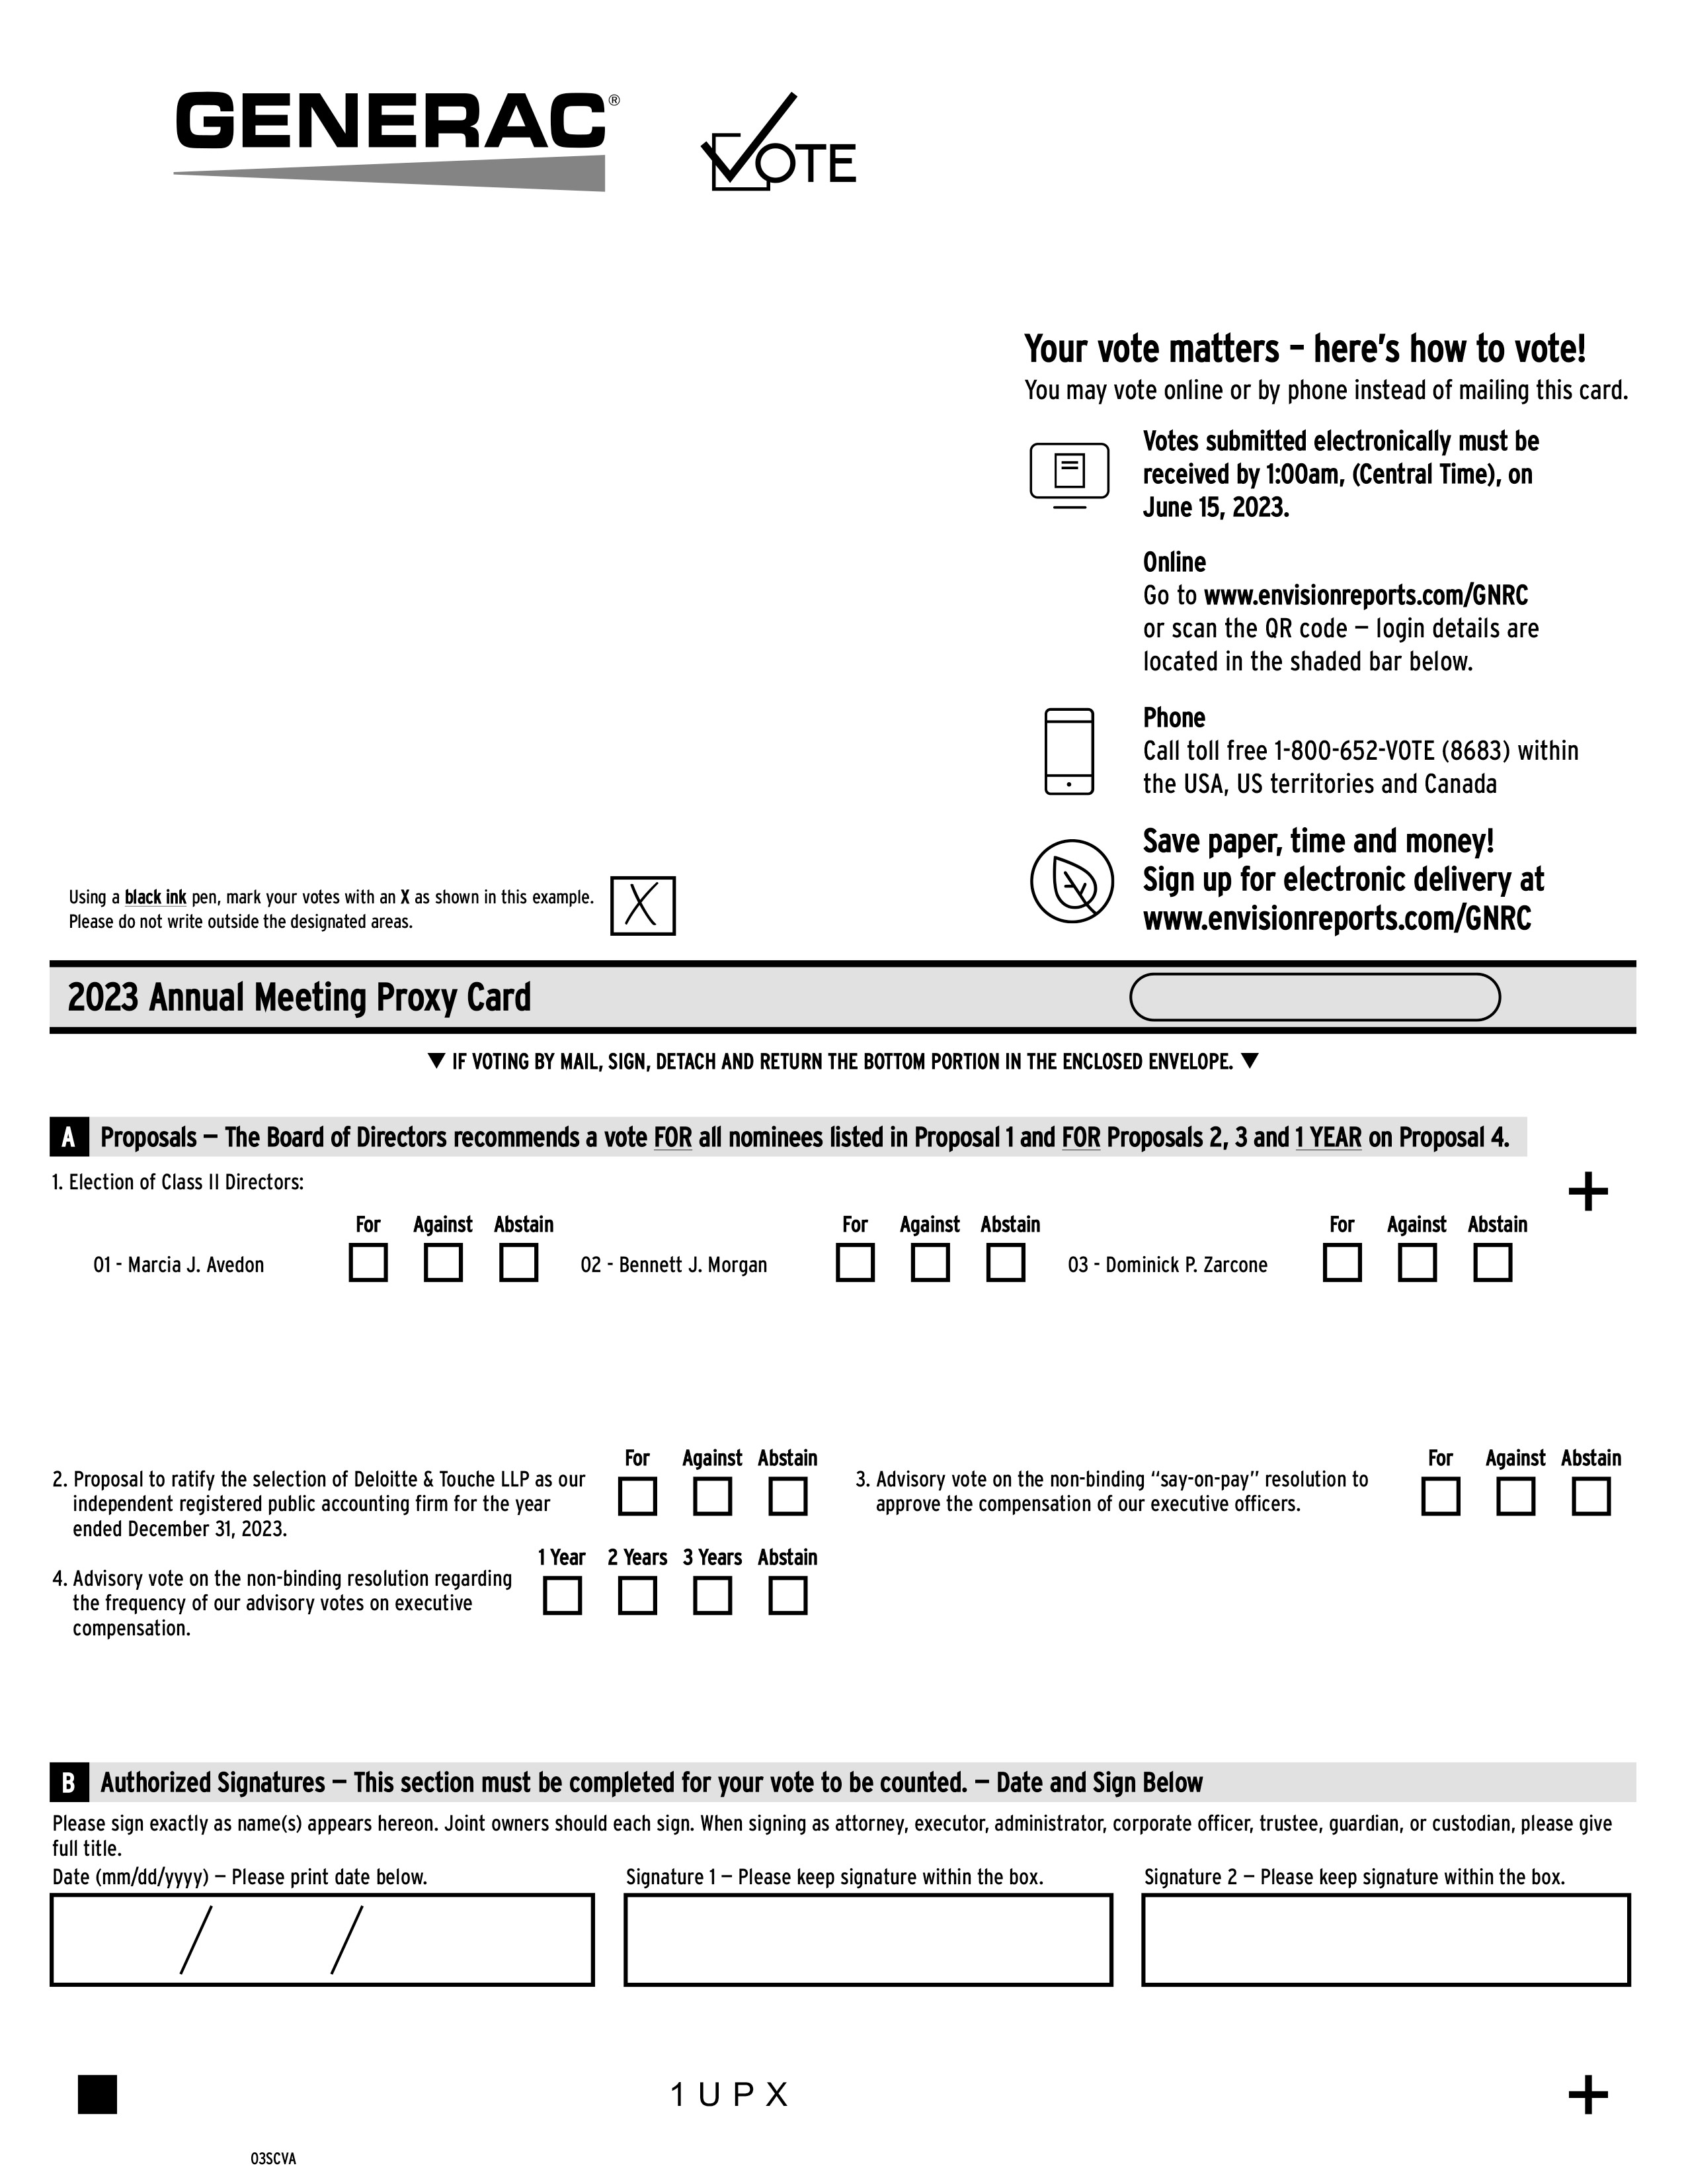
Using a black ink pen, mark your votes with an X as shown in this example. Please do not write outside the designated areas. Your vote matters — here’s how to vote! You may vote online or by phone instead of mailing this card. Votes submitted electronically must be received by 1:00am, (Central Time), on June 15, 2023. Online Go to www.envisionreports.com/GNRC or scan the QR code — login details are located in the shaded bar below. Phone Call toll free 1-800-652-VOTE (8683) within the USA, US territories and Canada Save paper, time and money! Sign up for electronic delivery at www.envisionreports.com/GNRC 2023 Annual Meeting Proxy Card 1. Election of Class II Directors: q IF VOTING BY MAIL, SIGN, DETACH AND RETURN THE BOTTOM PORTION IN THE ENCLOSED ENVELOPE. q A Proposals — The Board of Directors recommends a vote FOR all nominees listed in Proposal 1 and FOR Proposals 2, 3 and 1 YEAR on Proposal 4. For Against Abstain For Against Abstain For Against Abstain + 01 - Marcia J. Avedon 02 - Bennett J. Morgan 03 - Dominick P. Zarcone 2. Proposal to ratify the selection of Deloitte & Touche LLP as our independent registered public accounting firm for the year ended December 31, 2023. For Against Abstain 3. Advisory vote on the non-binding “say-on-pay” resolution to approve the compensation of our executive officers. For Against Abstain 4. Advisory vote on the non-binding resolution regarding the frequency of our advisory votes on executive compensation. 1 Year 2 Years 3 Years Abstain B Authorized Signatures — This section must be completed for your vote to be counted. — Date and Sign Below Please sign exactly as name(s) appears hereon. Joint owners should each sign. When signing as attorney, executor, administrator, corporate officer, trustee, guardian, or custodian, please give full title. Date (mm/dd/yyyy) — Please print date below. Signature 1 — Please keep signature within the box. Signature 2 — Please keep signature within the box. 03SCVA 1 U P X +

TABLE OF CONTENTS
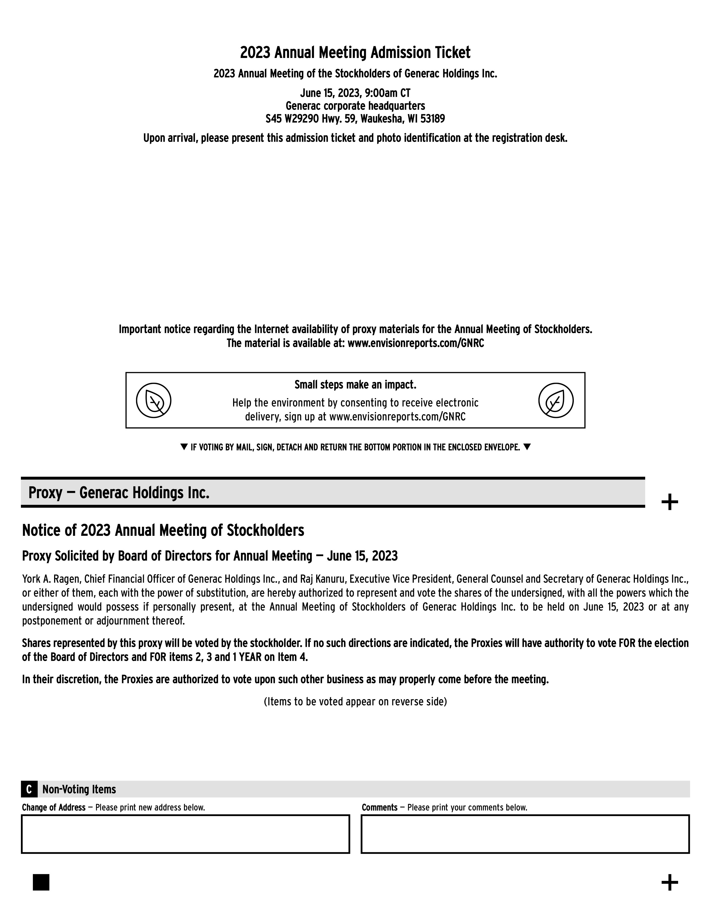
2023 Annual Meeting Admission Ticket 2023 Annual Meeting of the Stockholders of Generac Holdings Inc. June 15, 2023, 9:00am CT Generac corporate headquarters S45 W29290 Hwy. 59, Waukesha, WI 53189 Upon arrival, please present this admission ticket and photo identification at the registration desk. Important notice regarding the Internet availability of proxy materials for the Annual Meeting of Stockholders. The material is available at: www.envisionreports.com/GNRC Small steps make an impact. Help the environment by consenting to receive electronic delivery, sign up at www.envisionreports.com/GNRC q IF VOTING BY MAIL, SIGN, DETACH AND RETURN THE BOTTOM PORTION IN THE ENCLOSED ENVELOPE. q Proxy — Generac Holdings Inc. + Notice of 2023 Annual Meeting of Stockholders Proxy Solicited by Board of Directors for Annual Meeting — June 15, 2023 York A. Ragen, Chief Financial Officer of Generac Holdings Inc., and Raj Kanuru, Executive Vice President, General Counsel and Secretary of Generac Holdings Inc., or either of them, each with the power of substitution, are hereby authorized to represent and vote the shares of the undersigned, with all the powers which the undersigned would possess if personally present, at the Annual Meeting of Stockholders of Generac Holdings Inc. to be held on June 15, 2023 or at any postponement or adjournment thereof. Shares represented by this proxy will be voted by the stockholder. If no such directions are indicated, the Proxies will have authority to vote FOR the election of the Board of Directors and FOR items 2, 3 and 1 YEAR on Item 4. In their discretion, the Proxies are authorized to vote upon such other business as may properly come before the meeting. (Items to be voted appear on reverse side) Non-Voting Items C Change of Address — Please print new address below. Comments — Please print your comments below. +

TABLE OF CONTENTS
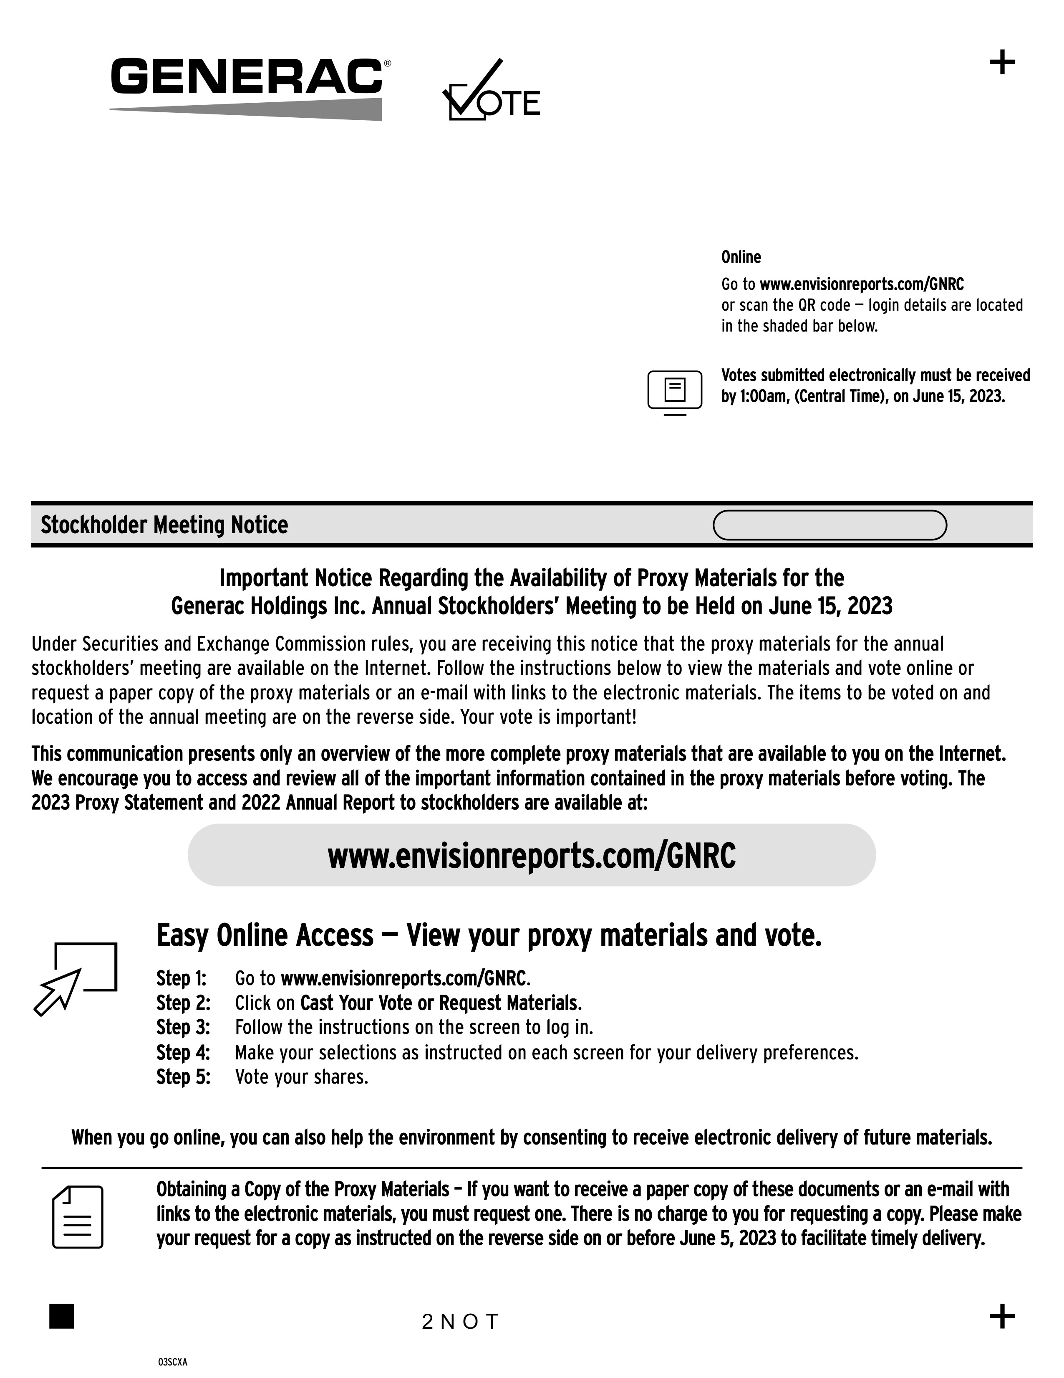
+ Online Go to www.envisionreports.com/GNRC or scan the QR code — login details are located in the shaded bar below. Votes submitted electronically must be received by 1:00am, (Central Time), on June 15, 2023. Stockholder Meeting Notice Important Notice Regarding the Availability of Proxy Materials for the Generac Holdings Inc. Annual Stockholders’ Meeting to be Held on June 15, 2023 Under Securities and Exchange Commission rules, you are receiving this notice that the proxy materials for the annual stockholders’ meeting are available on the Internet. Follow the instructions below to view the materials and vote online or request a paper copy of the proxy materials or an e-mail with links to the electronic materials. The items to be voted on and location of the annual meeting are on the reverse side. Your vote is important! www.envisionreports.com/GNRC This communication presents only an overview of the more complete proxy materials that are available to you on the Internet. We encourage you to access and review all of the important information contained in the proxy materials before voting. The 2023 Proxy Statement and 2022 Annual Report to stockholders are available at: Easy Online Access — View your proxy materials and vote. Step 1: Go to www.envisionreports.com/GNRC. Step 2: Click on Cast Your Vote or Request Materials. Step 3: Follow the instructions on the screen to log in. Step 4: Make your selections as instructed on each screen for your delivery preferences. Step 5: Vote your shares. When you go online, you can also help the environment by consenting to receive electronic delivery of future materials. Obtaining a Copy of the Proxy Materials — If you want to receive a paper copy of these documents or an e-mail with links to the electronic materials, you must request one. There is no charge to you for requesting a copy. Please make your request for a copy as instructed on the reverse side on or before June 5, 2023 to facilitate timely delivery. 03SCXA 2 N O T +

TABLE OF CONTENTS
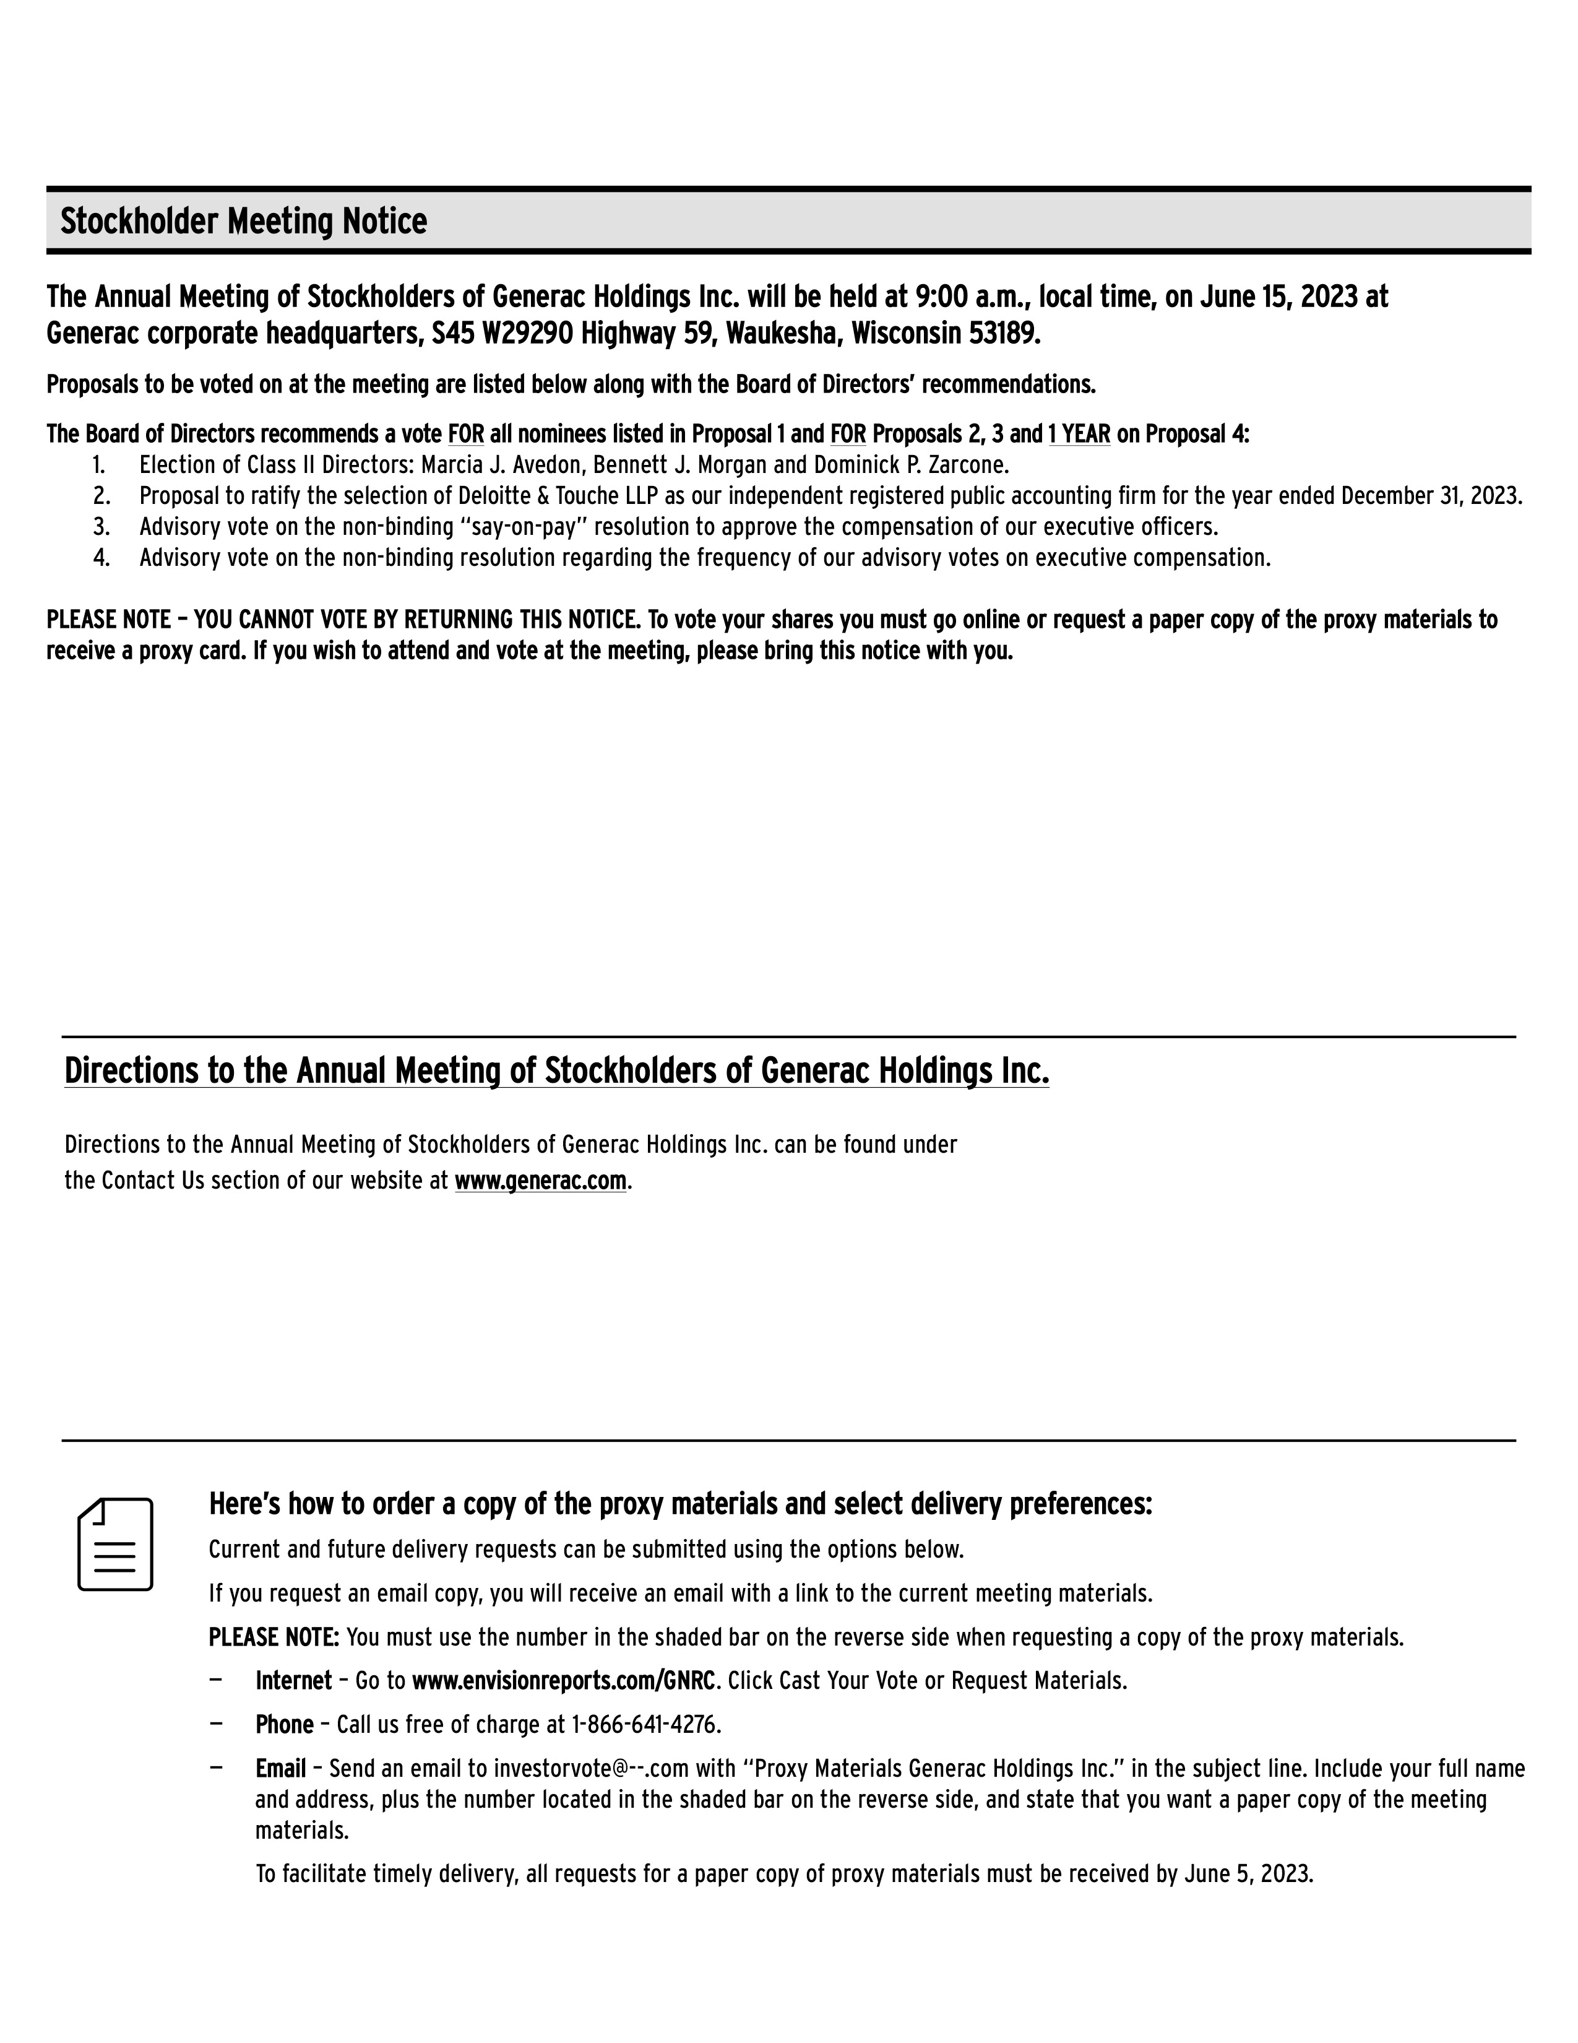
Stockholder Meeting Notice The Annual Meeting of Stockholders of Generac Holdings Inc. will be held at 9:00 a.m., local time, on June 15, 2023 at Generac corporate headquarters, S45 W29290 Highway 59, Waukesha, Wisconsin 53189. Proposals to be voted on at the meeting are listed below along with the Board of Directors’ recommendations. The Board of Directors recommends a vote FOR all nominees listed in Proposal 1 and FOR Proposals 2, 3 and 1 YEAR on Proposal 4: 1. Election of Class II Directors: Marcia J. Avedon, Bennett J. Morgan and Dominick P. Zarcone. 2. Proposal to ratify the selection of Deloitte & Touche LLP as our independent registered public accounting firm for the year ended December 31, 2023. 3. Advisory vote on the non-binding “say-on-pay” resolution to approve the compensation of our executive officers. 4. Advisory vote on the non-binding resolution regarding the frequency of our advisory votes on executive compensation. PLEASE NOTE — YOU CANNOT VOTE BY RETURNING THIS NOTICE. To vote your shares you must go online or request a paper copy of the proxy materials to receive a proxy card. If you wish to attend and vote at the meeting, please bring this notice with you. Directions to the Annual Meeting of Stockholders of Generac Holdings Inc. Directions to the Annual Meeting of Stockholders of Generac Holdings Inc. can be found under the Contact Us section of our website at www.generac.com. Here’s how to order a copy of the proxy materials and select delivery preferences: Current and future delivery requests can be submitted using the options below. If you request an email copy, you will receive an email with a link to the current meeting materials. PLEASE NOTE: You must use the number in the shaded bar on the reverse side when requesting a copy of the proxy materials. — Internet — Go to www.envisionreports.com/GNRC. Click Cast Your Vote or Request Materials. — Phone — Call us free of charge at 1-866-641-4276. — Email — Send an email to investorvote@ — .com with “Proxy Materials Generac Holdings Inc.” in the subject line. Include your full name and address, plus the number located in the shaded bar on the reverse side, and state that you want a paper copy of the meeting materials. To facilitate timely delivery, all requests for a paper copy of proxy materials must be received by June 5, 2023.

