TABLE OF CONTENTS
UNITED STATES
SECURITIES AND EXCHANGE COMMISSION
Washington, D.C. 20549
SCHEDULE 14A
Proxy Statement Pursuant to Section 14(a) of
the Securities Exchange Act of 1934 (Amendment No. )
Filed by the Registrant ☒
Filed by a Party other than the Registrant ☐
Check the appropriate box:
Preliminary Proxy Statement
☐
​
Confidential, for Use of the Commission Only (as permitted by Rule 14a-6(e)(2))
☐
​
Definitive Proxy Statement
☒
​
Definitive Additional Materials
☐
​
Soliciting Material under §240.14a-12
☐
​
GENERAC HOLDINGS INC.
​
(Name of Registrant as Specified In Its Charter)​

​
(Name of Person(s) Filing Proxy Statement, if other than the Registrant)​
Payment of Filing Fee (Check all boxes that apply):
No fee required.
☒
​
Fee paid previously with preliminary materials.
☐
​
Fee computed on table in exhibit required by Item 25(b) per Exchange Act Rules 14a-6(i)(1) and 0-11.
☐
​

TABLE OF CONTENTS

April 29, 2026
​
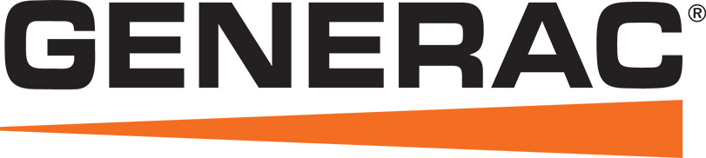
Notice of Annual
Meeting of Stockholders
To the Stockholders of our Company:
You are cordially invited to attend the 2026 Annual Meeting of Stockholders where we will be voting on the below matters.
Items of Business
To elect the three nominees named herein as Class II directors;
•
​
To ratify the selection of Deloitte & Touche LLP as our independent, registered public accounting firm for the year ending December 31, 2026; and
•
​
To approve, on an advisory, non-binding basis, the compensation of our executive officers.
•
​
In addition, we will consider any other matters that may properly come before the meeting or any adjournments or postponements of the meeting.
​ |   DATE AND TIME:  Thursday, June 11, 2026 9:00 a.m. CT | ​ | ​ | Instructions regarding all methods of voting are contained on any Notice of Internet Availability of Proxy Materials or proxy card provided. If your shares are held in the name of a bank, broker, fiduciary or custodian, follow the voting instructions you receive from your record holder.  Your vote is important. Whether or not you intend to be present at the meeting, to assure that your shares are represented at the meeting, please vote promptly using one of the methods mentioned below. | ​
​
 | ​
WHERE: | ​
Generac Power  Systems, Inc.  S45 W29290 Hwy. 59  Waukesha, Wisconsin 53189    ADMISSION: Holders of record of our common stock at the close of business on April 16, 2026 are entitled to notice of, and to vote at, the annual meeting. | ​

​ |  | ​ | ​ |  | ​ | ​ |  | ​ | ​ |  | ​
​ | Internet | ​ | ​ | Telephone | ​ | ​ | Mail | ​ | ​ | In Person | ​
​ | Visit the internet  website indicated on  the Notice of  Internet Availability  or any proxy card  you receive and  follow the on-screen  instructions. | ​ | ​ | Use the toll-free  telephone number  shown on any  proxy card you  receive. | ​ | ​ | If you request a paper proxy card by telephone or internet, you may elect to vote by mail. If you elect to do so, you should date, sign and promptly return your proxy card by mail in the postage prepaid envelope which accompanied that proxy card. | ​ | ​ | You can deliver a completed proxy card at the  meeting or vote in person. | ​
​ | Thank you for your continued support of and interest in the Company.  By Order of the Board of Directors,  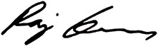  Raj Kanuru  Executive Vice President, General Counsel & Secretary |  |  |  |  |  |  |  |  |  | ​

TABLE OF CONTENTS​

TABLE OF CONTENTS
​ | SUMMARY INFORMATION | ​ | ​ | ​ | ​ | 1 | ​ | ​
​ | PROPOSAL 1 — ELECTION OF CLASS II DIRECTORS | ​ | ​ | ​ | ​ | 4 | ​ | ​
​ | CORPORATE GOVERNANCE | ​ | ​ | ​ | ​ | 16 | ​ | ​
​ | BENEFICIAL OWNERSHIP OF OUR COMMON STOCK | ​ | ​ | ​ | ​ | 25 | ​ | ​
​ | EXECUTIVE COMPENSATION | ​ | ​ | ​ | ​ | 27 | ​ | ​
​ | REPORT OF THE HUMAN CAPITAL AND COMPENSATION COMMITTEE | ​ | ​ | ​ | ​ | 45 | ​ | ​
​ | 2025 DIRECTOR COMPENSATION | ​ | ​ | ​ | ​ | 57 | ​ | ​
​ | RELATED PERSON TRANSACTIONS | ​ | ​ | ​ | ​ | 59 | ​ | ​
​ | PROPOSAL 2 — RATIFICATION OF THE SELECTION OF INDEPENDENT REGISTERED PUBLIC ACCOUNTING FIRM | ​ | ​ | ​ | ​ | 60 | ​ | ​
​ | PROPOSAL 3 — ADVISORY APPROVAL OF EXECUTIVE COMPENSATION | ​ | ​ | ​ | ​ | 62 | ​ | ​
​ | REPORT OF THE AUDIT COMMITTEE | ​ | ​ | ​ | ​ | 63 | ​ | ​
​ | NOMINATIONS AND PROPOSALS BY STOCKHOLDERS | ​ | ​ | ​ | ​ | 65 | ​ | ​
​ | INFORMATION CONCERNING SOLICITATION AND VOTING | ​ | ​ | ​ | ​ | 66 | ​ | ​
​ | ​ | Important notice:​ | ​ | ​
​ | ​ | The Board of Directors (the “Board of Directors” or “Board”) of Generac Holdings Inc. (“Generac,” “we,” “us,” “our,” or the “Company”) is soliciting your proxy to be voted at the Annual Meeting of Stockholders to be held on Thursday, June 11, 2026. | ​ | ​
​ | ​ | Instead of mailing a printed copy of our proxy materials to each stockholder, we furnish proxy materials to our stockholders over the internet by mailing a Notice of Internet Availability of Proxy Materials (“Notice of Internet Availability”), unless otherwise instructed by the stockholder. The Notice of Internet Availability includes information on where to view all proxy materials online, as well as voting instructions. If you received a Notice of Internet Availability and you would like to receive a printed copy of our proxy materials, you should follow the instructions for requesting such materials included in the Notice of Internet Availability. The Notice of Internet Availability was first mailed on or about April 29, 2026 to all stockholders of record as of the record date for the annual meeting, which was the close of business on April 16, 2026. | ​ | ​

​ |  | ​ | ​ | ​ | ​ | ​ | 2026 Proxy Statement | ​

TABLE OF CONTENTS​
Summary Information
Our Corporate Strategy

Generac By The Numbers
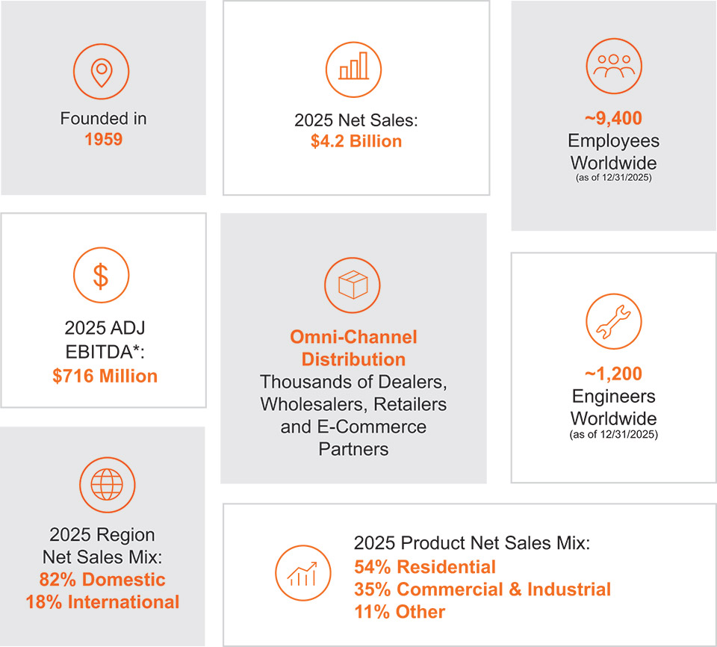
* A full discussion of our use of non-U.S. generally accepted accounting principles measures to provide a baseline for evaluating and comparing our operating results, and a reconciliation of Adjusted EBITDA to net income can be found in Item 7 of the Company’s Annual Report on Form 10-K for the fiscal year ended December 31, 2025.

​ |  | ​ | ​ | 1 | ​ | ​ | 2026 Proxy Statement | ​

TABLE OF CONTENTS
Summary Information
Proposals at the Annual Meeting |  |  |  | ​ | ​ | Board Recommendations: |  |  |  | ​
Proposal 1: Election of  Class II Directors  Marcia J. Avedon  Bennet J. Morgan  Dominick P. Zarcone | ​ | ​ | Pages 4-8 | ​ | ​ |  | ​ | ​ | FOR each  director  nominee | ​
Proposal 2:  To ratify the selection of  Deloitte & Touche LLP as our  independent registered public  accounting firm for the year  ending December 31, 2026 | ​ | ​ | Page 60 | ​ | ​ |  | ​ | ​ | FOR | ​
Proposal 3:  To approve, on an advisory,  non-binding basis,  the compensation of  our executive officers | ​ | ​ | Page 62 | ​ | ​ |  | ​ | ​ | FOR | ​

​ |  | ​ | ​ | 2 | ​ | ​ | 2026 Proxy Statement | ​

TABLE OF CONTENTS
Summary Information
Our 2025 Business Highlights and Performance
We had solid financial performance in 2025:
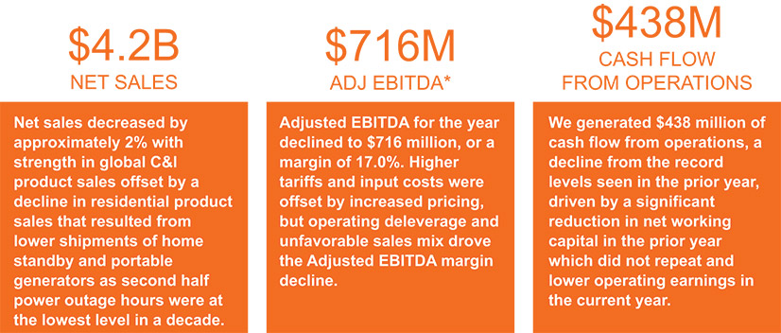
* A full discussion of our use of non-U.S. generally accepted accounting principles measures to provide a baseline for evaluating and comparing our operating results, and a reconciliation of Adjusted EBITDA to net income can be found in Item 7 of the Company’s Annual Report on Form 10-K for the fiscal year ended December 31, 2025.
Key Components and Design of the Executive Compensation Program
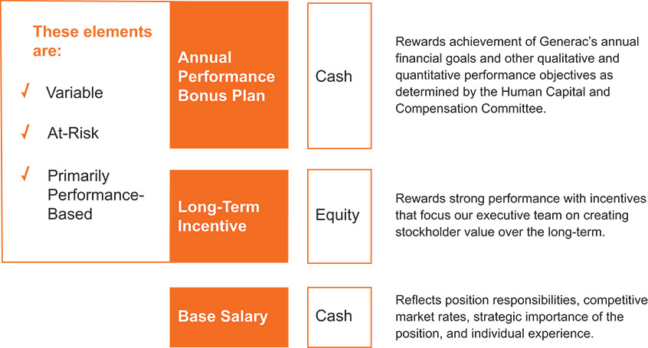

​ |  | ​ | ​ | 3 | ​ | ​ | 2026 Proxy Statement | ​

TABLE OF CONTENTS​
Proposal 1 — Election of Class II Directors
​
​

​ | ​ | The nominees for election as Class II Directors at the 2026 annual meeting are described below, each of whom has been nominated by the Board of Directors. If elected, each of the nominees is expected to serve for a three-year term expiring at the annual meeting of stockholders of the Company in 2029 and until their respective successors have been elected and qualified.  The Board of Directors recommends a vote FOR the Company’s nominees for Class II Directors. | ​ | ​

Our Board of Directors is divided into three classes, with each class serving a consecutive three-year term. The term of the current Class II Directors will expire on the date of the 2026 annual meeting, subject to the election and qualification of their respective successors. The Board of Directors expects that each of the nominees will be available for election as a director. However, if by reason of an unexpected occurrence, one or more of the nominees is not available for election, the persons named in the form of proxy have advised that they will vote for such substitute nominees as the Board of Directors may nominate.
In selecting director candidates, the Nominating and Corporate Governance Committee considers whether the candidates possess the required skill sets and fulfill the qualification requirements of directors approved by the Board of Directors.
The following table provides the current composition of each of our committees:
​ | Director | ​ | ​ | ​ | Audit Committee | ​ | ​ | ​ | Human  Capital and  Compensation  Committee | ​ | ​ | ​ | Nominating  and Corporate  Governance  Committee | ​
​ | Marcia Avedon | ​ | ​ | ​ | ​ | ​ | ​ | ​ | C | ​ | ​ | ​ | X | ​
​ | Kathryn Bohl | ​ | ​ | ​ | X | ​ | ​ | ​ | ​ | ​ | ​ | ​ | X | ​
​ | Robert Dixon | ​ | ​ | ​ | X | ​ | ​ | ​ | ​ | ​ | ​ | ​ | C | ​
​ | William Jenkins | ​ | ​ | ​ | ​ | ​ | ​ | ​ | X | ​ | ​ | ​ | ​ | ​
​ | Andrew Lampereur | ​ | ​ | ​ | C | ​ | ​ | ​ | ​ | ​ | ​ | ​ | ​ | ​
​ | Bennett Morgan (L) | ​ | ​ | ​ | ​ | ​ | ​ | ​ | X | ​ | ​ | ​ | X | ​
​ | Nam Nguyen | ​ | ​ | ​ | ​ | ​ | ​ | ​ | X | ​ | ​ | ​ | X | ​
​ | David Ramon | ​ | ​ | ​ | X | ​ | ​ | ​ | ​ | ​ | ​ | ​ | X | ​
​ | Dominick Zarcone | ​ | ​ | ​ | X | ​ | ​ | ​ | X | ​ | ​ | ​ | ​ | ​
“C” = Chairperson
“L” = Lead Director

​ |  | ​ | ​ | 4 | ​ | ​ | 2026 Proxy Statement | ​

TABLE OF CONTENTS
PROPOSAL 1 — ELECTION OF CLASS II DIRECTORS
Our director nominees and continuing directors bring a broad range of skills, experiences, and perspectives to our board. The table below summarizes the skills and experiences that bring value to our Company.
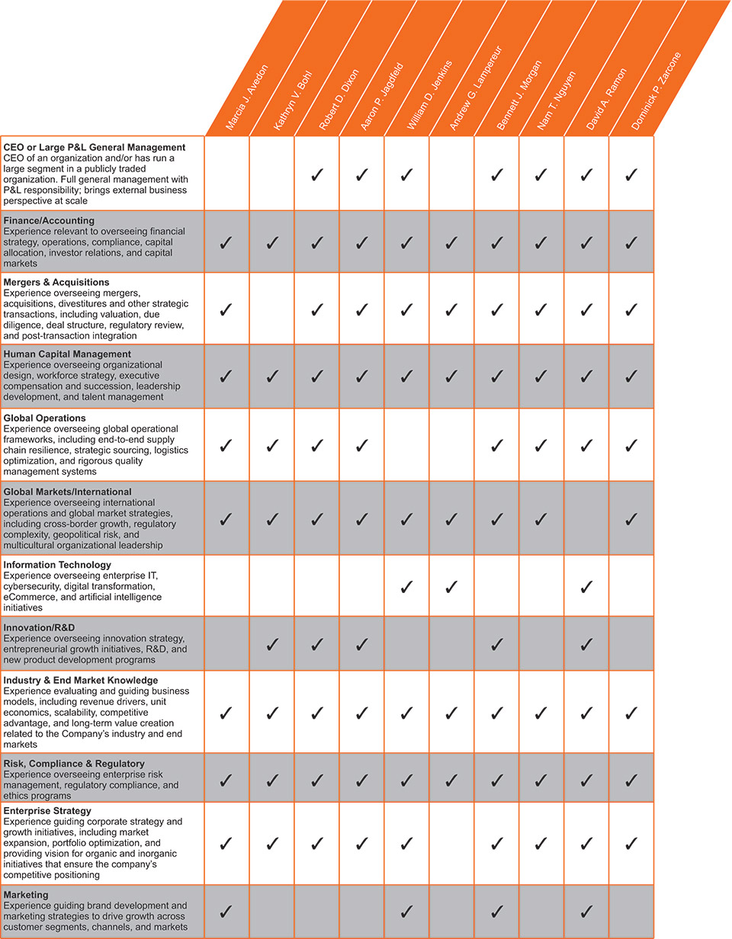

​ |  | ​ | ​ | 5 | ​ | ​ | 2026 Proxy Statement | ​

TABLE OF CONTENTS
PROPOSAL 1 — ELECTION OF CLASS II DIRECTORS
The following biographies describe the business experience of each director nominee and continuing director. Following the biographical information for each director below, we have listed qualifications that, in addition to those discussed above, the Board of Directors considered in determining whether to recommend the director be nominated for reelection.
Nominees for Election
Class II Directors
MARCIA J. AVEDON, PH.D. |  |  |  | ​
  Age: 64  Director Since: 2019 | ​ | ​ | EXPERIENCE & QUALIFICATIONS  2022-Current: Founder and CEO, Avedon Advisory, LLC  •  ​  2020-2022: Executive Vice President, Chief Human Resources, Marketing, & Communications Officer for Trane Technologies, a climate control innovation company focusing on heating and cooling in buildings, homes, and transportation (previously Ingersoll-Rand, plc)  •  ​  2007-2020: Senior Vice President of Human Resources, Communications, and Corporate Affairs for Ingersoll-Rand, plc, leading global human resources, public affairs, corporate social responsibility, communications, and strategic marketing  •  ​  2002-2006: Chief Human Resources Officer at Merck, a global pharmaceutical company  •  ​  1995-2002: Held increasingly responsible leadership positions in Human Resources and Communications for Honeywell International, a global diversified company  •  ​  Prior to 1995: Held positions in Human Resources at Anheuser-Busch Companies and as a consultant with Booz, Allen & Hamilton  •  ​  Other Board Service  Current Director of Acuity Brands, Inc., a publicly traded industrial technology company  •  ​  Current Director of Cornerstone Building Brands, a private manufacturer of exterior building products  •  ​  Former Director of GCP Applied Technologies  •  ​  Former Director of Lincoln National Corporation  •  ​  Ms. Avedon brings to Generac extensive expertise on global human resources and human capital topics. Ms. Avedon has over 30 years of experience leading organizational transformation, talent and succession management, culture change, corporate social responsibility, and communications.  Ms. Avedon earned a Bachelor of Arts in Psychology from the University of North Carolina at Wilmington, and a Master’s Degree and Ph.D. in Industrial and Organizational Psychology from George Washington University. | ​

​ |  | ​ | ​ | 6 | ​ | ​ | 2026 Proxy Statement | ​

TABLE OF CONTENTS
PROPOSAL 1 — ELECTION OF CLASS II DIRECTORS
BENNETT J. MORGAN |  |  |  | ​
  Age: 62  Director Since: 2013 | ​ | ​ | EXPERIENCE & QUALIFICATIONS  2005-2016: President and Chief Operating Officer, Polaris Industries Inc., a manufacturer of power sports vehicles (“Polaris”)  •  ​  2004-2005: Vice President and General Manager, ATV Division, Polaris  •  ​  2001-2004: General Manager, ATV Division, Polaris  •  ​  1997-2001: General Manager, PGA Division, Polaris  •  ​  1987-1997: Held various marketing, product development, and operations positions at Polaris Industries  •  ​  Mr. Morgan brings to Generac extensive leadership skills. Having served in senior roles as President and Chief Operating Officer for a public company, Mr. Morgan has over 25 years of expertise in international consumer durables products, dealer distribution, product development, and innovation. Serving in these leadership roles provides Mr. Morgan with in-depth knowledge of strategic growth and development and company oversight, including talent development, product development, sales and marketing, engineering, and manufacturing operations.  Mr. Morgan earned his Bachelor of Science in Economics from St. John’s University and Master of Business Administration from the Carlson School of Management at the University of Minnesota. | ​

​ |  | ​ | ​ | 7 | ​ | ​ | 2026 Proxy Statement | ​

TABLE OF CONTENTS​
PROPOSAL 1 — ELECTION OF CLASS II DIRECTORS
DOMINICK P. ZARCONE |  |  |  | ​
  Age: 67  Director Since: 2017 | ​ | ​ | EXPERIENCE & QUALIFICATIONS  2017-2024: President and Chief Executive Officer of LKQ Corporation, a global distributor of vehicle parts and accessories  •  ​  2015-2017: Chief Financial Officer, LKQ Corporation  •  ​  2011-2015: Managing Director and Chief Financial Officer of Baird Financial Group, a capital markets and wealth management company, and certain of its affiliates  •  ​  2011-2015: Treasurer of Baird Funds, Inc., a family of fixed income and equity mutual funds managed by Robert W. Baird & Co. Incorporated, a registered broker/dealer  •  ​  1995-2011: Managing Director of the Investment Banking department of Robert W. Baird & Co. Incorporated  •  ​  1986-1995: Held various positions with investment banking company Kidder, Peabody & Co., Incorporated, most recently as Senior Vice President of Investment Banking  •  ​  Other Board Service  Current Director at Asphalt ATD Holdco, LLC, a privately held company and wholesale distributor of vehicle replacement tires and related accessories  •  ​  Current Board Chair of MEKO Group AB (Stockholm), a publicly traded distributor of automotive parts and accessories in Europe  •  ​  Current Director at WillScot Holdings Corporation, a public company and provider of mobile storage solutions and modular buildings  •  ​  Former Director of LKQ Corporation  •  ​  Mr. Zarcone brings to Generac extensive management and leadership experience, serving in senior leadership roles as Chief Executive Officer and Chief Financial Officer of a public corporation. Mr. Zarcone has also held senior leadership roles as Managing Director and Chief Financial Officer of privately held companies. Mr. Zarcone has over 35 years of expertise in investment banking, wealth management, and capital markets bringing significant financial expertise to Generac.  Mr. Zarcone earned his Bachelor of Science in Finance from the University of Illinois at Urbana-Champaign and Master of Business Administration from the University of Chicago Graduate School of Business. | ​

​ |  | ​ | ​ | 8 | ​ | ​ | 2026 Proxy Statement | ​

TABLE OF CONTENTS
PROPOSAL 1 — ELECTION OF CLASS II DIRECTORS
Other Members of the Board of Directors
Including the nominees, the Board of Directors currently consists of ten directors, each of whom, other than the nominees, is described below. The terms of the Class III Directors expire at the 2027 annual meeting of Stockholders, subject to the election and qualification of their respective successors. The terms of the Class I Directors expire at the 2028 Annual Meeting of Stockholders, subject to the election and qualification of their respective successors.
Class I Directors
AARON P. JAGDFELD |  |  |  | ​
  Age: 54  Director Since: 2006  Chairman Since: 2016 | ​ | ​ | EXPERIENCE & QUALIFICATIONS  2008-Current: President and Chief Executive Officer of Generac  •  ​  2007: President of Generac, responsible for sales, marketing, engineering, and product development  •  ​  2002-2006: Chief Financial Officer, Generac  •  ​  1994-2001: Finance Department, Generac  •  ​  Prior to 1994: Audit Practice, Deloitte & Touche, LLP  •  ​  Other Board Service  Current Director of The Hillman Group, a public company providing complete hardware solutions  •  ​  As the Chief Executive Officer and the only management representative on the Board, Mr. Jagdfeld provides valuable insight to the Board regarding the day-to-day business issues facing the Company. Since joining the Company, he has navigated a number of achievements, including our initial public offering, the significant increase in sales, numerous acquisitions, and our international expansion. Mr. Jagdfeld has extensive finance and operational experience and has high-level leadership experience in several prior positions. Mr. Jagdfeld holds a Bachelor of Business Administration in Accounting from the University of Wisconsin-Whitewater. | ​

​ |  | ​ | ​ | 9 | ​ | ​ | 2026 Proxy Statement | ​

TABLE OF CONTENTS
PROPOSAL 1 — ELECTION OF CLASS II DIRECTORS
ANDREW G. LAMPEREUR |  |  |  | ​
  Age: 63  Director Since: 2014 | ​ | ​ | EXPERIENCE & QUALIFICATIONS  2000-2017: Executive Vice President and Chief Financial Officer, Actuant Corporation (now Enerpac Tool Group Corporation), a global diversified company that designs and manufactures industrial products and systems (“Actuant”)  •  ​  1999-2000: Applied Power (Actuant) Business Development Leader  •  ​  1998-1999: Vice President and General Manager — Distribution, Gardner Bender (Actuant subsidiary)  •  ​  1996-1998: Vice President Finance, Gardner Bender  •  ​  1993-1996: Corporate Controller, Actuant Corporation  •  ​  Prior to 1993: Held various financial positions with Fruehauf Trailer Corporation, Terex Corporation, and Price Waterhouse  •  ​  Other Board Service  Former Director of Jason Industries, Inc.  •  ​  Former Director of Robbins & Myers  •  ​  Mr. Lampereur brings extensive financial experience to Generac. Mr. Lampereur has over 26 years of senior-level financial experience in a variety of businesses complementary to Generac, including as a chief financial officer and director of a public company.  Mr. Lampereur graduated with a Bachelor of Business Administration in Accounting from St. Norbert College. | ​

​ |  | ​ | ​ | 10 | ​ | ​ | 2026 Proxy Statement | ​

TABLE OF CONTENTS
PROPOSAL 1 — ELECTION OF CLASS II DIRECTORS
NAM T. NGUYEN |  |  |  | ​
  Age: 50  Director Since: 2022 | ​ | ​ | EXPERIENCE & QUALIFICATIONS  2020-Current: Chief Operating Officer, Generate Capital, a leading sustainable infrastructure company  •  ​  2013-2020: Executive Vice President, SunPower Corp., a solar power products company  •  ​  Prior to 2013: Vice President of Global Business Development at First Solar and held various positions in investment banking, working in New York, Singapore and Los Angeles  •  ​  Other Board Service  Current director at Ubiquity, a private digital communications infrastructure company  •  ​  Current director at Conasa Infraestrutura S.A., a private holding company focusing on developing and operating infrastructure projects in Brazil  •  ​  Current director at Amp Americas, a private company specializing in producing and marketing renewable natural gas from dairy waste  •  ​  Ms. Nguyen brings to Generac over 20 years of experience as an executive leader in renewable energy and sustainable infrastructure. Ms. Nguyen specializes in P&L management, international market expansion, business development, sales strategy and operations, and financing. Working in the domestic and international solar sector, Ms. Nguyen has led startup and expansion projects, specifically driving revenue and scaling businesses in new markets. Ms. Nguyen’s background with solar power and renewable energy markets provides Generac with valuable expertise and strategic insight within key areas of Generac’s business. Ms. Nguyen also brings significant international experience, having worked in Latin America and Singapore.  Ms. Nguyen graduated with a Bachelor of Arts in Economics from Columbia University and a Master of Business Administration from Harvard University. | ​

​ |  | ​ | ​ | 11 | ​ | ​ | 2026 Proxy Statement | ​

TABLE OF CONTENTS
PROPOSAL 1 — ELECTION OF CLASS II DIRECTORS
Class III Directors
KATHRYN V. BOHL |  |  |  | ​
  Age: 65  Director Since: 2016 | ​ | ​ | EXPERIENCE & QUALIFICATIONS  2005-2016: Held various leadership roles at Sleep Number Corporation (formerly Select Comfort Corporation), a manufacturer of mattresses and sleep-related products, including  •  ​  Executive Vice President and Chief Services and Fulfillment Officer  ◦  ​  Executive Vice President, Product and Service, and  ◦  ​  Senior Vice President, Global Supply Chain  ◦  ​  1983-2005: Held various leadership roles at GE, including  •  ​  General Manager, Global Supply Chain Strategy, GE Healthcare,  ◦  ​  General Manager, Global Quality and Six Sigma, GE Healthcare,  ◦  ​  Vice President Technical Operations and Director/Vice President of Quality Programs for GE Clinical Services, a division of GE Healthcare, and various roles in Sourcing, Engineering, and Manufacturing at GE Information Services and GE Healthcare  ◦  ​  Other Board Service  Current Lead Director of Columbus McKinnon Corporation, a public company that designs and manufactures precision material handling systems  •  ​  Former Director of The Jones Family of Companies  •  ​  Ms. Bohl brings to Generac extensive leadership experience across B2B and B2C sophisticated technology products and services and consumer/retail businesses. Ms. Bohl has held several senior level management positions, giving her significant experience in strategic growth and development and human resources/talent management. Ms. Bohl has over 30 years of expertise that includes extensive risk management, regulatory compliance, operations, and supply chain experience.  Ms. Bohl graduated with a Bachelor of Science in Mechanical Engineering from Michigan State University. | ​

​ |  | ​ | ​ | 12 | ​ | ​ | 2026 Proxy Statement | ​

TABLE OF CONTENTS
PROPOSAL 1 — ELECTION OF CLASS II DIRECTORS
ROBERT D. DIXON |  |  |  | ​
  Age: 66  Director Since: 2012 | ​ | ​ | EXPERIENCE & QUALIFICATIONS  2014-2016: Chairman and CEO of Natural Systems Utilities LLC, a distributed water infrastructure company  •  ​  2012-2014: Chief Executive Officer of Seven Seas Water Corporation, an international services corporation  •  ​  1983-2011: Held various leadership roles at Air Products and Chemicals, Inc., including Senior Vice President & General Manager  •  ​  Other Board Service  Former Director of Valicor Environmental Services  •  ​  Mr. Dixon brings to Generac over 30 years of global management, operations and finance experience. Mr. Dixon has significant prior experience working in the energy industry, including specifically within the industrial gas sector on various clean energy initiatives. Mr. Dixon also brings vast international experience to Generac, having managed international operations for the majority of his career, including spending several years working overseas in Asia.  Mr. Dixon earned a Bachelor of Business Administration from Miami University and a Master of Business Administration from Pennsylvania State University. He also attended the Advanced Management Program at INSEAD in Fontainebleau, France. | ​

​ |  | ​ | ​ | 13 | ​ | ​ | 2026 Proxy Statement | ​

TABLE OF CONTENTS
PROPOSAL 1 — ELECTION OF CLASS II DIRECTORS
WILLIAM D. JENKINS, JR. |  |  |  | ​
  Age: 60  Director Since: 2017 | ​ | ​ | EXPERIENCE & QUALIFICATIONS  2021-Current: President of Palo Alto Networks, a public cybersecurity firm  •  ​  2012-2021: President & Chief Executive Officer of Barracuda Networks, a private network technology company  •  ​  1998-2012: Held various positions at EMC Corporation, an information infrastructure company, including President of the Backup Recovery Systems division  •  ​  Other Board Service  Former Director of Skydeck Acquisition Corporation  •  ​  Former Director of Barracuda Networks  •  ​  Former Director of Sumo Logic  •  ​  Former Lead Director for Apigee Corporation (acquired by Google, Inc.)  •  ​  Former Director for Nimble Storage, Inc. (acquired by Hewlett Packard Enterprise Company)  •  ​  Mr. Jenkins brings to Generac over 10 years of cybersecurity and technology experience, including currently serving as the President of a global cybersecurity company.  Mr. Jenkins holds a Bachelor of Science in General Engineering from the University of Illinois and a Master of Business Administration from Harvard Business School. | ​

​ |  | ​ | ​ | 14 | ​ | ​ | 2026 Proxy Statement | ​

TABLE OF CONTENTS
PROPOSAL 1 — ELECTION OF CLASS II DIRECTORS
DAVID A. RAMON |  |  |  | ​
  Age: 70  Director Since: 2010 | ​ | ​ | EXPERIENCE & QUALIFICATIONS  1998-Current: Founder and Managing Partner of Vaduz Partners, a private investment firm  •  ​  2019-2024: Investment Partner in Gratitude Railroad, an alternative investment capital firm  •  ​  2014-2018: Chairman and Chief Executive Officer of Diversified Maintenance, a specialized facility services company  •  ​  2000-2007: President and Chief Executive Officer of USA.NET, Inc.  •  ​  1997-1998: President, Coleman Outdoor Recreation Group  •  ​  1994-1997: Held various senior management positions, including President and Chief Operating Officer of New World Television, Inc.  •  ​  1982-1994: Executive Vice President and Chief Financial Officer of Gillett Holdings, Inc.  •  ​  Prior to 1982: Arthur Young & Company  •  ​  Other Board Service  Current Director of Sagent-CTAM Holdings, Inc., a private network solutions provider  •  ​  Former Director of Diversified Maintenance  •  ​  Former Director of New World Communications Group, Inc.  •  ​  Former Director of USA.NET, Inc.  •  ​  Mr. Ramon brings to Generac more than 30 years of broad management, operations, and investment experience with established consumer product markets, emerging companies in cloud computing and software services, and in enterprises that deliver positive social and environmental impact. Mr. Ramon also brings significant leadership and financial experience, having served as Chief Executive Officer, Chief Operating Officer, President or Chief Financial Officer for a number of privately held and public companies. Mr. Ramon’s work as a founder and managing partner of a private investment firm gives him significant and valuable capital markets experience.  Mr. Ramon earned a Bachelor of Business Administration in Accounting from the University of Wisconsin. | ​

​ |  | ​ | ​ | 15 | ​ | ​ | 2026 Proxy Statement | ​

TABLE OF CONTENTS​
Corporate Governance
Board of Directors Independence Standards for Directors
Pursuant to our Corporate Governance Guidelines and Principles, a copy of which is available on our website at www.generac.com, our Board of Directors affirmatively determines whether our directors are independent under the listing standards of the New York Stock Exchange (“NYSE”), the principal exchange on which our common stock is traded.
​
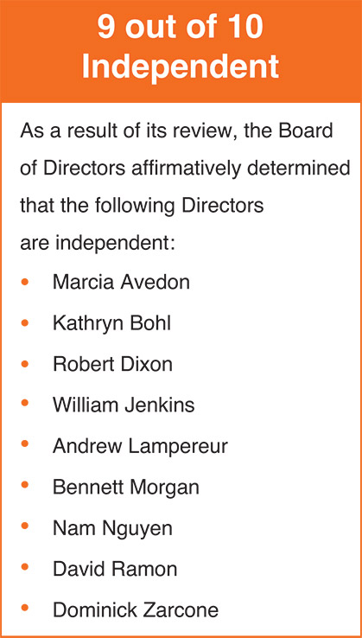
During its annual review of director independence, the Board of Directors considers all information it deems relevant, including any transactions and relationships between each director or any member of his or her immediate family and the Company and its subsidiaries and affiliates as disclosed by directors in the Directors and Officers Questionnaire that each director completes annually.
The Board of Directors also considers the recommendations of the Nominating and Corporate Governance Committee, which conducts a separate independence assessment of all directors as part of its nomination process for the Board of Directors and its respective committees. The purpose of this review is to determine whether any such relationship or transaction is considered a “material relationship” that would be inconsistent with a determination that a director is independent.
The Board of Directors has not adopted any “categorical standards” for assessing independence, preferring instead to consider all relevant facts and circumstances in making an independence determination including, without limitation, applicable independence standards promulgated by the NYSE.
In making its independence determination, the Board of Directors specifically considered Mr. Jenkins’ appointment as an executive officer of Palo Alto Networks, Inc., from which the Company purchased cybersecurity services in fiscal 2025. The value of such transactions represented an immaterial percentage of the Company and Palo Alto Networks’ revenue, and Mr. Jenkins was not personally involved in such transactions. Accordingly, the Board of Directors concluded that such transactions did not preclude Mr. Jenkins from being independent under applicable standards.

​ |  | ​ | ​ | 16 | ​ | ​ | 2026 Proxy Statement | ​

TABLE OF CONTENTS
CORPORATE GOVERNANCE
Committees of the Board of Directors
Our Board of Directors has three standing committees: an Audit Committee, a Human Capital and Compensation Committee, and a Nominating and Corporate Governance Committee. Our Board of Directors has adopted charters for each of its standing committees. Copies of our current committee charters are posted under “Corporate Governance” in the “Investors” section on our website at www.generac.com.
Audit Committee
Members | ​ | ​ | Key Responsibilities | ​ | ​ | (10 Meetings in 2025) | ​
ANDREW G.  LAMPEREUR  (Chair)  KATHRYN V. BOHL  ROBERT D. DIXON  DAVID A. RAMON  DOMINICK P.  ZARCONE | ​ | ​ | The Audit Committee, among other items, assists the Board of Directors in fulfilling its responsibility relating to the following:  the integrity of our financial statements,  •  ​  our systems of internal controls and disclosure controls and procedures,  •  ​  our compliance with applicable law and ethics programs,  •  ​  the annual independent audit of our financial statements,  •  ​  review and assessment of any sustainability reporting or disclosure of the Company and the controls and procedures related to such disclosure, and  •  ​  the evaluation of financial and enterprise risks, including areas related to legal compliance and ethics, cybersecurity, and certain other functional areas.  •  ​  The Board has determined that each of Messrs. Dixon, Lampereur, Ramon, and Zarcone is an “audit committee financial expert” as defined in Item 407(d)(5) of Regulation S-K, and the Board is satisfied that all members of our Audit Committee have sufficient expertise and business and financial experience necessary to effectively perform their duties as members of the Audit Committee. The Board has determined that all members of the Audit Committee meet the NYSE and SEC definitions of independence.  In connection with its review of the Company’s financial statements, the Audit Committee receives reports from the Company’s Chief Financial Officer and the Company’s independent registered public accounting firm regarding significant risks and exposures and assesses management’s steps to minimize them. The Audit Committee also reviews material legal and regulatory matters and compliance with significant applicable legal, ethical, and regulatory requirements, and receives reports from the Company’s General Counsel relating to these matters. The Audit Committee also reviews other areas within its oversight from members of management as appropriate. |  |  |  | ​
In discharging its duties, the Audit Committee has the sole authority to select, retain, oversee, and terminate, if necessary, the independent registered public accounting firm, review and approve the scope of the annual audit, review and preapprove the engagement of our independent registered public accounting firm to perform audit and non-audit services, meet independently with our independent registered public accounting firm and senior management, review the integrity of our financial reporting process, and review our financial statements and disclosures and certain SEC filings and financial press releases. The Audit Committee meets with our independent registered public accounting firm without management present on a regular basis.
In addition to the scheduled meetings, the members of the Audit Committee also met informally among themselves, with management, and with other members of the Board from time to time.

​ |  | ​ | ​ | 17 | ​ | ​ | 2026 Proxy Statement | ​

TABLE OF CONTENTS
CORPORATE GOVERNANCE
Human Capital and Compensation Committee
Members | ​ | ​ | Key Responsibilities | ​ | ​ | (5 Meetings in 2025) | ​
MARCIA J. AVEDON  (Chair)  WILLIAM D.  JENKINS, JR.  BENNETT J.  MORGAN  NAM T. NGUYEN  DOMINICK P.  ZARCONE | ​ | ​ | The Human Capital and Compensation Committee:  oversees the Company’s plans, policies, and programs relating to human capital management and corporate culture to help ensure the Company is seeking, developing, and retaining human capital appropriate to meet the Company’s needs,  •  ​  reviews, assesses, and advises the Board regarding the Company’s policies, practices, strategies, and goals with respect to those sustainability matters falling within its responsibilities,  •  ​  plays an integral role in the Company’s processes and procedures for the consideration and determination of executive and director compensation,  •  ​  determines the compensation policies and individual compensation decisions for our executive officers and ensures these policies and decisions are consistent with overall corporate performance,  •  ​  in conjunction with the Nominating and Corporate Governance Committee as needed, reviews the form and amount of director compensation and makes recommendations to the Board related thereto,  •  ​  has the authority to approve all equity and equity-based awards to our employees, directors, and executive officers,  •  ​  reviews and recommends to the Board of Directors the target annual incentive pool, the annual performance objectives for participants, and actual payouts to participants, including the executive officers,  •  ​  works with its independent compensation consultant and management in setting compensation to create incentives that encourage an appropriate level of risk taking that is consistent with the Company’s business strategy and maximization of stockholder value,  •  ​  reviews and approves annual performance goals for the CEO and certain executives related to incentive compensation,  •  ​  oversees the Company’s Organizational Talent Review process and human capital programs and initiatives to determine whether outcomes are effective and achieve their intended purposes, and  •  ​  reviews management development and executive succession plans, including for the CEO.  •  ​ |  |  |  | ​
The Human Capital and Compensation Committee has decision-making authority with respect to all compensation decisions for our executive officers, including annual incentive plan awards and grants of equity awards. The Human Capital and Compensation Committee is responsible for finalizing and approving the performance objectives relevant to the compensation of our CEO and other executive officers.
The Human Capital and Compensation Committee’s recommendations are developed with input from our CEO and, where appropriate, other senior executives. The Human Capital and Compensation Committee reviews management recommendations and input from compensation consultants, along with other sources of data when formulating its independent recommendations to the Board of Directors. A discussion and analysis of the Company’s compensation decisions

​ |  | ​ | ​ | 18 | ​ | ​ | 2026 Proxy Statement | ​

TABLE OF CONTENTS
CORPORATE GOVERNANCE
regarding the executive officers named in the Summary Compensation Table appears in this proxy statement under the heading “EXECUTIVE COMPENSATION — Compensation Discussion and Analysis.”
To assist it in performing its duties, the Human Capital and Compensation Committee has the authority to engage outside consulting firms. The Human Capital and Compensation Committee has engaged Pay Governance as its independent compensation consultant since October 2023. In its capacity as an outside and independent compensation consultant, Pay Governance reports directly to the Human Capital and Compensation Committee.
The Human Capital and Compensation Committee has sole authority to replace compensation consultants retained from time to time, and to hire additional consultants for the Committee at any time.
Representatives from Pay Governance engaged by the Human Capital and Compensation Committee attend meetings of the Committee, as requested, and communicate with the Chair of the Committee between meetings.
The Human Capital and Compensation Committee assessed the independence of Pay Governance pursuant to applicable SEC rules and concluded that no conflict of interest exists that would prevent Pay Governance from independently advising the Committee.
The Human Capital and Compensation Committee reviews and discusses with management proposed Compensation Discussion and Analysis disclosures and determines whether to recommend the Compensation Discussion and Analysis to the Board of Directors for inclusion in the Company’s proxy statement and annual report. The recommendation is described in the Human Capital and Compensation Committee Report included in this proxy statement.
In addition to scheduled meetings, the members of the Human Capital and Compensation Committee also met informally among themselves, with management, with other members of the Board, and with Pay Governance from time to time.
Nominating and Corporate Governance Committee
Members | ​ | ​ | Key Responsibilities | ​ | ​ | (7 Meetings in 2025) | ​
ROBERT D. DIXON  (Chair)  MARCIA J. AVEDON  KATHRYN V. BOHL  BENNETT J.  MORGAN  NAM T. NGUYEN  DAVID A. RAMON | ​ | ​ | The Nominating and Corporate Governance Committee:  identifies candidates to serve as directors and on committees of the Board of Directors,  •  ​  develops, recommends, and reviews our Corporate Governance Guidelines and Principles on a regular basis,  •  ​  oversees any necessary search, selection, and hiring process for appointing a new CEO,  •  ​  assists the Board of Directors in its annual review of the performance and effectiveness of the Board of Directors and its committees,  •  ​  reviews the Company’s sustainability policies, practices, and disclosures, and  •  ​  undertakes such other tasks delegated to the committee by the Board of Directors.  •  ​ |  |  |  | ​
Decisions regarding board nominations and corporate governance-related matters were approved by our Board after considering the recommendations of the Nominating and Corporate Governance Committee.

​ |  | ​ | ​ | 19 | ​ | ​ | 2026 Proxy Statement | ​

TABLE OF CONTENTS
CORPORATE GOVERNANCE
Criteria for Director Nominees
In selecting director candidates, the Nominating and Corporate Governance Committee considers whether the candidates possess the required skill sets and fulfill the qualification requirements of directors approved by the Board of Directors, including exhibiting integrity, objectivity, sound judgment, leadership, and a breadth of different perspectives and experience. Annually, the Nominating and Corporate Governance Committee assesses the composition of the Board of Directors, including the Committee’s effectiveness in balancing the above considerations.
Other than the foregoing, there are no minimum criteria for director nominees, although the Nominating and Corporate Governance Committee may consider such other factors as it may deem are in the best interests of the Company and its stockholders. The Nominating and Corporate Governance Committee does not assign specific weights to, and a potential or incumbent director will not necessarily satisfy all, the foregoing criteria, and in evaluating a candidate does not distinguish on the basis of whether the candidate was recommended by a stockholder.
Process for Identifying and Evaluating Director Nominees
The Nominating and Corporate Governance Committee identifies nominees by first evaluating the current members of the Board of Directors willing to continue in service. Current members of the Board of Directors with skills and experience that are relevant to the Company’s business and who are willing to continue in service are considered for renomination, balancing the value of continuity of service by existing members of the Board of Directors with that of obtaining a new perspective on the Board. If any member of the Board of Directors does not wish to continue in service or if the Nominating and Corporate Governance Committee decides not to renominate a member for reelection, the Nominating and Corporate Governance Committee identifies the desired skills and experience of a new nominee based on the criteria listed above. Current members of the Nominating and Corporate Governance Committee and Board of Directors are polled for suggestions as to individuals meeting the criteria set by the Nominating and Corporate Governance Committee. Executive search firms may also be retained to identify qualified individuals.
Stockholders who wish to recommend a candidate for consideration by the Nominating and Corporate Governance Committee may do so by sending the candidate’s name and supporting information to Mr. Robert Dixon, Nominating and Corporate Governance Committee, c/o Raj Kanuru, Executive Vice President, General Counsel & Secretary, Generac Power Systems, Inc., S45 W29290 Highway 59, Waukesha, Wisconsin 53189. Our Bylaws contain provisions that address the processes by which a stockholder may nominate an individual to stand for election to the Board of Directors. See “NOMINATIONS AND PROPOSALS BY STOCKHOLDERS” below for additional information.
Director Commitments and Board Limitations
Our Corporate Governance Guidelines and Principles state our expectation that directors be prepared to devote the time required to prepare for and attend Board meetings and fulfill their responsibilities effectively. Accordingly, our guidelines state the expectation that directors limit the number of public company boards on which they serve to no more than four additional public boards for non-employee directors who do not serve as an executive officer of a public company, and to one additional public company board in the case of directors who serve as an

​ |  | ​ | ​ | 20 | ​ | ​ | 2026 Proxy Statement | ​

TABLE OF CONTENTS
CORPORATE GOVERNANCE
executive officer of a public company. Directors are also required to notify and obtain approval from the Chairperson of the Board and Chairperson of the Nominating and Corporate Governance Committee in advance of accepting an invitation to serve on another public company or for-profit, private board. The Company monitors compliance with this policy through its annual Directors and Officers’ questionnaire process.
Board of Directors Role in Risk Oversight
Our Board oversees the risks and opportunities related to our business strategies. As part of our Enterprise Risk Management (“ERM”) process, our Board and management continually identify and monitor the material risks facing our Company, including financial risk, strategic risk, operational risk, legal and compliance risk, and other risks as described in the Company’s Annual Report on Form 10-K for the fiscal year ended December 31, 2025, and address these risks in an appropriate manner.
Overall responsibility for risk oversight rests with our Board and management regularly reports to the Board on its activities in monitoring and mitigating these identified risks. The Board may delegate risk oversight responsibility to a particular committee in situations in which the risk falls within the committee’s area of focus or expertise. Our Board believes that for certain areas of risk, our Company is better served by having the initial risk evaluation and risk monitoring undertaken by a subset of the entire Board that is more focused on the issues pertaining to the particular risk. For instance, our Human Capital and Compensation Committee assists the Board in evaluating whether compensation policies and procedures promote profitable growth without encouraging unnecessary risk taking. Our Audit Committee assists the Board in fulfilling the Board’s oversight responsibility relating to the evaluation of financial and legal risks, including information security and cybersecurity, environmental, health and safety, product regulatory, and product safety matters.
Board of Directors Leadership Structure
Aaron Jagdfeld has served as a director of the Company since 2006 and is the Company’s Chairman of the Board, President, and Chief Executive Officer. Bennett Morgan serves as the Board’s independent Lead Director.
The Lead Director has broad responsibility and authority, including to:
Review the agendas for and preside over meetings of the independent directors.
•
​
Preside at all meetings of the Board of Directors at which the Chairman is not present, including executive sessions of the independent directors.
•
​
Call meetings of the independent directors.
•
​
Serve as the principal liaison between the Chairman and CEO and the independent directors.
•
​
Consult with the Chairman and CEO regarding:
•
​
Information sent to the Board of Directors, including the quality, quantity, appropriateness, and timeliness of such information.
◦
​
Meeting agendas for the Board of Directors.
◦
​
The frequency of Board of Directors meetings and meeting schedules, assuring there is sufficient time for discussion of all agenda items.
◦
​
Development of annual priorities and goals for the Board of Directors.
◦
​

​ |  | ​ | ​ | 21 | ​ | ​ | 2026 Proxy Statement | ​

TABLE OF CONTENTS
CORPORATE GOVERNANCE
Be available, when appropriate, for consultation and direct communication with stockholders.
•
​
Select, retain, and consult with outside counsel and other advisors as the Lead Director deems appropriate.
•
​
In conjunction with both the Human Capital and Compensation Committee and the full Board of Directors:
•
​
Annually review the performance of, and provide feedback to, the CEO.
◦
​
Annually meet with each Director to collect and review feedback.
◦
​
Periodically, our Board assesses these roles and the Board leadership structure to ensure the interests of the Company and its stockholders are best served.
Our Board has determined that its current structure, with a combined Chairman and CEO role and an independent Lead Director, is in the best interests of the Company and its stockholders at this time based on a number of factors, including:
A combined Chairman and CEO structure provides the Company with decisive and effective leadership with clearer accountability to our stockholders and customers.
•
​
The combined role is both counterbalanced and enhanced by the effective oversight and independence of our Board of Directors, and the independent leadership provided by our Lead Director and independent committee chairs.
•
​
The Board believes that the appointment of a strong independent Lead Director and the use of regular executive sessions of the non-management directors, along with the Board’s strong committee system and all directors being independent except for Mr. Jagdfeld, allow it to maintain effective oversight of management and the Company.
•
​
Stockholders and other parties interested in communicating directly with Mr. Bennett Morgan as Lead Director may do so by writing to Mr. Bennett Morgan, Lead Director, c/o Generac Holdings Inc., S45 W29290 Highway. 59, Waukesha, Wisconsin 53189.
Attendance at Meetings
It is our policy that each director is expected to dedicate sufficient time to the performance of his or her duties as a director, including by attending meetings of the stockholders, Board of Directors, and committees of which he or she is a member. All then-serving members of the Board of Directors attended the 2025 annual meeting of stockholders.
In 2025, the Board of Directors held six meetings (including regularly scheduled and special meetings) and took action by unanimous written consent from time to time. All incumbent directors attended at least 75% of (i) the total number of meetings of the Board of Directors (held during the period for which he or she has been a director); and (ii) the total number of meetings held by all committees on which he or she served (during the periods that he or she served).
Stockholder Communications with the Board of Directors
Stockholders and other parties interested in communicating directly with the Board of Directors, whether individually or as a group, may do so by writing to the Board of Directors, c/o Generac Holdings Inc., S45 W29290 Highway 59, Waukesha, Wisconsin 53189. The Secretary will review all correspondence and regularly forward to the Board of Directors all such correspondence that, in the opinion of the Secretary, deals with the functions of the Board of Directors or committees thereof, or that the Secretary otherwise determines requires attention. Concerns relating to

​ |  | ​ | ​ | 22 | ​ | ​ | 2026 Proxy Statement | ​

TABLE OF CONTENTS
CORPORATE GOVERNANCE
accounting, internal controls, or auditing matters will immediately be brought to the attention of the Chair of the Audit Committee. We have adopted a Whistleblower Policy, which establishes procedures for submitting these types of concerns, either personally or anonymously through a toll-free telephone “hotline” or web transmission operated by an independent party. Our Whistleblower Policy can be found on the Company’s website at www.generac.com.
Stockholders and other parties interested in communicating directly with Mr. Andrew Lampereur, as Chair of the Audit Committee, may do so by writing to Mr. Lampereur, Chair, Audit Committee, c/o Generac Holdings Inc., S45 W29290 Highway 59, Waukesha, Wisconsin 53189.
Code of Conduct
We have adopted a Code of Conduct (the “Code”), that applies to all our directors, officers and employees, including our principal executive officer and principal financial accounting officer. In addition, we have adopted a Supplemental Code of Conduct and Ethics (the “Supplement”) that applies to all our directors and executive officers, including our principal executive officer and principal financial accounting officer. The Code and the Supplement are both posted on our website at www.generac.com. Any amendments to, or waivers under, the Code or the Supplement which are required to be disclosed by the rules promulgated by the SEC will be disclosed on the Company’s website at www.generac.com.
Corporate Governance Guidelines and Principles
We have adopted Corporate Governance Guidelines and Principles. These guidelines outline the role of our Board of Directors, the composition and operating principles of our Board of Directors and its committees, and our Board of Directors’ working process. Our Corporate Governance Guidelines and Principles are posted on our website at www.generac.com.
Insider Trading Policy
We have an Insider Trading Policy governing the purchase, sale and/or other dispositions of its securities by our directors, officers, and employees that the company believes is reasonably designed to promote compliance with insider trading laws, rules and regulations, and NYSE listing standards. It is also the policy of the Company to comply with all applicable securities laws and listing standards when transacting in its own securities or the securities of others.
Under our Insider Trading Policy, officers, directors, and certain employees, including their family members, are prohibited from short selling Company stock or engaging in hedging transactions, including forward sale contracts, equity swaps, collars, or similar derivatives. These individuals are also prohibited from purchasing publicly traded options, engaging in short swing transactions, or directly or indirectly pledging Company securities, including holding such securities in margin accounts. This prohibition does not restrict general portfolio diversification or investments in broad based index funds.
Our Practices Regarding Sustainability
In April 2025, we published the latest edition of our Sustainability and Impact Report (“Sustainability Report”), which also may be found at www.generac.com.
Political Contributions
It is Generac’s policy that Company funds or assets will not be used to make a political contribution to any political party or candidate, unless approval has been given by the Board of Directors or

​ |  | ​ | ​ | 23 | ​ | ​ | 2026 Proxy Statement | ​

TABLE OF CONTENTS
CORPORATE GOVERNANCE
its authorized designee. Generac did not contribute to any political parties or candidates in 2025. In addition, Generac has not organized or established any political action committee.
Website Information
Website references and their hyperlinks throughout this document are provided for convenience only, and the content of the referenced websites, including but not limited to the content contained in our Sustainability Report, is not incorporated by reference into this proxy statement, nor does it constitute a part of this proxy statement.
Human Capital and Compensation Committee Interlocks and Insider Participation
In 2025, the members of our Human Capital and Compensation Committee were Marcia Avedon (Chairperson), John Bowlin1, William Jenkins, Bennett Morgan, Nam Nguyen, and Dominick Zarcone. No member of the Human Capital and Compensation Committee was, during 2025 or previously, an officer or employee of Generac or its subsidiaries. In addition, during 2025, there were no Human Capital and Compensation Committee interlocks required to be disclosed.
​
Mr. Bowlin served on the Human Capital and Compensation Committee until June 2025, at which time he did not stand for reelection and retired from the Board.
1
​

​ |  | ​ | ​ | 24 | ​ | ​ | 2026 Proxy Statement | ​

TABLE OF CONTENTS​
Beneficial Ownership of our Common Stock
The following table shows information regarding the beneficial ownership of our common stock as of April 16, 2026, by:
each person or group who is known to own beneficially more than five percent of our common stock;
•
​
each member of our Board of Directors, each nominee for election as a director, and each of our named executive officers; and
•
​
all members of our Board of Directors and our executive officers as a group.
•
​
Beneficial ownership of shares is determined under rules of the SEC, and generally includes any shares over which a person exercises sole or shared voting or investment power. Except as noted by footnote, and subject to community property laws where applicable, we believe based on the information provided to us that the persons and entities named in the table below have sole voting and investment power with respect to all shares of our common stock shown as beneficially owned by them.
Unless otherwise indicated, the address for each holder listed below is c/o Generac Holdings Inc., S45 W29290 Highway 59, Waukesha, Wisconsin 53189.
​ | Name and address of beneficial owner | ​ | ​ | Number of  Shares |  |  |  | ​ | ​ | Percentage of  Shares |  |  |  | ​
​ | Principal stockholders | ​ | ​ | ​ | ​ | ​ | ​ | ​ | ​ | ​ | ​ | ​ | ​ | ​
​ | BlackRock, Inc.(1) | ​ | ​ | ​ | ​ | 3,652,509 | ​ | ​ | ​ | ​ | ​ | 6.2% | ​ | ​
​ | Directors and Named Executive Officers(2)(3) | ​ | ​ | ​ | ​ | ​ | ​ | ​ | ​ | ​ | ​ | ​ | ​ | ​
​ | Aaron Jagdfeld | ​ | ​ | ​ | ​ | 965,060 | ​ | ​ | ​ | ​ | ​ | 1.6% | ​ | ​
​ | York Ragen | ​ | ​ | ​ | ​ | 209,458 | ​ | ​ | ​ | ​ | ​ | 0.4% | ​ | ​
​ | Norman Taffe | ​ | ​ | ​ | ​ | 21,182 | ​ | ​ | ​ | ​ | ​ | * | ​ | ​
​ | Raj Kanuru | ​ | ​ | ​ | ​ | 20,613 | ​ | ​ | ​ | ​ | ​ | * | ​ | ​
​ | Erik Wilde | ​ | ​ | ​ | ​ | 38,278 | ​ | ​ | ​ | ​ | ​ | * | ​ | ​
​ | Marcia Avedon | ​ | ​ | ​ | ​ | 8,665 | ​ | ​ | ​ | ​ | ​ | * | ​ | ​
​ | Kathryn Bohl | ​ | ​ | ​ | ​ | 13,319 | ​ | ​ | ​ | ​ | ​ | * | ​ | ​
​ | Robert Dixon | ​ | ​ | ​ | ​ | 11,903 | ​ | ​ | ​ | ​ | ​ | * | ​ | ​
​ | William Jenkins | ​ | ​ | ​ | ​ | 10,627 | ​ | ​ | ​ | ​ | ​ | * | ​ | ​
​ | Andrew Lampereur | ​ | ​ | ​ | ​ | 27,974 | ​ | ​ | ​ | ​ | ​ | * | ​ | ​
​ | Bennett Morgan | ​ | ​ | ​ | ​ | 31,616 | ​ | ​ | ​ | ​ | ​ | * | ​ | ​
​ | Nam Nguyen | ​ | ​ | ​ | ​ | 5,159 | ​ | ​ | ​ | ​ | ​ | * | ​ | ​
​ | David Ramon | ​ | ​ | ​ | ​ | 37,474 | ​ | ​ | ​ | ​ | ​ | * | ​ | ​
​ | Dominick Zarcone | ​ | ​ | ​ | ​ | 18,792 | ​ | ​ | ​ | ​ | ​ | * | ​ | ​
​ | All members of the Board of Directors and executive officers as a group (14 persons)﻿(4) | ​ | ​ | ​ | ​ | 1,441,439 | ​ | ​ | ​ | ​ | ​ | 2.4% | ​ | ​
​
Less than 0.1%
*
​
Based on information obtained from Amendment No. 10 to Schedule 13G filed by Blackrock, Inc. on January 29, 2024. According to that report, Blackrock, Inc. possesses sole power to vote 3,395,268 of such shares and possesses sole power to dispose 3,652,509 of such shares.
(1)
​

​ |  | ​ | ​ | 25 | ​ | ​ | 2026 Proxy Statement | ​

TABLE OF CONTENTS
BENEFICIAL OWNERSHIP OF OUR COMMON STOCK
In addition, according to that report, Blackrock, Inc.’s business address is 50 Hudson Yards, New York, New York 10001.
With respect to Messrs. Jagdfeld, Ragen, Taffe, Kanuru and Wilde, the number of shares beneficially owned includes 390,532, 70,530, 4,774, 7,762, and 22,713 shares respectively, which may be acquired pursuant to options issued under the equity compensation plan because such options are exercisable within 60 days. The respective number of shares for the individuals mentioned above were in each case also added to the denominator for purposes of calculating the percentage ownership of that individual.
(2)
​
With respect to Mses. Avedon and Bohl and Messrs. Dixon, Jenkins, Lampereur, Morgan, Ramon and Zarcone, the number of shares beneficially owned includes 2,520, 13,319, 11,903, 1,417, 21,306, 14,458, 7,946 and 15,959 Deferred Stock Units, respectively, all of which were issued pursuant to the Company’s Deferred Stock Unit Plan for Non-Employee Directors, effective April 1, 2017.
(3)
​
With respect to the Company’s other executive officers, the number of shares beneficially owned includes 10,200 shares, which may be acquired pursuant to options issued under the equity compensation plans because such options are exercisable within 60 days. The respective number of shares for the individuals mentioned above were in each case also added to the denominator for purposes of calculating the percentage ownership of that individual.
(4)
​

​ |  | ​ | ​ | 26 | ​ | ​ | 2026 Proxy Statement | ​

TABLE OF CONTENTS​
Executive Compensation
To Our Valued Stockholders:
April 29, 2026
As members of the Human Capital and Compensation Committee (“Committee”), we are responsible for ensuring that our executive compensation program aligns the interests of our leadership team with Generac stockholders through our pay-for-performance philosophy.
The executive compensation program has been designed to support Generac’s business and talent needs by driving execution of our strategy while attracting, retaining, and rewarding leaders to deliver strong results to enhance long-term stockholder value. Our commitment to strong pay-for-performance alignment is demonstrated by our Named Executive Officers, having on average at least 75% of their target total compensation opportunity as at-risk or variable, subject to achievement of specific financial goals or changes in value based on the Company’s stock price.
At Generac, our executive incentive compensation program objectives reflect:
Our commitment to driving long-term stockholder value through executing our strategy of profitable multi-year growth and efficient capital management
•
​
Our focus on accountability and motivation with financial targets that are linked to our strategic plan for our primary financial measures — Adjusted EBITDA, Primary Working Capital (“PWC”), Revenue Growth and Free Cash Flow
•
​
Our alignment of executives and stockholders with sustained financial performance, with meaningful stock ownership
•
​
Our efforts to remain competitive with market compensation and incentive upside opportunities
•
​
The Board believes our Powering a Smarter World enterprise strategy continues to present significant long-term growth opportunities. Capturing these opportunities requires the ongoing execution of multi-year strategic initiatives and continued investment in innovation and technical talent.
While 2025 reflected a more challenging operating environment following a strong prior year, the Committee believes the results appropriately reflect both absolute performance and long-term value creation, reinforcing alignment between executive pay and Generac’s short- and long-term financial objectives.
Sincerely,
THE HUMAN CAPITAL & COMPENSATION COMMITTEE
Marcia Avedon, Chair
William Jenkins
Nam Nguyen
Bennett Morgan
Dominick Zarcone

​ |  | ​ | ​ | 27 | ​ | ​ | 2026 Proxy Statement | ​

TABLE OF CONTENTS
Executive Compensation
Compensation Discussion and Analysis
This Compensation Discussion and Analysis (“CD&A”) describes our executive compensation program. It provides an overview of the 2025 compensation for the following named executive officers (“NEOs”), executive compensation practices and policies, and how the Human Capital and Compensation Committee (defined as the “Committee” for purposes of this CD&A) made its decisions.
​ | Named Executive Officer | ​ | ​ | Title | ​
​ | Aaron Jagdfeld | ​ | ​ | President, Chief Executive Officer & Chairman | ​
​ | York Ragen | ​ | ​ | Chief Financial Officer | ​
​ | Norman Taffe(1) | ​ | ​ | President, Generac Home | ​
​ | Erik Wilde | ​ | ​ | President, Domestic Commercial and Industrial | ​
​ | Raj Kanuru | ​ | ​ | Executive Vice President, General Counsel & Secretary | ​
​
Mr. Taffe became President, Generac Home effective February 27, 2026. For fiscal 2025, Mr. Taffe served as President, Energy Technology
(1)
​
​ |  | ​ | ​ | 2025 Business Highlights & Performance | ​
We had solid financial performance in 2025:
* A full discussion of our use of non-U.S. generally accepted accounting principles measures to provide a baseline for evaluating and comparing our operating results, and a reconciliation of Adjusted EBITDA to net income can be found in Item 7 of the Company’s Annual Report on Form 10-K for the fiscal year ended December 31, 2025.
Following a year of significant power outage activity in 2024, Generac was able to hold a new and higher baseline of demand. 2025 net sales declined only 2% from the prior year despite a challenging operating environment that included a decade-low for second half total power outage hours and higher than expected input costs resulting from tariffs and elevated commodity prices, which negatively impacted demand. However, our diversified portfolio of backup power products and energy technology solutions allowed us to nearly fully offset lower home standby and portable shipments with significant growth in sales of residential energy technology solutions and initial revenue from products sold to global data-center customers. Adjusted EBITDA declined to $716 million during the year as net favorable price/cost realization was more than offset by operating deleverage on the lower sales volumes and unfavorable sales mix impact. Cash flow from operations declined from the record levels seen in 2024 due to lower

​ |  | ​ | ​ | 28 | ​ | ​ | 2026 Proxy Statement | ​

TABLE OF CONTENTS
Executive Compensation
operating earnings and working capital as a use of cash as inventory built into year-end following a significantly weaker than expected second half outage environment.
Importantly, 2025 was a year of innovation for Generac as we introduced several new products across our portfolio. In April, we launched our new large megawatt generators, significantly expanding our addressable market by allowing us to participate in the massive growth potential presented by the data center market. Our next generation home standby generators began shipping in the second half of the year, including the market’s first 28kW air-cooled unit and other important feature upgrades. Within residential energy technology, we introduced multiple new solutions including PWRcell 2, our second-generation energy storage system, and PWRmicro, the first Generac-branded microinverter that allows us to serve the solar-only market, as well as enhanced home energy management capabilities for ecobee smart thermostats, helping to strengthen and differentiate our home energy ecosystem. These new products are all thoughtfully designed to help our end customers solve for the energy challenges presented by the mega-trends of lower power quality and higher power prices.
Additionally, we continued to deploy capital in accordance with our disciplined and balanced capital allocation framework, which we believe serves to further enhance shareholder value:
Capital expenditures of $170 million as we prioritized production capacity expansion efforts, primarily in our C&I product category.
•
​
Repayment of approximately $48 million of debt to maintain a healthy balance sheet, resulting in a gross debt to Adjusted EBITDA leverage ratio of 1.9 times at year-end, within our target leverage range of 1 to 2.
•
​
Repurchase of approximately 1.1 million shares of our common stock for $148 million, or $133 per share, continuing our track record of opportunistically returning value to shareholders.
•
​
We believe the strategic execution during 2025 has helped Generac to be uniquely positioned in helping home and business owners solve for the energy-related challenges that come from the mega-trends of lower power quality and higher power prices.
Looking ahead to 2026, we are focused on executing against two primary strategic priorities. First, within Generac Home, we intend to accelerate growth and realize operational synergies and efficiencies through organizational realignment that is expected to facilitate continued innovation in home energy technologies, deeper integration across its home energy ecosystem, and ongoing enhancements to dealer productivity, lead generation, and installation capabilities. Second, we are prioritizing global growth in our Commercial & Industrial segment, with a particular focus on expanding our role as a provider of backup power solutions to data center customers. This includes continued investment in manufacturing capacity, operational capabilities, and customer relationships to support increasing demand for large-megawatt solutions while also driving growth in the product lines and end markets in which we have has traditionally participated.

​ |  | ​ | ​ | 29 | ​ | ​ | 2026 Proxy Statement | ​

TABLE OF CONTENTS
Executive Compensation
​ | ​ | Financial Results | ​ | ​
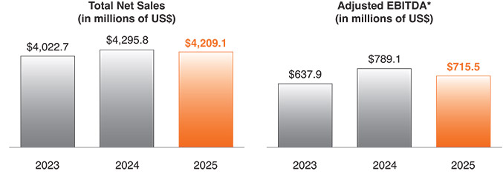
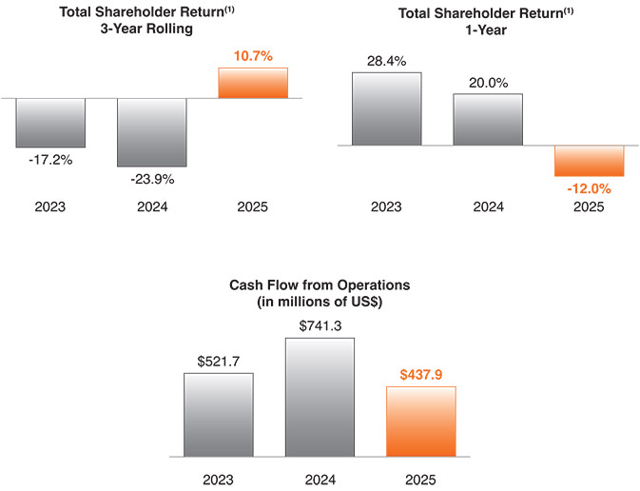
* A full discussion of our use of non-U.S. generally accepted accounting principles measures to provide a baseline for evaluating and comparing our operating results, and a reconciliation of Adjusted EBITDA to net income can be found in Item 7 of the Company’s Annual Report on Form 10-K for the fiscal year ended December 31, 2025.
(1) Total Shareholder Return reflects the compound annual price appreciation of Generac shares expressed as a percentage.

​ |  | ​ | ​ | 30 | ​ | ​ | 2026 Proxy Statement | ​

TABLE OF CONTENTS
Executive Compensation
Generac’s Executive Compensation Practices
The following best practices ensure alignment between stockholders and executives while maintaining strong corporate governance.
​ | WHAT WE DO: |  |  |  |  |  |  | ​
​ |  | ​ | ​ | Pay for Performance | ​ | ​ | On average 75% or more of NEO pay is at-risk or variable based on the achievement of specific annual and long-term strategic and financial goals. Further, the entire LTIP award value is directly aligned to the Company’s stock price. | ​
​ |  | ​ | ​ | Independent Compensation Consultant | ​ | ​ | An independent consultant is retained by the Human Capital and Compensation Committee. | ​
​ |  | ​ | ​ | Stock Ownership Guidelines | ​ | ​ | Market-based stock ownership guidelines have been established for executive officers and directors. | ​
​ |  | ​ | ​ | Compensation Risk Assessment | ​ | ​ | A compensation risk assessment is performed on an annual basis. In June 2025, the Human Capital and Compensation Committee, based on an assessment completed by their independent consultant, concluded that our compensation programs do not incentivize excessive risk-taking that could harm the Company or its stakeholders. | ​
​ |  | ​ | ​ | Clawback Policies | ​ | ​ | We have a clawback policy that requires all executive officers to return excess incentive-based compensation resulting from an applicable accounting restatement. There is a second clawback policy that requires the CEO, CFO, all other NEOs, as well as certain members of executive management, to reimburse or forfeit certain incentive compensation received in instances of gross negligence or misconduct that result in significant harm to the Company. | ​
​ | WHAT WE DO NOT DO: |  |  |  |  |  |  | ​
​ |  | ​ | ​ | Hedging of Company Stock | ​ | ​ | It is against Company policy to trade in puts or calls in Company securities, sell Company securities short, or otherwise hedge ownership of Company securities. | ​
​ |  | ​ | ​ | Pledging of Company Stock | ​ | ​ | Executive officers may not pledge Company securities or hold Company securities in margin accounts. | ​
​ |  | ​ | ​ | Tax Gross Ups | ​ | ​ | Executive officers do not receive tax gross ups either directly or indirectly. | ​
​ |  | ​ | ​ | Dividends on Unearned Equity Awards | ​ | ​ | Executive officers do not receive dividends on unearned performance shares or restricted stock. | ​
​ |  | ​ | ​ | “Single Trigger” Change in Control Severance Provisions | ​ | ​ | Executive officers do not have severance arrangements that trigger solely by virtue of a change in control. | ​

​ |  | ​ | ​ | 31 | ​ | ​ | 2026 Proxy Statement | ​

TABLE OF CONTENTS
Executive Compensation
ABOUT OUR EXECUTIVE COMPENSATION PROGRAM
Recent Executive Compensation Program Changes
In 2025, the Compensation Committee refined the methodology used to determine annual long-term incentive award values for executive officers as a dollar value, no longer as a percentage of base salary.
The Committee determined that a fixed-value framework better supports consistent positioning of executive long-term incentive awards relative to market benchmarks, internal equity and long-term performance objectives. The transition did not increase target total direct compensation for any executive officer beyond amounts approved through the Committee’s annual compensation review process.
In addition, in 2025, the Compensation Committee revised the design of the Company’s business group bonus plans to better balance business group performance with consolidated results. Under the updated design, the weighting of business group performance was reduced from 75% to 50%, with the remaining 50% based on consolidated Company results (Adjusted EBITDA), increasing alignment between the business-level execution and Company-wide performance objectives.
Philosophy and Objectives
We believe that the compensation program for our executives should directly support the achievement of specific annual, long-term, and strategic goals of the business and, thereby, align the interests of executives with the interests of our stockholders. Our compensation program is designed to balance rewards for corporate, business, and individual results.
We also believe that stockholders are best served when we can attract and retain high-caliber executive talent. To that end, we offer competitive base salaries, as well as annual and long-term incentive opportunities that encourage performance against specific objectives and reward our executives’ successful efforts. Within this context, the four major objectives for our executive compensation program are:
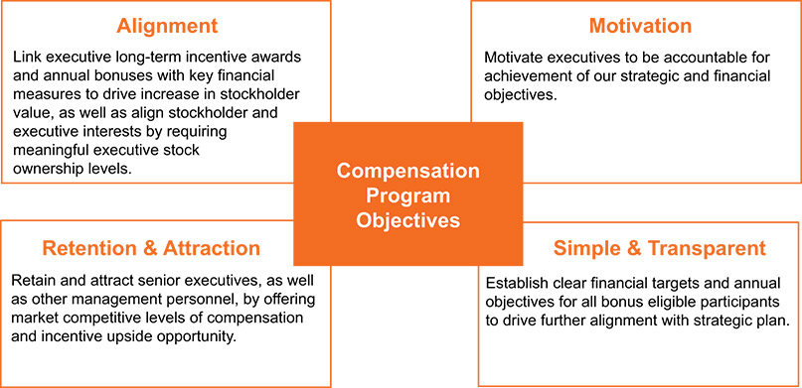

​ |  | ​ | ​ | 32 | ​ | ​ | 2026 Proxy Statement | ​

TABLE OF CONTENTS
Executive Compensation
To achieve these objectives, we have structured a compensation program that provides our executives with the following:
​ | Pay Element | ​ | ​ | Form | ​ | ​ | Purpose | ​
​ | Base Salary | ​ | ​ | Cash (Fixed) | ​ | ​ | Reflects position responsibilities, competitive market rates, strategic importance of the position, and individual experience. | ​
​ | Annual Performance Bonus Plan (Short- Term Incentive) | ​ | ​ | Cash (Variable) | ​ | ​ | Rewards achievement of Generac’s annual financial goals and other qualitative and quantitative performance objectives as determined by the Committee. | ​
​ | Long-Term Incentives | ​ | ​ | Equity (Variable) | ​ | ​ | Rewards strong performance by emphasizing incentives that drive long-term stockholder value. With performance shares representing 50% of our annual target equity awards and 25% each for restricted stock and stock options, our program reflects a strong focus on outcomes-based compensation as part of our pay-for-performance philosophy. | ​
The total direct compensation of our executives is market-based, and a significant portion of that compensation, including annual and long-term incentives, is also performance-based. The Committee believes this construct results in a fair level of pay for achieving target performance, and an above-market opportunity if the executive team exceeds target goals. We target total direct compensation (base salary, target annual bonus, and long-term equity incentives) around the median of the market, considering the relative responsibilities of our executives. Actual total compensation in any given year may be above or below the total target level based on individual, business group, and corporate performance.
Target Pay Mix
The charts below reflect the target pay mix for our CEO and average target pay mix for our other named executives, and show that the majority of the total target direct compensation for our CEO and other NEOs in 2025 was variable or at-risk:
​ | CEO Target Pay Mix | ​ | ​ | All Other NEOs  Avg Target Pay Mix | ​
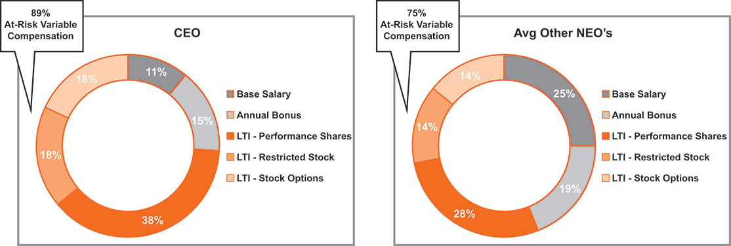

​ |  | ​ | ​ | 33 | ​ | ​ | 2026 Proxy Statement | ​

TABLE OF CONTENTS
Executive Compensation
HOW COMPENSATION DECISIONS ARE MADE
​ | ​ | Role of the Human Capital and Compensation Committee and Management | ​ | ​
The Committee, composed solely of independent directors, is responsible for making executive compensation decisions for the NEOs. The Committee works closely with its independent compensation consultant and management to examine pay and performance matters throughout the year.
In determining compensation for executive officers (or, in the case of the CEO, recommending it to the independent members of the Board of Directors), the Committee considers the following:
Competitive market pay data (see “Assessing External Market Practice” below)
•
​
Balance between short- and long-term incentives
•
​
Profitable growth and recent financial performance
•
​
Annual budget and long-range plan, as approved by the Board of Directors
•
​
Input from the CEO and EVP, Human Resources for positions other than their own; neither the CEO nor the EVP, Human Resources makes recommendations with respect to his or her own compensation
•
​
Evaluation of performance through the lens of our core values and leadership principles, including practicing integrity, driving innovation, demonstrating agility, operational excellence, developing our employees, and building a team environment
•
​
​ | ​ | The Role of the Independent Consultant | ​ | ​
In 2025, Pay Governance provided advice to the Committee regarding areas under its purview including peer group composition, executive market benchmarking and target pay setting, annual and long-term incentive design, and other compensation-related topics and trends. The Committee has assessed the independence of Pay Governance pursuant to the SEC rules and concluded that no conflict of interest exists that would prevent Pay Governance from independently advising the Committee.

​ |  | ​ | ​ | 34 | ​ | ​ | 2026 Proxy Statement | ​

TABLE OF CONTENTS
Executive Compensation
​ | ​ | Assessing External Market Practice | ​ | ​
Attracting and incentivizing high-caliber executive talent is a critical part of our compensation philosophy and leadership strategy. Therefore, integral to our approach for setting compensation levels is ensuring we have a competitive pay framework. In support of this objective, our independent compensation consultant annually provides the Committee with pay data for companies in the compensation peer group (“Peer Group”), as available, as well as for similar sized general industry and technology companies from published surveys (Peer Group and survey data are collectively referred to as “market data”). In 2025, market data was considered in determining market total direct compensation benchmarks for all NEOs. The Committee has generally targeted the market median for total cash compensation of our NEOs, with the opportunity to meet or exceed the market median if the Company achieves outstanding financial performance each year. The Committee has also set long-term incentive grant values at the market median, which may result in actual total direct compensation at or above the market median for outstanding financial performance and stock price appreciation from the date of grant.
Peer Group composition is also reviewed annually. At the Committee’s request, Pay Governance evaluated the Peer Group to ensure alignment with the Company’s strategy, business model, end markets and size. As part of the review, the Committee considered the following criteria for inclusion in the Peer Group: company type, geographic span, location, annual revenues, and other factors. Based on the foregoing criteria, no changes were made in 2025. Accordingly, the Committee examined the compensation practices of the following Peer Group companies as one of several inputs for 2025 compensation decisions:
​ | ​ | A.O. Smith Corporation (AOS) | ​ | ​ | Enphase Energy, Inc. (ENPH) | ​ | ​ | Lennox International, Inc. (LII) | ​ | ​ | Skyworks Solutions, Inc. (SWKS) | ​ | ​
​ | ​ | Acuity Brands, Inc. (AYI) | ​ | ​ | First Solar, Inc. (FSLR) | ​ | ​ | Nordson Corporation (NDSN) | ​ | ​ | Snap-on Incorporated (SNA) | ​ | ​
​ | ​ | AMETEK, Inc. (AME) | ​ | ​ | Hubbell Incorporated (HUBB) | ​ | ​ | Regal Rexnord Corporation (RRX) | ​ | ​ | SolarEdge Technologies, Inc. (SEDG) | ​ | ​
​ | ​ | Dover Corporation (DOV) | ​ | ​ | IDEX Corporation (IDEX) | ​ | ​ | Resideo Technologies, Inc. (REZI) | ​ | ​ | Sunrun Inc. (RUN) | ​ | ​
​ | ​ | EnerSys (ENS) | ​ | ​ | Ingersoll Rand, Inc. (IR) | ​ | ​ | Rockwell Automation, Inc. (ROK) | ​ | ​ | Xylem, Inc. (XYL) | ​ | ​
In September 2025, the Committee conducted its annual peer group assessment in preparation for benchmarking 2026 executive compensation. Following this review, the Company removed AMETEK, Inc., and SolarEdge Technologies, Inc. from the Peer Group and subsequently added Qorvo, Inc., and Sensata Technologies Holdings plc to the Peer Group. The Committee believes these changes better align the Peer Group to the Company’s strategy, business model, end markets, and size.

​ |  | ​ | ​ | 35 | ​ | ​ | 2026 Proxy Statement | ​

TABLE OF CONTENTS
Executive Compensation
​ | ​ | Stockholder Input and Outreach | ​ | ​
​
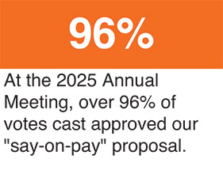
The Committee also considers the results of advisory “say-on-pay” stockholder votes when making compensation decisions. At the 2025 Annual Meeting of Stockholders, when the Company’s most recent advisory say-on-pay vote was held, over 96% of shares voting approved the compensation of the Company’s executive officers. The Committee believes that our say-on-pay vote results demonstrate strong stockholder support for our compensation practices. The Company currently holds say-on-pay votes every year.
During 2025, we met with various stockholders to discuss corporate governance, executive compensation, and other matters. The Board and the Committee consider feedback from these discussions as we review and evaluate our corporate governance practices and executive compensation programs.

​ |  | ​ | ​ | 36 | ​ | ​ | 2026 Proxy Statement | ​

TABLE OF CONTENTS
Executive Compensation
2025 EXECUTIVE COMPENSATION PROGRAM DECISIONS
Base Salary
The Committee reviews and approves base salary levels for named executive officers at the beginning of each year. The following decisions reflect the Committee’s consideration in February 2025 of external market practices, company performance, Peer Group and published survey data, and other factors, including the executive’s industry knowledge, experience, scope, complexity of position, skill set, performance, and future potential.
​ | Named Executive Officer | ​ | ​ | Annual Base  Salary at  12/31/2024 |  |  |  | ​ | ​ | Annual Base  Salary at  12/31/2025 |  |  |  | ​ | ​ | % Change |  |  |  | ​
​ | Aaron Jagdfeld | ​ | ​ | ​ | $ | 1,050,000 | ​ | ​ | ​ | ​ | $ | 1,100,000 | ​ | ​ | ​ | ​ | ​ | 4.8% | ​ | ​
​ | York Ragen | ​ | ​ | ​ | $ | 550,000 | ​ | ​ | ​ | ​ | $ | 578,000 | ​ | ​ | ​ | ​ | ​ | 5.1% | ​ | ​
​ | Norman Taffe | ​ | ​ | ​ | $ | 450,000 | ​ | ​ | ​ | ​ | $ | 466,000 | ​ | ​ | ​ | ​ | ​ | 3.6% | ​ | ​
​ | Erik Wilde | ​ | ​ | ​ | $ | 450,000 | ​ | ​ | ​ | ​ | $ | 466,000 | ​ | ​ | ​ | ​ | ​ | 3.6% | ​ | ​
​ | Raj Kanuru | ​ | ​ | ​ | $ | 440,000 | ​ | ​ | ​ | ​ | $ | 471,000 | ​ | ​ | ​ | ​ | ​ | 7.0% | ​ | ​
Based on sustained performance, market benchmarking and to further align pay to competitive market levels, the Committee increased Mr. Kanuru’s base salary 7.0%, which exceeded the general merit-based increases in base salaries for other NEOs.
Annual Performance Bonus Plan
Under the Annual Performance Bonus Plan, the Committee approved the financial targets of the 2025 Annual Incentive Plan (“AIP”). The target annual incentive is calculated as a percentage of base salary and is paid in cash.
In February 2025, the Committee approved increases to the target AIP award opportunity to align total direct compensation to market levels for Messrs. Jagdfeld and Ragen from 130% to 135% and 80% to 85% of salary, respectively. Target AIP multiples of salary remained unchanged for the other NEOs.
The Threshold, Target, and Maximum annual incentive opportunities as a percent of base salary for each NEO for 2025 are as follows:
​ | ​ | ​ | ​ | Bonus as % of Base Salary |  |  |  |  |  |  |  |  |  |  |  |  |  |  |  |  |  |  |  |  |  | ​ | ​ | Individual  Performance  Modifier(2) | ​
​ | Named Executive Officer | ​ | ​ | Below  Threshold |  |  |  | ​ | ​ | Threshold |  |  |  | ​ | ​ | Target |  |  |  | ​ | ​ | Maximum(1) |  |  |  | ​ | ​ | Individual  Performance  Modifier(2) | ​
​ | Aaron Jagdfeld | ​ | ​ | ​ | ​ | 0% | ​ | ​ | ​ | ​ | ​ | 67.5% | ​ | ​ | ​ | ​ | ​ | 135% | ​ | ​ | ​ | ​ | ​ | 270% | ​ | ​ | ​ | -100% to +15% | ​
​ | York Ragen | ​ | ​ | ​ | ​ | 0% | ​ | ​ | ​ | ​ | ​ | 42.5% | ​ | ​ | ​ | ​ | ​ | 85% | ​ | ​ | ​ | ​ | ​ | 170% | ​ | ​ | ​ | -100% to +15% | ​
​ | Norman Taffe | ​ | ​ | ​ | ​ | 0% | ​ | ​ | ​ | ​ | ​ | 40% | ​ | ​ | ​ | ​ | ​ | 80% | ​ | ​ | ​ | ​ | ​ | 160% | ​ | ​ | ​ | -100% to +15% | ​
​ | Erik Wilde | ​ | ​ | ​ | ​ | 0% | ​ | ​ | ​ | ​ | ​ | 37.5% | ​ | ​ | ​ | ​ | ​ | 75% | ​ | ​ | ​ | ​ | ​ | 150% | ​ | ​ | ​ | -100% to +15% | ​
​ | Raj Kanuru | ​ | ​ | ​ | ​ | 0% | ​ | ​ | ​ | ​ | ​ | 37.5% | ​ | ​ | ​ | ​ | ​ | 75% | ​ | ​ | ​ | ​ | ​ | 150% | ​ | ​ | ​ | -100% to +15% | ​
​
The Maximum annual incentive opportunity does not reflect an adjustment for the individual performance modifier.
(1)
​
In its discretion, the Committee may reduce the amount of any payout calculated in accordance with the financial measures to zero or increase the payout by up to 15% in recognition of individual achievements.
(2)
​

​ |  | ​ | ​ | 37 | ​ | ​ | 2026 Proxy Statement | ​

TABLE OF CONTENTS
Executive Compensation
For 2025, the financial metrics used to determine payouts under the consolidated AIP did not change from 2024, as the Committee determined that the plan effectively connected the CEO, our executives, and our employees to our strategy and appropriate financial metrics for managing the business. The two financial metrics are: Adjusted EBITDA (excluding the impact of acquisitions that occurred during the performance period and before deduction for noncontrolling interests), which constituted 75% of the target AIP opportunity, and Primary Working Capital (“PWC”) as a percentage of net sales, which constituted 25% of the target AIP opportunity. The Threshold payout level remained at 50% of target for both financial metrics.
An individual performance modifier can be applied after the company’s financial performance results are calculated and may result in a payout reduction to zero or an increase up to 15%.
Messrs. Jagdfeld, Ragen, and Kanuru had 100% of their cash incentive tied to the Company’s consolidated financial performance. Messrs. Taffe and Wilde had 50% of their cash incentive tied to the performance of a specific business group measured by Revenue and PWC as a percentage of net sales, as described below. We consider business group performance levels to be competitively sensitive information that is not otherwise disclosed; however, the Committee intended to apply the same general level of rigor in setting business group performance goals as in setting consolidated financial performance goals.
2025 Annual Performance Bonus Plan Results — Consolidated
The 2025 consolidated financial targets for Adjusted EBITDA and PWC (as a percentage of net sales) were $846.3 million and 29.9%, respectively.
Achievement of the consolidated financial targets would result in a 100% total payout, assuming no individual performance modifier was applied to recognize individual performance. Under the AIP, the consolidated Adjusted EBITDA (excluding the impact of acquisitions that occurred during the performance period and before deduction for noncontrolling interests) was $715.5 million, which is between the threshold and target. The consolidated PWC (as a percentage of net sales), excluding the impact of acquisitions, was 35.1%, which is below the threshold. As a result, the Committee approved a 46% of target payout for 2025 for those with enterprise-wide responsibilities, including Messrs. Jagdfeld, Ragen, and Kanuru.
​ | ​ | ​ | ​ | 2025 Financial Goals |  |  |  |  |  |  |  |  |  | ​ | ​ | ​ | ​
​ | Annual  Performance  Bonus Metrics –  Consolidated | ​ | ​ | Threshold | ​ | ​ | Target | ​ | ​ | Maximum | ​ | ​ | 2025 Achievement | ​ | ​ | Weighted  Payout % | ​
​ | Adjusted EBITDA (75%)* | ​ | ​ | $677.0 million | ​ | ​ | $846.3 million | ​ | ​ | $1,015.6 million | ​ | ​ | $715.5 million | ​ | ​ | 46.0% | ​
​ | PWC as % of Net Sales (25%) | ​ | ​ | 32.9% | ​ | ​ | 29.9% | ​ | ​ | 26.9% | ​ | ​ | 35.1% | ​ | ​ | 0.0% | ​
​ | Overall Payout | ​ | ​ | ​ | ​ | ​ | ​ | ​ | ​ | ​ | ​ | ​ | ​ | ​ | ​ | 46.0% | ​
​
Adjusted EBITDA under the AIP excludes the impact of acquisitions that occurred during the performance period and is calculated before deduction for noncontrolling interests.
*
​

​ |  | ​ | ​ | 38 | ​ | ​ | 2026 Proxy Statement | ​

TABLE OF CONTENTS
Executive Compensation
For the two other NEOs, AIP payouts were determined as follows:
​ | NEO | ​ | ​ | Metrics | ​ | ​ | Results | ​
​ | Norman Taffe | ​ | ​ | Energy Technology Revenue — 25%  Energy Technology PWC as % of Net Sales — 25%  Consolidated Adjusted EBITDA — 50% | ​ | ​ | Above Target  Above Target  Below Target | ​
​ | Erik Wilde | ​ | ​ | Domestic C&I Revenue — 25%  Domestic C&I PWC as % of Net Sales — 25%  Consolidated Adjusted EBITDA — 50% | ​ | ​ | Above Target  Above Target  Below Target | ​
The Committee reserves the discretion to adjust annual performance bonus payouts, regardless of results against incentive bonus metrics. For 2025, the Committee made no adjustments or modifications to the financial targets or payouts. The payout for financial results is then subject to the individual performance modifier, which is a multiplicative factor that can increase or decrease the final payout. The individual performance modifier allows adjustments to each NEO’s payout against defined, measurable goals established at the commencement of the year and developed to achieve specific initiatives related to the Company’s long-term strategy. The Committee determined the individual performance modifier for the CEO and reviewed the CEO’s recommendations for the other NEOs, considering each executive’s performance. An individual performance modifier was applied to the payout for one NEO (Mr. Wilde), as shown below, based on his performance relative to business group strategic and operational results.
​ | Named Executive Officer | ​ | ​ | AIP Target |  |  |  | ​ | ​ | 2025 AIP  Financial  Achievement(1) |  |  |  | ​ | ​ | Individual  Performance  Modifier |  |  |  | ​ | ​ | 2025 AIP  Payment |  |  |  | ​
​ | Aaron Jagdfeld | ​ | ​ | ​ | $ | 1,485,000 | ​ | ​ | ​ | ​ | ​ | 46.0% | ​ | ​ | ​ | ​ | ​ | 0% | ​ | ​ | ​ | ​ | $ | 683,286 | ​ | ​
​ | York Ragen | ​ | ​ | ​ | $ | 491,300 | ​ | ​ | ​ | ​ | ​ | 46.0% | ​ | ​ | ​ | ​ | ​ | 0% | ​ | ​ | ​ | ​ | $ | 226,059 | ​ | ​
​ | Norman Taffe | ​ | ​ | ​ | $ | 372,800 | ​ | ​ | ​ | ​ | ​ | 104.4% | ​ | ​ | ​ | ​ | ​ | 0% | ​ | ​ | ​ | ​ | $ | 389,203 | ​ | ​
​ | Erik Wilde | ​ | ​ | ​ | $ | 349,500 | ​ | ​ | ​ | ​ | ​ | 98.9% | ​ | ​ | ​ | ​ | ​ | +5% | ​ | ​ | ​ | ​ | $ | 362,847 | ​ | ​
​ | Raj Kanuru | ​ | ​ | ​ | $ | 353,250 | ​ | ​ | ​ | ​ | ​ | 46.0% | ​ | ​ | ​ | ​ | ​ | 0% | ​ | ​ | ​ | ​ | $ | 162,539 | ​ | ​
​
Achievement percentages are based on achievement of financial targets and are exclusive of the individual performance modifier.
(1)
​
Long-Term Incentives
Generac believes that equity awards are a critical component of a competitive, comprehensive annual compensation program for NEOs and other executives.
Our long-term incentive program (“LTIP”) is designed to reward our executives for their contribution to the Company’s long-term growth and performance, and to better align the interests of our NEOs with those of our stockholders. In addition, our long-term awards are used to attract and retain critical employee talent by providing a competitive market-based opportunity.

​ |  | ​ | ​ | 39 | ​ | ​ | 2026 Proxy Statement | ​

TABLE OF CONTENTS
Executive Compensation
The grants made in 2025 had the following terms:
Performance Shares. Fifty percent (50%) of the target award was granted in the form of performance shares, which are performance-based restricted stock units. NEOs may earn from 0% to 200% of their target performance share awards based on the achievement of specified revenue growth, EBITDA margin, and Free Cash Flow Conversion goals. Each performance share has a value equal to a share of common stock, and the number of shares that can be earned is contingent upon Company performance, over a three-year performance period, against goals approved by the Committee.
•
​
Restricted Stock. Twenty-five percent (25%) of the target award was granted in the form of time-based restricted stock, with those shares vesting equally over the three annual anniversaries immediately following the date of grant.
•
​
Stock Options. Twenty-five percent (25%) of the target award was granted in the form of stock options, with those options vesting equally over the four annual anniversaries immediately following the date of grant.
•
​
2025 Long-Term Equity Incentive Target Mix
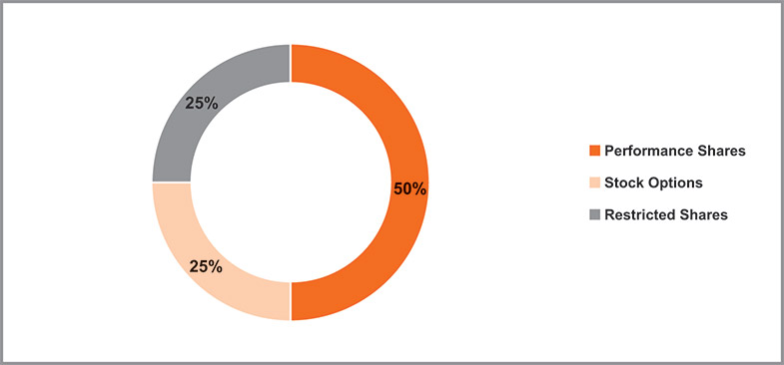
2025 Long-Term Equity Award Target Grant Values
The March 2025 grant date value of the LTIP awards to the NEOs were as follows:
​ | Named Executive Officer | ​ | ​ | Stock  Options |  |  |  | ​ | ​ | Restricted  Stock |  |  |  | ​ | ​ | Performance  Shares |  |  |  | ​ | ​ | Total LTIP Grants |  |  |  | ​
​ | Aaron Jagdfeld | ​ | ​ | ​ | $ | 1,750,006 | ​ | ​ | ​ | ​ | $ | 1,750,062 | ​ | ​ | ​ | ​ | $ | 3,500,123 | ​ | ​ | ​ | ​ | $ | 7,000,190 | ​ | ​
​ | York Ragen | ​ | ​ | ​ | $ | 375,027 | ​ | ​ | ​ | ​ | $ | 375,052 | ​ | ​ | ​ | ​ | $ | 750,104 | ​ | ​ | ​ | ​ | $ | 1,500,183 | ​ | ​
​ | Norman Taffe | ​ | ​ | ​ | $ | 250,042 | ​ | ​ | ​ | ​ | $ | 250,125 | ​ | ​ | ​ | ​ | $ | 500,115 | ​ | ​ | ​ | ​ | $ | 1,000,282 | ​ | ​
​ | Erik Wilde | ​ | ​ | ​ | $ | 250,042 | ​ | ​ | ​ | ​ | $ | 250,125 | ​ | ​ | ​ | ​ | $ | 500,115 | ​ | ​ | ​ | ​ | $ | 1,000,282 | ​ | ​
​ | Raj Kanuru | ​ | ​ | ​ | $ | 250,042 | ​ | ​ | ​ | ​ | $ | 250,125 | ​ | ​ | ​ | ​ | $ | 500,115 | ​ | ​ | ​ | ​ | $ | 1,000,282 | ​ | ​
2023-2025 Performance Share Results — Consolidated
The NEOs held performance shares granted in 2023 that could vest based on results during the three-year performance period covering 2023 to 2025. This grant was intended to encourage revenue growth measured in compound annual growth rate (“CAGR”), Adjusted EBITDA margin, and Free Cash Flow (“FCF”) Conversion for 2023 to 2025. Specifically, if the revenue CAGR,

​ |  | ​ | ​ | 40 | ​ | ​ | 2026 Proxy Statement | ​

TABLE OF CONTENTS
Executive Compensation
average Adjusted EBITDA margin, and FCF Conversion for the period were achieved within the defined range on the performance matrix, the NEOs would earn between 50% and 200% of their target performance share awards. The revenue CAGR, Adjusted EBITDA margin, and FCF Conversion targets were set at levels, given business conditions at the time the awards were granted, that were designed to be challenging yet achievable with strong management performance. At the end of the three-year period, the performance share targets were measured against Generac’s actual financial results, excluding any acquisitions during the period.
For the three-year period from 2023 to 2025, the Committee determined that the revenue CAGR and average adjusted EBITDA margin did not achieve threshold levels, while FCF Conversion exceeded the maximum level, resulting in vesting of the awards at 66.7% of Target. The Threshold, Target, and Maximum financial performance metrics and the actual results for the 2023 to 2025 performance awards are reflected in the table below:
​ | Performance Measure | ​ | ​ | Weight |  |  |  | ​ | ​ | Threshold |  |  |  | ​ | ​ | Target |  |  |  | ​ | ​ | Maximum |  |  |  | ​ | ​ | Actual 2023-2025  Cycle Results |  |  |  | ​ | ​ | Final  Vesting |  |  |  | ​
​ | Revenue Growth (CAGR) | ​ | ​ | ​ | ​ | 33% | ​ | ​ | ​ | ​ | ​ | 6.0% | ​ | ​ | ​ | ​ | ​ | 9.0% | ​ | ​ | ​ | ​ | ​ | 12.0% | ​ | ​ | ​ | ​ | ​ | -2.7% | ​ | ​ | ​ | ​ | ​ | ​ | ​ | ​
​ | Adjusted EBITDA Margin % | ​ | ​ | ​ | ​ | 33% | ​ | ​ | ​ | ​ | ​ | 19.0% | ​ | ​ | ​ | ​ | ​ | 20.5% | ​ | ​ | ​ | ​ | ​ | 22.0% | ​ | ​ | ​ | ​ | ​ | 17.1% | ​ | ​ | ​ | ​ | ​ | 66.7% | ​ | ​
​ | FCF Conversion % | ​ | ​ | ​ | ​ | 33% | ​ | ​ | ​ | ​ | ​ | 90.0% | ​ | ​ | ​ | ​ | ​ | 95.0% | ​ | ​ | ​ | ​ | ​ | 100.0% | ​ | ​ | ​ | ​ | ​ | 110.3% | ​ | ​ | ​ | ​ | ​ | ​ | ​ | ​
2023-2025 Performance Share Results — Energy Technology
In September 2022, the Committee granted Mr. Taffe a supplemental performance share award with a target value of $1,500,000, designed to vest based on business group performance for the period January 1, 2023 through December 31, 2025. The performance metrics for this award are financial and operational goals associated with the Company’s Energy Technology business group. Consistent with our longstanding practice, performance goals and results at the business group level are considered highly sensitive competitive information and therefore are not disclosed. All other terms of this supplemental award are consistent with the performance share awards granted to other executives in 2023. The Committee approved this supplemental grant to motivate and retain Mr. Taffe during a period of significant strategic execution and to further link compensation to long-term value creation.
For the three-year period from 2023 to 2025, the Committee determined that the revenue CAGR and average adjusted EBITDA margin did not achieve threshold levels, and Inventory dollars at December 31, 2025 results were between the threshold and target levels. The actual results for the 2023 to 2025 performance awards granted to Mr. Taffe are reflected in the table below:
​ | NEO | ​ | ​ | Metrics | ​ | ​ | Results | ​ | ​ | Final Vesting | ​
​ | Norman Taffe | ​ | ​ | Revenue Growth (CAGR) — 33%  Average EBITDA Margin % — 33%  Inventory dollars at December 31, 2025 — 33% | ​ | ​ | Below Threshold  Below Threshold  Below Target | ​ | ​ | 27.2% | ​

​ |  | ​ | ​ | 41 | ​ | ​ | 2026 Proxy Statement | ​

TABLE OF CONTENTS
Executive Compensation
Key 2026 Compensation Decisions
For 2026, no significant changes were made to the design of the Company’s annual compensation programs; however, the business group weighting and metrics will be based on Business Group Revenue (25%), Business Group EBITDA (25%), and Consolidated Bonus Plan Results, which are based on Consolidated Adjusted EBITDA and PWC as a% of Net Sales, (50%) to create a more balanced, internally aligned framework. These updates reward both business-level execution and achievement of Company-wide performance goals.
On March 20, 2026, the Committee approved certain incremental equity awards for Mr. Taffe and Mr. Wilde, which were granted April 1, 2026. The equity award for Mr. Taffe includes an award of performance shares with a target value of $1 million that vests on the second anniversary of the grant date, subject to the achievement of certain performance metrics with a performance period ending December 31, 2027. The equity award for Mr. Wilde includes an award of performance shares with a target value of $2 million that vests on the third anniversary of the grant date, subject to the achievement of certain performance metrics with a performance period ending December 31, 2028. Messrs. Taffe and Wilde may earn 0% to 200% of the target performance share award based on the achievement of specified performance conditions unique to each award that were established by the Committee. Such awards are intended to align the interests of Messrs. Taffe and Wilde with the Company’s Generac Home and Domestic C&I initiatives, respectively.

​ |  | ​ | ​ | 42 | ​ | ​ | 2026 Proxy Statement | ​

TABLE OF CONTENTS
Executive Compensation
OTHER PRACTICES, POLICIES & GUIDELINES
Clawback Policies
The Company maintains a clawback policy that allows for the recoupment of incentive compensation from the CEO, CFO and other key members of executive management (collectively, Covered Employees) in the event of an accounting restatement, as required under SEC and NYSE rules. Under this policy, the Company will recover erroneously awarded incentive-based compensation received by Covered Employees that exceeds what would have been received based on the restated financial results. Recovery will occur in a reasonable and prompt manner using any lawful method, subject to limited exceptions permitted by NYSE listing standards.
In addition to the SEC- and NYSE-mandated requirements, the Company also maintains a second policy that permits the recoupment or forfeiture of certain incentive compensation from Covered Employees in cases of gross negligence, misconduct, or violations of law or Company policy that result in significant financial or reputational harm.
Stock Ownership and Retention Guidelines
The Committee believes that it is in the best interest of Generac and its stockholders to align the financial interests of the Company’s officers and directors with those of Generac’s stockholders by requiring officers and directors to establish and maintain a permanent minimum ownership position in Company stock (based on the market value of our common stock), and by limiting the ability to sell Company stock until guideline ownership levels have been achieved. In addition, the Committee believes that the investment community values stock ownership by such officers and that share ownership demonstrates a commitment to and belief in the long-term strategic direction of Generac. Accordingly, the following stock ownership guidelines have been established for the Company’s officers and directors, including all the NEOs.
​ | Position/Level | ​ | ​ | Stock Ownership Requirements | ​
​ | Non-Employee Directors | ​ | ​ | 5 times annual retainer | ​
​ | Chief Executive Officer | ​ | ​ | 6 times annual base salary | ​
​ | Top Executives | ​ | ​ | 3 times annual base salary | ​
Executives are expected to build ownership value over time because of their performance and participation in the Company’s equity compensation programs. Under the guidelines, no period is specified for compliance by new officers and the Board of Directors, however executives have retention requirements to remain in compliance until the stock ownership guidelines are met. In the event of a promotion to a new level or a significant reduction in stock price, executives have three years to meet the applicable new minimum ownership requirement. The Committee reviewed a market analysis of stock ownership guidelines and approved changes at the September 2025 meeting. Specifically, it simplified the retention ratios to be 50% of after-tax shares received from compensatory equity awards; however, if an executive is not in compliance after 5 years, the retention ratio is 100% of after-tax shares. As of March 31, 2026, all NEOs have met their ownership requirements.
Long-Term Equity Award Grant Timing
The Committee generally makes grants of long-term equity awards to our NEOs at the first Committee meeting of our fiscal year, which is the same meeting at which the Committee takes other compensation actions and performs its annual performance evaluation of management. Annual long-term equity awards for our officers occur on the same date as long-term equity awards for our other professional and managerial employees, which is typically on March 1 of

​ |  | ​ | ​ | 43 | ​ | ​ | 2026 Proxy Statement | ​

TABLE OF CONTENTS
Executive Compensation
the fiscal year. Awards are neither timed to relate to the price of our stock nor to correspond with the release of material non-public information, although grants are generally made when our trading window is open. We may make grants to new employees, including potential NEOs, upon hire. Awards for NEOs are made following committee approval and typically occur in the quarter following the employee’s start date.
During 2025, we did not award stock options or stock appreciation rights to any of our NEOs in the period beginning four business days before our filing of a Form 10-Q or Form 10-K, or the filing or furnishing of a Form 8-K that disclosed material nonpublic information, and ending one business day after the filing or furnishing of such report.
Benefits and Perquisites
Generac does not provide special medical, dental, insurance or disability benefits for the NEOs beyond that offered to all employees. In addition, Generac does not offer special perquisites for any of the NEOs.
Retirement Plans
The NEOs are eligible to participate in the Generac Power Systems, Inc. Employees 401(k) Savings Plan on the same terms as other participating employees.

​ |  | ​ | ​ | 44 | ​ | ​ | 2026 Proxy Statement | ​

TABLE OF CONTENTS​
Report of the Human Capital and Compensation Committee
The Human Capital and Compensation Committee has reviewed and discussed the Compensation Discussion and Analysis section with our management. Based upon this review and discussion, the Human Capital and Compensation Committee recommended to the Board of Directors that the Compensation Discussion and Analysis section be included in this Proxy Statement, which has been incorporated by reference in our Annual Report on Form 10-K for the fiscal year ended December 31, 2025.
Respectfully submitted by the Human Capital and Compensation Committee of the Board of Directors.
Marcia Avedon, Chair
William Jenkins
Nam Nguyen
Bennett Morgan
Dominick Zarcone

​ |  | ​ | ​ | 45 | ​ | ​ | 2026 Proxy Statement | ​

TABLE OF CONTENTS

2025 Summary Compensation Table
The following table shows compensation information for 2023, 2024 and 2025 for our named executive officers.
​ | Name and principal position | ​ | ​ | Year |  |  |  | ​ | ​ | Salary  ($) |  |  |  | ​ | ​ | Bonus  ($) |  |  |  | ​ | ​ | Stock  awards  ($)(1) |  |  |  | ​ | ​ | Option  awards  ($)(1) |  |  |  | ​ | ​ | Non-equity  incentive plan  compensation  ($)(2) |  |  |  | ​ | ​ | All other  compensation  ($)(3) |  |  |  | ​ | ​ | Total  ($) |  |  |  | ​
​ | Aaron Jagdfeld  Chairman, President and Chief Executive Officer | ​ | ​ | ​ | ​ | 2025 | ​ | ​ | ​ | ​ | ​ | 1,090,548 | ​ | ​ | ​ | ​ | ​ | — | ​ | ​ | ​ | ​ | ​ | 5,250,185 | ​ | ​ | ​ | ​ | ​ | 1,750,006 | ​ | ​ | ​ | ​ | ​ | 683,286 | ​ | ​ | ​ | ​ | ​ | 35,740 | ​ | ​ | ​ | ​ | ​ | 8,809,765 | ​ | ​
​ |  | ​ | ​ | ​ | ​ | 2024 | ​ | ​ | ​ | ​ | ​ | 1,050,000 | ​ | ​ | ​ | ​ | ​ | — | ​ | ​ | ​ | ​ | ​ | 4,687,703 | ​ | ​ | ​ | ​ | ​ | 1,562,539 | ​ | ​ | ​ | ​ | ​ | 1,963,553 | ​ | ​ | ​ | ​ | ​ | 34,171 | ​ | ​ | ​ | ​ | ​ | 9,297,966 | ​ | ​
​ |  | ​ | ​ | ​ | ​ | 2023 | ​ | ​ | ​ | ​ | ​ | 1,050,000 | ​ | ​ | ​ | ​ | ​ | — | ​ | ​ | ​ | ​ | ​ | 3,996,222 | ​ | ​ | ​ | ​ | ​ | 2,004,001 | ​ | ​ | ​ | ​ | ​ | — | ​ | ​ | ​ | ​ | ​ | 34,742 | ​ | ​ | ​ | ​ | ​ | 7,084,966 | ​ | ​
​ | York Ragen  Chief Financial Officer | ​ | ​ | ​ | ​ | 2025 | ​ | ​ | ​ | ​ | ​ | 572,707 | ​ | ​ | ​ | ​ | ​ | — | ​ | ​ | ​ | ​ | ​ | 1,125,156 | ​ | ​ | ​ | ​ | ​ | 375,027 | ​ | ​ | ​ | ​ | ​ | 226,059 | ​ | ​ | ​ | ​ | ​ | 22,758 | ​ | ​ | ​ | ​ | ​ | 2,321,707 | ​ | ​
​ | York Ragen  Chief Financial Officer | ​ | ​ | ​ | ​ | 2024 | ​ | ​ | ​ | ​ | ​ | 545,150 | ​ | ​ | ​ | ​ | ​ | — | ​ | ​ | ​ | ​ | ​ | 984,387 | ​ | ​ | ​ | ​ | ​ | 328,138 | ​ | ​ | ​ | ​ | ​ | 632,936 | ​ | ​ | ​ | ​ | ​ | 21,433 | ​ | ​ | ​ | ​ | ​ | 2,512,044 | ​ | ​
​ | York Ragen  Chief Financial Officer | ​ | ​ | ​ | ​ | 2023 | ​ | ​ | ​ | ​ | ​ | 525,000 | ​ | ​ | ​ | ​ | ​ | — | ​ | ​ | ​ | ​ | ​ | 874,316 | ​ | ​ | ​ | ​ | ​ | 438,418 | ​ | ​ | ​ | ​ | ​ | — | ​ | ​ | ​ | ​ | ​ | 19,846 | ​ | ​ | ​ | ​ | ​ | 1,857,580 | ​ | ​
​ | Norman Taffe  President, Generac Home | ​ | ​ | ​ | ​ | 2025 | ​ | ​ | ​ | ​ | ​ | 462,975 | ​ | ​ | ​ | ​ | ​ | — | ​ | ​ | ​ | ​ | ​ | 750,240 | ​ | ​ | ​ | ​ | ​ | 250,042 | ​ | ​ | ​ | ​ | ​ | 389,203 | ​ | ​ | ​ | ​ | ​ | 14,305 | ​ | ​ | ​ | ​ | ​ | 1,866,765 | ​ | ​
​ | Norman Taffe  President, Generac Home | ​ | ​ | ​ | ​ | 2024 | ​ | ​ | ​ | ​ | ​ | 446,799 | ​ | ​ | ​ | ​ | ​ | — | ​ | ​ | ​ | ​ | ​ | 2,650,447 | ​ | ​ | ​ | ​ | ​ | 216,782 | ​ | ​ | ​ | ​ | ​ | 246,175 | ​ | ​ | ​ | ​ | ​ | 11,499 | ​ | ​ | ​ | ​ | ​ | 3,571,702 | ​ | ​
​ | Norman Taffe  President, Generac Home | ​ | ​ | ​ | ​ | 2023 | ​ | ​ | ​ | ​ | ​ | 426,956 | ​ | ​ | ​ | ​ | ​ | — | ​ | ​ | ​ | ​ | ​ | 1,495,415 | ​ | ​ | ​ | ​ | ​ | 248,777 | ​ | ​ | ​ | ​ | ​ | 50,160 | ​ | ​ | ​ | ​ | ​ | 10,106 | ​ | ​ | ​ | ​ | ​ | 2,231,115 | ​ | ​
​ | Erik Wilde  President, Domestic C&I | ​ | ​ | ​ | ​ | 2025 | ​ | ​ | ​ | ​ | ​ | 462,975 | ​ | ​ | ​ | ​ | ​ | — | ​ | ​ | ​ | ​ | ​ | 750,240 | ​ | ​ | ​ | ​ | ​ | 250,042 | ​ | ​ | ​ | ​ | ​ | 362,847 | ​ | ​ | ​ | ​ | ​ | 18,059 | ​ | ​ | ​ | ​ | ​ | 1,844,163 | ​ | ​
​ | Erik Wilde  President, Domestic C&I | ​ | ​ | ​ | ​ | 2024 | ​ | ​ | ​ | ​ | ​ | 447,439 | ​ | ​ | ​ | ​ | ​ | — | ​ | ​ | ​ | ​ | ​ | 655,359 | ​ | ​ | ​ | ​ | ​ | 218,442 | ​ | ​ | ​ | ​ | ​ | 600,656 | ​ | ​ | ​ | ​ | ​ | 20,154 | ​ | ​ | ​ | ​ | ​ | 1,942,050 | ​ | ​
​ | Erik Wilde  President, Domestic C&I | ​ | ​ | ​ | ​ | 2023 | ​ | ​ | ​ | ​ | ​ | 423,866 | ​ | ​ | ​ | ​ | ​ | — | ​ | ​ | ​ | ​ | ​ | 489,636 | ​ | ​ | ​ | ​ | ​ | 245,490 | ​ | ​ | ​ | ​ | ​ | 459,427 | ​ | ​ | ​ | ​ | ​ | 12,250 | ​ | ​ | ​ | ​ | ​ | 1,630,669 | ​ | ​
​ | Raj Kanuru  Executive VP, General Counsel & Secretary | ​ | ​ | ​ | ​ | 2025 | ​ | ​ | ​ | ​ | ​ | 465,140 | ​ | ​ | ​ | ​ | ​ | — | ​ | ​ | ​ | ​ | ​ | 750,240 | ​ | ​ | ​ | ​ | ​ | 250,042 | ​ | ​ | ​ | ​ | ​ | 162,539 | ​ | ​ | ​ | ​ | ​ | 20,809 | ​ | ​ | ​ | ​ | ​ | 1,648,770 | ​ | ​
​
The amounts reported for 2025 represent the aggregate grant date fair value for awards of restricted stock, stock options, and performance shares and are computed in accordance with Financial Accounting Standards Board Accounting Standards Codification Subtopic 718. See Note 17 to the Consolidated Financial Statements included in our Annual Report on Form 10-K for the year ended December 31, 2025 for a discussion of the relevant assumptions used in calculating these amounts. All amounts represent potential future income calculated for financial reporting purposes; actual amounts recognized by the named executive officers may be materially different depending on, among other things, the Company’s stock price performance and the period of service of the executive. The Stock Award amounts are composed of approximately 33% restricted stock and approximately 67% performance shares, with the performance share portion assuming target performance by the Company during the relevant performance period. The values of the performance shares at grant date if the maximum potential payout is made would be as follows: Mr. Jagdfeld — $7,000,246, Mr. Ragen — $1,500,208, Mr. Taffe — $1,000,229, Mr. Wilde — $1,000,229, and Mr. Kanuru — $1,000,229.
(1)
​
The non-equity incentive plan compensation column reflects cash incentive awards earned pursuant to our Annual Performance Bonus Plan as previously described. These awards are earned during the year reflected and paid in the following year.
(2)
​
All other compensation represents the employer matching contributions, unused vacation payout, and employer nonelective contributions of the 401(k) Savings Plan. The employer matching contributions were $11,087, $11,642, $11,750, $11,750 and $11,751 for Mr. Jagdfeld, Mr. Ragen, Mr. Taffe, Mr. Wilde, and Mr. Kanuru respectively. The unused vacation payouts were $21,154 and $11,115 for Mr. Jagdfeld and Mr. Ragen, respectively.
(3)
​

​ |  | ​ | ​ | 46 | ​ | ​ | 2026 Proxy Statement | ​

TABLE OF CONTENTS

Grants of Plan-Based Awards in 2025
The following table indicates potential cash incentive compensation under our Annual Performance Bonus Plan based on 2025 performance and equity awards granted in 2025 under our Amended and Restated 2019 Equity Incentive Plan.
​ | ​ | ​ | ​ | ​ | ​ | ​ | ​ | ​ | ​ | ​ | ​ | ​ | ​ | ​ | ​ | Possible payouts  under non-equity  incentive plan awards(1) |  |  |  |  |  |  |  |  |  |  |  |  |  |  |  | ​ | ​ | Possible payouts  under equity  incentive plan awards(2) |  |  |  |  |  |  |  |  |  |  |  |  |  |  |  | ​ | ​ | All other  stock  awards:  number of  shares of  stock or  units  (#)(3) |  |  |  | ​ | ​ | All other  option  awards:  number of  securities  underlying  options  (#)(4) |  |  |  | ​ | ​ | Exercise  or base  price of  option  awards  ($/sh)(5) |  |  |  | ​ | ​ | Closing  market  price on  date  of  grant  ($/sh) |  |  |  | ​ | ​ | Grant  date  fair value  of stock  and  option  awards  ($)(6) |  |  |  | ​
​ | Name | ​ | ​ | Grant  Date |  |  |  | ​ | ​ | Approval  Date |  |  |  | ​ | ​ | Threshold  ($) |  |  |  | ​ | ​ | Target  ($) |  |  |  | ​ | ​ | Maximum  ($) |  |  |  | ​ | ​ | Threshold  (#) |  |  |  | ​ | ​ | Target  (#) |  |  |  | ​ | ​ | Maximum  (#) |  |  |  | ​
​ | Aaron Jagdfeld | ​ | ​ | ​ | ​ | — | ​ | ​ | ​ | ​ | ​ | — | ​ | ​ | ​ | ​ | ​ | 742,500 | ​ | ​ | ​ | ​ | ​ | 1,485,000 | ​ | ​ | ​ | ​ | ​ | 2,970,000 | ​ | ​ | ​ | ​ | ​ | — | ​ | ​ | ​ | ​ | ​ | — | ​ | ​ | ​ | ​ | ​ | — | ​ | ​ | ​ | ​ | ​ | — | ​ | ​ | ​ | ​ | ​ | — | ​ | ​  ​  ​  ​  —  ​  ​  ​  ​  ​  —  ​  ​  ​  ​  ​  —  ​  ​
​ | Aaron Jagdfeld | ​ | ​ | ​ | ​ | 3/1/25 | ​ | ​ | ​ | ​ | ​ | 2/28/25 | ​ | ​ | ​ | ​ | ​ | — | ​ | ​ | ​ | ​ | ​ | — | ​ | ​ | ​ | ​ | ​ | — | ​ | ​ | ​ | ​ | ​ | 12,888 | ​ | ​ | ​ | ​ | ​ | 25,776 | ​ | ​ | ​ | ​ | ​ | 51,552 | ​ | ​ | ​ | ​ | ​ | — | ​ | ​ | ​ | ​ | ​ | — | ​ | ​  ​  ​  ​  —  ​  ​  ​  ​  ​  —  ​  ​  ​  ​  ​  3,500,123  ​  ​
​ | Aaron Jagdfeld | ​ | ​ | ​ | ​ | 3/1/25 | ​ | ​ | ​ | ​ | ​ | 2/28/25 | ​ | ​ | ​ | ​ | ​ | — | ​ | ​ | ​ | ​ | ​ | — | ​ | ​ | ​ | ​ | ​ | — | ​ | ​ | ​ | ​ | ​ | — | ​ | ​ | ​ | ​ | ​ | — | ​ | ​ | ​ | ​ | ​ | — | ​ | ​ | ​ | ​ | ​ | 12,888 | ​ | ​ | ​ | ​ | ​ | — | ​ | ​  ​  ​  ​  —  ​  ​  ​  ​  ​  —  ​  ​  ​  ​  ​  1,750,062  ​  ​
​ | Aaron Jagdfeld | ​ | ​ | ​ | ​ | 3/1/25 | ​ | ​ | ​ | ​ | ​ | 2/28/25 | ​ | ​ | ​ | ​ | ​ | — | ​ | ​ | ​ | ​ | ​ | — | ​ | ​ | ​ | ​ | ​ | — | ​ | ​ | ​ | ​ | ​ | — | ​ | ​ | ​ | ​ | ​ | — | ​ | ​ | ​ | ​ | ​ | — | ​ | ​ | ​ | ​ | ​ | — | ​ | ​ | ​ | ​ | ​ | 24,251 | ​ | ​  ​  ​  $  135.79  ​  ​  ​  ​  $  136.15  ​  ​  ​  ​  ​  1,750,006  ​  ​
​ | York Ragen | ​ | ​ | ​ | ​ | — | ​ | ​ | ​ | ​ | ​ | — | ​ | ​ | ​ | ​ | ​ | 245,650 | ​ | ​ | ​ | ​ | ​ | 491,300 | ​ | ​ | ​ | ​ | ​ | 982,600 | ​ | ​ | ​ | ​ | ​ | — | ​ | ​ | ​ | ​ | ​ | — | ​ | ​ | ​ | ​ | ​ | — | ​ | ​ | ​ | ​ | ​ | — | ​ | ​ | ​ | ​ | ​ | — | ​ | ​  ​  ​  ​  —  ​  ​  ​  ​  ​  —  ​  ​  ​  ​  ​  —  ​  ​
​ | York Ragen | ​ | ​ | ​ | ​ | 3/1/25 | ​ | ​ | ​ | ​ | ​ | 2/28/25 | ​ | ​ | ​ | ​ | ​ | — | ​ | ​ | ​ | ​ | ​ | — | ​ | ​ | ​ | ​ | ​ | — | ​ | ​ | ​ | ​ | ​ | 2,762 | ​ | ​ | ​ | ​ | ​ | 5,524 | ​ | ​ | ​ | ​ | ​ | 11,048 | ​ | ​ | ​ | ​ | ​ | — | ​ | ​ | ​ | ​ | ​ | — | ​ | ​  ​  ​  ​  —  ​  ​  ​  ​  ​  —  ​  ​  ​  ​  ​  750,104  ​  ​
​ | York Ragen | ​ | ​ | ​ | ​ | 3/1/25 | ​ | ​ | ​ | ​ | ​ | 2/28/25 | ​ | ​ | ​ | ​ | ​ | — | ​ | ​ | ​ | ​ | ​ | — | ​ | ​ | ​ | ​ | ​ | — | ​ | ​ | ​ | ​ | ​ | — | ​ | ​ | ​ | ​ | ​ | — | ​ | ​ | ​ | ​ | ​ | — | ​ | ​ | ​ | ​ | ​ | 2,762 | ​ | ​ | ​ | ​ | ​ | — | ​ | ​  ​  ​  ​  —  ​  ​  ​  ​  ​  —  ​  ​  ​  ​  ​  375,052  ​  ​
​ | York Ragen | ​ | ​ | ​ | ​ | 3/1/25 | ​ | ​ | ​ | ​ | ​ | 2/28/25 | ​ | ​ | ​ | ​ | ​ | — | ​ | ​ | ​ | ​ | ​ | — | ​ | ​ | ​ | ​ | ​ | — | ​ | ​ | ​ | ​ | ​ | — | ​ | ​ | ​ | ​ | ​ | — | ​ | ​ | ​ | ​ | ​ | — | ​ | ​ | ​ | ​ | ​ | — | ​ | ​ | ​ | ​ | ​ | 5,197 | ​ | ​  ​  ​  $  135.79  ​  ​  ​  ​  $  136.15  ​  ​  ​  ​  ​  375,027  ​  ​
​ | Norman Taffe | ​ | ​ | ​ | ​ | — | ​ | ​ | ​ | ​ | ​ | — | ​ | ​ | ​ | ​ | ​ | 186,400 | ​ | ​ | ​ | ​ | ​ | 372,800 | ​ | ​ | ​ | ​ | ​ | 745,600 | ​ | ​ | ​ | ​ | ​ | — | ​ | ​ | ​ | ​ | ​ | — | ​ | ​ | ​ | ​ | ​ | — | ​ | ​ | ​ | ​ | ​ | — | ​ | ​ | ​ | ​ | ​ | — | ​ | ​  ​  ​  ​  —  ​  ​  ​  ​  ​  —  ​  ​  ​  ​  ​  —  ​  ​
​ | Norman Taffe | ​ | ​ | ​ | ​ | 3/1/25 | ​ | ​ | ​ | ​ | ​ | 2/28/25 | ​ | ​ | ​ | ​ | ​ | — | ​ | ​ | ​ | ​ | ​ | — | ​ | ​ | ​ | ​ | ​ | — | ​ | ​ | ​ | ​ | ​ | 1,842 | ​ | ​ | ​ | ​ | ​ | 3,683 | ​ | ​ | ​ | ​ | ​ | 7,366 | ​ | ​ | ​ | ​ | ​ | — | ​ | ​ | ​ | ​ | ​ | — | ​ | ​  ​  ​  ​  —  ​  ​  ​  ​  ​  —  ​  ​  ​  ​  ​  500,115  ​  ​
​ | Norman Taffe | ​ | ​ | ​ | ​ | 3/1/25 | ​ | ​ | ​ | ​ | ​ | 2/28/25 | ​ | ​ | ​ | ​ | ​ | — | ​ | ​ | ​ | ​ | ​ | — | ​ | ​ | ​ | ​ | ​ | — | ​ | ​ | ​ | ​ | ​ | — | ​ | ​ | ​ | ​ | ​ | — | ​ | ​ | ​ | ​ | ​ | — | ​ | ​ | ​ | ​ | ​ | 1,842 | ​ | ​ | ​ | ​ | ​ | — | ​ | ​  ​  ​  ​  —  ​  ​  ​  ​  ​  —  ​  ​  ​  ​  ​  250,125  ​  ​
​ | Norman Taffe | ​ | ​ | ​ | ​ | 3/1/25 | ​ | ​ | ​ | ​ | ​ | 2/28/25 | ​ | ​ | ​ | ​ | ​ | — | ​ | ​ | ​ | ​ | ​ | — | ​ | ​ | ​ | ​ | ​ | — | ​ | ​ | ​ | ​ | ​ | — | ​ | ​ | ​ | ​ | ​ | — | ​ | ​ | ​ | ​ | ​ | — | ​ | ​ | ​ | ​ | ​ | — | ​ | ​ | ​ | ​ | ​ | 3,465 | ​ | ​  ​  ​  $  135.79  ​  ​  ​  ​  $  136.15  ​  ​  ​  ​  ​  250,042  ​  ​
​ | Erik Wilde | ​ | ​ | ​ | ​ | — | ​ | ​ | ​ | ​ | ​ | — | ​ | ​ | ​ | ​ | ​ | 174,750 | ​ | ​ | ​ | ​ | ​ | 349,500 | ​ | ​ | ​ | ​ | ​ | 699,000 | ​ | ​ | ​ | ​ | ​ | — | ​ | ​ | ​ | ​ | ​ | — | ​ | ​ | ​ | ​ | ​ | — | ​ | ​ | ​ | ​ | ​ | ​ | ​ | ​ | ​ | ​ | ​ | ​ | ​ | ​  ​  ​  ​  ​  ​  ​  ​  ​  ​  ​  ​  ​  ​  ​  ​  ​  ​  ​
​ | Erik Wilde | ​ | ​ | ​ | ​ | 3/1/25 | ​ | ​ | ​ | ​ | ​ | 2/28/25 | ​ | ​ | ​ | ​ | ​ | — | ​ | ​ | ​ | ​ | ​ | — | ​ | ​ | ​ | ​ | ​ | — | ​ | ​ | ​ | ​ | ​ | 1,842 | ​ | ​ | ​ | ​ | ​ | 3,683 | ​ | ​ | ​ | ​ | ​ | 7,366 | ​ | ​ | ​ | ​ | ​ | — | ​ | ​ | ​ | ​ | ​ | — | ​ | ​  ​  ​  ​  —  ​  ​  ​  ​  ​  —  ​  ​  ​  ​  ​  500,115  ​  ​
​ | Erik Wilde | ​ | ​ | ​ | ​ | 3/1/25 | ​ | ​ | ​ | ​ | ​ | 2/28/25 | ​ | ​ | ​ | ​ | ​ | — | ​ | ​ | ​ | ​ | ​ | — | ​ | ​ | ​ | ​ | ​ | — | ​ | ​ | ​ | ​ | ​ | — | ​ | ​ | ​ | ​ | ​ | — | ​ | ​ | ​ | ​ | ​ | — | ​ | ​ | ​ | ​ | ​ | 1,842 | ​ | ​ | ​ | ​ | ​ | — | ​ | ​  ​  ​  ​  —  ​  ​  ​  ​  ​  —  ​  ​  ​  ​  ​  250,125  ​  ​
​ | Erik Wilde | ​ | ​ | ​ | ​ | 3/1/25 | ​ | ​ | ​ | ​ | ​ | 2/28/25 | ​ | ​ | ​ | ​ | ​ | — | ​ | ​ | ​ | ​ | ​ | — | ​ | ​ | ​ | ​ | ​ | — | ​ | ​ | ​ | ​ | ​ | — | ​ | ​ | ​ | ​ | ​ | — | ​ | ​ | ​ | ​ | ​ | — | ​ | ​ | ​ | ​ | ​ | — | ​ | ​ | ​ | ​ | ​ | 3,465 | ​ | ​  ​  ​  $  135.79  ​  ​  ​  ​  $  136.15  ​  ​  ​  ​  ​  250,042  ​  ​
​ | Raj Kanuru | ​ | ​ | ​ | ​ | — | ​ | ​ | ​ | ​ | ​ | — | ​ | ​ | ​ | ​ | ​ | 176,625 | ​ | ​ | ​ | ​ | ​ | 353,250 | ​ | ​ | ​ | ​ | ​ | 706,500 | ​ | ​ | ​ | ​ | ​ | ​ | ​ | ​ | ​ | ​ | ​ | ​ | ​ | ​ | ​ | ​ | ​ | ​ | ​ | ​ | ​ | ​ | ​ | ​ | ​ | ​ | ​ | ​ | ​ | ​ | ​ | ​  ​  ​  ​  ​  ​  ​  ​  ​  ​  ​  ​  ​  ​  ​  ​  ​  ​  ​
​ | Raj Kanuru | ​ | ​ | ​ | ​ | 3/1/25 | ​ | ​ | ​ | ​ | ​ | 2/28/25 | ​ | ​ | ​ | ​ | ​ | — | ​ | ​ | ​ | ​ | ​ | — | ​ | ​ | ​ | ​ | ​ | — | ​ | ​ | ​ | ​ | ​ | 1,842 | ​ | ​ | ​ | ​ | ​ | 3,683 | ​ | ​ | ​ | ​ | ​ | 7,366 | ​ | ​ | ​ | ​ | ​ | — | ​ | ​ | ​ | ​ | ​ | — | ​ | ​  ​  ​  ​  —  ​  ​  ​  ​  ​  —  ​  ​  ​  ​  ​  500,115  ​  ​
​ | Raj Kanuru | ​ | ​ | ​ | ​ | 3/1/25 | ​ | ​ | ​ | ​ | ​ | 2/28/25 | ​ | ​ | ​ | ​ | ​ | — | ​ | ​ | ​ | ​ | ​ | — | ​ | ​ | ​ | ​ | ​ | — | ​ | ​ | ​ | ​ | ​ | — | ​ | ​ | ​ | ​ | ​ | — | ​ | ​ | ​ | ​ | ​ | — | ​ | ​ | ​ | ​ | ​ | 1,842 | ​ | ​ | ​ | ​ | ​ | — | ​ | ​  ​  ​  ​  —  ​  ​  ​  ​  ​  —  ​  ​  ​  ​  ​  250,125  ​  ​
​ | Raj Kanuru | ​ | ​ | ​ | ​ | 3/1/25 | ​ | ​ | ​ | ​ | ​ | 2/28/25 | ​ | ​ | ​ | ​ | ​ | — | ​ | ​ | ​ | ​ | ​ | — | ​ | ​ | ​ | ​ | ​ | — | ​ | ​ | ​ | ​ | ​ | — | ​ | ​ | ​ | ​ | ​ | — | ​ | ​ | ​ | ​ | ​ | — | ​ | ​ | ​ | ​ | ​ | — | ​ | ​ | ​ | ​ | ​ | 3,465 | ​ | ​  ​  ​  $  135.79  ​  ​  ​  ​  $  136.15  ​  ​  ​  ​  ​  250,042  ​  ​
​
For additional information regarding the AIP, please see the Compensation Discussion and Analysis above.
(1)
​
Represents an award of performance shares that vests between 50% to 200% of target on the third anniversary of the grant date if certain Company performance goals relating to the 2025-2027 performance period are met.
(2)
​
Represents an award of restricted stock, vesting in equal installments on each anniversary of the date of grant over three years.
(3)
​
Represents an award of stock options, vesting in equal installments of each anniversary of the date of grant over four years.
(4)
​
The exercise price is determined by averaging the high and low trading prices on the date of grant.
(5)
​
The grant date fair values were computed in accordance with Financial Accounting Standards Board Accounting Standards Codification Subtopic 718. See Note 17 to the Consolidated Financial Statements included in our Annual Report on Form 10-K for the year ended December 31, 2025 for a discussion of the relevant assumptions used in calculating these amounts.
(6)
​

​ |  | ​ | ​ | 47 | ​ | ​ | 2026 Proxy Statement | ​

TABLE OF CONTENTS

2025 Outstanding Equity Awards at Fiscal Year-End
The following table sets forth information regarding outstanding equity awards held by our named executive officers as of December 31, 2025:
​ | ​ | ​ | ​ | Option awards |  |  |  |  |  |  |  |  |  |  |  |  |  |  |  |  |  |  |  |  |  | ​ | ​ | ​ | Stock awards |  |  |  |  |  |  |  |  |  |  |  |  |  |  |  |  |  |  |  |  |  | ​
​ | Name | ​ | ​ | Number of  securities  underlying  unexercised  options (#)  exercisable |  |  |  | ​ | ​ | Number of  securities  underlying  unexercised  options (#)  unexercisable |  |  |  | ​ | ​ | Option  exercise  price  ($) |  |  |  | ​ | ​ | Option  expiration  date |  |  |  | ​ | ​ | ​ | Number of  shares or  units of stock  that have  not vested  (#) |  |  |  | ​ | ​ | Market value  of shares or  units of  stock  that have  not vested  ($) |  |  |  | ​ | ​ | Equity incentive  plan awards:  number of  unearned  shares, units or  other rights  that have not  vested (#) |  |  |  | ​ | ​ | Equity incentive  plan awards:  market or  payout value of  unearned  shares, units or  other rights  that have not  vested ($) |  |  |  | ​
​ | Aaron Jagdfeld | ​ | ​ | ​ | ​ | 109,052 | ​ | ​ | ​ | ​ | ​ | —(1) | ​ | ​ | ​ | ​ | $ | 33.23 | ​ | ​ | ​ | ​ | ​ | 02/18/26 | ​ | ​ | ​ | ​ | ​ | ​ | — | ​ | ​ | ​ | ​ | ​ | — | ​ | ​ | ​ | ​ | ​ | — | ​ | ​ | ​ | ​ | ​ | — | ​ | ​
​ | Aaron Jagdfeld | ​ | ​ | ​ | ​ | 95,069 | ​ | ​ | ​ | ​ | ​ | —(2) | ​ | ​ | ​ | ​ | $ | 40.12 | ​ | ​ | ​ | ​ | ​ | 03/01/27 | ​ | ​ | ​ | ​ | ​ | ​ | — | ​ | ​ | ​ | ​ | ​ | — | ​ | ​ | ​ | ​ | ​ | — | ​ | ​ | ​ | ​ | ​ | — | ​ | ​
​ | Aaron Jagdfeld | ​ | ​ | ​ | ​ | 94,044 | ​ | ​ | ​ | ​ | ​ | —(3) | ​ | ​ | ​ | ​ | $ | 43.88 | ​ | ​ | ​ | ​ | ​ | 03/01/28 | ​ | ​ | ​ | ​ | ​ | ​ | — | ​ | ​ | ​ | ​ | ​ | — | ​ | ​ | ​ | ​ | ​ | — | ​ | ​ | ​ | ​ | ​ | — | ​ | ​
​ | Aaron Jagdfeld | ​ | ​ | ​ | ​ | 90,533 | ​ | ​ | ​ | ​ | ​ | —(4) | ​ | ​ | ​ | ​ | $ | 52.07 | ​ | ​ | ​ | ​ | ​ | 03/01/29 | ​ | ​ | ​ | ​ | ​ | ​ | — | ​ | ​ | ​ | ​ | ​ | — | ​ | ​ | ​ | ​ | ​ | — | ​ | ​ | ​ | ​ | ​ | — | ​ | ​
​ | Aaron Jagdfeld | ​ | ​ | ​ | ​ | 37,762 | ​ | ​ | ​ | ​ | ​ | —(5) | ​ | ​ | ​ | ​ | $ | 102.42 | ​ | ​ | ​ | ​ | ​ | 03/01/30 | ​ | ​ | ​ | ​ | ​ | ​ | — | ​ | ​ | ​ | ​ | ​ | — | ​ | ​ | ​ | ​ | ​ | — | ​ | ​ | ​ | ​ | ​ | — | ​ | ​
​ | Aaron Jagdfeld | ​ | ​ | ​ | ​ | 13,590 | ​ | ​ | ​ | ​ | ​ | —(6) | ​ | ​ | ​ | ​ | $ | 335.91 | ​ | ​ | ​ | ​ | ​ | 03/01/31 | ​ | ​ | ​ | ​ | ​ | ​ | — | ​ | ​ | ​ | ​ | ​ | — | ​ | ​ | ​ | ​ | ​ | — | ​ | ​ | ​ | ​ | ​ | — | ​ | ​
​ | Aaron Jagdfeld | ​ | ​ | ​ | ​ | 11,349 | ​ | ​ | ​ | ​ | ​ | 3,784(7) | ​ | ​ | ​ | ​ | $ | 315.88 | ​ | ​ | ​ | ​ | ​ | 03/01/32 | ​ | ​ | ​ | ​ | ​ | ​ | 5,571(11) | ​ | ​ | ​ | ​ | ​ | 759,717 | ​ | ​ | ​ | ​ | ​ | 8,358(12) | ​ | ​ | ​ | ​ | ​ | 1,139,712 | ​ | ​
​ | Aaron Jagdfeld | ​ | ​ | ​ | ​ | 16,775 | ​ | ​ | ​ | ​ | ​ | 16,776(8) | ​ | ​ | ​ | ​ | $ | 119.54 | ​ | ​ | ​ | ​ | ​ | 03/01/33 | ​ | ​ | ​ | ​ | ​ | ​ | 9,264(14) | ​ | ​ | ​ | ​ | ​ | 1,263,332 | ​ | ​ | ​ | ​ | ​ | 13,896(15) | ​ | ​ | ​ | ​ | ​ | 1,894,929 | ​ | ​
​ | Aaron Jagdfeld | ​ | ​ | ​ | ​ | 6,588 | ​ | ​ | ​ | ​ | ​ | 19,764(9) | ​ | ​ | ​ | ​ | $ | 112.45 | ​ | ​ | ​ | ​ | ​ | 03/01/34 | ​ | ​ | ​ | ​ | ​ | ​ | 12,888(16) | ​ | ​ | ​ | ​ | ​ | 1,757,537 | ​ | ​ | ​ | ​ | ​ | 12,888(17) | ​ | ​ | ​ | ​ | ​ | 1,757,537 | ​ | ​
​ | Aaron Jagdfeld | ​ | ​ | ​ | ​ | — | ​ | ​ | ​ | ​ | ​ | 24,251(10) | ​ | ​ | ​ | ​ | $ | 135.79 | ​ | ​ | ​ | ​ | ​ | 03/01/35 | ​ | ​ | ​ | ​ | ​ | ​ | ​ | ​ | ​ | ​ | ​ | ​ | ​ | ​ | ​ | ​ | ​ | ​ | ​ | ​ | ​ | ​ | ​ | ​ | ​ | ​ | ​
​ | York Ragen | ​ | ​ | ​ | ​ | 24,362 | ​ | ​ | ​ | ​ | ​ | —(2) | ​ | ​ | ​ | ​ | $ | 40.12 | ​ | ​ | ​ | ​ | ​ | 03/01/27 | ​ | ​ | ​ | ​ | ​ | ​ | — | ​ | ​ | ​ | ​ | ​ | — | ​ | ​ | ​ | ​ | ​ | — | ​ | ​ | ​ | ​ | ​ | — | ​ | ​
​ | York Ragen | ​ | ​ | ​ | ​ | 23,791 | ​ | ​ | ​ | ​ | ​ | —(3) | ​ | ​ | ​ | ​ | $ | 43.88 | ​ | ​ | ​ | ​ | ​ | 03/01/28 | ​ | ​ | ​ | ​ | ​ | ​ | — | ​ | ​ | ​ | ​ | ​ | — | ​ | ​ | ​ | ​ | ​ | — | ​ | ​ | ​ | ​ | ​ | — | ​ | ​
​ | York Ragen | ​ | ​ | ​ | ​ | 22,634 | ​ | ​ | ​ | ​ | ​ | —(4) | ​ | ​ | ​ | ​ | $ | 52.07 | ​ | ​ | ​ | ​ | ​ | 03/01/29 | ​ | ​ | ​ | ​ | ​ | ​ | — | ​ | ​ | ​ | ​ | ​ | — | ​ | ​ | ​ | ​ | ​ | — | ​ | ​ | ​ | ​ | ​ | — | ​ | ​
​ | York Ragen | ​ | ​ | ​ | ​ | 8,497 | ​ | ​ | ​ | ​ | ​ | —(5) | ​ | ​ | ​ | ​ | $ | 102.42 | ​ | ​ | ​ | ​ | ​ | 03/01/30 | ​ | ​ | ​ | ​ | ​ | ​ | — | ​ | ​ | ​ | ​ | ​ | — | ​ | ​ | ​ | ​ | ​ | — | ​ | ​ | ​ | ​ | ​ | — | ​ | ​
​ | York Ragen | ​ | ​ | ​ | ​ | 2,582 | ​ | ​ | ​ | ​ | ​ | —(6) | ​ | ​ | ​ | ​ | $ | 335.91 | ​ | ​ | ​ | ​ | ​ | 03/01/31 | ​ | ​ | ​ | ​ | ​ | ​ | — | ​ | ​ | ​ | ​ | ​ | — | ​ | ​ | ​ | ​ | ​ | — | ​ | ​ | ​ | ​ | ​ | — | ​ | ​
​ | York Ragen | ​ | ​ | ​ | ​ | 2,591 | ​ | ​ | ​ | ​ | ​ | 864(7) | ​ | ​ | ​ | ​ | $ | 315.88 | ​ | ​ | ​ | ​ | ​ | 03/01/32 | ​ | ​ | ​ | ​ | ​ | ​ | — | ​ | ​ | ​ | ​ | ​ | — | ​ | ​ | ​ | ​ | ​ | — | ​ | ​ | ​ | ​ | ​ | — | ​ | ​
​ | York Ragen | ​ | ​ | ​ | ​ | 3,670 | ​ | ​ | ​ | ​ | ​ | 3,670(8) | ​ | ​ | ​ | ​ | $ | 119.54 | ​ | ​ | ​ | ​ | ​ | 03/01/33 | ​ | ​ | ​ | ​ | ​ | ​ | 1,219(11) | ​ | ​ | ​ | ​ | ​ | 166,235 | ​ | ​ | ​ | ​ | ​ | 1,829(12) | ​ | ​ | ​ | ​ | ​ | 249,353 | ​ | ​
​ | York Ragen | ​ | ​ | ​ | ​ | 1,383 | ​ | ​ | ​ | ​ | ​ | 4,151(9) | ​ | ​ | ​ | ​ | $ | 112.45 | ​ | ​ | ​ | ​ | ​ | 03/01/34 | ​ | ​ | ​ | ​ | ​ | ​ | 1,946(14) | ​ | ​ | ​ | ​ | ​ | 265,376 | ​ | ​ | ​ | ​ | ​ | 2,918(15) | ​ | ​ | ​ | ​ | ​ | 397,928 | ​ | ​
​ | York Ragen | ​ | ​ | ​ | ​ | — | ​ | ​ | ​ | ​ | ​ | 5,197(10) | ​ | ​ | ​ | ​ | $ | 135.79 | ​ | ​ | ​ | ​ | ​ | 03/01/35 | ​ | ​ | ​ | ​ | ​ | ​ | 2,762(16) | ​ | ​ | ​ | ​ | ​ | 376,654 | ​ | ​ | ​ | ​ | ​ | 2,762(17) | ​ | ​ | ​ | ​ | ​ | 376,654 | ​ | ​
​ | Norman Taffe | ​ | ​ | ​ | ​ | 2,080 | ​ | ​ | ​ | ​ | ​ | 2,080(8) | ​ | ​ | ​ | ​ | $ | 119.54 | ​ | ​ | ​ | ​ | ​ | 03/01/33 | ​ | ​ | ​ | ​ | ​ | ​ | 690(11) | ​ | ​ | ​ | ​ | ​ | 94,095 | ​ | ​ | ​ | ​ | ​ | 1,036(12) | ​ | ​ | ​ | ​ | ​ | 141,279 | ​ | ​
​ | Norman Taffe | ​ | ​ | ​ | ​ | 914 | ​ | ​ | ​ | ​ | ​ | 2,742(9) | ​ | ​ | ​ | ​ | $ | 112.45 | ​ | ​ | ​ | ​ | ​ | 03/01/34 | ​ | ​ | ​ | ​ | ​ | ​ | 8,364(13) | ​ | ​ | ​ | ​ | ​ | 1,140,599 | ​ | ​ | ​ | ​ | ​ | 10,821(15) | ​ | ​ | ​ | ​ | ​ | 1,475,660 | ​ | ​
​ | Norman Taffe | ​ | ​ | ​ | ​ | — | ​ | ​ | ​ | ​ | ​ | 3,465(10) | ​ | ​ | ​ | ​ | $ | 135.79 | ​ | ​ | ​ | ​ | ​ | 03/01/35 | ​ | ​ | ​ | ​ | ​ | ​ | 1,286(14) | ​ | ​ | ​ | ​ | ​ | 175,372 | ​ | ​ | ​ | ​ | ​ | 3,338(18) | ​ | ​ | ​ | ​ | ​ | 455,203 | ​ | ​
​ | Norman Taffe | ​ | ​ | ​ | ​ | — | ​ | ​ | ​ | ​ | ​ | — | ​ | ​ | ​ | ​ | ​ | — | ​ | ​ | ​ | ​ | ​ | — | ​ | ​ | ​ | ​ | ​ | ​ | 1,842(16) | ​ | ​ | ​ | ​ | ​ | 251,194 | ​ | ​ | ​ | ​ | ​ | 1,842(17) | ​ | ​ | ​ | ​ | ​ | 251,125 | ​ | ​
​ | Erik Wilde | ​ | ​ | ​ | ​ | 8,375 | ​ | ​ | ​ | ​ | ​ | —(4) | ​ | ​ | ​ | ​ | $ | 52.07 | ​ | ​ | ​ | ​ | ​ | 03/01/29 | ​ | ​ | ​ | ​ | ​ | ​ | — | ​ | ​ | ​ | ​ | ​ | — | ​ | ​ | ​ | ​ | ​ | — | ​ | ​ | ​ | ​ | ​ | — | ​ | ​
​ | Erik Wilde | ​ | ​ | ​ | ​ | 4,734 | ​ | ​ | ​ | ​ | ​ | —(5) | ​ | ​ | ​ | ​ | $ | 102.42 | ​ | ​ | ​ | ​ | ​ | 03/01/30 | ​ | ​ | ​ | ​ | ​ | ​ | — | ​ | ​ | ​ | ​ | ​ | — | ​ | ​ | ​ | ​ | ​ | — | ​ | ​ | ​ | ​ | ​ | — | ​ | ​
​ | Erik Wilde | ​ | ​ | ​ | ​ | 1,879 | ​ | ​ | ​ | ​ | ​ | —(6) | ​ | ​ | ​ | ​ | $ | 335.91 | ​ | ​ | ​ | ​ | ​ | 03/01/31 | ​ | ​ | ​ | ​ | ​ | ​ | — | ​ | ​ | ​ | ​ | ​ | — | ​ | ​ | ​ | ​ | ​ | — | ​ | ​ | ​ | ​ | ​ | — | ​ | ​
​ | Erik Wilde | ​ | ​ | ​ | ​ | 1,451 | ​ | ​ | ​ | ​ | ​ | 484(7) | ​ | ​ | ​ | ​ | $ | 315.88 | ​ | ​ | ​ | ​ | ​ | 03/01/32 | ​ | ​ | ​ | ​ | ​ | ​ | — | ​ | ​ | ​ | ​ | ​ | — | ​ | ​ | ​ | ​ | ​ | — | ​ | ​ | ​ | ​ | ​ | — | ​ | ​
​ | Erik Wilde | ​ | ​ | ​ | ​ | 2,055 | ​ | ​ | ​ | ​ | ​ | 2,055(8) | ​ | ​ | ​ | ​ | $ | 119.54 | ​ | ​ | ​ | ​ | ​ | 03/01/33 | ​ | ​ | ​ | ​ | ​ | ​ | 682(11) | ​ | ​ | ​ | ​ | ​ | 93,004 | ​ | ​ | ​ | ​ | ​ | 1,024(12) | ​ | ​ | ​ | ​ | ​ | 139,643 | ​ | ​
​ | Erik Wilde | ​ | ​ | ​ | ​ | 921 | ​ | ​ | ​ | ​ | ​ | 2,763(9) | ​ | ​ | ​ | ​ | $ | 112.45 | ​ | ​ | ​ | ​ | ​ | 03/01/34 | ​ | ​ | ​ | ​ | ​ | ​ | 1,296(14) | ​ | ​ | ​ | ​ | ​ | 176,736 | ​ | ​ | ​ | ​ | ​ | 1,943(15) | ​ | ​ | ​ | ​ | ​ | 264,899 | ​ | ​
​ | Erik Wilde | ​ | ​ | ​ | ​ | — | ​ | ​ | ​ | ​ | ​ | 3,465(10) | ​ | ​ | ​ | ​ | $ | 135.79 | ​ | ​ | ​ | ​ | ​ | 03/01/35 | ​ | ​ | ​ | ​ | ​ | ​ | 1,842(16) | ​ | ​ | ​ | ​ | ​ | 251,194 | ​ | ​ | ​ | ​ | ​ | 1,842(17) | ​ | ​ | ​ | ​ | ​ | 251,125 | ​ | ​
​ | Raj Kanuru | ​ | ​ | ​ | ​ | 1,570 | ​ | ​ | ​ | ​ | ​ | —(6) | ​ | ​ | ​ | ​ | $ | 335.91 | ​ | ​ | ​ | ​ | ​ | 03/01/31 | ​ | ​ | ​ | ​ | ​ | ​ | — | ​ | ​ | ​ | ​ | ​ | — | ​ | ​ | ​ | ​ | ​ | — | ​ | ​ | ​ | ​ | ​ | — | ​ | ​
​ | Raj Kanuru | ​ | ​ | ​ | ​ | 1,258 | ​ | ​ | ​ | ​ | ​ | 420(7) | ​ | ​ | ​ | ​ | $ | 315.88 | ​ | ​ | ​ | ​ | ​ | 03/01/32 | ​ | ​ | ​ | ​ | ​ | ​ | — | ​ | ​ | ​ | ​ | ​ | — | ​ | ​ | ​ | ​ | ​ | — | ​ | ​ | ​ | ​ | ​ | — | ​ | ​
​ | Raj Kanuru | ​ | ​ | ​ | ​ | 1,040 | ​ | ​ | ​ | ​ | ​ | 2,080(8) | ​ | ​ | ​ | ​ | $ | 119.54 | ​ | ​ | ​ | ​ | ​ | 03/01/33 | ​ | ​ | ​ | ​ | ​ | ​ | 690(11) | ​ | ​ | ​ | ​ | ​ | 94,095 | ​ | ​ | ​ | ​ | ​ | 1,036(12) | ​ | ​ | ​ | ​ | ​ | 141,279 | ​ | ​
​ | Raj Kanuru | ​ | ​ | ​ | ​ | 784 | ​ | ​ | ​ | ​ | ​ | 2,352(9) | ​ | ​ | ​ | ​ | $ | 112.45 | ​ | ​ | ​ | ​ | ​ | 03/01/34 | ​ | ​ | ​ | ​ | ​ | ​ | 1,103(14) | ​ | ​ | ​ | ​ | ​ | 150,416 | ​ | ​ | ​ | ​ | ​ | 1,654(15) | ​ | ​ | ​ | ​ | ​ | 225,556 | ​ | ​
​ | Raj Kanuru | ​ | ​ | ​ | ​ | — | ​ | ​ | ​ | ​ | ​ | 3,465(10) | ​ | ​ | ​ | ​ | $ | 135.79 | ​ | ​ | ​ | ​ | ​ | 03/01/35 | ​ | ​ | ​ | ​ | ​ | ​ | 1,842(16) | ​ | ​ | ​ | ​ | ​ | 251,194 | ​ | ​ | ​ | ​ | ​ | 1,842(17) | ​ | ​ | ​ | ​ | ​ | 251,125 | ​ | ​
​
These options were granted on February 18, 2016, and have fully vested.
(1)
​
These options were granted on March 1, 2017, and have fully vested.
(2)
​
These options were granted on March 1, 2018, and have fully vested.
(3)
​
These options were granted on March 1, 2019, and have fully vested.
(4)
​
These options were granted on March 1, 2020, and have fully vested.
(5)
​
These options were granted on March 1, 2021, and have fully vested.
(6)
​

​ |  | ​ | ​ | 48 | ​ | ​ | 2026 Proxy Statement | ​

TABLE OF CONTENTS

These options were granted on March 1, 2022, and vest 25% on each anniversary of the date of grant over four years.
(7)
​
These options were granted on March 1, 2023, and vest 25% on each anniversary of the date of grant over four years.
(8)
​
These options were granted on March 1, 2024, and vest 25% on each anniversary of the date of grant over four years.
(9)
​
These options were granted on March 1, 2025, and vest 25% on each anniversary of the date of grant over four years.
(10)
​
Represents an award of restricted stock granted March 1, 2023, and vests in equal installments on each anniversary of the date of grant over three years.
(11)
​
Represents an award of restricted stock with performance features granted March 1, 2023, at threshold performance level, which vests from 50% to 200% on the third anniversary of the grant date based on meeting certain Company performance goals relating to 2023-2025 fiscal years.
(12)
​
Represents an award of restricted stock granted September 1, 2023, that cliff vests on the third anniversary of the grant date.
(13)
​
Represents an award of restricted stock granted March 1, 2024, and vests in equal installments on each anniversary of the date of grant over three years.
(14)
​
Represents an award of restricted stock with performance features granted March 1, 2024, at threshold performance level, which vests from 50% to 200% on the third anniversary of the grant date based on meeting certain Company performance goals relating to 2024-2026 fiscal years.
(15)
​
Represents an award of restricted stock granted March 1, 2025, and vests in equal installments on each anniversary of the date of grant over three years
(16)
​
Represents an award of restricted stock with performance features granted March 1, 2025, at threshold performance level, which vests from 50% to 200% on the third anniversary of the grant date based on meeting certain Company performance goals relating to 2025-2027 fiscal years.
(17)
​
Represents an award of restricted stock with performance features granted September 1, 2022 at threshold performance level, which vests from 50% to 200% on March 1, 2026, based on meeting certain Company performance goals relating to 2023-2025 fiscal years.
(18)
​

​ |  | ​ | ​ | 49 | ​ | ​ | 2026 Proxy Statement | ​

TABLE OF CONTENTS

Option Exercises and Stock Vested in 2025
The following table sets forth information regarding option exercises and the vesting of stock awards during 2025 for our NEOs:
​ | ​ | ​ | ​ | Option Exercises and Stock Vested in 2025 |  |  |  |  |  |  |  |  |  |  |  |  |  |  |  |  |  |  |  |  |  | ​
​ | ​ | ​ | ​ | Option awards |  |  |  |  |  |  |  |  |  | ​ | ​ | Stock awards |  |  |  |  |  |  |  |  |  | ​
​ | Name | ​ | ​ | Number of  shares  acquired on  exercise (#) |  |  |  | ​ | ​ | Value  realized  on exercise  ($) |  |  |  | ​ | ​ | Number of  shares acquired on  vesting  (#)(1) |  |  |  | ​ | ​ | Value  realized  on vesting  ($) |  |  |  | ​
​ | Aaron Jagdfeld | ​ | ​ | ​ | ​ | — | ​ | ​ | ​ | ​ | ​ | — | ​ | ​ | ​ | ​ | ​ | 12,224 | ​ | ​ | ​ | ​ | $ | 1,659,897 | ​ | ​
​ | York Ragen | ​ | ​ | ​ | ​ | — | ​ | ​ | ​ | ​ | ​ | — | ​ | ​ | ​ | ​ | ​ | 2,651 | ​ | ​ | ​ | ​ | $ | 359,979 | ​ | ​
​ | Norman Taffe | ​ | ​ | ​ | ​ | — | ​ | ​ | ​ | ​ | ​ | — | ​ | ​ | ​ | ​ | ​ | 2,075 | ​ | ​ | ​ | ​ | $ | 318,464 | ​ | ​
​ | Erik Wilde | ​ | ​ | ​ | ​ | — | ​ | ​ | ​ | ​ | ​ | — | ​ | ​ | ​ | ​ | ​ | 1,587 | ​ | ​ | ​ | ​ | $ | 215,499 | ​ | ​
​ | Raj Kanuru | ​ | ​ | ​ | ​ | — | ​ | ​ | ​ | ​ | ​ | — | ​ | ​ | ​ | ​ | ​ | 1,465 | ​ | ​ | ​ | ​ | $ | 198,932 | ​ | ​
​
The actual shares received after withholding shares using the net share settlement method to cover the tax liability resulting from the vesting of such shares were 6,477, 1,457, 1,294, 895, and 801, for Mr. Jagdfeld, Mr. Ragen, Mr. Taffe, Mr. Wilde, and Mr. Kanuru respectively.
(1)
​
Employment Agreements and Severance Benefits
Mr. Jagdfeld’s Employment Agreement and Equity Awards
Mr. Jagdfeld is party to an employment agreement that provides for an initial three-year term beginning November 5, 2018, with automatic one-year renewals thereafter. The agreement most recently renewed on November 5, 2025. In the event of a Change in Control (as defined in the Company’s Executive Change in Control Policy), the term of the agreement automatically extends 24 months following a Change in Control.
If the Company terminates Mr. Jagdfeld’s employment without Cause (as defined in his employment agreement), or if he resigns for Good Reason (as defined in his employment agreement), he is only entitled to: (i) accrued but unpaid base salary and unused vacation; (ii) any earned annual bonus for the year of termination (or prior year, if unpaid); (iii) 24 months continued Company-paid medical, dental, hospitalization, and life insurance coverage for his spouse and dependents, (followed by COBRA rights); (iv) 24 months of continued base salary, payable in accordance with standard payroll practices; and (v) payments equal to 200% of his target annual bonus, paid in equal installments over a period of 24 months. Outstanding equity awards vest in accordance with their terms.
All severance benefits require a release of claims and continued compliance with a Restrictive Covenant Agreement (as defined herein).
The following table sets forth the severance benefits that would have been payable to Mr. Jagdfeld if we had terminated Mr. Jagdfeld’s employment without Cause on December 31, 2025 or if he terminated his employment for Good Reason on December 31, 2025:
​ | Scenario | ​ | ​ | Severance  Period | ​ | ​ | Salary |  |  |  | ​ | ​ | Bonus |  |  |  | ​ | ​ | Benefits |  |  |  | ​ | ​ | Value of  Accelerated  Equity(1) | ​ | ​ | Total  Severance | ​
​ | Absent Change in  Control | ​ | ​ | 24 months | ​ | ​ | ​ | $ | 2,200,000 | ​ | ​ | ​ | ​ | $ | 2,970,000 | ​ | ​ | ​ | ​ | $ | 28,450 | ​ | ​ | ​ | $1,690,134 | ​ | ​ | $6,888,584 | ​
​ | Result of Change  in Control | ​ | ​ | 24 months | ​ | ​ | ​ | $ | 2,200,000 | ​ | ​ | ​ | ​ | $ | 2,970,000 | ​ | ​ | ​ | ​ | $ | 28,450 | ​ | ​ | ​ | $14,134,102 | ​ | ​ | $19,332,552 | ​

​ |  | ​ | ​ | 50 | ​ | ​ | 2026 Proxy Statement | ​

TABLE OF CONTENTS

In the event Mr. Jagdfeld is terminated by us without Cause or by Mr. Jagdfeld for Good Reason, his outstanding restricted stock and stock options, awarded prior to 2025, shall continue to vest for one additional year from the date of such termination of employment. Outstanding restricted stock and stock options awarded in 2025 will forfeit upon termination of employment. In the event that Mr. Jagdfeld’s employment is terminated by us without Cause or by Mr. Jagdfeld for Good Reason following a change in control, his outstanding equity shall accelerate, with performance-based awards vesting at target.
(1)
​
Simultaneously with the execution of Mr. Jagdfeld’s employment agreement, we entered into a confidentiality, non-competition and intellectual property agreement (“Restrictive Covenant Agreement”) with Mr. Jagdfeld. Pursuant to the Restrictive Covenant Agreement, Mr. Jagdfeld has agreed to maintain Confidential Information (as defined in the Restrictive Covenant Agreement) in confidence and secrecy and has agreed not to compete with us or solicit any of our employees during his employment and for a period of 24 months following his termination.
Executive Change in Control Policy
All executive officers, other than the CEO, are participants under the Company’s Executive Change in Control Policy (“CIC Policy”). Under the CIC Policy, an eligible executive is entitled to severance benefits only if employment is terminated without Cause or for Good Reason during the Protection period, which is 24 months from the date of the Change in Control. “Cause” means the Executive’s willful and continued failure to substantially perform duties (other than due to disability) after written notice and failure to cure within a specified period, conviction of or plea to a felony or crime involving moral turpitude, gross negligence or willful misconduct (including material policy violations), fraud or other material dishonesty or breach of fiduciary duty, drug addiction or habitual intoxication or ethics violations that materially impair performance or harm the Company, or any material breach of an agreement with the Company. “Good Reason” means, without the Executive’s express written consent and during the applicable protection period, (i) a reduction of more than 5% in base salary or target annual bonus opportunity (excluding across-the-board reductions affecting all executive officers), (ii) a material diminution of duties, authority, status, title, or reporting responsibilities inconsistent with the Executive’s position, or (iii) relocation of the Executive’s principal office more than 50 miles from its location immediately prior to a Change in Control.
A Change in Control generally includes the acquisition of more than 50% of the Company’s voting power, significant turnover of the Board, certain mergers or asset sales, or stockholder approval of a liquidation.
Upon a qualifying termination during the protection period, the executive is entitled to: (i) any earned but unpaid salary, vacation pay, and prior-year bonus; (ii) a lump-sum payment equal to two times the sum of annual base salary and target bonus; (iii) 24 months of continued medical, dental, and life insurance benefits; and (iv) accelerated vesting of outstanding equity awards in accordance with applicable award agreements, with performance-based awards vesting at target. The CIC Policy does not include excise-tax gross-ups.
Messrs. Ragen, Taffe, Wilde, and Kanuru have also executed standard employee nondisclosure and noncompete agreements that apply outside of the CIC Policy.
Under the CIC Policy, if we had terminated the employment of Messrs. Ragen, Taffe, Wilde, or Kanuru without Cause or if they terminated their employment for Good Reason on December 31,

​ |  | ​ | ​ | 51 | ​ | ​ | 2026 Proxy Statement | ​

TABLE OF CONTENTS

2025 and such date was within a Protection Period, they would have been entitled to the amounts set forth in the following table:
​ | Executive | ​ | ​ | Change in  Control  Severance  Period  (in months) | ​ | ​ | Salary |  |  |  | ​ | ​ | Bonus |  |  |  | ​ | ​ | Benefits |  |  |  | ​ | ​ | Value of  Accelerated  Equity(1) |  |  |  | ​ | ​ | Total  Severance |  |  |  | ​
​ | York Ragen | ​ | ​ | 24 | ​ | ​ | ​ | $ | 1,156,000 | ​ | ​ | ​ | ​ | $ | 982,600 | ​ | ​ | ​ | ​ | $ | 31,330 | ​ | ​ | ​ | ​ | $ | 3,020,206 | ​ | ​ | ​ | ​ | $ | 5,190,136 | ​ | ​
​ | Norman Taffe | ​ | ​ | 24 | ​ | ​ | ​ | $ | 932,000 | ​ | ​ | ​ | ​ | $ | 745,600 | ​ | ​ | ​ | ​ | $ | 26,909 | ​ | ​ | ​ | ​ | $ | 6,410,399 | ​ | ​ | ​ | ​ | $ | 8,114,908 | ​ | ​
​ | Erik Wilde | ​ | ​ | 24 | ​ | ​ | ​ | $ | 932,000 | ​ | ​ | ​ | ​ | $ | 699,000 | ​ | ​ | ​ | ​ | $ | 34,285 | ​ | ​ | ​ | ​ | $ | 1,934,954 | ​ | ​ | ​ | ​ | $ | 3,600,239 | ​ | ​
​ | Raj Kanuru | ​ | ​ | 24 | ​ | ​ | ​ | $ | 942,000 | ​ | ​ | ​ | ​ | $ | 706,500 | ​ | ​ | ​ | ​ | $ | 36,280 | ​ | ​ | ​ | ​ | $ | 1,824,902 | ​ | ​ | ​ | ​ | $ | 3,509,682 | ​ | ​
​
Represents the value of the long-term incentive awards that would vest upon a Qualifying Termination. Under the terms of the CIC Policy, if during a Protection Period the Executive’s employment is terminated by the Company without Cause (or by the Executive for Good Reason), the Executive’s outstanding restricted stock, stock options, and performance shares shall vest as of the date of such termination of employment. In the case of the outstanding restricted stock and performance share awards, the equity value represents the value of the shares (determined by multiplying the closing price of $136.37 per share on December 31, 2025 by the number of unvested shares of restricted stock and performance shares that would vest upon termination of employment, with the number of performance shares calculated at target achievement, and in accordance with the applicable award agreements). In the case of stock option awards, the equity value was determined by multiplying (i) the spread between the exercise price and the closing price of $136.37 per share on December 31, 2025 and (ii) the number of unvested option shares that would vest following termination.
(1)
​
All severance benefits are subject to the Executive’s execution and the effectiveness of a release of claims, as well as continued compliance with the nondisclosure and noncompete agreement between each Executive and the Company.
Pay Ratio Disclosure
In accordance with Item 402(u) of Regulation S-K, passed as part of the Dodd-Frank Wall Street Reform Act and Consumer Protection Act of 2010, we determined the ratio of the annual total compensation of our CEO, Mr. Jagdfeld, relative to the annual total compensation of our median employee.
Generac is a global organization with approximately 9,000 employees. For purposes of our 2025 pay ratio disclosure, we used the same median employee that we used for our 2023 and 2024 disclosure, as there has not been a significant change in our employee population or employee compensation arrangements that we believe would significantly impact the pay ratio disclosure.
We identified our median employee using payroll data to examine the annual base salaries for all individuals who were employed as of November 30, 2023. We then used annual cash compensation paid to each employee, other than our CEO, to select the median employee. For purposes of reporting annual total compensation and the 2025 ratio of annual total compensation of the CEO to the median employee, both the CEO and median employee’s annual total compensation were calculated consistent with the disclosure requirement of executive compensation under the Summary Compensation Table. Consistent with prior years and to

​ |  | ​ | ​ | 52 | ​ | ​ | 2026 Proxy Statement | ​

TABLE OF CONTENTS

present a holistic view of total compensation, we elected to include the value of health and welfare benefits in the annual total compensation of both our CEO and our median employee. The results of the 2025 ratio calculation are as follows:
Annual total compensation of our median employee: $72,040
•
​
Annual total compensation of CEO: $8,823,989
•
​
Ratio of CEO annual total compensation to median employee compensation: 122 to 1
•
​
Pay Versus Performance
As required by Section 953(a) of the Dodd-Frank Wall Street Reform and Consumer Protection Act, and Item 402(v) of Regulation S-K, we are providing the following information about the relationship between executive compensation actually paid and certain financial performance measures of the Company. The table below reflects Compensation Actually Paid to the Company’s CEO and average Compensation Actually Paid to Non-CEO NEOs during 2021 through 2025. In addition, the table compares the Company’s Total Shareholder Return (“TSR”) against Peer Group TSR using S&P 500 Industrials (sector comparison). For further information concerning the Company’s variable pay-for-performance philosophy and how the Company aligns executive compensation with the Company’s performance, refer to “EXECUTIVE COMPENSATION — Compensation Discussion and Analysis” above.
​ | ​ | ​ | ​ | Summary  Compensation  Table Total for  CEO  ($)(1) |  |  |  | ​ | ​ | Compensation  Actually Paid to  CEO  ($)(1) |  |  |  | ​ | ​ | Average  Summary  Compensation  Table Total for  Non-CEO NEOs  ($)(1) |  |  |  | ​ | ​ | Average  Compensation  Actually Paid to  Non-CEO NEOs  ($)(1) |  |  |  | ​ | ​ | Value of Initial Fixed $100  Investment Based On:(2) |  |  |  |  |  |  |  |  |  | ​ | ​ | Net Income  ($ millions) |  |  |  | ​ | ​ | Adjusted  EBITDA  ($ millions)(4) |  |  |  | ​
​ | Fiscal  Year | ​ |  |  |  |  |  |  |  |  |  |  |  |  |  |  |  |  |  |  |  |  |  |  |  |  | ​ | Total  Shareholder  Return ($) |  |  |  | ​ | ​ | S&P 500  Industrials  (Sector)  TSR ($)(3) |  |  |  | ​
​ | 2025 | ​ | ​ | ​ | ​ | 8,809,765 | ​ | ​ | ​ | ​ | ​ | 4,503,043 | ​ | ​ | ​ | ​ | ​ | 1,920,351 | ​ | ​ | ​ | ​ | ​ | 408,612 | ​ | ​ | ​ | ​ | ​ | 59.93 | ​ | ​ | ​ | ​ | ​ | 189.72 | ​ | ​ | ​ | ​ | ​ | 161.4 | ​ | ​ | ​ | ​ | ​ | 715.5 | ​ | ​
​ | 2024 | ​ | ​ | ​ | ​ | 9,297,966 | ​ | ​ | ​ | ​ | ​ | 12,023,483 | ​ | ​ | ​ | ​ | ​ | 2,463,437 | ​ | ​ | ​ | ​ | ​ | 3,140,627 | ​ | ​ | ​ | ​ | ​ | 68.15 | ​ | ​ | ​ | ​ | ​ | 158.87 | ​ | ​ | ​ | ​ | ​ | 316.9 | ​ | ​ | ​ | ​ | ​ | 789.1 | ​ | ​
​ | 2023 | ​ | ​ | ​ | ​ | 7,084,966 | ​ | ​ | ​ | ​ | ​ | 9,034,716 | ​ | ​ | ​ | ​ | ​ | 1,771,206 | ​ | ​ | ​ | ​ | ​ | 2,130,483 | ​ | ​ | ​ | ​ | ​ | 56.81 | ​ | ​ | ​ | ​ | ​ | 135.24 | ​ | ​ | ​ | ​ | ​ | 217.1 | ​ | ​ | ​ | ​ | ​ | 637.9 | ​ | ​
​ | 2022 | ​ | ​ | ​ | ​ | 6,807,676 | ​ | ​ | ​ | ​ | ​ | (19,271,201) | ​ | ​ | ​ | ​ | ​ | 1,613,648 | ​ | ​ | ​ | ​ | ​ | (2,405,918) | ​ | ​ | ​ | ​ | ​ | 44.25 | ​ | ​ | ​ | ​ | ​ | 114.48 | ​ | ​ | ​ | ​ | ​ | 408.9 | ​ | ​ | ​ | ​ | ​ | 825.4 | ​ | ​
​ | 2021 | ​ | ​ | ​ | ​ | 7,519,812 | ​ | ​ | ​ | ​ | ​ | 40,727,644 | ​ | ​ | ​ | ​ | ​ | 2,178,594 | ​ | ​ | ​ | ​ | ​ | 9,342,402 | ​ | ​ | ​ | ​ | ​ | 154.73 | ​ | ​ | ​ | ​ | ​ | 121.12 | ​ | ​ | ​ | ​ | ​ | 556.6 | ​ | ​ | ​ | ​ | ​ | 861.4 | ​ | ​
​
Amounts represent Summary Compensation Table (“SCT”) total compensation and compensation actually paid (“CAP”) to our primary executive officer (our CEO), and the average SCT compensation and CAP to our remaining NEOs for the relevant fiscal year. Our NEOs include the individuals indicated in the table below for each fiscal year:
(1)
​
​ | Year | ​ | ​ | CEO | ​ | ​ | Non-CEO NEOs | ​
​ | 2025 | ​ | ​ | Aaron P Jagdfeld | ​ | ​ | Raj Kanuru, York Ragen, Norman Taffe, and Erik Wilde | ​
​ | 2024 | ​ | ​ | Aaron P Jagdfeld | ​ | ​ | Kyle Raabe, York Ragen, Norman Taffe, and Erik Wilde | ​
​ | 2023 | ​ | ​ | Aaron P Jagdfeld | ​ | ​ | Kyle Raabe, York Ragen, Norman Taffe, and Erik Wilde | ​
​ | 2022 | ​ | ​ | Aaron P Jagdfeld | ​ | ​ | Patrick Forsythe, York Ragen, Norman Taffe, and Erik Wilde | ​
​ | 2021 | ​ | ​ | Aaron P Jagdfeld | ​ | ​ | Patrick Forsythe, Russell Minick, York Ragen, and Erik Wilde | ​

​ |  | ​ | ​ | 53 | ​ | ​ | 2026 Proxy Statement | ​

TABLE OF CONTENTS

CAP represents the SCT total compensation for the applicable fiscal year, adjusted as set forth below. None of our NEOs participate in a pension plan; therefore, no adjustments from the SCT total related to pension value are needed.
​ | ​ | ​ | ​ | 2025 |  |  |  |  |  |  |  |  |  | ​
​ | Adjustments | ​ | ​ | PEO |  |  |  | ​ | ​ | Average non-  PEO NEOs |  |  |  | ​
​ | Deduction for Amounts Reported under the “Stock Awards” and “Option  Awards” Columns in the Summary Compensation Table for Applicable  FY | ​ | ​ | ​ | $ | (7,000,190) | ​ | ​ | ​ | ​ | $ | (1,125,257) | ​ | ​
​ | Increase based on ASC 718 Fair Value of Awards Granted during Applicable FY that Remain Unvested as of Applicable FY End, determined as of Applicable FY End | ​ | ​ | ​ | $ | 6,289,384 | ​ | ​ | ​ | ​ | $ | 1,010,945 | ​ | ​
​ | Increase based on ASC 718 Fair Value of Awards Granted during Applicable FY that Vested during Applicable FY, determined as of Vesting Date | ​ | ​ | ​ | $ | 0 | ​ | ​ | ​ | ​ | $ | 0 | ​ | ​
​ | Increase/deduction for Awards Granted during Prior FY that were  Outstanding and Unvested as of Applicable FY End, determined based on change in ASC 718 Fair Value from Prior FY End to Applicable FY End | ​ | ​ | ​ | $ | (3,030,863) | ​ | ​ | ​ | ​ | $ | (1,322,646) | ​ | ​
​ | Increase/deduction for Awards Granted during Prior FY that Vested During Applicable FY, determined based on change in ASC 718 Fair Value from Prior FY End to Vesting Date | ​ | ​ | ​ | $ | (565,052) | ​ | ​ | ​ | ​ | $ | (74,781) | ​ | ​
​ | Deduction of ASC 718 Fair Value of Awards Granted during Prior FY that  were Forfeited during Applicable FY, determined as of Prior FY End | ​ | ​ | ​ | $ | 0 | ​ | ​ | ​ | ​ | $ | 0 | ​ | ​
​ | Increase based on Dividends or Other Earnings Paid during Applicable FY prior to Vesting Date | ​ | ​ | ​ | $ | 0 | ​ | ​ | ​ | ​ | $ | 0 | ​ | ​
​ | TOTAL ADJUSTMENTS | ​ | ​ | ​ | $ | (4,306,721) | ​ | ​ | ​ | ​ | $ | (1,511,739) | ​ | ​
​
TSR is calculated based on a fixed investment of one hundred dollars measured from the market close on December 31, 2020 through and including the end of each fiscal year reported in the table.
2.
​
Our Peer Group is the S&P 500 Industrials (Sector) Index, which is the industry index used to show our performance in our Form 10-K.
3.
​
Our company-selected measure, which is the measure we believe represents the most important financial performance measure not otherwise presented in the table above that we used to link CAP for fiscal 2025 to performance, is Adjusted EBITDA, which is a Non-GAAP measure that excludes the impact of acquisitions. A reconciliation of Adjusted EBITDA to net income can be found in Item 7 of the Company’s Annual Report on Form 10-K for the fiscal year ended December 31, 2025.
4.
​

​ |  | ​ | ​ | 54 | ​ | ​ | 2026 Proxy Statement | ​

TABLE OF CONTENTS
Relationship Between Pay and Performance Measures
The line graphs below compare CAP for our CEO and the average of CAP for our remaining NEOs, with (i) our cumulative TSR, (ii) cumulative peer group TSR, (iii) our net income, and (iv) our Adjusted EBITDA, in each case, for the fiscal years ended December 31, 2021, 2022, 2023, 2024, and 2025.
TSR amounts reported in the graph assume an initial fixed investment of $100 made on the last trading day of 2020, and that all dividends, if any, were reinvested.
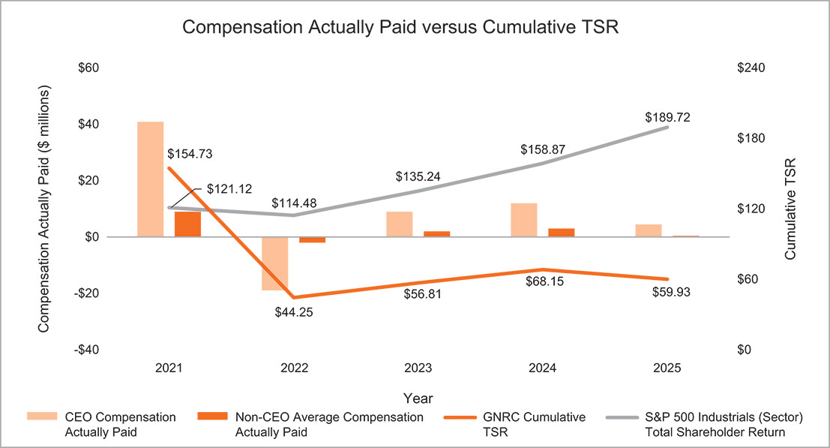
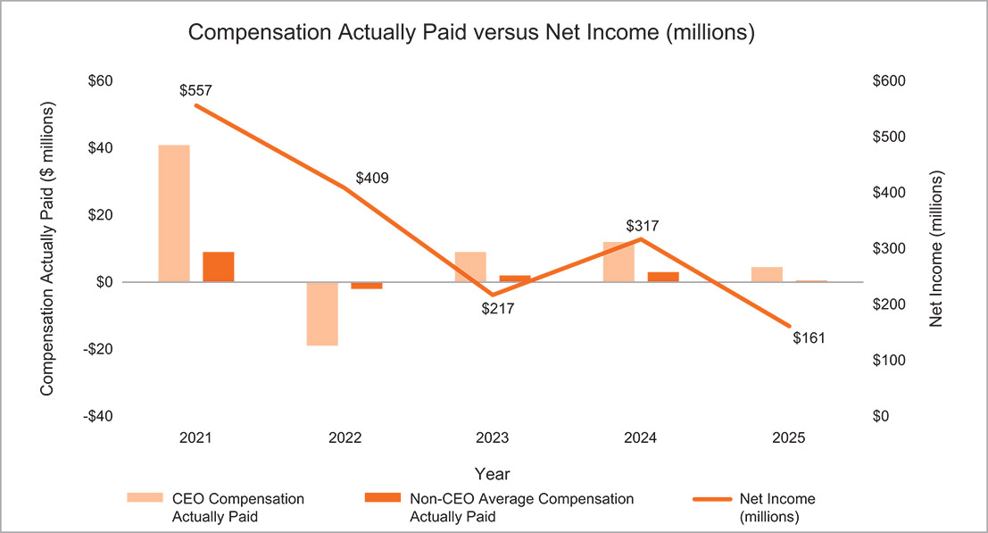

​ |  | ​ | ​ | 55 | ​ | ​ | 2026 Proxy Statement | ​

TABLE OF CONTENTS
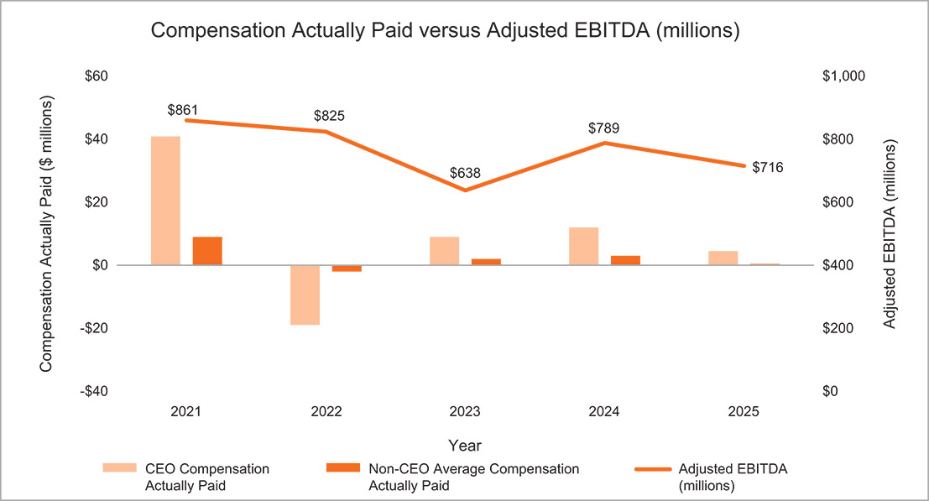
Most Important Pay Versus Performance Financial Measures
We believe the following represent the most important financial performance measures used by us to link CAP to our NEOs for the fiscal year ended December 31, 2025:
​ | ​ | ​
​ | Adjusted EBITDA | ​
​ | Primary Working Capital (“PWC”) as a Percent of Net Sales | ​
​ | Annual Revenue Growth Rate (“CAGR”) | ​
​ | Adjusted EBITDA Margin Percentage | ​
​ | Free Cash Flow (“FCF”) | ​
The Compensation Discussion and Analysis provides a further description of how these metrics
are defined and used in the Company’s executive compensation program.

​ |  | ​ | ​ | 56 | ​ | ​ | 2026 Proxy Statement | ​

TABLE OF CONTENTS​
2025 Director Compensation
2025 Director Compensation
Non-employee directors are paid in accordance with the Company’s Non-Employee Director Compensation Policy, as amended. The following table shows the 2025 compensation information for our Board of Directors.
​ | Name | ​ | ​ | Fees earned  ($) |  |  |  | ​ | ​ | Stock awards  ($)(1)(2) |  |  |  | ​ | ​ | Total  ($) |  |  |  | ​
​ | Marcia Avedon | ​ | ​ | ​ | ​ | 110,000 | ​ | ​ | ​ | ​ | ​ | 155,107 | ​ | ​ | ​ | ​ | ​ | 265,107 | ​ | ​
​ | Kathryn Bohl | ​ | ​ | ​ | ​ | 90,000 | ​ | ​ | ​ | ​ | ​ | 155,107 | ​ | ​ | ​ | ​ | ​ | 245,107 | ​ | ​
​ | John D. Bowlin(3) | ​ | ​ | ​ | ​ | — | ​ | ​ | ​ | ​ | ​ | 136,908 | ​ | ​ | ​ | ​ | ​ | 136,908 | ​ | ​
​ | Robert Dixon | ​ | ​ | ​ | ​ | 105,000 | ​ | ​ | ​ | ​ | ​ | 155,107 | ​ | ​ | ​ | ​ | ​ | 260,107 | ​ | ​
​ | William Jenkins(4) | ​ | ​ | ​ | ​ | 155,000 | ​ | ​ | ​ | ​ | ​ | 90,297 | ​ | ​ | ​ | ​ | ​ | 245,297 | ​ | ​
​ | Andrew Lampereur | ​ | ​ | ​ | ​ | — | ​ | ​ | ​ | ​ | ​ | 270,442 | ​ | ​ | ​ | ​ | ​ | 270,442 | ​ | ​
​ | Bennett Morgan | ​ | ​ | ​ | ​ | — | ​ | ​ | ​ | ​ | ​ | 275,279 | ​ | ​ | ​ | ​ | ​ | 275,279 | ​ | ​
​ | Nam Nguyen | ​ | ​ | ​ | ​ | 90,000 | ​ | ​ | ​ | ​ | ​ | 155,107 | ​ | ​ | ​ | ​ | ​ | 245,107 | ​ | ​
​ | David A. Ramon | ​ | ​ | ​ | ​ | 90,000 | ​ | ​ | ​ | ​ | ​ | 155,107 | ​ | ​ | ​ | ​ | ​ | 245,107 | ​ | ​
​ | Dominick Zarcone | ​ | ​ | ​ | ​ | 45,000 | ​ | ​ | ​ | ​ | ​ | 200,173 | ​ | ​ | ​ | ​ | ​ | 245,173 | ​ | ​
​
Represents shares received in connection with annual equity grants and, if elected in lieu of cash by the non-employee director, quarterly retainer fees. The amounts indicated represent the aggregate grant date fair value for awards of stock (including Deferred Stock Units), computed in accordance with Financial Accounting Standards Board Accounting Standards Codification Subtopic 718. See Note 17 to the Consolidated Financial Statements included in our Annual Report on Form 10-K for the year ended December 31, 2025 for a discussion of the relevant assumptions used in calculating these amounts.
(1)
​
As of December 31, 2025, each individual who served as a non-employee director during 2025 had outstanding the following number of stock awards, all of which consist of Deferred Stock Units issued pursuant to the Company’s Deferred Stock Unit Plan for Non-Employee Directors:
(2)
​
​ | Name | ​ | ​ | Stock awards  (#) |  |  |  | ​
​ | Marcia Avedon | ​ | ​ | ​ | ​ | 2,520 | ​ | ​
​ | Kathryn Bohl | ​ | ​ | ​ | ​ | 13,319 | ​ | ​
​ | John D. Bowlin | ​ | ​ | ​ | ​ | — | ​ | ​
​ | Robert Dixon | ​ | ​ | ​ | ​ | 11,903 | ​ | ​
​ | William Jenkins | ​ | ​ | ​ | ​ | 1,417 | ​ | ​
​ | Andrew Lampereur | ​ | ​ | ​ | ​ | 21,164 | ​ | ​
​ | Bennett Morgan | ​ | ​ | ​ | ​ | 14,458 | ​ | ​
​ | Nam Nguyen | ​ | ​ | ​ | ​ | — | ​ | ​
​ | David A. Ramon | ​ | ​ | ​ | ​ | 7,946 | ​ | ​
​ | Dominick Zarcone | ​ | ​ | ​ | ​ | 15,845 | ​ | ​
​
Mr. Bowlin retired from the Board at the end of his term at the 2025 annual meeting.
(3)
​
Mr. Jenkins has met the minimum stock ownership requirements and elected to receive his annual equity retainer in the form of cash.
(4)
​

​ |  | ​ | ​ | 57 | ​ | ​ | 2026 Proxy Statement | ​

TABLE OF CONTENTS
2025 Director Compensation
Non-employee directors are subject to our stock ownership policy described under “Stock Ownership and Retention Guidelines.” Non-employee directors have five years to meet their minimum ownership requirement. All non-employee directors are compliant with the applicable stock ownership guidelines.
Non-Employee Director Pay
Non-employee directors receive an annual cash retainer of $90,000, paid on a quarterly basis, and an annual equity grant valued at $155,000. The additional annual retainer paid to the Chair of the Audit Committee is $25,000, the additional annual retainer paid to the Chair of the Human Capital and Compensation Committee is $20,000, the additional annual retainer paid to the Chair of the Nominating and Corporate Governance Committee is $15,000, and the additional annual retainer paid to the Lead Director is $30,000. The annual equity grant is made in the form of fully vested shares of our common stock; however, any director who has met the minimum stock ownership requirement may elect to receive the value of the annual equity grant in cash. Our non-employee directors are reimbursed for out-of-pocket expenses incurred in connection with rendering board services.
​ | ​ | ​ | ​ | 2025 Annual  Retainers |  |  |  | ​
​ | Board Compensation | ​ | ​ | ​ | ​ | ​ | ​ | ​
​ | Annual Cash Retainer | ​ | ​ | ​ | $ | 90,000 | ​ | ​
​ | Annual Equity Retainer | ​ | ​ | ​ | $ | 155,000 | ​ | ​
​ | Additional Board Leadership Retainers | ​ | ​ | ​ | ​ | ​ | ​ | ​
​ | Lead Director | ​ | ​ | ​ | $ | 30,000 | ​ | ​
​ | Audit Committee Chair | ​ | ​ | ​ | $ | 25,000 | ​ | ​
​ | Human Capital and Compensation Committee Chair | ​ | ​ | ​ | $ | 20,000 | ​ | ​
​ | Nominating and Corporate Governance Committee Chair | ​ | ​ | ​ | $ | 15,000 | ​ | ​
2025 Equity Compensation Plan Information at Fiscal Year-End
​ | Plan Category | ​ | ​ | Number of  securities to be  issued upon  exercise of  outstanding  options,  warrants and rights  (a) |  |  |  | ​ | ​ | Weighted average  exercise price of  outstanding  options,  warrants and rights  (b) |  |  |  | ​ | ​ | Number of  securities  remaining available  for future issuance  under equity  compensation plans  (excluding  securities reflected  in column (a))  (c) |  |  |  | ​
​ | Equity compensation plans approved by security holders | ​ | ​ | ​ | ​ | 1,392,432 | ​ | ​ | ​ | ​ | $ | 95.28 | ​ | ​ | ​ | ​ | ​ | 3,886,748 | ​ | ​
​ | Equity compensation plans not approved by security holders﻿﻿(1) | ​ | ​ | ​ | ​ | — | ​ | ​ | ​ | ​ | ​ | — | ​ | ​ | ​ | ​ | ​ | — | ​ | ​
​
Not applicable. There were no equity compensation plans not approved by the security holders.
(1)
​

​ |  | ​ | ​ | 58 | ​ | ​ | 2026 Proxy Statement | ​

TABLE OF CONTENTS​
Related Person Transactions
Policies for Approval of Related Person Transactions
We have adopted a written policy relating to the approval of related person transactions. Our Audit Committee reviews and approves or ratifies all relationships and related person transactions between us and (1) our directors, director nominees, or executive officers, (2) any five percent record or beneficial owner of our common stock, or (3) any immediate family member of any person specified in (1) and (2) above. Our Chief Financial Officer is primarily responsible for the development and implementation of processes and controls to obtain information from our directors and executive officers with respect to related person transactions and for determining, based on the facts and circumstances, whether we or a related person have a direct or indirect material interest in the transaction.
As set forth in the Company’s related person transaction policy, in the course of its review and approval or ratification of a related party transaction, the Audit Committee will consider:
the nature of the related person’s interest in the transaction;
•
​
the availability of other sources of comparable products or services;
•
​
the material terms of the transaction, including, without limitation, the amount and type of transaction; and
•
​
the importance of the transaction to us.
•
​
Any member of the Audit Committee who is a related person with respect to a transaction under review will not be permitted to participate in the discussions or approval or ratification of the transaction. However, such member of the Audit Committee will provide all material information concerning the transaction to the Audit Committee.
There were no related person transactions required to be disclosed since January 1, 2025, and no such transactions are currently proposed.

​ |  | ​ | ​ | 59 | ​ | ​ | 2026 Proxy Statement | ​

TABLE OF CONTENTS​
Proposal 2 — Ratification of the Selection of Independent Registered Public Accounting Firm
The Board of Directors recommends that the stockholders ratify the selection of Deloitte & Touche LLP as our independent registered public accounting firm for the year ending December 31, 2026.
A representative of Deloitte & Touche LLP will attend the annual meeting, will have an opportunity to make a statement if such representative desires to do so, and will be available to respond to appropriate questions.
Although the Company is not required to seek stockholder approval of this appointment, the Board of Directors believes that doing so is consistent with good corporate governance practices. If the appointment is not ratified, the Audit Committee will explore the reasons for stockholder rejection and will reconsider the appointment.
​

​ | ​ | The Board of Directors unanimously recommends a vote FOR ratification of the selection of Deloitte & Touche LLP as our independent registered public accounting firm. | ​ | ​

Principal Accounting Fees and Services
Deloitte & Touche LLP (“Deloitte & Touche”) has audited our financial statements since fiscal year 2016 and currently serves as our independent registered public accounting firm. The following table presents fees paid for the audit of our annual consolidated financial statements and all other professional services for each of the last two years:
​ | ​ | ​ | ​ | For the Years Ended  December 31, |  |  |  |  |  |  |  |  |  | ​
​ | ​ | ​ | ​ | 2024 |  |  |  | ​ | ​ | 2025 |  |  |  | ​
​ | Audit fees(1) | ​ | ​ | ​ | $ | 2,108,000 | ​ | ​ | ​ | ​ | $ | 2,241,000 | ​ | ​
​ | Audit related fees(2) | ​ | ​ | ​ | $ | 57,000 | ​ | ​ | ​ | ​ | $ | 38,000 | ​ | ​
​ | Tax fees(3) | ​ | ​ | ​ | $ | 902,000 | ​ | ​ | ​ | ​ | $ | 1,024,000 | ​ | ​
​ | All other fees(4) | ​ | ​ | ​ | $ | 2,000 | ​ | ​ | ​ | ​ | $ | 4,000 | ​ | ​
​ | Total Fees | ​ | ​ | ​ | $ | 3,069,000 | ​ | ​ | ​ | ​ | $ | 3,307,000 | ​ | ​
​
Audit fees include amounts for the annual audit of our consolidated financial statements and internal control over financial reporting, statutory audits at certain foreign subsidiaries, and the reviews of the consolidated financial statements included in our Quarterly Reports on Form 10-Q.
(1)
​
Audit related fees represent amounts reasonably related to the performance of the audit or review of the consolidated financial statements that are not reported under the Audit Fees category such as attestation services requested by management.
(2)
​

​ |  | ​ | ​ | 60 | ​ | ​ | 2026 Proxy Statement | ​

TABLE OF CONTENTS

Tax fees were primarily related to tax planning and compliance services, including assistance related to certain foreign subsidiaries. The increase in 2025 is primarily related to tax compliance services in connection with a recent divestiture and assistance with R&D tax credit assessments.
(3)
​
All other fees are licensing fees for technical research tools.
(4)
​
The services provided by Deloitte & Touche were preapproved by the Audit Committee. The Audit Committee has considered whether the provision of the above noted services is compatible with maintaining the independence of the independent registered public accounting firm and has determined, based on advice from Deloitte & Touche, that the provision of such services has not adversely affected Deloitte & Touche’s independence.
According to its charter, the Audit Committee is responsible for approving all audit engagement fees, terms, and non-audit engagements with the independent auditors on behalf of the Company in advance of providing any service.

​ |  | ​ | ​ | 61 | ​ | ​ | 2026 Proxy Statement | ​

TABLE OF CONTENTS​

Proposal 3 — Advisory Approval of Executive Compensation
As required by Regulation 14A of the Exchange Act, we are offering our stockholders an opportunity to cast an advisory vote on the compensation of our named executive officers, as disclosed in this proxy statement. Although the vote is non-binding, we value continuing and constructive feedback from our stockholders on compensation and other important matters. The Board and the Human Capital and Compensation Committee will consider the voting results when making future compensation decisions.
At the 2025 annual meeting of stockholders, we provided our stockholders with the opportunity to cast an advisory vote on the compensation of our named executive officers as disclosed in the proxy statement for the 2025 annual meeting, and our stockholders overwhelmingly approved the proposal, with 96% of the votes cast in favor.
As described in the “Compensation Discussion and Analysis” section of this proxy statement, we believe that our executive compensation program enables us to attract, retain, and motivate a high-performance executive management team that improves our fundamental financial performance and provides value to the long-term interests of Generac and its stockholders.
We ask for your advisory vote on the following resolution:
“RESOLVED, that the stockholders hereby approve the compensation of Generac’s named executive officers, as described in this proxy statement pursuant to the compensation disclosure rules of the Securities and Exchange Commission.”
•
​
​

​ | ​ | The Board of Directors unanimously recommends a vote “FOR” approval of the compensation of our executive officers. | ​ | ​

​ |  | ​ | ​ | 62 | ​ | ​ | 2026 Proxy Statement | ​

TABLE OF CONTENTS​

Report of the Audit Committee
The Audit Committee represents and assists the Board in fulfilling its oversight responsibility relating to (i) the integrity of the Company’s financial statements and financial reporting process and the Company’s systems of internal accounting and financial controls; (ii) the performance of the internal audit services function; (iii) the annual independent audits of the Company’s financial statements and management’s report regarding the effectiveness of the Company’s system of internal control over financial reporting, the engagement of the independent auditors and the evaluation of the independent auditors’ qualifications, independence, and performance; (iv) the compliance by the Company with legal and regulatory requirements, including the Company’s disclosure controls and procedures; (v) the evaluation of enterprise risk issues; and (vi) the fulfillment of the other responsibilities set out in the Audit Committee’s charter. The Audit Committee has the responsibility for the engagement and retention of the Company’s independent registered public accounting firm and the approval of all audit and other engagement fees.
In discharging its responsibilities, the Audit Committee is not itself responsible for the planning or conducting of audits or for any determination that the Company’s financial statements are complete and accurate or in accordance with generally accepted accounting principles. The Company’s management is primarily responsible for its financial statements and the quality and integrity of the reporting process. The independent registered public accounting firm Deloitte & Touche LLP (“Deloitte & Touche”) is responsible for auditing those financial statements in accordance with accounting principles generally accepted in the United States of America.
In fulfilling its oversight responsibilities, the Audit Committee has reviewed and discussed the audited consolidated financial statements for the year ended December 31, 2025, management’s report of the effectiveness of the Company’s system of internal control over financial reporting, and Deloitte & Touche’s report of the effectiveness of the Company’s system of internal control over financial reporting with the Company’s management and representatives of the independent registered public accounting firm. The Audit Committee discussed with the independent registered public accounting firm the matters required to be discussed by the applicable requirements of the Public Company Accounting Oversight Board (“PCAOB”) and the SEC. In addition, the Audit Committee has received the written disclosures and the letter from the independent registered public accounting firm required by applicable requirements of the PCAOB regarding the independent registered public accounting firm’s communications with the Audit Committee concerning independence and has discussed with the independent registered public accounting firm its independence.
Both the Director — Internal Audit and Deloitte & Touche have direct access to the Audit Committee at any time, and the Committee has the same direct access to the Director — Internal Audit and Deloitte & Touche. The Audit Committee met quarterly with Deloitte & Touche and with the Director — Internal Audit, with and without management present, to discuss the results of their examinations, and the quality of our internal controls and financial reporting. The Audit Committee also met quarterly with the General Counsel on legal and compliance-related matters. The Audit Committee reviewed the Company’s ERM program and met with other members of management in the course of their review of other areas of risk, including information technology systems and security and regulatory matters.

​ |  | ​ | ​ | 63 | ​ | ​ | 2026 Proxy Statement | ​

TABLE OF CONTENTS

In reliance on its review of the audited consolidated financial statements, the review of the report of management on the effectiveness of the Company’s internal control over financial reporting and Deloitte & Touche’s report thereon, the discussions referred to above, and the receipt of the written disclosures referred to above, the Audit Committee has recommended to the Board of Directors that the audited consolidated financial statements be included in the Company’s Annual Report on Form 10-K for the year ended December 31, 2025, for filing with the SEC.
Respectfully submitted by the Audit Committee of the Board of Directors.
Andrew Lampereur, Chair
Kathryn Bohl
Robert Dixon
David Ramon
Dominick Zarcone

​ |  | ​ | ​ | 64 | ​ | ​ | 2026 Proxy Statement | ​

TABLE OF CONTENTS​

Nominations and Proposals by Stockholders
Stockholder Proposals for Inclusion in Our Proxy Statement — Proposals that stockholders wish to submit for inclusion in our proxy statement for our 2027 annual meeting of stockholders pursuant to Rule 14a-8 under the Exchange Act must be received by us no later than December 30, 2026, unless the date of our 2027 annual meeting is more than 30 days before or after June 11, 2027, in which case the deadline will be a reasonable time before we begin to print and mail our proxy materials. Any stockholder proposal submitted for inclusion must be eligible for inclusion in our proxy statement in accordance with the rules and regulations promulgated by the SEC.
Proxy Access Nominations — In 2023, we adopted a proxy access Bylaw that permits a stockholder or group of up to 20 stockholders owning at least 3% of our outstanding common stock continuously for at least the previous three years to nominate up to the greater of two individuals or 20% of the Board of Directors. Requests to include stockholder-nominated candidates in our proxy statement for our 2027 annual meeting of stockholders must be received by us no earlier than November 30, 2026 and no later than December 30, 2026. Each nominee must meet the qualifications required by our Bylaws, and the nominating stockholder or group of stockholders must provide certain information and meet the other specific requirements of our Bylaws.
Stockholder Nominations and Proposals Other than for Inclusion in Our Proxy Statement — With respect to nominations or proposals submitted by a stockholder other than for inclusion in our proxy statement for our 2027 annual meeting of stockholders, timely notice of any stockholder proposal must be received by us in accordance with our Bylaws no later than the close of business on March 13, 2027 nor earlier than the close of business on February 11, 2027, unless the date of our 2027 annual meeting is more than 30 days before or 60 days after June 11, 2027, in which case notice by the stockholder to be timely must be so delivered not earlier than the close of business on the 120th day prior to such annual meeting and not later than the close of business on the later of the 90th day prior to the date of such annual meeting or, if the first public announcement of the date of such annual meeting is less than 100 days prior to the date of such annual meeting, the 10th day following the day on which public announcement of the date of such meeting is first made. The notice must contain the information required by our Bylaws. A stockholder nomination must be accompanied by the information required by our Bylaws with respect to a stockholder director nominee. We may require any proposed nominee to furnish other information as we may reasonably require to determine the eligibility of the proposed nominee to serve as a director of the Company.
In addition to satisfying the foregoing requirements, to comply with the universal proxy rules, stockholders who intend to solicit proxies in support of director nominees other than the Board of Directors’ nominees must provide notice that sets forth the information required by Rule 14a-19 under the Exchange Act no later than April 12, 2027.
Address for Notices — In the case of any notice of a nomination or proposal submitted in accordance with the procedures above, the notice must be received by us at S45 W29290 Hwy. 59, Waukesha, WI 53189, attention of Raj Kanuru, Executive Vice President, General Counsel & Secretary.

​ |  | ​ | ​ | 65 | ​ | ​ | 2026 Proxy Statement | ​

TABLE OF CONTENTS​
Information Concerning Solicitation and Voting
The Board of the Company is soliciting your proxy to be voted at the Annual Meeting of Stockholders to be held on Thursday, June 11, 2026, at 9:00 a.m. Central Time, at Generac’s headquarters located at S45 W29290 Highway 59 Waukesha, Wisconsin 53189, and any postponement or adjournment thereof.
Record Date; Stock Outstanding and Entitled to Vote
Holders of common stock as of the record date, April 16, 2026, are entitled to notice of, and to vote at, the annual meeting. As of the record date, there were 58,811,741 shares of common stock outstanding and entitled to vote at the annual meeting, with each share entitled to one vote.
If you are a stockholder of record, you will need to present the Notice of Internet Availability or proxy card that you received, together with a form of personal photo identification, in order to be admitted into the meeting. If you are the beneficial owner of shares held in “street name,” you will need to provide proof of ownership, such as a recent account statement or letter from your bank, broker, or other nominee as of the close of business on April 16, 2026, along with a form of personal photo identification. Alternatively, you may contact the broker, bank, or other nominee in whose name your shares of common stock are registered and obtain a legal proxy to bring to the meeting. Audio or visual recording of any portion of the annual meeting is not permitted. No cameras, recording equipment, large bags, briefcases, or packages will be allowed in the meeting or adjacent areas. All other items may be subject to search.

​ |  | ​ | ​ | 66 | ​ | ​ | 2026 Proxy Statement | ​

TABLE OF CONTENTS
INFORMATION CONCERNING SOLICITATION AND VOTING
Information About This Proxy Statement
Why you received a Notice of Internet Availability. We are mailing only a Notice of Internet Availability to all stockholders. The Notice of Internet Availability includes information on where to view all proxy materials online, as well as voting instructions. These materials have been made available to you on the internet because our Board of Directors is soliciting your proxy to vote your shares at the annual meeting and any postponement or adjournment thereof. This proxy statement includes information that we are required to provide to you under the rules of the SEC and that is designed to assist you in voting your shares. If you own our common stock in more than one account, such as individually and also jointly with your spouse, you may receive more than one Notice of Internet Availability relating to these proxy materials. To assist us in saving money and to serve you more efficiently, we encourage you to have all your accounts registered in the same name and address by contacting our transfer agent:
Computershare, Inc.
P.O. Box 43006
Providence, RI 02940-3006
United States of America
By Overnight Delivery:
Computershare, Inc.
250 Royall Street
Canton, MA 02021
United States of America
Toll Free — 877-373-6374
U.S. — 800-962-4284
Householding. The SEC’s rules permit us to deliver a single Notice of Internet Availability or set of annual meeting materials to one address shared by two or more of our stockholders. This delivery method is referred to as “householding” and can result in significant cost savings. To take advantage of this opportunity, we have delivered only one Notice of Internet Availability to multiple stockholders who share an address, unless we received contrary instructions from the impacted stockholders prior to the mailing date. We agree to deliver promptly, upon written or oral request, a separate Notice of Internet Availability to any stockholder at the shared address to which a single copy of the Notice of Internet Availability was delivered. If you are a record holder and if you prefer to receive separate copies of the proxy materials, or if you currently receive multiple copies and prefer to receive a single copy, please contact Raj Kanuru, Executive Vice President, General Counsel & Secretary, Generac Holdings Inc., S45 W29290 Highway 59, Waukesha, Wisconsin 53189, or by telephone at (262) 544-4811.

​ |  | ​ | ​ | 67 | ​ | ​ | 2026 Proxy Statement | ​

TABLE OF CONTENTS
INFORMATION CONCERNING SOLICITATION AND VOTING
Voting by and Revocation of Proxies
Stockholders of record are requested to vote by proxy in one of the following ways:
By telephone — Use the toll-free telephone number shown on the Notice of Internet Availability or any proxy card you receive;
•
​
By internet — Visit the internet website indicated on the Notice of Internet Availability or any proxy card you receive and follow the on-screen instructions;
•
​
By mail — If you request a paper proxy card by telephone or internet, you may elect to vote by mail. If you elect to do so, you should date, sign, and promptly return your proxy card by mail in the postage prepaid envelope which accompanied that proxy card; or
•
​
In person — You can deliver a completed proxy card at the meeting or vote in person.
•
​
Voting instructions (including instructions for both telephonic and internet proxies) are provided on the Notice of Internet Availability and on any proxy card you receive. The internet and telephone proxy procedures are designed to authenticate stockholder identities, to allow stockholders to give voting instructions, and to confirm that stockholders’ instructions have been recorded properly. A control number, located on the Notice of Internet Availability or proxy card, will identify stockholders and allow them to submit their proxies and confirm that their voting instructions have been properly recorded. Costs associated with electronic access, such as usage charges from internet access providers and telephone companies, must be borne by the stockholder. If you submit your proxy by internet or telephone, it will not be necessary to return a proxy card for your vote to be counted.
If a stockholder does not submit a proxy via the internet or by telephone or return a signed proxy card, and does not attend the meeting and vote in person, his or her shares will not be voted. Shares of our common stock represented by properly executed proxies received by us or proxies submitted by telephone or via the internet, which are not revoked, will be voted at the meeting in accordance with the instructions contained therein.
If instructions are not given and you do not indicate how your shares should be voted on a proposal, the shares represented by a properly completed proxy will be voted as the Board recommends. In addition, we reserve the right to exercise discretionary authority to vote proxies, in the manner determined by the Board in its sole discretion, on any matters brought before the annual meeting for which we did not receive adequate notice under the proxy rules promulgated by the SEC.
Any proxy signed and returned by a stockholder or submitted by telephone or via the internet may be revoked at any time before it is exercised by giving written notice of revocation to the Company’s Secretary at our address set forth herein, by executing and delivering a later-dated proxy (either in writing, by telephone or via the internet), or by voting in person at the meeting. Attendance at the meeting will not, in and of itself, constitute revocation of a proxy.
If your shares are held in the name of a bank, broker, fiduciary or custodian, follow the voting instructions on the form you receive from your record holder. The availability of internet and telephone proxies for these stockholders will depend on their voting procedures.
Quorum
The presence at the Annual Meeting, in person or by proxy, of the holders of at least a majority of the number of shares of common stock issued and outstanding and entitled to vote as of the record date, is required to constitute a quorum to transact business at the Annual Meeting. Abstentions and broker non-votes will be counted toward the establishment of a quorum.

​ |  | ​ | ​ | 68 | ​ | ​ | 2026 Proxy Statement | ​

TABLE OF CONTENTS
INFORMATION CONCERNING SOLICITATION AND VOTING
Required Votes
Election of Three Nominees Named Herein as Class II Directors. Under our Bylaws, the affirmative vote of a plurality of shares of common stock voting on this matter at the annual meeting is required to elect each nominee named herein as a director. Consequently, only shares that are voted in favor of a particular nominee will be counted toward such nominee’s achievement of a plurality. Notwithstanding the foregoing, if a nominee for Director receives more “against” votes for his or her election than votes “for” his or her election in an uncontested election at a meeting of stockholders, without regard for abstentions, the Director shall, in accordance with and subject to our Corporate Governance Guidelines and Principles, promptly tender his or her resignation to the Board.
Ratification of the selection of Deloitte & Touche LLP as our Independent Registered Public Accounting Firm. Proposal 2, relating to the ratification of the appointment of Deloitte & Touche LLP as our independent registered public accounting firm for 2026, will be approved if it receives the affirmative vote of a majority of the shares of common stock present in person or represented by proxy at the Annual Meeting and voting on the proposal.
Approval of Non-Binding “Say-on-Pay” Resolution Regarding Executive Compensation. Proposal 3, relating to the non-binding resolution to approve our executive compensation, will be approved if it receives the affirmative vote of a majority of the shares of common stock present in person or represented by proxy at the annual meeting and voting on the proposal.
Impact of Abstentions. Abstentions will have no effect on the determination of the election of directors or the outcome of any proposal.
Shares Held by Brokers
If you are the beneficial owner of shares held for you by a broker, your broker must vote those shares in accordance with your instructions. If you do not give voting instructions to your broker, your broker may vote your shares for you on any discretionary items of business to be voted upon at the annual meeting. If you do not provide voting instructions on a non-discretionary item, including the election of the Class II director nominees named herein, the shares will be treated as “broker non-votes.” We believe that the ratification of the selection of Deloitte & Touche LLP (Proposal 2) is a routine matter on which brokers will generally be permitted to vote any unvoted shares in their discretion. We believe that election of the three nominees named herein as Class II directors (Proposal 1), and the advisory, non-binding approval of executive compensation (Proposal 3), are non-routine matters on which brokers will not be permitted to vote any unvoted shares. “Broker non-votes” will have no effect on the election of directors or the outcome of any proposal.
Proxy Solicitation
The Company will bear the costs of solicitation of proxies for the annual meeting, including preparation, assembly, printing, and mailing of the Notice of Internet Availability, this proxy statement, the annual report, any proxy card, and any additional information furnished to stockholders. Copies of our proxy statement will be furnished, upon request, to banks, brokerage houses, fiduciaries, and custodians holding shares of common stock beneficially owned by others to forward to such beneficial owners. We may reimburse persons representing beneficial owners of common stock for their costs of forwarding solicitation material to such beneficial owners. Solicitation of proxies by mail may be supplemented by telephone, email, or personal

​ |  | ​ | ​ | 69 | ​ | ​ | 2026 Proxy Statement | ​

TABLE OF CONTENTS
INFORMATION CONCERNING SOLICITATION AND VOTING
solicitation by Computershare or by directors, officers, or other regular employees of the Company. No additional compensation will be paid to directors, officers, or other regular employees for such services.
Other Business
The Board of Directors has no knowledge of any other matter to be submitted at the annual meeting. If any other matter shall properly come before the annual meeting, the persons named as proxies in the Notice of Internet Availability or on the proxy card will have discretionary authority to vote the shares thereby represented in accordance with their best judgment.
Annual Report and Company Information
Our Annual Report to Stockholders, which contains consolidated financial statements for the year ended December 31, 2025, is being furnished to stockholders concurrently herewith. You also may obtain a copy of our Annual Report on Form 10-K for the year ended December 31, 2025 that was filed with the SEC, without charge, by writing to Generac Holdings Inc., Attn: Investor Relations, S45 W29290 Hwy. 59, Waukesha, Wisconsin 53189. These materials will also be available without charge at “Investors” on our website at www.generac.com.
It is important that your proxy be returned promptly, whether by mail, by the internet, or by telephone. The proxy may be revoked at any time by you before it is exercised. If you attend the meeting in person, you may withdraw any proxy (including an internet or telephonic proxy) and vote your own shares.
By Order of the Board of Directors,
Raj Kanuru
Executive Vice President, General Counsel & Secretary

​ |  | ​ | ​ | 70 | ​ | ​ | 2026 Proxy Statement | ​

TABLE OF CONTENTS
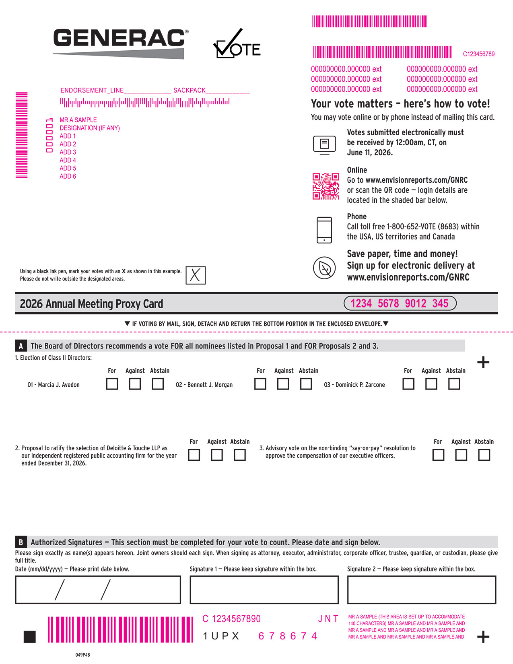
01 - Marcia J. Avedon 02 - Bennett J. Morgan 03 - Dominick P. Zarcone 1UPX For Against Abstain For Against Abstain For Against Abstain The Board of Directors recommends a vote FOR all nominees listed in Proposal 1 and FOR Proposals 2 and 3. A 049P4B 2. Proposal to ratify the selection of Deloitte & Touche LLP as our independent registered public accounting firm for the year ended December 31, 2026. 3. Advisory vote on the non-binding “say-on-pay” resolution to approve the compensation of our executive officers. 1. Election of Class II Directors: For Against Abstain For Against Abstain Please sign exactly as name(s) appears hereon. Joint owners should each sign. When signing as attorney, executor, administrator, corporate officer, trustee, guardian, or custodian, please give full title. Signature 1 — Please keep signature within the box. Signature 2 — Please keep signature within the box. Date (mm/dd/yyyy) — Please print date below. Authorized Signatures — This section must be completed for your vote to count. Please date and sign below. B 2026 Annual Meeting Proxy Card Using a black ink pen, mark your votes with an X as shown in this example. Please do not write outside the designated areas. q IF VOTING BY MAIL, SIGN, DETACH AND RETURN THE BOTTOM PORTION IN THE ENCLOSED ENVELOPE.qMMMMMMMMMMMMMMMMMMMMM 1234 5678 9012 345 678674 If no electronic voting, delete QR code and control # 000001 MR A SAMPLE DESIGNATION (IF ANY) ADD 1 ADD 2 ADD 3 ADD 4 ADD 5 ADD 6 ENDORSEMENT_LINE______________ SACKPACK_____________ MMMMMMMMMMMMMMM C123456789 000000000.000000 ext 000000000.000000 ext 000000000.000000 ext 000000000.000000 ext 000000000.000000 ext 000000000.000000 ext MR A SAMPLE (THIS AREA IS SET UP TO ACCOMMODATE 140 CHARACTERS) MR A SAMPLE AND MR A SAMPLE AND MR A SAMPLE AND MR A SAMPLE AND MR A SAMPLE AND MR A SAMPLE AND MR A SAMPLE AND MR A SAMPLE AND C 1234567890 J N T MMMMMMM You may vote online or by phone instead of mailing this card. Online Go to www.envisionreports.com/GNRC or scan the QR code — login details are located in the shaded bar below. Your vote matters – here’s how to vote! Votes submitted electronically must be received by 12:00am, CT, on June 11, 2026. Save paper, time and money! Sign up for electronic delivery at www.envisionreports.com/GNRC Phone Call toll free 1-800-652-VOTE (8683) within the USA, US territories and Canada

TABLE OF CONTENTS

Small steps make an impact. Help the environment by consenting to receive electronic delivery, sign up at www.envisionreports.com/GNRC Notice of 2026 Annual Meeting of Stockholders Proxy Solicited by Board of Directors for Annual Meeting — June 11, 2026 York A. Ragen, Chief Financial Officer of Generac Holdings Inc., and Raj Kanuru, Executive Vice President, General Counsel and Corporate Secretary of Generac Holdings Inc., or either of them, each with the power of substitution, are hereby authorized to represent and vote the shares of the undersigned, with all the powers which the undersigned would possess if personally present, at the Annual Meeting of Stockholders of Generac Holdings Inc. to be held on June 11, 2026 or at any postponement or adjournment thereof. Shares represented by this proxy will be voted by the stockholder. If no such directions are indicated, the Proxies will have authority to vote FOR the election of the Board of Directors and FOR items 2 and 3. In their discretion, the Proxies are authorized to vote upon such other business as may properly come before the meeting. (Items to be voted appear on reverse side) Proxy — Generac Holdings Inc. Non-Voting Items C q IF VOTING BY MAIL, SIGN, DETACH AND RETURN THE BOTTOM PORTION IN THE ENCLOSED ENVELOPE.q Change of Address — Please print new address below. Comments — Please print your comments below. Important notice regarding the Internet availability of proxy materials for the Annual Meeting of Stockholders. The material is available at: www.envisionreports.com/GNRC 2026 Annual Meeting Admission Ticket 2026 Annual Meeting of the Stockholders of Generac Holdings Inc. June 11, 2026, 9:00am CT Generac Corporate Headquarters S45 W29290 Highway 59, Waukesha, WI 53189 Upon arrival, please present this admission ticket and photo identification at the registration desk.

TABLE OF CONTENTS
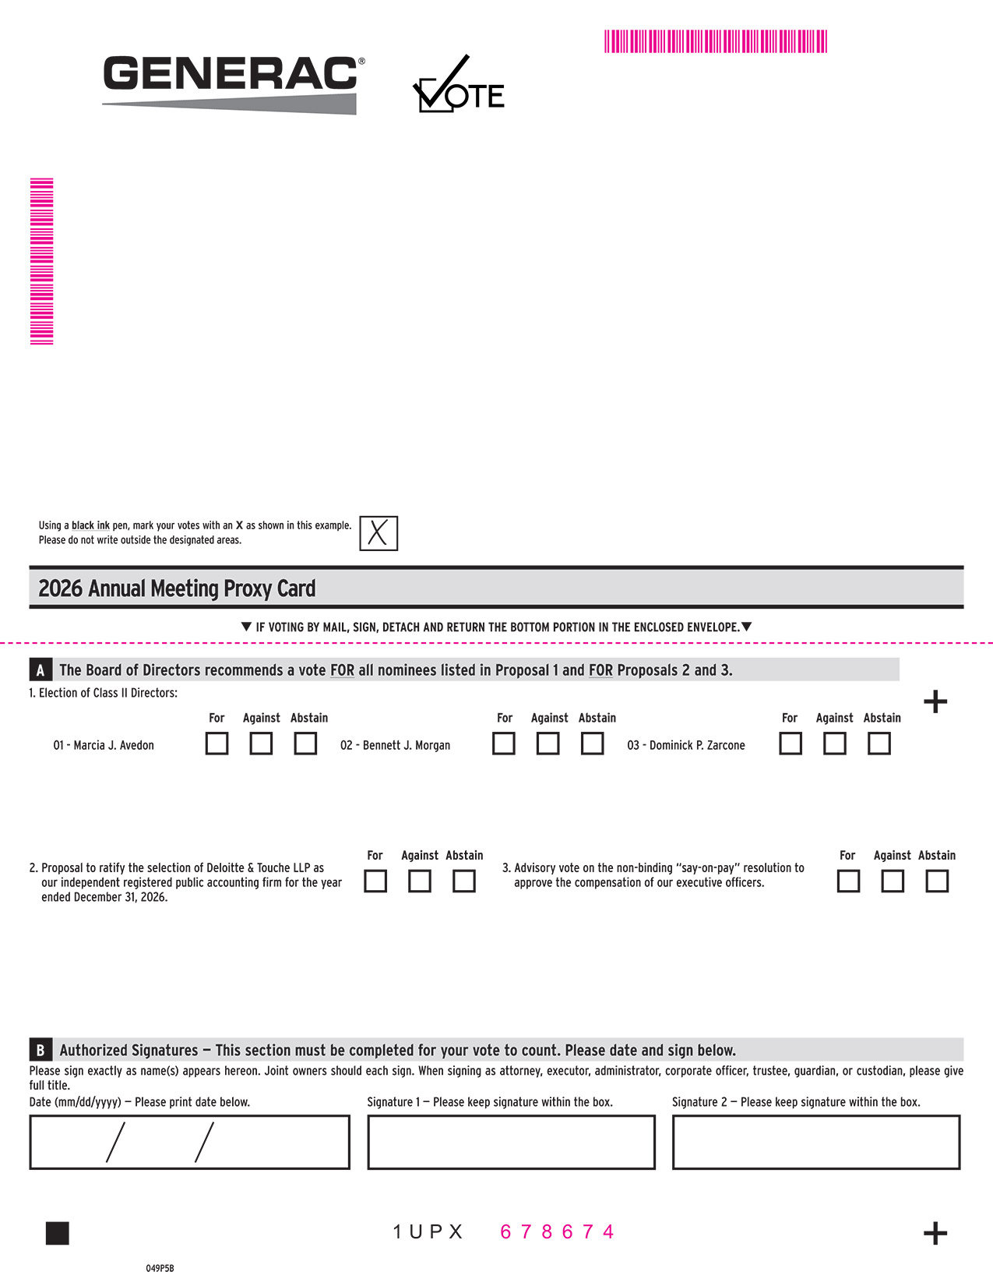
01 - Marcia J. Avedon 02 - Bennett J. Morgan 03 - Dominick P. Zarcone 1UPX For Against Abstain For Against Abstain For Against Abstain The Board of Directors recommends a vote FOR all nominees listed in Proposal 1 and FOR Proposals 2 and 3. A 049P5B 2. Proposal to ratify the selection of Deloitte & Touche LLP as our independent registered public accounting firm for the year ended December 31, 2026. 3. Advisory vote on the non-binding “say-on-pay” resolution to approve the compensation of our executive officers. 1. Election of Class II Directors: For Against Abstain For Against Abstain Please sign exactly as name(s) appears hereon. Joint owners should each sign. When signing as attorney, executor, administrator, corporate officer, trustee, guardian, or custodian, please give full title. Signature 1 — Please keep signature within the box. Signature 2 — Please keep signature within the box. Date (mm/dd/yyyy) — Please print date below. Authorized Signatures — This section must be completed for your vote to count. Please date and sign below. B 2026 Annual Meeting Proxy Card Using a black ink pen, mark your votes with an X as shown in this example. Please do not write outside the designated areas. q IF VOTING BY MAIL, SIGN, DETACH AND RETURN THE BOTTOM PORTION IN THE ENCLOSED ENVELOPE.q MMMMMMMMMMMMMMMMMMMMM 678674

TABLE OF CONTENTS

Notice of 2026 Annual Meeting of Stockholders Proxy Solicited by Board of Directors for Annual Meeting — June 11, 2026 York A. Ragen, Chief Financial Officer of Generac Holdings Inc., and Raj Kanuru, Executive Vice President, General Counsel and Corporate Secretary of Generac Holdings Inc., or either of them, each with the power of substitution, are hereby authorized to represent and vote the shares of the undersigned, with all the powers which the undersigned would possess if personally present, at the Annual Meeting of Stockholders of Generac Holdings Inc. to be held on June 11, 2026 or at any postponement or adjournment thereof. Shares represented by this proxy will be voted by the stockholder. If no such directions are indicated, the Proxies will have authority to vote FOR the election of the Board of Directors and FOR items 2 and 3. In their discretion, the Proxies are authorized to vote upon such other business as may properly come before the meeting. (Items to be voted appear on reverse side) Proxy — Generac Holdings Inc. q IF VOTING BY MAIL, SIGN, DETACH AND RETURN THE BOTTOM PORTION IN THE ENCLOSED ENVELOPE.

